Time Series
Fall 2005
March 14, 2006

Time Series Final Project

In this project, non-seasonally adjusted Consumer Price Index (CPI) data is analyzed.
Initial Evaluation of Time Series Data
First, the non-seasonally adjusted CPI data set for months January 1945 – December 2005 is examined.

[NEAS: The candidate uses the CPI index. The inflation rate is the first difference of the logarithm of the consumer price index. The first difference of an interest rate is the second difference of the CPI index.

[NEAS: By using non-seasonal adjusted data, we expect to see seasonal variations. We show both seasonally adjusted (SA) and non-seasonally adjusted (NSA) indices on the discussion board. Many variations on this theme are suitable for student projects.

~ You can compare seasonality in the SA and NSA CPI indices to verify that the seasonal autocorrelations in the NSA index are eliminated in the SA index.
~ You can compare ARIMA models for the SA and NSA indices. You should get a better fit for the SA index, even after including a AR(12) term for the NSA model, since the seasonality adjustment is more sophisticated than an AR(12) term.]

[NEAS: The time series drifts upward. The elements are the price level, not the inflation rate, so we assume the drift is exponential. Inflation was low from 1945 to 1975, high from 1975 to 1985, and low from 1985 to 2005. These time periods are rough approximations. We deliberately avoid giving you more precise inflation rate eras. You should examine the CPI indices and choose more precise dates.

The differences stemmed from federal government policy:

~ 1945-1975: high post-World War II labor productivity of 3.5% per annum; steady growth of the money supply, low unemployment benefits, and plentiful jobs.
~ 1975-1985: stagflation; government attempts to reduce unemployment by allowing inflation; unemployment benefits increased and the money supply grew rapidly.
~ 1985-2005: post-Volcker era; slow and steady growth of money supply to restrain inflation; explicit Federal Reserve Board monitoring of the inflation rate.

The inflation rates differ in these three periods, and no single ARIMA process works well throughout. We have three choices, each of which forms a good student project:

~ Regress the inflation rate on economic variables like growth in the money supply and model the residuals by an ARIMA process. Milton Freidman’s early fame stemmed from an extensive analysis of this sort.
~ Divide the time period into three eras and construct an ARIMA process for each era. The ARIMA processes differ greatly. Your student project can compare the eras (means, drifts, variances, and ARIMA parameters) and explain how you chose the different periods.
~ Use more complex ARIMA processes. Explain how you choose between parsimony and in-sample goodness-of-fit tests.]

A graph of the CPI versus the month shows a noticeable exponential trend.

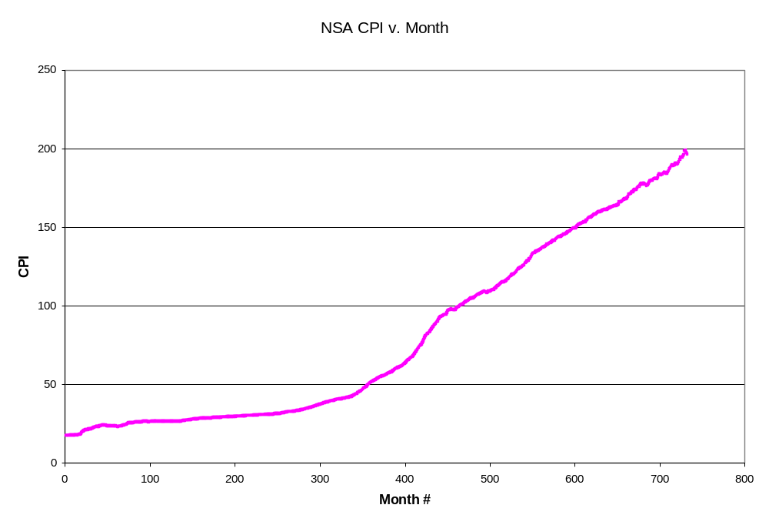

Seasonality is also a concern with the data set, shown below by focusing on a time period of 60 months.
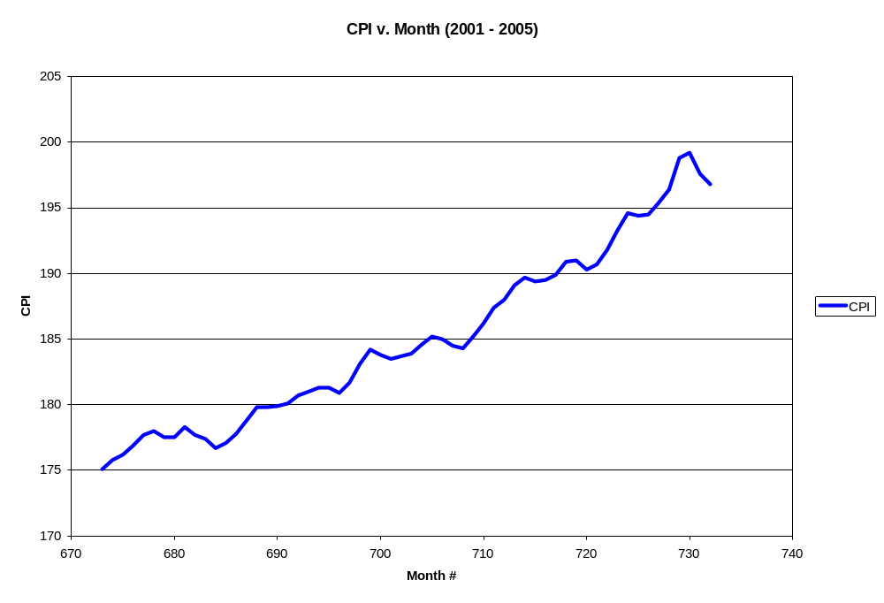
[NEAS: The graph shows a 12 month cycle, with a dip in the price level every 12 months. Economists disagree about the cause of the seasonality. One theory is that in December of each year, the demand for money increases as consumers spend for holiday shopping. The nominal money supply is relatively fixed, so the price level must dip for the real money supply to increase.

Format your graphs with vertical tabs at 12 month intervals to highlight the seasonality.]

With evidence of an exponential trend and seasonality, the time series is obviously not stationary.

Adjusting the Non-Stationary Time Series
The exponential trend in the data is addressed first, by taking the natural logarithm of each CPI data point. This removes much of the exponential trend, leaving a noticeably more linear relationship between the x and y variables.

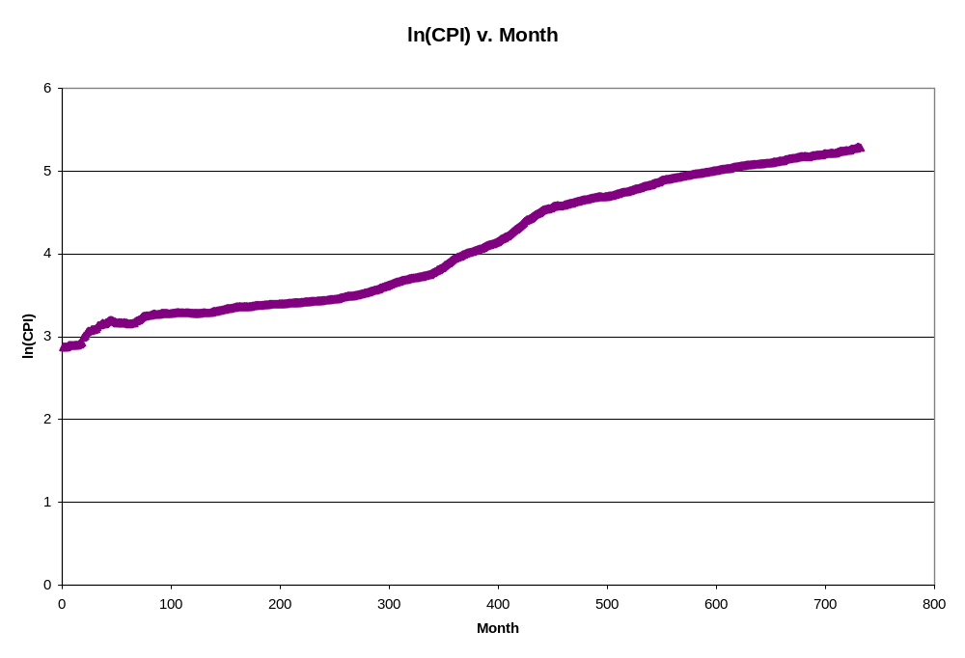
First differences are then taken to address the linear trend.
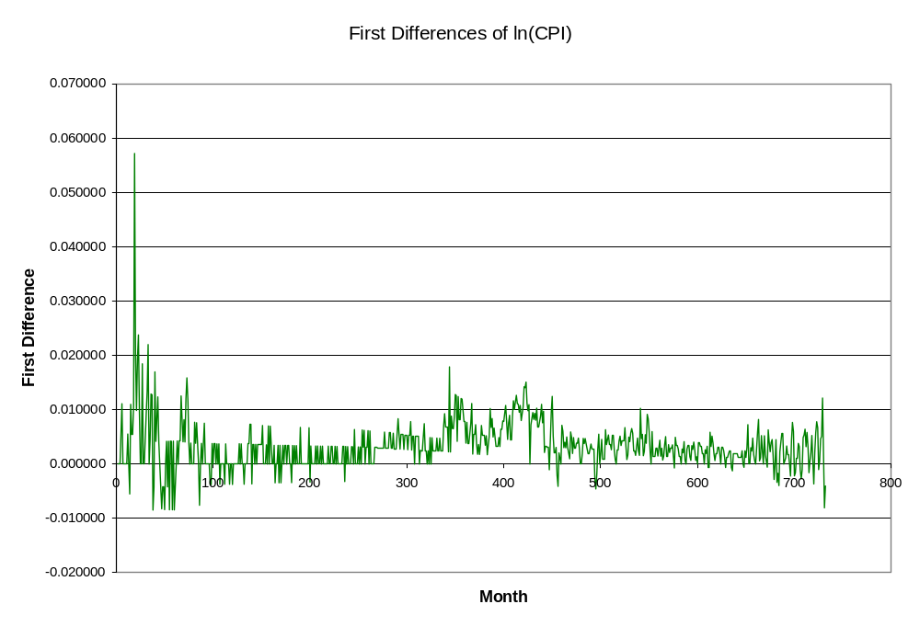
[NEAS: We can (i) take logarithms and then first differences or (ii) form ratios. The former method gives the continuously compounded inflation rate and the latter method gives one plus the monthly compounded inflation rate. The logarithm of the ratios is the first differences of the logarithms.]

The seasonality of the time series is more difficult to address, since the seasonality could be on a monthly basis, quarterly basis, etc. Looking at the 3-month and 12-month moving average graphs gives no evidence as to the type of seasonality in the data. Therefore, a correlogram must be used to reach a conclusion regarding any seasonality in the data.
[NEAS: Moving averages smooth seasonality. The correlogram shows seasonal effects. Alternatively, divide each month’s price level by the 12 month moving average and examine the monthly averages. The two methods are each appropriate in certain cases. You can do a student project examining methods of adjusting for seasonality.]

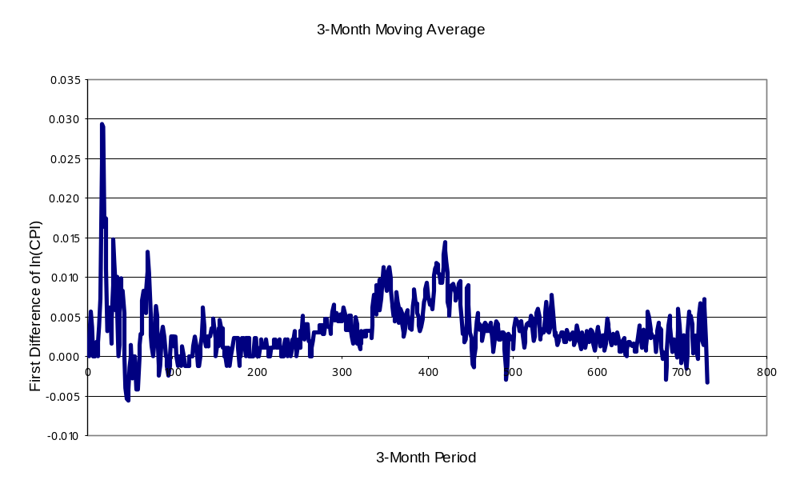
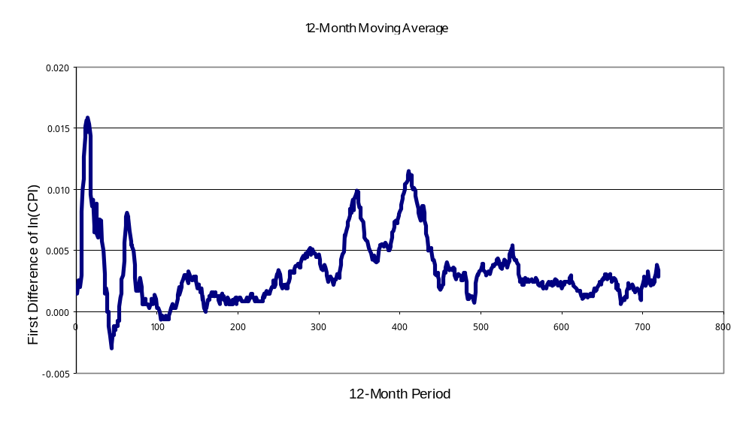
The correlogram below is a plot of autocorrelation versus lag (k), which shows that the autocorrelation function drops off dramatically as k increases. Thus, it is reasonable to conclude that after taking the first differences of the natural logarithms of the CPI data points, the resulting time series is stationary.

[NEAS: The textbook is not clear. Sample autocorrelations that remain positive and greater than 20% for 14 lags are generally not a stationary process. The decline is too slow for this to be a simple autoregressive or moving average model. In a stationary process, the autocorrelations should fluctuate about zero after about 5 or 6 lags. The candidate began with the CPI index, so the first differences are the inflation rate. We do not expect the inflation rate itself to be stationary, and the correlogram confirms this.]

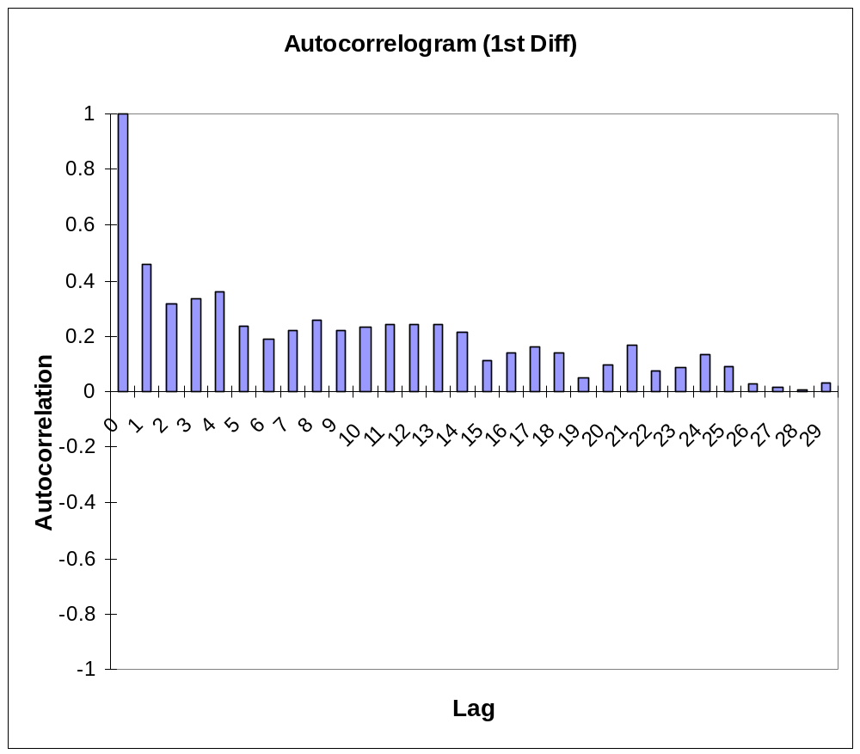

Testing for White Noise
According to Pindyck and Rubinfeld in Econometric Models and Economic Forecasts, “if the autocorrelation function is zero or close to zero for all k>0, there is little or no value in using a model to forecast the series” (495). This condition is called white noise. The Durbin-Watson statistic, Bartlett’s test, and the Box-Pierce Q statistic are used to determine if a time series is a white noise process.

Durbin-Watson Statistic
The Durbin-Watson test uses a statistic (DW) to test autocorrelations of lag 1. For the CPI data set, DW is 0.700. Since the DW statistic is not close to 2, it cannot be concluded that the time series is a white noise process. A DW statistic very close to 2 would have allowed the conclusion to be reached that the time series is a white noise process.

[NEAS: A Durbin-Watson statistic of 0.700 indicates very strong positive serial correlation. For a time series of 720 elements, the p-value is about zero. If the Durbin-Watson statistic were between 1.85 and 2.15, we would not reject the null hypothesis that there is no serial correlation. With a Durbin-Watson statistic of 0.700, we can reject the null hypothesis at any reasonable significance level.

This is expected from the data. We have a time series of inflation rates that increase and then decrease. The overall drift is about zero, but it is positive in the first half of the series and negative in the second half of the series. This give strong positive serial correlation.]

Bartlett’s Test
According to Bartlett, if a time series has been generated by a white noise process, the sample autocorrelation coefficients have an approximate normal distribution with mean zero and standard deviation 1/√T, where T is the number of observations. Given the 731 observations, the hypothesis for this test is that the sample autocorrelation coefficients are (approximately) normally distributed with mean zero and standard deviation 0.037. Since there are autocorrelation coefficients greater than 0.037, it is 95% certain that the true autocorrelation function is not equal to or near to zero. Thus, Bartlett’s test fails to show that the time series has been generated by a white noise process.

[NEAS: Even for a white noise process, we expect 5% of the sample autocorrelations outside the 95% confidence interval. For 720 sample autocorrelations, we need at least 7% to 8% outside the 95% confidence interval to conclude that this is not a white noise process. In these data, the number of sample autocorrelations outside the 95% confidence interval shows that the time series is not a white noise process.

Bartlett’s test never shows that the time series is a white noise process. We reject the null hypothesis that the time series is a white noise process if many sample autocorrelations are outside the confidence interval; otherwise, we do not reject the null hypothesis. The time series could always be a non-white noise process that has low autocorrelations.]

Box-Pierce Q Statistic
The Box-Pierce Q Statistic tests the joint hypothesis that all the autocorrelation coefficients are zero. The statistic Q = T*Σ (ρk)2 is summed from k=1 to k=K and is approximately distributed as a chi-square with K degrees of freedom. With K set at 29, the Q statistic for the CPI time series is 906.7. Therefore, the hypothesis that all the autocorrelation coefficients are zero is rejected at all critical levels.

Based on the results of these statistical tests, the time series does not appear to have been generated by a white noise process.

Autoregressive Models
Since the time series is probably not white noise, the question now is what type of ARIMA model best fits the time series. Examining the sample autocorrelation and sample partial autocorrelation functions using correlograms will help answer this question.
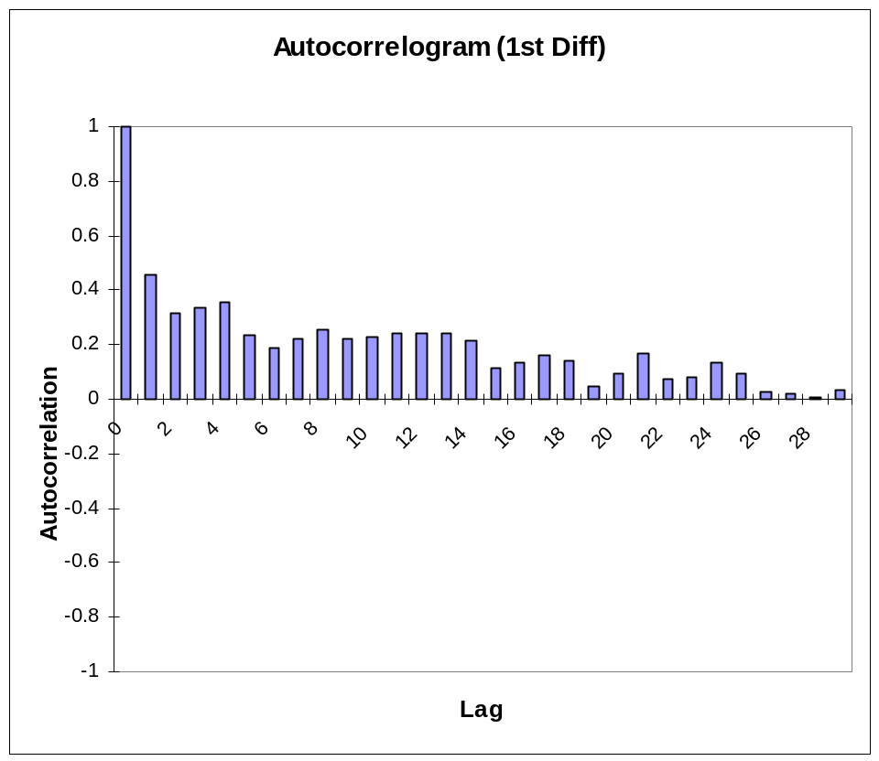
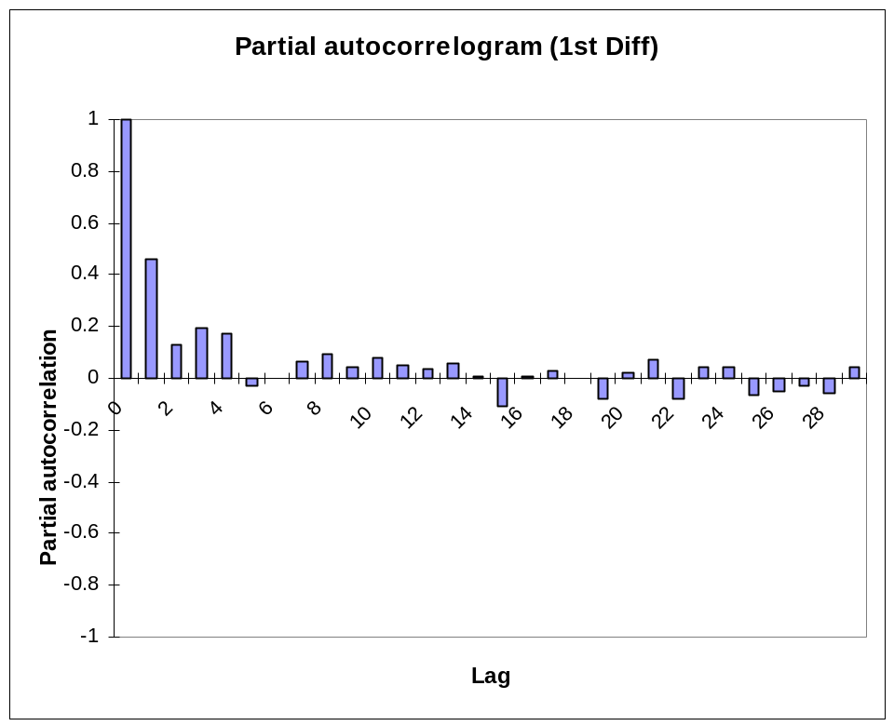

A geometrically declining sample autocorrelation function and spikes in the partial autocorrelation function indicate an autoregressive model. Spikes in the sample autocorrelation function and a declining partial autocorrelation function indicate a moving average model. Since sample autocorrelations are used here, the model descriptions are, at best, rough descriptions. The graph above of the autocorrelation versus lag shows an initial drop-off, followed by a quick yet steady decline toward zero. The graph of the partial autocorrelation versus lag spikes and oscillates. Given these autocorrelation and partial autocorrelation characteristics, an AR(1) appears to be the best choice of models.

Statistical Tests
The AR(1) model must be tested to confirm that it is the best model on hand. First, ordinary least squares for the autoregressive parameter is used to fit an AR(1) model. The resulting AR(1) equation is:
yt = -0.0000004t + 0.0034

[NEAS: This is a linear trend model, not an AR(1) model. If the true process is AR(1), a linear trend model has strong positive serial correlation and fails Bartlett’s test and the Box-Pierce Q statistic. The textbook discusses how to distinguish random walks from linear trends. Some candidates presume that random walks and AR(1) models are linear trends with stochasticity. This is not correct. We have placed a long posting elsewhere on the discussion forum explaining the difference.]

The Durbin-Watson statistic, Barlett’s test, and the Box-Pierce Q statistic are used to test the AR(1) model.

Durbin-Watson Statistic
The Durbin-Watson Statistic for the AR(1) model is 1.077. Since this number is a significant distance from 2, nothing can be concluded from this test.

[NEAS: If the Durbin-Watson statistic is between d_{l} and d_{u}, we can not conclude definitely whether serial correlation exists. A Durbin-Watson statistic of 1.077 with over 700 degrees of freedom is unambiguous evidence of positive serial correlation. A random walk or an AR(1) process that is modeled as a linear trend shows strong positive serial correlation.]

Bartlett’s Test
As Bartlett’s Test was described previously, if a time series has been generated by a white noise process, the sample autocorrelation coefficients have an approximate normal distribution with mean zero and standard deviation 1/√T, where T is the number of observations. Given the 731 observations, the hypothesis is that the sample autocorrelation coefficients are (approximately) normally distributed with mean zero and standard deviation 0.037. The autocorrelation coefficients associated with the fitted AR(1) model are greater than 0.037, shown in the graph below. Thus, Bartlett’s test fails to show that the time series has been generated by a white noise process.
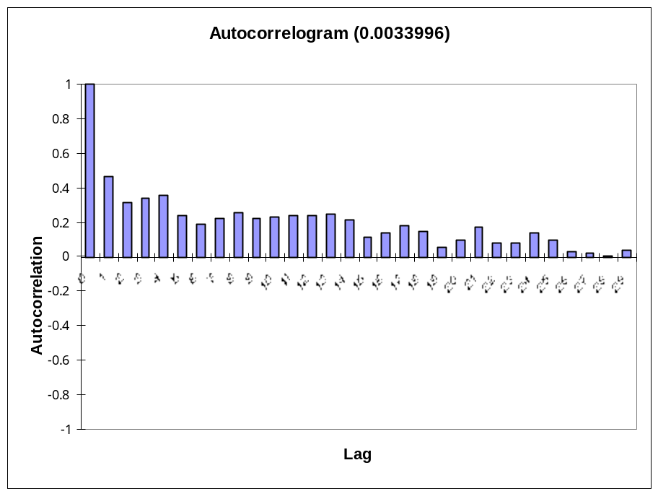
[NEAS: The candidate used a linear trend instead of an AR(1) model, so the correlogram has the same shape as the previous one. If a correlogram shows strong non-stationarity and the correlogram of the first differences has the same shape, check your work.]

Box-Pierce Q Statistic
The Q Statistic for the AR(1) model is much higher than the highest chi-square critical value for 29 degrees of freedom. Therefore, the hypothesis that all the autocorrelation coefficients are zero is rejected at all critical levels.

Conclusion
The initial analysis of the non-seasonally adjusted Consumer Price Index data revealed an exponential trend and seasonality. After adjusting for these trends, the Durbin-Watson Statistic, Bartlett’s Test and the Box-Pierce Q Statistic for the data were examined. It could not be concluded that the adjusted CPI time series was a white noise process.
Analysis of the autocorrelogram and the partial autocorrelogram, resulted in the conclusion that an autoregressive model should be used. Despite the results of the statistical tests, the AR(1) model is chosen for the CPI data set because of the principle of parsimony.

[NEAS: This posting shows the variations you can use in your own project.
~ You can use non-seasonally adjusted data and compare autoregressive models with and without seasonal terms.
~ You can compare seasonally adjusted and non-seasonally adjusted data to see which is better modeled by an ARIMA process.
~ You can compare an AR(1) model with a linear trend to see which gives better forecasts. Use a relatively steady time period, where both models give acceptable fits.

