TS sproj 101415021521182522231503

The Time Series Analysis of the Unemployment Rate in
Bloomington-Normal, Illinois(1990-2004)

Introduction
In the heart of Illinois lie two neighboring cities that have been vastly growing for quite some time. State Farm Insurance Companies and several other major employers located in and around these cities have provided many jobs that have helped to provide this growth. Even with the increased number of jobs, unemployment still exists in this area. The unemployment rate is an extremely important economic indicator. The unemployment rate, if analyzed correctly, can help to determine impacts to both the insurance and financial markets. The focus of this project will be the analysis of the Bloomington-Normal monthly unemployment rate from 1990 to 2004. The development of a time series model for the successful forecasting of the unemployment rate will be the overall goal.

Model Specification
The first step of the modeling process is the model specification. It must be determined which order of an ARIMA model is most appropriate for this series. We must first look at the given data¹ to determine this order. There are several procedures and tools that can help us with this process. All of the analysis and work described in this project can be found in the attached Excel file.
Stationarity of the series must be present before any ARIMA model is formed. We can determine the stationarity of the series by looking at the data itself or looking at the sample autocorrelation function of the series. If a series is not stationary, we must take differences to produce a stationary series before developing the model. Below is the graph of the actual data:

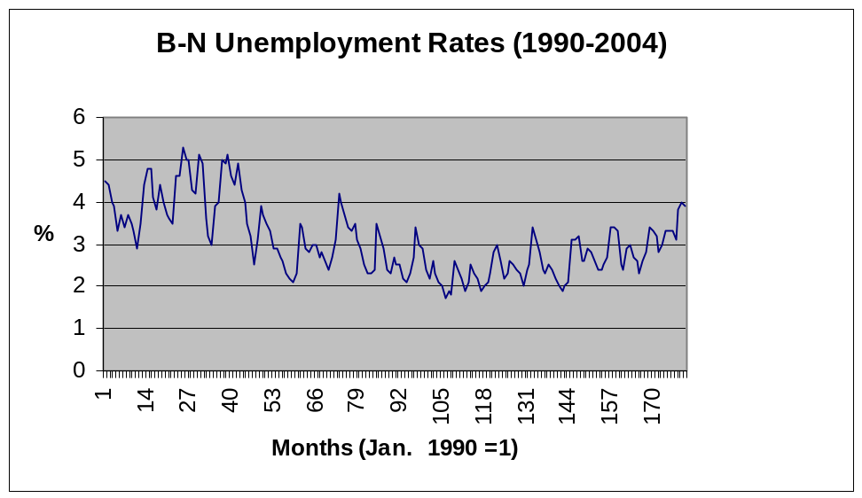

At first glance, there is not any major indications that this series is or isn’t stationary. Although we cannot say with certainty that this is a stationary series, non-stationary series usually produce more noticeable trends. We now turn to the sample autocorrelation function to help determine stationarity.

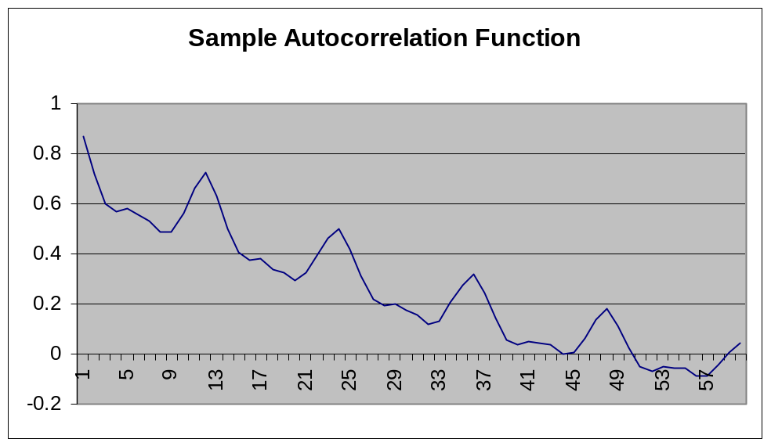

If the sample autocorrelations dampen to zero as lag k increases, the series is stationary. Although this series does dampen to zero, there are significant spikes every lag of twelve. This is an indication that we should take twelve-month differences to remove these spikes. We calculate this new series and reevaluate for stationarity. Below is the new twelve month differenced series as well as that series’ sample autocorrelation function.

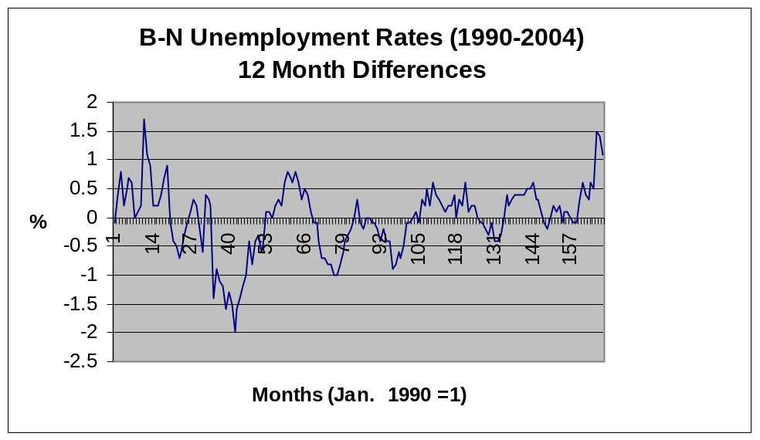
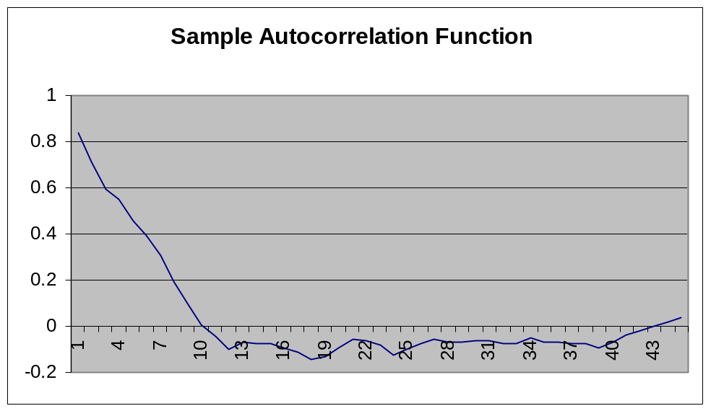
Now that we have developed a stationary series, we will move on with the modeling process. Close examination of the sample autocorrelation function will help determine the order of our ARIMA model. Below are the first few autocorrelations of our series:

Rho | Sample Autocorr.
1 | 0.837206
2 | 0.712856
3 | 0.593226
4 | 0.548971
5 | 0.454827
6 | 0.396248
7 | 0.304679
8 | 0.196002
9 | 0.09569
10 | 0.008686

After looking closer, it appears that these points are declining in a geometrical pattern. Each point is approximately 85% of the preceding point. This is an indication that an autoregressive model should be used. There is no evidence that any moving average terms are present. We will therefore proceed with developing several autoregressive models.

Model Estimation
Estimating the model parameters can be very challenging. However, since we have determined that there will be no moving average terms, we can use a simple linear regression to determine our parameters. Since we are using twelve-month differences, we lost twelve of our 180 data points. We will also leave the last six points out of the model in order to use those points as a check of our model accuracy. We will begin with the AR(1) model. Since the sample autocorrelations declined geometrically from the first autocorrelation, we predict that this may be the optimal model. All of the regression output can be found in the attached Excel file. Below is our estimated model:

y_{t} = -.006 + .842y_{t-1}
Adjusted R² = .704

This model follows along with our intuition of the sample autocorrelation function. This model would produce the following autocorrelation points:

Rho | Autocorr.
1 | .8500
2 | .7225
3 | .6141
4 | .5220
5 | .4437
6 | .3771
7 | .3206
8 | .2725
9 | .2316
10 | .1969

This follows along very closely with our sample autocorrelation function, one sign that this may be a good model. We may also be able to remove the intercept from the model, since it produces a very high P-value. Let’s now turn to an AR(2) model. Below is our estimated model:

y_{t} = -.008 + .787y_{t-1} + .066y_{t-2}
Adjusted R² = .707

The addition of the next term adds almost nothing to the model. The adjusted R² barely increases, and the coefficient for the new term is nearly zero. The P-value for the new term is also very high. Let’s examine an AR(3) model for completeness.

y_{t} = -.012 + .774y_{t-1} + .106y_{t-2} - .033y_{t-3}
Adjusted R² = .706

This model again adds nothing. Before we throw any model out, we will test all three through a series of diagnostic checks to determine the accuracy of the models. This procedure will help us to determine the best model.

Diagnostic Checking
Diagnostic checking is used to determine if the model is specified correctly. Comparison of the autocorrelation function to the sample autocorrelation function, the Durbin-Watson Test, and the Box and Pierce Test are all good measures of correct specification. We will use all three to test all of our models.
The autocorrelation functions of all three models are not significantly different from the sample autocorrelation function with the AR(1) model being the best fit. Therefore, we will check the residuals of the models with the Durbin-Watson Test and the Box and Pierce Test. The Durbin-Watson Test is used to check for serial correlation between the residuals. The Box and Pierce Test will test the residuals to see if a white noise process produces them.
The AR(1) model produces a Durbin-Watson test statistic of 2.09. This number is not significantly different than 2, and therefore means that the residuals are not serial correlated. This is a good indication. The Box and Pierce statistic for the AR(1) model is equal to 36.16. The comparison value for a chi-squared distribution with 20 degrees of freedom at the 5% level of significance is 31.41. Since our value is larger, a white noise process may not have produced the residuals. This is not a good indication, however, this may be the best model that can be produced with this data. Let us examine these statistics with the other models to see how they compare.
The AR(2) and AR(3) models produce Durbin-Watson statistics of 2.01 and 1.94 respectively. Once again, both of these indicate that the residuals are not serial correlated. The Box and Pierce statistics are 33.51 and 31.93 for the AR(2) and AR(3) models. This is getting closer to our 5% level of significance measurement of 31.41. Although this is not perfect, they are almost close enough to assume that the error terms are a white noise process.
Since all of the models are very similar and due to the theory of parsimony, we will select the AR(1) model as our optimal model. We will assume that the constant term is zero due to the large P-value and also round the coefficient to three decimal places. Our final model is as follows:
y_{t} = .842y_{t-1}

Evaluation
We will now evaluate the accuracy of the model by forecasting the next six months and compare it to the data that we intentionally left out of the model estimation. This is called an Ex Post forecast. The first forecasted period is July of 2004. The numbers that the model produce are twelve-month differences and must be added back to the previous year point to get the overall prediction. The graph below showcases both the actual data points and the forecasted points. Series one is the actual data and series two is the forecasted data.
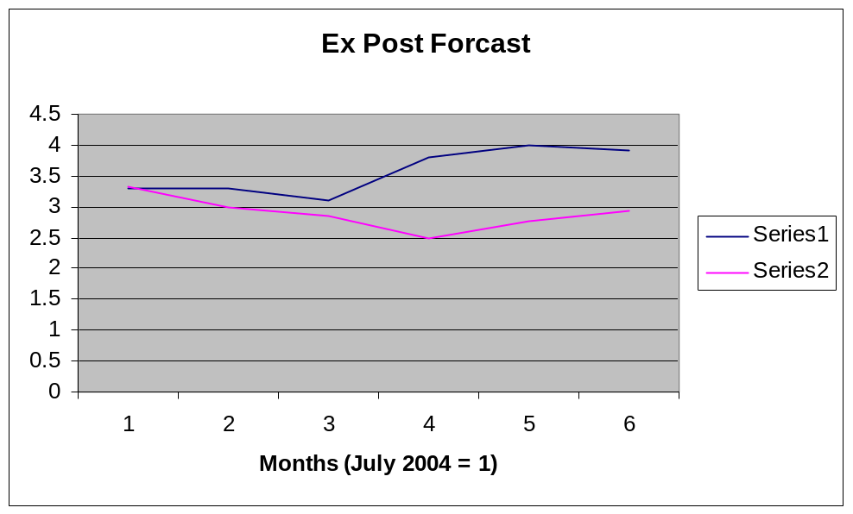
As you can see, the model follows somewhat closely to actual series for only a short time. The determined model may only be useful for a few months or so out, and thus may not be reliable for longer-term predictions. Before this model is thrown out, it must be determined what the overall purpose of this model was for and if it is worth exploring alternative models.

Conclusion
The AR(1) model for unemployment rates in Bloomington-Normal, Illinois was not perfect, however, it was the best one out of all the models that were developed. Nearly all of the signs indicated the appropriateness of the AR(1) model. Unexplained circumstances make modeling an extremely difficult art. Structural economic models may be a better predictor of the unemployment rate, however they can be very long and expensive projects. The AR(1) model may be the best option available and may work well for its purpose. The AR(1) model should be used until a better model can be determined.

