Study on Inpatient Medical Cost in County B

Objective

Time Series analysis has been used in variety of financial data analyses to reveal cost trends. In healthcare systems, it helps insurance companies to study medical costs and forecast future costs.

In this project, I decided to study medical costs in County B, state A and focus only on inpatient costs. My company has contracted with several hospitals in the county and most of them have Percentage-of-charge type of contract in inpatient reimbursement. Instead of fixed fees, percentage reimbursement makes the company exposed to the cost risk. In such case, cost study is more important.

Data

To study the cost, the time series data of total inpatient charges per member per month (PMPM) from those hospitals were used. Real company data were extracted from the company’s data marts. The time period is from May, 2005 to Dec, 2008, with 5-month runout. To comply with company policy while still keeping the statistical features of data, the charges and membership data were scaled.

Another concern is hospital’s change master changes. Manually check-up was done and the increases were found to spread during each year. It seems unnecessary to do any adjustment based on those charge master changes.

The table in the work sheet on tab ‘Original Data’ shows columns of incurred month, total charges and number of members in that month. The final column is the time series data I used, which is total charges divided by members. The plot of PMPM charges is shown below:

Model Specification

The first step is to see if there is any log, linear or exponential trend in the data set. From the plot, I decided to use order 0. No differentiation is needed as the data showed a consistent range from $200 to $250.

After considering the order, the time series data itself was used without any further differentiating. The next step would be generating the correlogram plot to see if the data is stationary. In the worksheet on tab ‘Calculate Autocorrelation’, the lag 1-16 data were shown in column C through column R. Covariances were calculated using Excel function ‘Correl()’. Then the autocorrelation with leg 1 to 16 were calculated based on the formula below:
the j^{th} autocorrelation = ρ_{j} =corr (Y_{t}, Y_{t-j})=$\frac{\text{cov}(Y_{t},Y_{t−j})}{\sqrt{\text{Var}(Y_{t})\text{Var}(Y_{t−j})}}$

The figure below shows the correlogram plot. From the plot, we can see that autocorrelation drops as the lag increases. This indicates a stationary time series data and a typical auto-regression process. The only outlier is lag 12. The high correlation implies a strong annual pattern.

Auto-regression Analysis

From above analysis, I decided to use autoregressive model of order p. The model is shown below, where $y_{t}$ is the data at time t, $δ$ is a constant,$φ_{i}$ is the coefficients for lag i data,$ε_{t}$ is the error term at time t, and $p$ is the order of auto-regression to be determined.
$$y_{t}=δ+\sum_{i=1}^{p}{φ_{i}y_{t−i}}+ε_{t}$$
p, the order of auto-regression, needs to be determined first. As the strong indication of annual seasonality showed above, I decided to try p=12. The following table shows the dataset used:

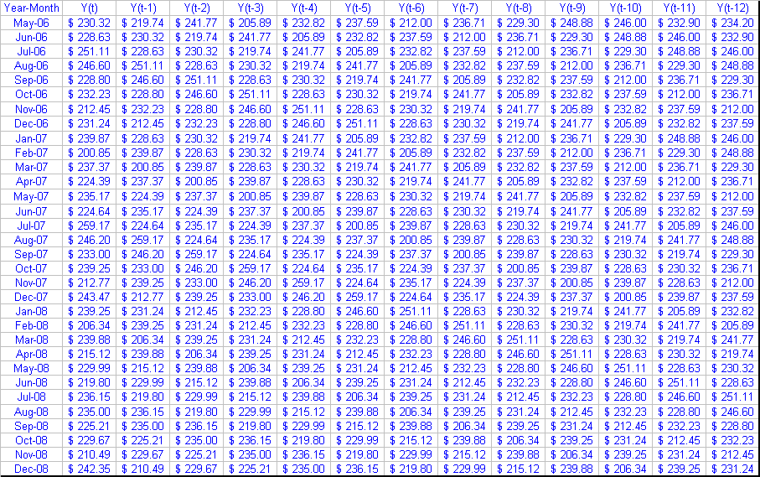

The auto-regression was performed by using Excel built-in regression tool in the “Analysis ToolPak”. The following are the key results from the auto-regression.

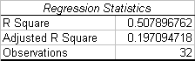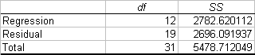

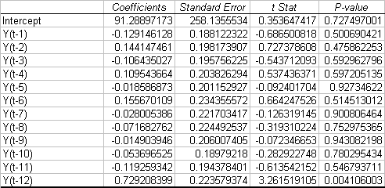

The adjusted R Square drops dramatically compared with R Square, this indicates the observation might not be sufficient to derive a meaningful regression with 12 variables and an error variable in the regression. Studying the t Stats and P-values for each variables gives us the implication that we should skip at least Y(t-5), Y(t-6), Y(t-7), Y(t-8, Y(t-9) and Y(t-10), as the regression resulted in lower t Stats and higher P-values for those variables. Y(t-3),Y(t-4) and Y(t-11) needs further consideration. So, I tried two regressions, one with Y(t-3), Y(t-4) and Y(t-11), and another one without those variables.

The following tables show the regression statistics for the more complex model:

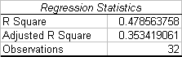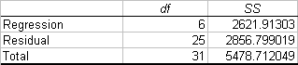

The following tables show the regression statistics used only Y(t-1), Y(t-2) and Y(t-12):

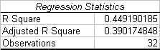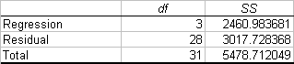

The stats show compatible qualities. As we don’t want to introduce complexity to improve the model just a little bit, we can conclude that the model with lag 1, 2, and 12 is the best fit in this situation.

Forecast & Conclusion

Fitting the coefficients would make the model as below:
$$y_{t}=δ−0\text{.}\text{1965}y_{t−1}+0\text{.}\text{2170}y_{t−2}+0\text{.}\text{6484}y_{t−\text{12}}+ε_{t}$$

The following plot shows the forecast vs. real data.

The fitting is not bad, especially in the late half of the period. There are always gaps between fitted and real data, which can be regarded as random error terms.

Time Series analysis provides a way to model medical cost with an acceptable quality. In this project, 32-month data were used. The fitted model shows strong annual seasonality.

