xxxxxxxx xxxxxxxxx
Regression Analysis Project
Spring 2009

Introduction & Data
My project is on suggested retail price of new cars in 2004. I found 2004 car and truck data from the American Statistical Association website through its Journal of Statistics Education publication. The data was collected by Kiplinger’s Personal Finance for their December 2003 issue. There are 428 vehicle observations. The length and width for pickup trucks were missing data in the data set so I went to http://www.kiplinger.com/tools/carfinder/ and found the length and width of each truck with the missing values and filled them in. Variables included:

- Vehicle Type (Sports Car, SUV, Wagon, Minivan or Pickup)
- Drive Type (All Wheel or Rear Wheel)
- Suggested Retail Price
- Dealer Cost
- Engine Size (liters)
- Number of Cylinders (=-1 if rotary engine)
- Horsepower
- City Miles Per Gallon
- Highway Miles Per Gallon
- Weight (Pounds)
- Wheel Base (inches)
- Length (inches)
- Width (inches)

I am interested in looking at Suggested Retail Price as it relates to a vehicle’s specifications (ie Vehicle Type, Drive Type, Horsepower, City MPG, Highway MPG, etc). I picked this topic because I recently bought a new car and price was a huge factor in what I chose (as it is for many people). I wanted to see if price truly reflected what you are getting in a car.
One factor that I thought would influence retail price was company name or brand name. To some extent when you buy a car, you are paying for the name also. For example, a Porche would be more than a Kia. However, if I were to put brand name as a factor, there would be many problems. First it would make my variables increase dramatically since I would have to make a new variable for each brand and there are easily 50 brands. Also many brands have a variety of cars from economy to luxury. For example, looking at the Dodge brand name, a Dodge Neon’s retail price is $13,670 while a Dodge Viper’s retail price is $81,795. I still wanted to attempt to account for the effect of company/brand. I concluded that Origin of Company Name Plate would be a good way to categorize these cars so my last variable was:
- Origin of Company Name Plate (Japanese, Korean, German and American).

Linear Regression
I began by running a stepwise regression in SAS. The first time I ran the regression, I included dealer cost as a predictor variable. When I ran the stepwise regression, I noticed that my final variable selection had very high R² values. My R²=0.9982 for cost alone.

Summary of Stepwise Selection
Variable Variable Number Partial Model
Step Entered Removed Vars In R-Square R-Square C(p) F Value Pr > F
1 cost 1 0.9982 0.9982 50.8189 228562 <.0001

Dealer cost is an obvious factor in the retail price of a vehicle. It, however, does not tell you anything about the car itself. Since, it wasn’t really a part of the specifications of the actual car, I decided to remove this factor and run the stepwise again:

Summary of Stepwise Selection
Variable Variable Number Partial Model
Step Entered Removed Vars In R-Square R-Square C(p) F Value Pr > F

1 horse 1 0.6832 0.6832 192.709 877.61 <.0001
2 european 2 0.0636 0.7468 74.6811 102.02 <.0001
3 wheel 3 0.0130 0.7598 52.1620 21.91 <.0001
4 rear 4 0.0043 0.7641 46.0647 7.35 0.0070
5 length 5 0.0038 0.7679 40.8189 6.67 0.0102
6 city 6 0.0045 0.7725 34.2429 8.03 0.0048
7 weight 7 0.0094 0.7819 18.4927 17.30 <.0001
8 van 8 0.0025 0.7844 15.7602 4.65 0.0316
9 sports 9 0.0019 0.7863 14.1453 3.58 0.0593
10 width 10 0.0030 0.7893 10.5776 5.57 0.0187 11 pickup 11 0.0013 0.7906 10.0956 2.49 0.1151
12 engine 12 0.0012 0.7918 9.8334 2.28 0.1318

I then ran the R² procedure and found that to include the other 7 variables would increase the R² only by 0.002, so I was decided to leave it at these 12 variables.

Model 1: Linear Regression and Diagnostic Checking
I ran a simple linear regression in SAS with diagnostic checks. The histogram of residuals appeared fairly bell-shaped and centered at 0. The QQ plot displayed a somewhat linear pattern (except for endpoints). And the fitted values vs. residuals plot displayed a megaphone pattern.
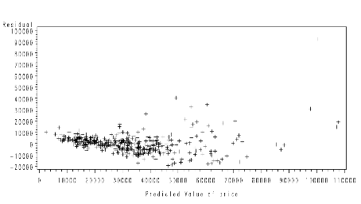

My data appeared close to normal. However, the fitted values plot told me that the homogeneity of variances assumption was not satisfied. Looking at my data again, I found that my largest variances were due to the more expensive cars (the right side of the graph above). Since, many luxury cars (like the Mercedes Benz, Jaguar type cars) do not have specifications far greater than other cars, but have much higher prices, I concluded that it was best to limit my study to cars whose prices were below $70,000.

Model 2: Stepwise Regression & Multicollinearity Check
Limiting my data to cars priced below $70,000, I had 380 Observations. Rerunning the stepwise I got:
Summary of Stepwise Selection
Variable Variable Number Partial Model
Step Entered Removed Vars In R-Square R-Square C(p) F Value Pr > F

1 horse 1 0.7224 0.7224 425.101 947.19 <.0001
2 european 2 0.1185 0.8409 91.1063 270.37 <.0001
3 weight 3 0.0064 0.8473 75.0395 15.10 0.0001
4 pickup 4 0.0070 0.8543 57.1305 17.40 <.0001
5 rear 5 0.0100 0.8643 30.8184 26.49 <.0001
6 sports 6 0.0018 0.8661 27.7209 4.82 0.0288
7 city 7 0.0024 0.8684 22.9964 6.45 0.0115
8 width 8 0.0017 0.8701 20.2672 4.58 0.0329
9 length 9 0.0026 0.8727 14.9081 7.26 0.0074
10 allwheel 10 0.0020 0.8747 11.3548 5.55 0.0190
11 american 11 0.0015 0.8761 9.1791 4.21 0.0409
12 suv 12 0.0006 0.8767 9.5336 1.66 0.1982

From this, I chose the first 9 variables to include in my model. So my R² = 0.8727. I then decided to test for multicollinearity by running the proc corr procedure in SAS. I found that:
- weight and horsepower were highly correlated(r=0.70261)
- length and width were highly correlated (r=0.75058)
- City MPG and horsepower were highly correlated (r=-0.74846)
As a result I eliminated the weight, width and City MPG variables.
Model 2: Linear Regression
Running the regression I found that
Analysis of Variance
Source DF Sum of Squares Mean Square F Value Pr > F

Model 6 42313039737 7052173290 352.67 <.0001
Error 371 7418661454 19996392
Corrected Total 377 49731701191

Root MSE 4471.73256 R-Square 0.8508
Dependent Mean 28853 Adj R-Sq 0.8484
Coeff Var 15.49853

Parameter Estimates
Variable DF β_{i} Standard Error t Value Pr > |t|

Intercept 1 -17362 4073.56143 -4.26 <.0001
horse 1 134.28459 5.30261 25.32 <.0001
european 1 9697.77951 601.32442 16.13 <.0001
pickup 1 -5503.39708 1101.71761 -5.00 <.0001
rear 1 2027.92374 620.58358 3.27 0.0012
sports 1 923.05989 1045.20685 0.88 0.3777
length 1 85.55859 24.68179 3.47 0.0006

The test for the global utility of the model H₀: β₁ = β₂ = β₃ = β₄ = β₅ = β₆ = 0 was highly significant since F is large (F=352.67) and the p-value is small (p<.0001). So I rejected H₀ and concluded at least one of the parameters β₁,…, β₆ were non-zero. The t-tests for the individual β’s were significant, except for one – the β associated with the sports car variable. While the sports car variable was probably contributing to the model, the pickup variable was already contributing to the model (since both variables are measuring type of car), therefore making the sports car variable effect not significant. As a result I decided to remove the sports car variable. Running the regression again, I got:

Model 2.5
Analysis of Variance
Source DF Sum of Squares Mean Square F Value Pr > F

Model 5 42297443964 8459488793 423.30 <.0001
Error 372 7434257228 19984562
Corrected Total 377 49731701191

Root MSE 4470.40965 R-Square 0.8505
Dependent Mean 28853 Adj R-Sq 0.8485
Coeff Var 15.49395

Parameter Estimates
Variable DF β_{i} Standard Error t Value Pr > |t|

Intercept 1 -15640 3575.63774 -4.37 <.0001
horse 1 136.04123 4.91395 27.68 <.0001
european 1 9584.81419 587.38819 16.32 <.0001
pickup 1 -5446.39373 1099.49982 -4.95 <.0001
rear 1 2160.87385 601.86901 3.59 0.0004
length 1 74.73072 21.41482 3.49 0.0005

Using this model I found that the model was significant as were each of the individual β’s. Also the coefficients are what I expect intuitively and my R² = 0.8505. My model is:

$Y=−\text{15640}+\text{136}\text{.}\text{04}X_{1}+\text{9584}\text{.}\text{81}X_{2}−\text{5446}\text{.}\text{39}X_{3}+\text{2160}\text{.}\text{87}X_{4}+\text{74}\text{.}\text{73}X_{5}$

where Y= suggested retail price X₃ = Pickup (0=no, 1=yes)
X₁ = Horsepower X₄ = Rear-wheel drive (0=no, 1=yes)
X₂ = European (0=no, 1=yes) X₅ = Length

In terms of diagnostic checking, my normality assumption was met. The histogram of residuals was bell shaped and centered at 0 and the normality tests had p-values>0.05, meaning we accept the H₀ and conclude that the errors are normally distributed.

Tests for Normality

Test --Statistic--- -----p Value-----

Shapiro-Wilk W 0.988500 Pr < W 0.054
Kolmogorov-Smirnov D 0.044466 Pr > D 0.069
Cramer-von Mises W-Sq 0.155759 Pr > W-Sq 0.125
Anderson-Darling A-Sq 1.057592 Pr > A-Sq 0.089
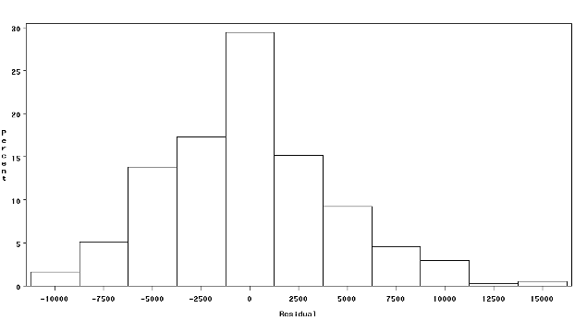

Likewise, the QQ plot displayed a fairly linear pattern, except at the endpoints, implying the error terms are normally distributed.
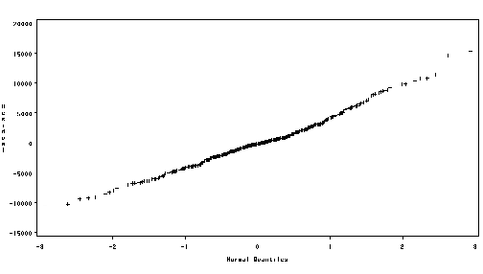
The residuals vs. the fitted values however, still displayed a megaphone pattern, implying heteroscedasticity of variances.
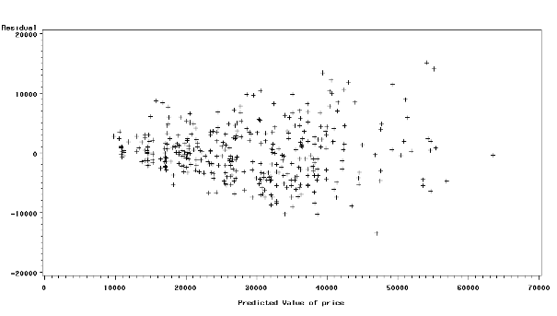

Model 3: Natural Log Transformation
To correct this problem, I decided to use a natural log transformation on the dependent variable, price. Using that, the residual plot indicates that the logarithmic transformation significantly reduced the heteroscedasticity. The plot now shows no structure, implying that the homogeneity of variance assumption is satisfied.
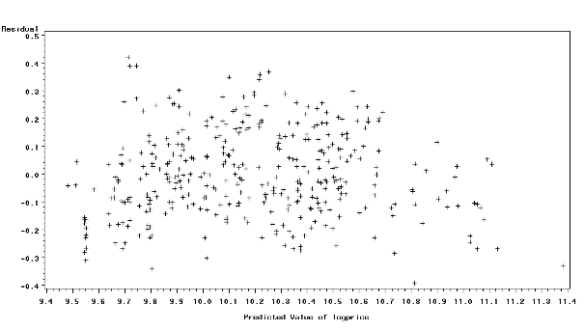

Analysis of Variance
Source DF Sum of Squares Mean Square F Value Pr > F

Model 5 51.73808 10.34762 435.94 <.0001
Error 372 8.82997 0.02374
Corrected Total 377 60.56805

Root MSE 0.15407 R-Square 0.8542
Dependent Mean 10.19151 Adj R-Sq 0.8523
Coeff Var 1.51171

Parameter Estimates
Variable DF β_{i} Standard Error t Value Pr > |t|

Intercept 1 8.32191 0.12323 67.53 <.0001
horse 1 0.00463 0.00016935 27.32 <.0001
european 1 0.33018 0.02024 16.31 <.0001
pickup 1 -0.23081 0.03789 -6.09 <.0001
rear 1 0.06809 0.02074 3.28 0.0011
length 1 0.00447 0.00073803 6.06 <.0001

Checking model adequacy, R²=0.8542, a slight improvement on the untransformed model (R²=0.8505). So about 85% of the total variation in ln(price) is accounted for by this model. The F-value is large (F=435.94) and the associated p-value<.0001 means the model is statistically significant. The individual t-tests all have small p-values<0.05, so they too are statistically significant. So my final model is:

$$\text{ln}Y=8\text{.}\text{32191}+0\text{.}\text{00463}X_{1}+0\text{.}\text{33018}X_{2}−0\text{.}\text{23081}X_{3}+\text{20}\text{.}\text{06809}X_{4}+0\text{.}\text{00447}X_{5}$$

where Y= suggested retail price
X₁ = horsepower
X₂ = European(0=no, 1=yes)
X₃ = pickup(0=no, 1=yes)
X₄ = rear-wheel drive (0=no, 1=yes)
X₅ = length

And we can find the value of Y (suggested retail price) by solving:
$$\hat{Y}=e^{\text{ln}y}$$

Conclusion
My regression model for predicting vehicle price proved to be significant. However, I think that there were problems and limitations to my analysis. There were unobservable factors that could not be measure directly, such as reputation, perceived quality, perceived value, perceived luxury, and the effect of brand name. Although I tried to account for this last variable with the company name plate country of origin, I don’t think it was enough. One way to attempt to measure these factors, would be to take a survey asking people to measure their perception of certain cars using a point scale. Perhaps if I had had the resources to take a large sample survey of people’s perceptions of different cars, I would have been able to better account for these unobservable factors and my model would have come out better.

