The Time Series Analysis of the Gold Price

Introduction

Sunspot activity is highly correlated to recorded solar flare activity. Solar flares can be extremely harmful to satellites that orbit the Earth. This report is to develop a proper ARIMA model to forecast the average yearly number of observed sunspots. The yearly average sunspot index from 1700 to 1998 will be used to construct the model and values from 1989 through 2000 will be used to validate the model.

Data

The data was obtained directly from the “R” statistical software package, and can also be obtained from the website of www.windows.ucar.edu/tour/link=/sun/activity/sunspot_history.html. The yearly average number of observed sunspots was obtained and the data from 1700 to 1988 will be used to build the model and data from 1989 through 2000 will be used to validate the model. The actual data are plotted in Figure 1 and it shows an obvious seasonal cycle during the study period.
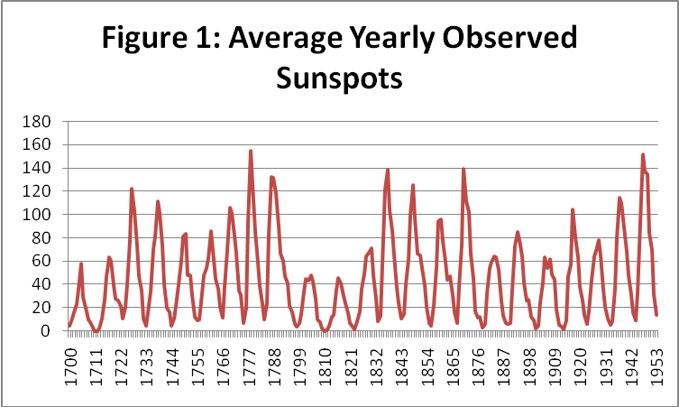
Test of Stationarity

The data will be examined first to make sure it is stationary. If it is stationary, then it can be modeled as an equation with fixed coefficients that can be estimated from past data.
Test of stationarity will be based on autocorrelation function, which is simply the ratio of the sample covariance to sample variance.
$${\hat{ρ}}_{k}=\frac{{\hat{γ}}_{k}}{{\hat{γ}}_{0}}$$
A plot of ${\hat{ρ}}_{k}$ against k is known as the sample correlogram as below Figure 2 and detailed calculation can be found in the tab “Correlogram” in the attached Excel spreadsheet.

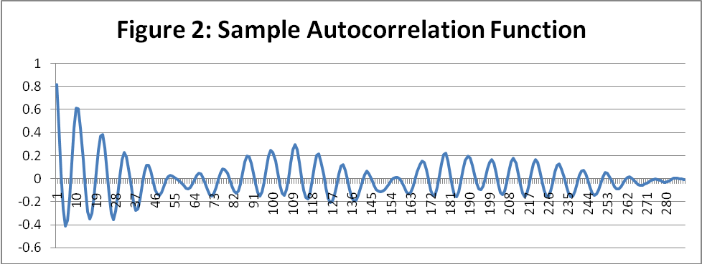

Figure 2 shows us that the sample autocorrelation functions do not decline and remain near zero, which indicates the series is not stationary. In addition to this, the Correlogram confirms that there is a seasonal component to the series. To estimate the period of seasonality, I looked at the peaks of the Correlogram. The peaks occurred at Lags 1, 10, 22, 32, etc. Therefore, I estimated the period of seasonality to be every ten (10) years.

Note: research from the web indicated that the seasonal period for sunspot activity to be every 11.2 years, however, for the purposes of this project, I have used a seasonal period of every ten (10) years.

Seasonal Adjustment

Since there is a seasonal component to the series, we must make some adjustment to the series to remove the seasonality. A series of analysis was performed to find the most reasonable method. In the end, the series was transformed by taking the first order differences between like periods (i.e., Y(t) – Y(t-10)). This transformed series was then analyzed to see if it was stationary.

You can find further documentation of the analysis performed in the “Seasonal Adjust SxI” and “First Diff of Seasonally Adj” tabs in the attached Excel spreadsheet. As you can see from the Correlograms in those tabs, neither the Seasonally Adjusted, nor First Order Seasonally Adjusted, series is a stationary series.

Figure 3 below documents the Correlogram for the transformed series, and indicates that it is a stationary series because the autocorrelation function rapidly declines to zero, and remains near zero.
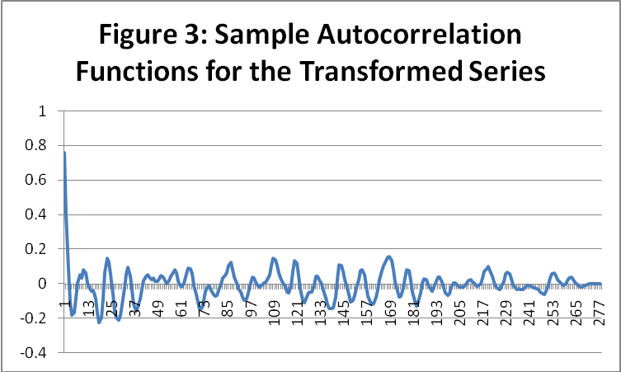

Model Estimation

The transformed series therefore can be described by autoregressive model with different orders (p = 1, 2, and 3) as below.
$$Y_{t}=δ+\sum_{i=1}^{p}{φ_{i}Y_{t−i}}+ε_{t}$$
where $Y_{t}$ is the difference in observed sunpots between time t and t-10
$δ$ is a constant
$φ_{i}$ is the coefficients for lag i data
$ε_{t}$ is the error term at time t
$p$ is the order of auto-regression to be determined
Using Excel built-in regression to perform auto regression and the details can be found in the tabs “AR1”, “AR2”, and “AR3” in the attached Excel spreadsheet.

AR(1): $Y_{t}$= 0.572 + 0.758$Y_{t−1}$+ $ε_{t}$
AR(2): $Y_{t}$= 0.822 + 1.065$Y_{t−1}$ - 0.406$Y_{t−2}$+ $ε_{t}$
AR(3): $Y_{t}$= 0.923 + 1.022$Y_{t−1}$ - 0.295$Y_{t−2}$ - .104$Y_{t−3}$+ $ε_{t}$
From summary table, in all different-order autoregressive models, the summations of φ_{i} are less than one. So the fitted models are stationary in consistent with the actual data. The R² and the adjusted R² are not significantly different among the AR(2) and AR(3) models but AR(2) has the highest R² and the adjusted R². Furthermore, the third coefficient for the AR(3) model is not significant at the 5% level (p value = .086).

Summary Table
 | Σφ_{ι} | R² | Adj. R²
AR(1) | 0.758 | 0.574 | 0.573
AR(2) | 0.659 | 0.644 | 0.642
AR(3) | 0.623 | 0.648 | 0.644

Durbin-Watson Test

A Durbin-Watson statistic of 2 indicates no serial correlation. The following are the results for the three regressions:

 | DWS
AR(1) | 1.384
AR(2) | 2.085
AR(3) | 1.995

For the AR(2) and AR(3) models, the Durbin Watson Statistics are close to 2, and indicate no serial correlation among the residuals for the two regressions.

Box-Pierce Q Statistic

The Box Pierce Q Statistic(BPQS) is used to test if the residuals are a white noise process. This statistic is estimated using the following formula:

$$\text{BPQS}=T\sum_{k=1}^{K}{{\hat{r}}_{k}^{2}}$$
The Box-Pierce Q statistic has a χ² distribution with K-p-q degrees of freedom. In all three cases the Q statistic are less than the χ² statistic at a 10% significant level with 272 degrees of freedom (304.4). This indicates that we cannot reject the null hypothesis that the residuals are a white noise process.
 | BPQS
AR(1) | 278.6
AR(2) | 200.8
AR(3) | 188.5

Above tests indicate the residuals of AR(1), AR(2) and AR(3) are white noise processes. Both the adjusted R² and the DWS are not significantly different among the AR(2) and AR(3) models. Since the adjusted R² is not significantly different, the AR(2) model is chosen as the best fit due to the rule of parsimony. The equation for the model is as follow:
AR(2): $Y_{t}$= 0.822 + 1.065$Y_{t−1}$ - 0.406$Y_{t−2}$+ $ε_{t}$

Forecasting

To validate the model, we will forecast the number of observed sunspots from 1989 through 2000 and compare the predicted values with real observation. The results are demonstrated in the Figure 4.
Some expected values are close to actual one and some are not. Although the values of the two series are not perfect matched, the predicted series follows the same trends as the actual series. This indicates that the AR(2) model can describe the sunspot activity at least for the study period.
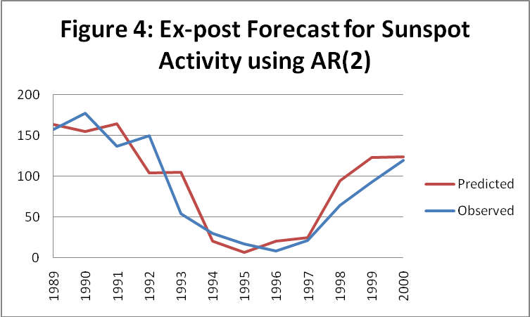

Conclusion

The yearly average number of observed sunspots are examined to see if past sunspot activity was able to predict future one. Three auto-regression models with order 1, 2, and 3 are tested in this project. Various statistics are calculated to test the significance of models to explain the data. Due to principle of parsimony and the highest R², the AR(2) model is recommended for this project.

