NEAS - Regression Analysis

Student Project

xxxxxxx xxxxxxxxxx

Background

Regression analysis has widespread applications in actuarial work – in this project, we apply regression analysis to determine trend rates in the health care insurance industry. A customer belonging to a company person usually chooses a particular plan and pays a premium every month in order to receive the benefits stated in the plan. The pool of money collected from the premiums is used to pay for the incurred claims on a daily basis. For the sake of easier analysis these claims are usually summed by the month. A member who agrees to pay the premium for the benefit of the insurance plan is called as a contract holder. The total premium received divided by the total number of contract holders who paid the premiums is called as Per Contract Per Month (PCPM)

This quantity is a very important measure for an actuary in order to be able to determine the future trends in health care costs. It is also often required of an actuary to estimate the total yearly costs, and thus the premium to be charged from a member enrolled in a particular product.

In this project, we will develop a trend for the PCPM for the forthcoming 12 month period based on the existing data. This will be approached after we compare the actual PCPM history with the output of the model for accuracy and check for the existence of any outliers and also review the regression model for validity and soundness.

Data Simulation

Actual data from the medical claims and enrollment is confidential information for any private organization. For the purpose of this project the actual monthly claims are re-centered and re-scaled to obtain a new set of transformed data. Claims which have been summarized by the month over a period of six years are used in the project. The medical claims are assumed to follow a normal distribution and the six year data have a sample mean $\bar{X}$and sample standard deviation$S_{x}$, which are approximations of the population mean$μ_{x}$and population standard deviation$σ$, which are not known. To keep the actual data anonymous, the following technique is used to get a sample whose behavior will be similar to the original data.
$x_{i−\text{new}}=\frac{(x_{i}−y)}{z}$ Where $(x_{i}−y)>0 \text{for} \text{all} i$
Here “y” and “z” in the above equation are arbitrary constants to make sure that all the resulting new claims after the transformation are not negative. The resultant data will have a sample mean $(\bar{X}−y)$and sample standard deviation of ${S_{x}}/z$.

A similar reconditioning of the data is done for the total monthly contracts to get the PCPM for each month. For confidentiality’s sake the values of “y” and “z” are not disclosed as well.

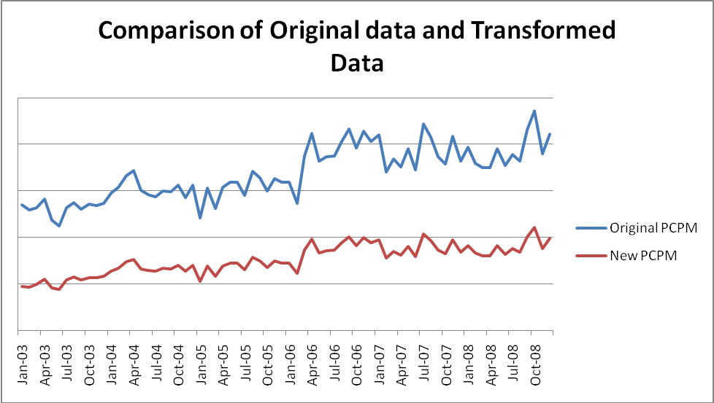

Figure1: The result of re-centering and re-scaling the data are displayed in the chart above.

Regression Model

This section discusses the hypotheses that we wish to test as well as the results of the regression analysis performed on the data from the previous section. The primary purpose of the regression analysis is to test whether the trend growth/decay rate of the PCPM is zero. Since we are dealing with dollar values we would expect an exponential regression curve to fit the PCPM data. For this purpose, we fit the transformed values of the PCPM to the following exponential regression equation
$$Y={\text{Ar}}^{X}$$

This is similar to fitting the following data
$$\text{ln}(Y)=\text{ln}(A)+\text{ln}(r)∗X$$

This equation can also be expressed as
$$\text{ln}(Y)=α+βX$$

To obtain the new estimates of PCPM, we need to perform the following calculation
$$Y=e^{α+βX}$$

where $Y$= estimated PCPM
$e^{α}$= base value of PCPM
$e^{β}$ = trend rate of PCPM growth or decay
$X$= development day of the year

Three models, based on the number of years of data used, are developed to simulate the trend rate of the PCPM and the validity of each one is checked and are compared against each other after validation. Once the validity of the model is established, the final trend that is of interest is the estimate of the yearly PCPM increase which is given by

$$\text{yearly}−\text{trend}=e^{β∗\text{365}}−1$$
Thus the hypothesis test is transformed into checking whether $e^{β∗\text{365}}−1=0$i.e. $β=0$

Data Analysis

Figure (1) below shows the output of the regression analysis on model 1 with two years of data:

Figure 2: Output of Regression Analysis with two years of data

Figure (2) below shows the output of the regression analysis on model 2 with four years of data:
Figure 3: Output of Regression Analysis on Un-Restricted Model

Figure (3) below shows the output of the regression analysis on model 3 with six years of data:

Figure 4: Output of Regression Analysis on Un-Restricted Model

The residual plots of the three models are shown below

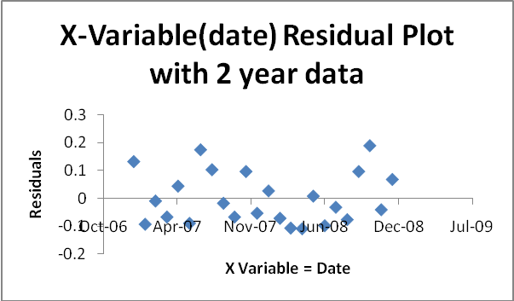
Figure 5: Residual Plots of a Model with 2 year data

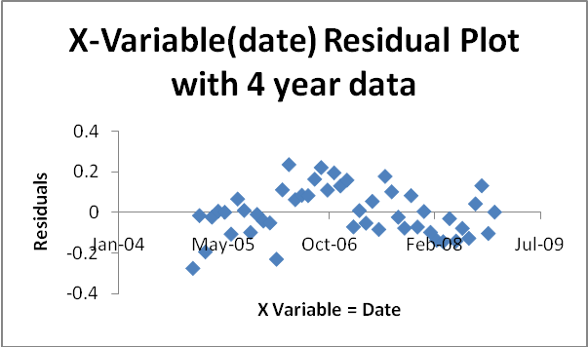
Figure 6: Residual Plots of a Model with 4 year data

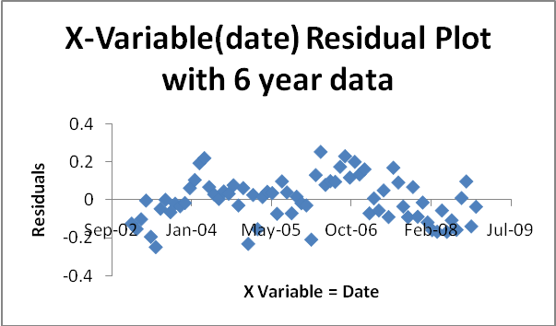
Figure 7: Residual Plots of a Model with 6 year data

From the model with two years of data the residuals look like they seem to have a slight pattern suggesting that the error terms in the regression might be correlated. The models with four years and six years of data do not show any clear patterns of the residuals.

The significance F value in each case gives us the p-value to test our hypothesis of non-zero slope of the linear regression.
In each case above we have

Model | Estimated Values | Adjusted R Square | Significance F
1 | 0.000110504 | 0.019466556 | 0.240286131
2 | 0.000243372 | 0.425172737 | 3.09975 E-07
3 | 0.000300142 | 0.727296355 | 1.19460 E-21

The above results are from the three regressions are based on a 95% confidence level. We see that at a 95% confidence level, the first model is not statistically significant enough to deny that the slope is non-zero. The other two models statistically signify that the models have a non-zero slope and thus could be used to simulate the sample data.

Predicted versus the Actual Data

Fitting the data that was used to determine the model versus the predicted values from the model are shown below:
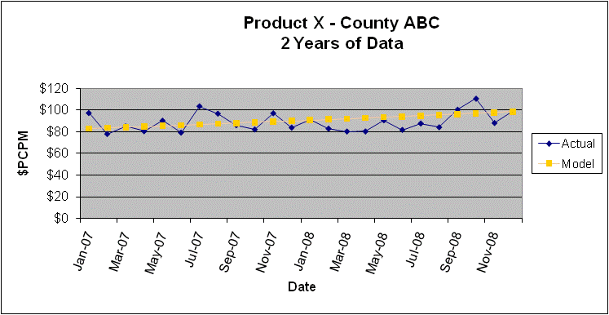
Figure 8: Actual data versus Predicted data from model based on 2 years of data

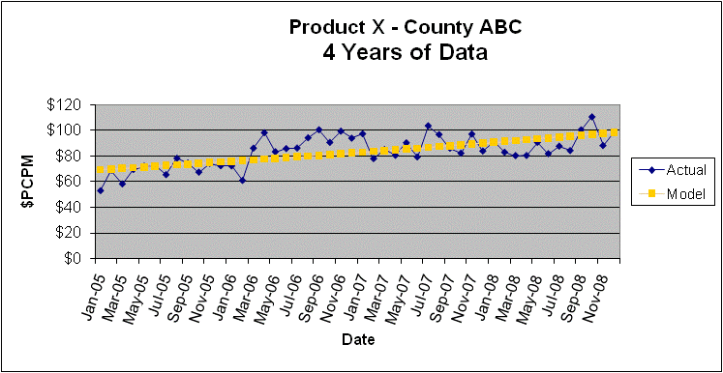
Figure 9: Actual data versus Predicted data from model based on 4 years of data

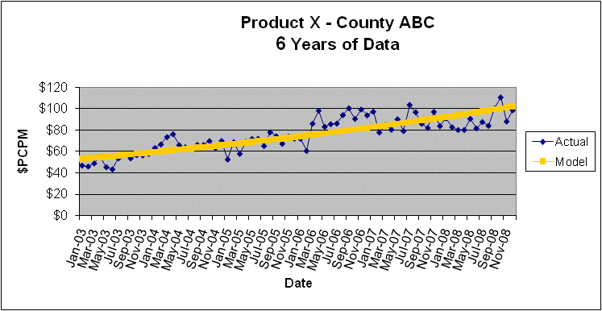
Figure 10: Actual data versus Predicted data from model based on 6 years of data

Each model seems to appropriately fit the data, as seen in figures 8,9 and 10 above, that was used in the model but retro-fitting the predictions to earlier data in model-1 and model-2, as seen in the figures 11,12, and 13 below, show that the predicted values are not very good estimations of the actual value and seem to have larger residuals which is an indicator that the future values from the prediction would also have larger residuals.
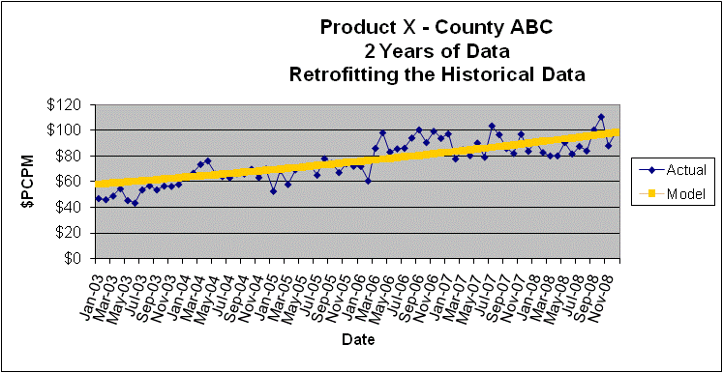

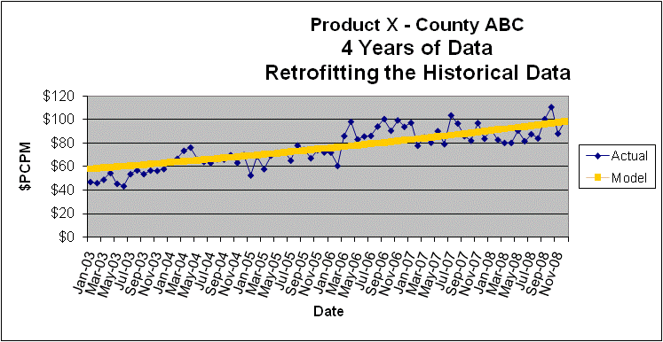

Annual Trend
The annual trend based on the three models is given below:
 | Model-1 | Model-2 | Model-3
 | Coefficients | Coefficients | Coefficients
$$α$$ | 0.127314001 | -5.093120453 | -7.313576103
$$β$$ | 0.000110504 | 0.000243372 | 0.000300142

Thus the annual trends predicted by each model are given by: $e^{β∗\text{365}}−1$ where we use X=365 days.

 | Model-1 | Model-2 | Model-3
Trend-Rate | 4.12% | 9.29 % | 11.58%

Since we accepted only model-2 and model-3, we can say with 95% confidence, that in one year’s time the expected PCPM would be approximately 9.29% or 11.58%.

Conclusions

This project shows a very particular example of how regression analysis can be applied to actuarial analysis. We were given a situation and we were able to model and perform regression analysis on transformed PCPM values to test the null hypothesis that the growth or decay of the PCPM rate is not zero. The rejection of the null hypothesis supports our intuition from experience that the over a period of time, the per-contract per-month rates do change and seem to increase gradually. Then we examined the output of the regression analysis and we able to verify that the estimated regression parameters are indeed close to the true parameters as expected.

