Simple and Multiple

Regression Models

xxxxx xxxxx
VEE Regression Project
Fall 2007

Part 1 - Introduction and Background.

The data consist of the average grades for 2,497 university students in the 1st, 2nd and 4th years. During the 3rd year of their 4-year degree program, students can choose to study abroad for one or two semesters since the university started to offer an international exchange program (IEP).
Out of 2,497 students, 533 students participated in the IEP from 1992 to 2004 (students’ graduating years).

Figure 1 and Table 1 show the percentage of graduating students in a particular year participating in the IEP. In Figure 1, the pattern shows a gradual increase in popularity for the IEP over the last 13 years. Notably, there is a larger than expected increase for the last three years. In 2004, almost 50% of students are exchange students.

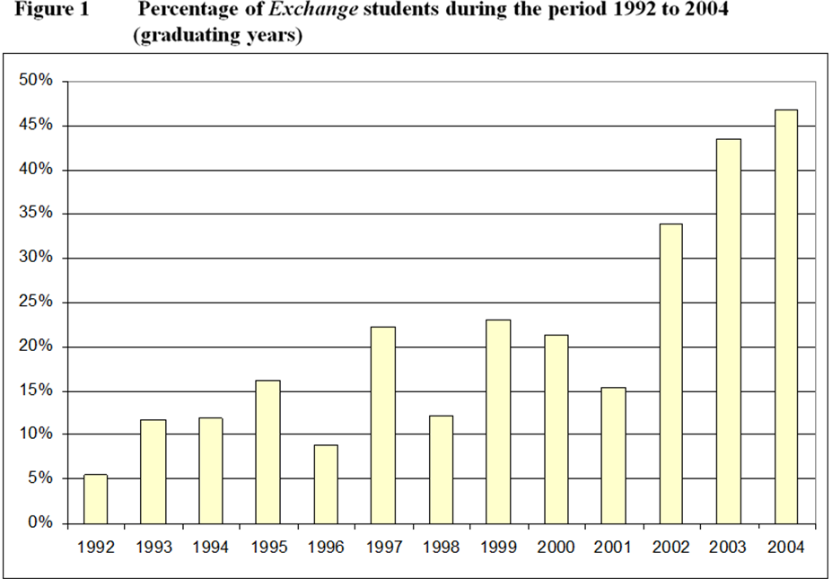

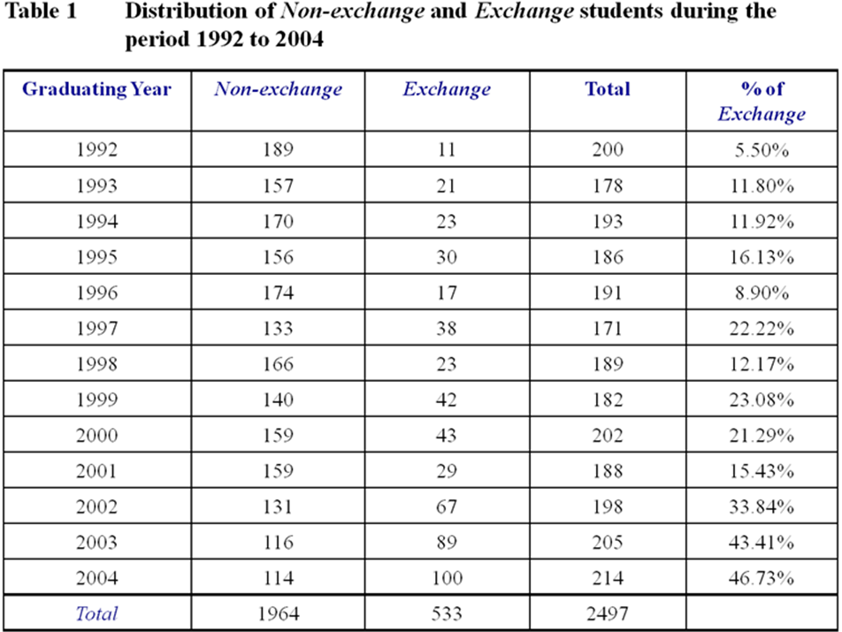

The object of this project is to examine the effect of the IEP on the students’ performance as measured by their average grade. The analysis compares the 4th year grades between students who participated in the IEP and those who did not. Specifically, this project addresses the following question;

“Do the students who participated in the IEP improve their grade more than those who did not?”

From my perspective, the IEP should lead to gains in both academic and non-academic areas of a student’s development. The IEP experience fosters international co-operation and connections with foreign students and faculty. Through these interactions, they can benefit from increased international business knowledge, increased motivation and satisfaction and new skills that supplement those from home universities. Therefore, I expected IEP students to improve their grades upon returning more than those who stayed at their university.

Analysis is based on simple and multiple regression models. I used R for data visualization and exploration, statistical modeling and programming.

Part 2 - Comparing the two groups by Delta

a - Simple Regression

For analysis, I require a suitable measure of a student’s improvement. I denote this as Delta, where
Delta = 4th year grade – Cumulative average of 1st and 2nd year grades

A positive Delta indicates an increase in grade and consequently better performance in 4th year than the first two years. Figure 2 shows the box plots comparing the Exchange (group of students who went on IEP in their 3rd year and continued their 4th year at home university) and Non-exchange (group of students who did not go on IEP in their 3rd year) for Delta. A single dot inside the box indicates the mean and the horizontal line the median of Delta for the corresponding group. The visual impression of the box plots suggests that there is a difference in Delta between Non-exchange and Exchange since the positions of the boxes differ.

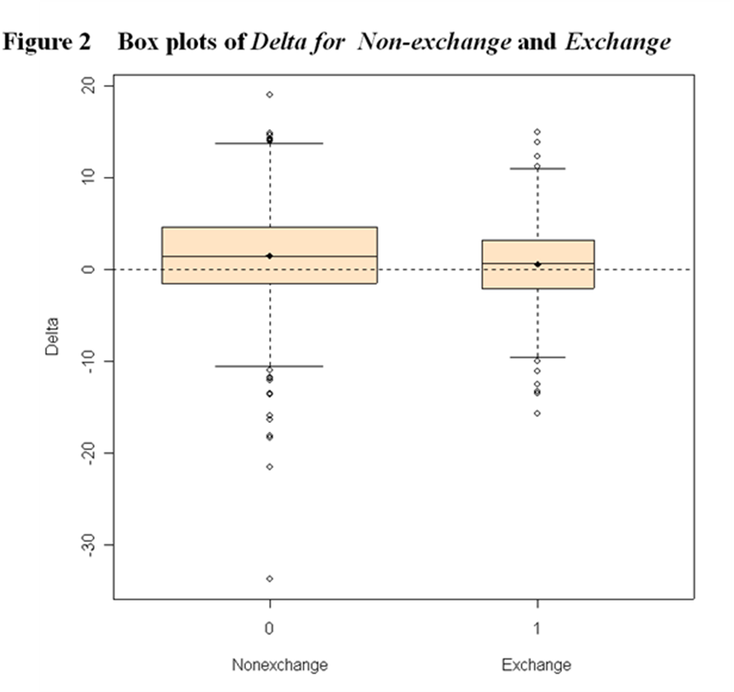

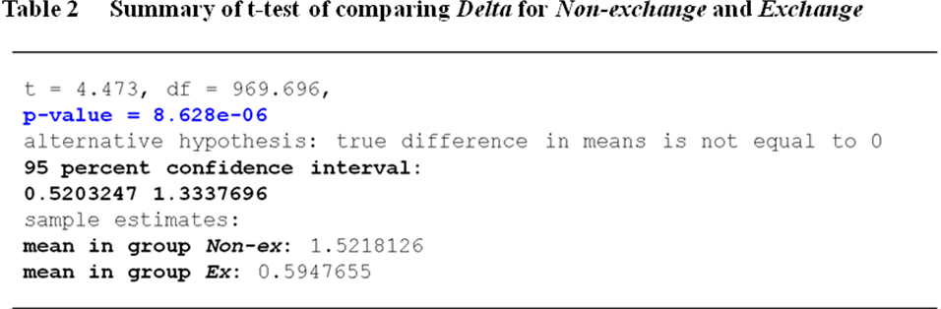

The t-test to determine the significance of the difference in Delta is shown in Table 2. The small (essentially zero) p-value provides strong evidence that Non-exchange and Exchange have different Deltas. The 95% confidence interval for the difference between two means is (0.5, 1.3). This means that Exchange students did worse by 0.5 to 1.3 percentage points than Non-exchange students.

To explore the sample data further, a scatter plot is used. Figure 3 shows the scatter plots of Delta vs. Cumulative average for Exchange and Non-exchange combined (Note: Cumulative average represents the mean of 1st and 2nd year grades, (Y1 + Y2) / 2, throughout this paper). Exchange and Non-exchange are shown with different colours; green (Exchange) and red (Non-exchange). Several observations are graphically apparent.

- The two groups behave very similarly as indicated by the homogeneous overlap of the data points for the two groups (red and green).
- The relationship between Cumulative average and Delta is approximately linear for both groups.
- The students who obtained relatively high Cumulative averages tend to experience lower 4th year grades. Conversely, students who had low Cumulative averages appear to get higher 4th year grades. This is indicated by both regression lines having negative slopes. .
- The two regression lines follow each other very closely. In fact, the regression line for Exchange is only slightly above that for the Non-exchange.
- The slope in the line is consistent with Exchange students’ Delta values being lower because Exchange students tend to have higher Cumulative averages than the Non–exchange.

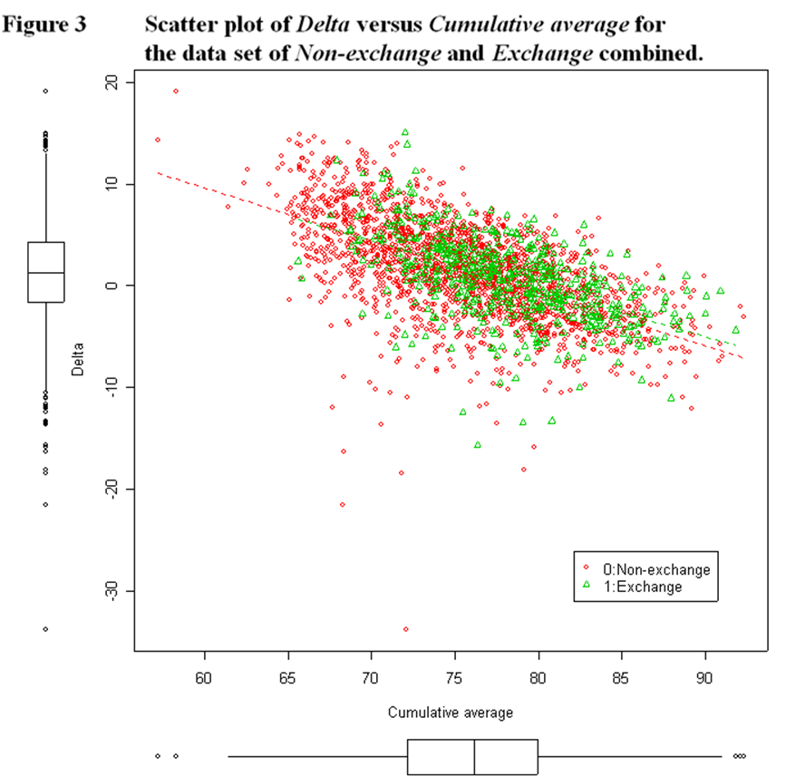

b - Multiple Regression

I test the significance of the difference of the two regression lines by using Multiple Regression (MR). The dummy variables, 0 for Non-exchange and 1 for Exchange, are used for MR. The MR finds the difference of the slopes and intercepts of the two regression lines. This is analogous to finding the difference in Delta between the two groups.

The results of the MR are shown in Table 3. These results suggest that there is no significant difference in the intercepts and the slopes of the two lines. This can be seen by the p-values of the term “Went” and the interaction term "Cumul avg * Went". The term “Went” represents the intercept difference and the term "Cumul avg * Went" indicates the slope difference between the two groups. We regress the model again in the second MR by dropping the non-significant interaction term "Cumul avg * Went " to re-estimate the difference in the intercepts with greater accuracy. This regression shows that Non-exchange and Exchange have some but very inconclusive different intercepts (P-value = 0.078). The third MR output confirms that slopes of the two lines are not significantly different. Finally when we drop both terms from the regression we get a P-value of 0. This indicates that the negative slope is significant. Further, the 95% confidence interval (CI) for the slope is:

For Non-exchange and Exchange: | – 0.53 < slope < – 0.48

This CI implies that the odds are 95 out of 100 that the true population slope is somewhere between -0.48 and -0.53. This means that each additional percentage of Cumulative average is accompanied by a decrease between 0.48 and 0.53 percentage point in the 4th year grade, on average.

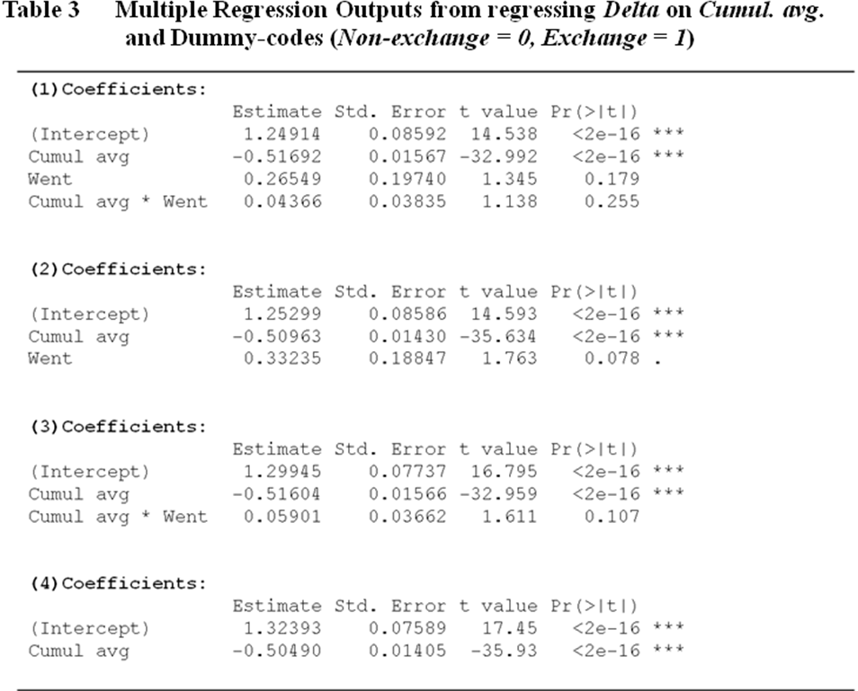

Part 3 - Comparing the two groups by True Improvement

We have seen that Delta is dependent on the Cumulative average. This dependency may result in an artificial “bias” in favour of Non-exchange having higher Deltas. This is because the bottom range of Cumulative average (which corresponds to the positive range of Delta) is mostly populated by Non-exchange students. This can be seen in Figure 3 where the data points below 70% Cumulative average are mostly red (Non-exchange). Figure 3 shows the spread of Cumulative average for the Exchange group (green) is shifted to the right (the direction of higher marks) from the Non-exchange group (red). The spread for the Exchange group ranges from 66~ 92% whereas for Non-exchange the range is 57~92%. This occurs because the minimum 70% Cumulative average is a criterion for acceptance into the IEP. Consequently, although working with Delta is intuitive, it may be misleading for our analyses.

In order to overcome this problem, I modify Delta to take into account the relationship between 4th year grades and Cumulative averages. Specifically, I compare an Exchange student’s 4th year grade to one’s expected 4th year grade if he/she had not gone on the IEP. This is analogous to comparing an Exchange student’s 4th year grade to the 4th year grades of Non-exchange students who had the same Cumulative average as him/her. This procedure is possible because Exchange and Non-exchange behave similarly on the graph (Figure 3). Looking at Figure 3 we cannot distinguish red and green points above 70% of Cumulative average.

Then, how do we predict 4th year grades for specific Cumulative averages for Exchange?
This is done by “regressing” the Non-exchange students’ 4th year grades on Cumulative averages.
The reason I use Non-exchange is because I want to see what 4th year grade the Exchange student would have received if he/she didn’t go on IEP. In other words, I use Non-exchange as a baseline for the comparison.

Regression enables us to quantify the relationship between Cumulative average and 4th year grade. Figure 4 shows this relationship graphically and the regression line. The regression line’s equation is (refer to Table 4):

Non-exchange 4th year grade = 0.48 × Cumulative average + 40.62

Using this equation we can best estimate a 4th year grade based on a Cumulative average. The confidence interval for the slope is (0.45, 0.51). (Note: Y4 (the label of y-axis) represents 4th year grade)

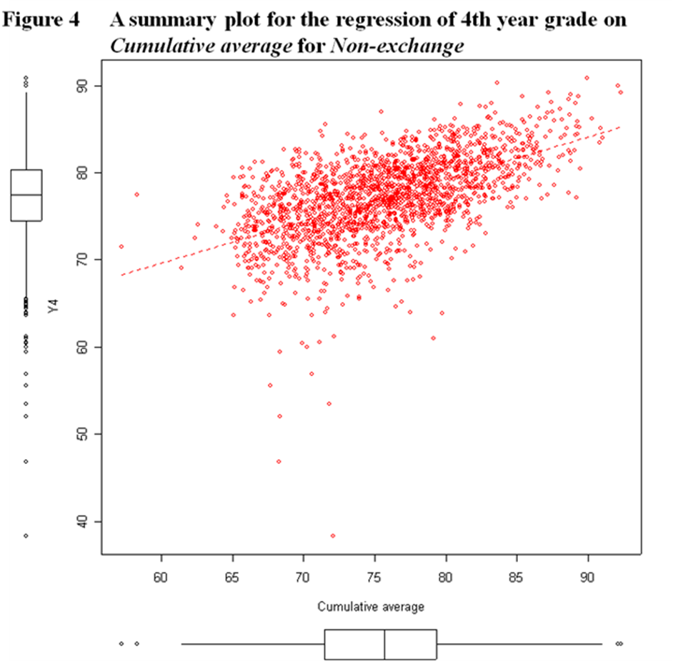

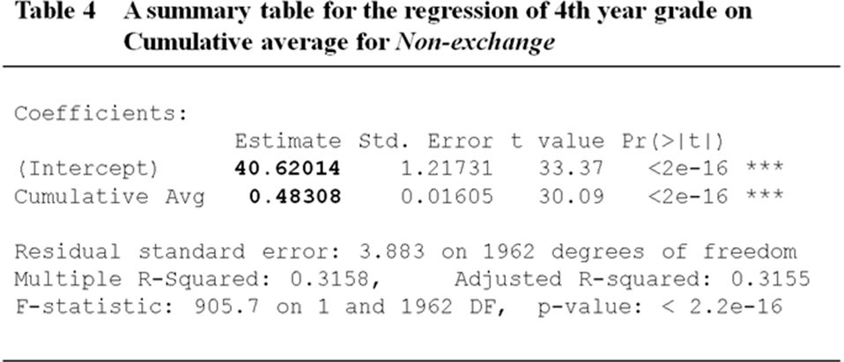

As an example, consider Bob. He is an exchange student with a Cumulative average of 90% and gets a grade of 88% in his 4th year. How has he done? His grade deteriorated by 2 percentage points (=90% – 88%). This is our original conclusion with Delta alone. Alternatively, the best estimation of his 4th year grade if he did not go on the IEP can be calculated by the regression equation;

40.62 + 0.48 × 90 = 83.82.

Therefore, we conclude that Bob actually improved after the IEP since his observed 4th year grade of 88% is higher than the expected grade of 83.82% by 4.18 percentage points.

Conversely, consider Joe, an exchange student with a Cumulative average of 70% and a 4th year grade of 72%. Since he received a low mark, we can reasonably expect some improvement using Delta. However, did he perform as well as expected based on other students? The equation suggests an expected grade of

40.62 + 0.48 × 70 = 74.22

if Joe did not go on the IEP. Therefore, he did not do as well as he originally thought (a 2 percentage point (=70% – 72%) increase concluded with Delta alone). We conclude that Joe did not improve after the IEP since his observed 4th year grade of 72% is lower than the expected grade of 74.22% by 2.22 percentage point.

Accordingly, we interpret an Exchange student’s grade change using the performance predicted by the quantity, 40.78 + 0.48 × Cumulative average. In other words, an Exchange students’ true improvement is calculated as the difference between the observed 4th year grade and the expected 4th year grade if he/she did not go on the IEP. I call this the Best Estimate of the True Improvement. The term Improvement is used for simplicity where;
Improvement = (Observed 4th year grade) – (Expected 4th year grade)

or (Observed 4th year grade) – {40.78 + 0.48 × (Y1 +Y2)/2}

Hence, if the observed is greater than expected, we conclude that the Exchange student improved and the IEP has a positive effect. Consequently, we want to show that Improvement is significantly greater than zero to show that Exchange did better than Non-exchange.
Figure 4 shows the scatter plot of Improvement vs. Cumulative average for the data set of Non-exchange and Exchange combined. For Non-exchange, the regression line is horizontal at zero (slope and intercept of 0). In other words, scatter points for Non-exchange in Figure 4 (red) can be interpreted as residuals from the fitted regression equation. With respect to the Exchange regression line, its slope is not significantly different from that of Non-exchange as shown by P-value of 0.17 (Table 5).

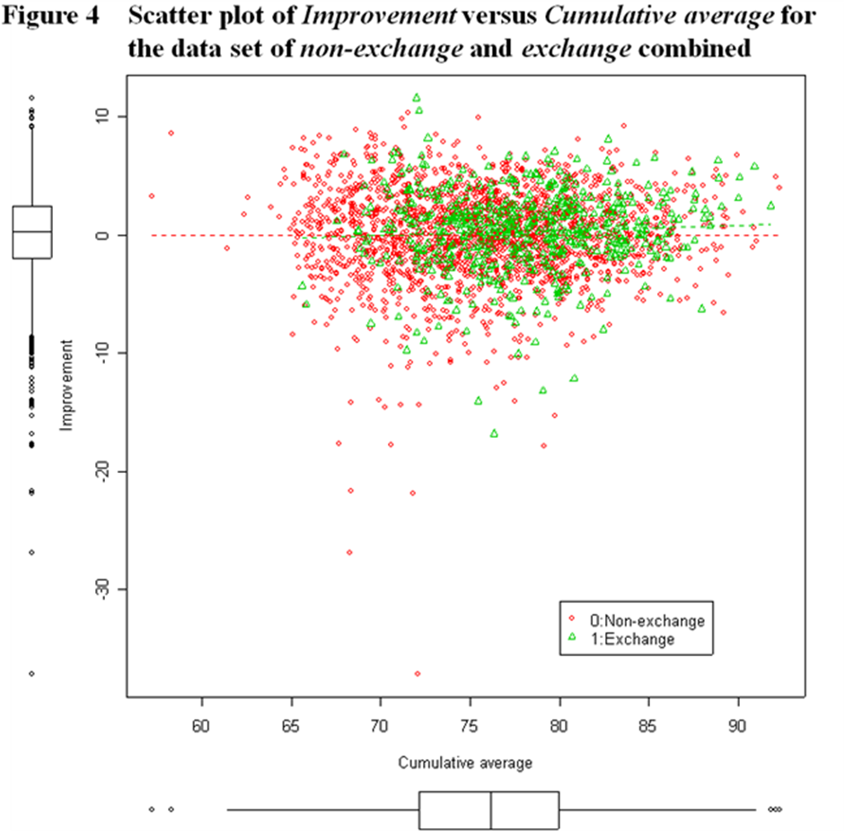
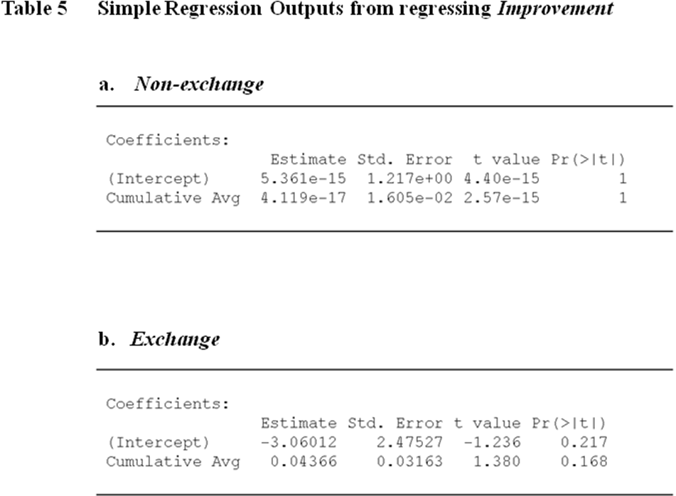

Another way to see the differences in Improvement between the two groups is a box plot and a t-test. In Figure 5, the box plot contrasts the Improvement for both Non-exchange and Exchange. The higher box position for Exchange suggests that Exchange improved their grades more than Non-exchange. The t-test gives some evidence of a difference between Non-exchange and Exchange, with Exchange doing better (P-value = 0.04). The 95% confidence interval shows that the IEP has a small favourable effect of between 0.01 and 0.69 percentage points on Improvement (refer to Table 6).

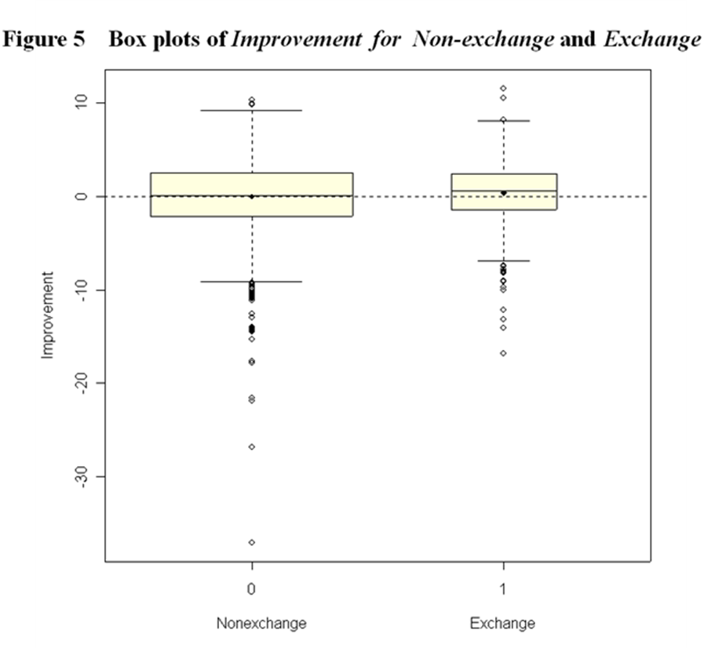

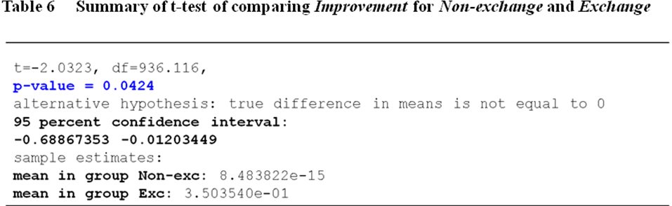

Part 4 - Conclusion

The second analysis using the new variable “Improvement” differs from what I found from the multiple regression analysis. This is because in the t-test I suppose that the true regression for Non-exchange is exactly a horizontal line at zero. I have used the phrasing "true regression" because I assumed the regression equation from Non-exchange to represent the true population. However, in reality, this horizontal line has an uncertainty in both slope and intercept.
On the other hand, using the multiple regression analysis has the advantage. That is, MR takes into account any errors in the fit to both groups. Therefore, I would conclude that the best comparison of the difference in Improvement between the two groups is the multiple regression analysis.

Taken together, although the t-test suggests some evidence (P-value = 0.04) for positive effects of the IEP, the multiple regression analysis fails to show a significant difference in Improvement between Non-exchange and Exchange. Overall, I have reasonable evidence to conclude that at the very least, the IEP has no adverse effect on students’ subsequent grades.

