Time Series Analysis of Firearm Homocides Rates in Australia

Abstract:
Understanding the relationship between firearms availability and gun deaths is an important policy question for many countries. Australia’s 1996-1997 National Firearms Agreement (NFA), which tightened gun ownership and licensing requirements and removed 600,000 guns from a country with a population of 20 million – offers a potentially useful natural experiment. The purpose of this project is to analyze the trend of firearm homicide rates over the time period 1915-2004. Visual inspection and residual analysis of the data were performed. Multiple data transformation methods were evaluated, followed by model fitting and diagnostic checking.

Data source and Software:
Data is obtained from:
Hyndman, R.J. (n.d.) Time Series Data Library, http://www.robhyndman.info/TSDL.
Background information:
Gun politics in Australia
From Wikipedia, the free encyclopedia
http://en.wikipedia.org/wiki/Gun_politics_in_Australia
Software used for the time series analysis:
- ASTSA - ASTSA is an interactive, menu driven time series package that is distributed as Freeware and is provided “As is” without warranty of any kind, either expressed or implied. It can be downloaded from internet.
- Microsoft Excel

Introduction:
Many Australians (765,000 or 5.2% of Australian adults as of August 2007) legally own and use firearms for hunting, the control of feral animals, and target shooting. Low levels of violent crime through much of the 20th century kept levels of Government concern about firearms low. However, in the last two decades, following several mass killings and rising concern, Australian State Governments have, with Federal Government co-ordination, enacted more restrictive firearms legislation. Currently, the possession and use of firearms in Australia is governed by state laws which were partly aligned by the 1996 National Firearms Agreement (NFA). Anyone wishing to buy, own, or use a firearm must have a Firearms Licence and be over the age of 18, although there are exceptions.

In 1997, the Prime Minister appointed the Australian Institute of Criminology to analyse of the effects of the gun buyback. Since then, a number of papers have been published reporting trends and statistics around legal gun ownership and gun crime, which they have found to be mostly related to illegally-held firearms. Some studies claimed that the NFA has a dramatic effect on reducing firearm deaths, while others argue that the level of legal gun ownership actually increased in recent years. There are also results showing no impact of the gun laws on homicide. It’s not the purpose of this project to discount one theory or another since there are many possible dependent variables when it comes to social problems as complicated as the effectiveness of gun control. Instead the focus would be on the data serie itself and to find an appropriate predictive model.

Data Analysis and Conclusions:
The figure below shows the Homicide Rates (per 100,000 population) from 1915 to 2004 in Australia. The red line indicates the rate of firearm related homicide, the blue line shows the non-firearm related homicide, while the greenline is the combined. The overall homicide rate declined quite significantly around 1930-1950, and then rose relatively sharply in the mid to late 70s and then again in late 80s, early 90s. Afterwards it declined back to about the level as in the70s. Gun related homicide rates followed similar but less dramatic trend. It’s worth noting that after 1990s the gun related homicide rate shows a declining trend while the nonfirearm related homicide remains relatively steady.

The following figure gives us a closer look at gun related homicide rate. The data fluctuated quite significantly before the mid 1950s. At around 60s – 80s the rates picked up, and then started dropping at around early 90s, with the exception of a couple of big spikes in 1996-1997. Afterwards it continues declining steadily, which might be a result of implementation of NFA.

Overall exogeneous factors with large and discrete effects seem to be distorting the time series. The original data clearly is not stationary so some transformations need to be performed before we fit any models. Just to confirm, a residual test in ASTSA is done on the original data series and it shows below that the residual is not a white noise process.
Residual tests for Firearm Homicide Rate in Australia
T = 90
Box-Pierce test
lag chi sq. p-value
1 29.26 < .01
20 138.76 < .01
Non-independence.

Normal test
corr. p-value
.99479 N.S.
Probable Gaussian distribution.

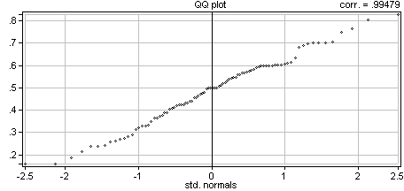
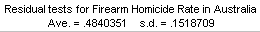

Several transformations have been attempted and the plots are shown in the following order:
- First difference
- Log transformation (on the rate*100)
- First difference of the Log transformation above
- Second difference
- Minus Average

The 5 plots indicated that taking 1st difference removes the trend efficiently. Log transformation, removing means and higher order differencing don’t seem to work as well or provide additional value. Residual test in ASTSA shows that the residuals of the differenced data are approximately normally distributed with mean 0.
Residual tests for Firearm Homicide Rate in Australia D1
T = 89
Box-Pierce test
lag chi sq. p-value
1 15.14 < .01
20 48.30 < .01
Non-independence.
Normal test
corr. p-value
.99447 N.S.
Probable Gaussian distribution.
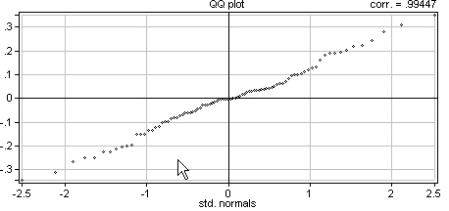
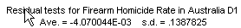

The following figure shows the correlograms of the 1st order differenced data. It’s clear that a simple MA or AR model will not be sufficient. The next step is to see whether we can find a good ARIMA model.
Firearm Homicide Rate in Australia D1
ACF
zero lag autocovariance = .01904

lag ACF lag ACF lag ACF lag ACF
1 -.4056 2 -.0111 3 -.1255 4 .1218
5 .0523 6 -.1940 7 .1576 8 -.0803
9 .1700 10 -.2343 11 .2292 12 -.0964
13 .0140 14 -.0547 15 -.0809 16 .1227
17 .0221 18 .0559 19 -.1890 20 .0901
21 -.0205 22 .0833 23 -.1060 24 -.0064
25 .0714 26 -.0207 27 -.0907 28 .1494
29 -.0143 30 -.1021 31 .0230 32 -.0589
33 .1972 34 -.1498 35 .0468 36 -.0788
37 .0550 38 -.0499 39 .0070 40 .1126

95% significance is .2078

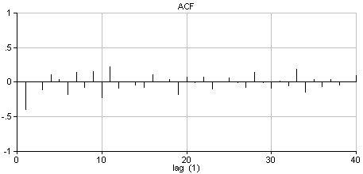
There is a very neat “ARIMA search” feature in ASTSA application. See the screen shot below. All that the user need to do is to enter the minmum and maximum of MA order, AR order, order of difference, seasonal MA order, seasonal AR order, order of seasonal difference, etc. I set the order of difference to 1 and then let the software search for the optimal ARIMA model with MA order ranging between 0-10 and AR order ranging between 0-10.
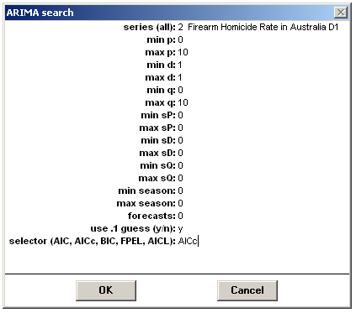
After running through a total of 121 combinations of ARIMA models, the ASTSA ARIMA search returns that the best fitting model is ARIMA (6, 1, 8). The parameters are shown below. The p values of all the parameters are below 0.05.
ARIMA search on Firearm Homicide Rate in Australia
ARIMA on Firearm Homicide Rate in Australia

ARIMA(6,1,8) from Firearm Homicide Rate in Australia
AICc = -3.76042 variance = .00658179 d.f. = 69
Start values = .1

predictor coef st. error t-ratio p-value
AR(1) -.4680 .00919 -50.9499 .000
AR(2) .1747 .00736 23.7419 .000
AR(3) -.1702 .00635 -26.7986 .000
AR(4) -.2708 .00623 -43.4540 .000
AR(5) -.1787 .01140 -15.6736 .000
AR(6) -.5270 .01151 -45.7711 .000
MA(1) .1608 .01480 10.8602 .000
MA(2) .7157 .01484 48.2196 .000
MA(3) -.3313 .01480 -22.3827 .000
MA(4) -.6825 .01480 -46.1126 .000
MA(5) -.1302 .01488 -8.7527 .000
MA(6) -.6051 .01489 -40.6280 .000
MA(7) .3358 .01494 22.4838 .000
MA(8) -.1913 .01494 -12.8048 .000

The specified models is:

(1 +.47B1 -.17B2 +.17B3 +.27B4 +.18B5 +.53B6) (D1) x(t) =
(1 -.16B1 -.72B2 +.33B3 +.68B4 +.13B5 +.61B6 -.34B7 +.19B8) w(t)

The predicted values are in red. And it looks like the predicted values are really close to the observed values.

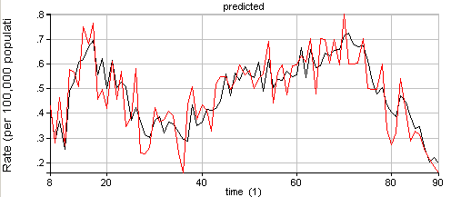

The Box Pierce Q statistics provided by ASTSA for the 50 lag is 41.10:
Df = 50 – 14 = 36
Chi-squares critical value (at 5% signicance level, df 36) is 47.2122;
Therefore the ARIMA (6,1,8) model is a good fit for the Australian firearm homicide data.

