Unemployment Rate VS Interest Rate and Inflation Rate
A Regression Analysis Project

Date: Jan 20th, 2009
By: xxxx xxxxx

Introduction

The current financial crisis is causing a great number of job losses, hence raising the unemployment rate. Many countries from all around the world have lowered its interest rates coincidently to mitigate the circumstances. In this study report, we will examine the relationship between unemployment rate vs. interest rate and inflation rate.

Data

Data was recorded at a monthly basis, from Jan 1st, 1956 – May 1st, 2006, slightly more than 50 years; that gives us about 600 data points. Three sets of data are taken into the study: the US unemployment rate, US Prime Bank Loan Rate, and the US inflation rate. We will consider the US Prime Bank Loan Rate as the prime interest rate in this report.

Software

I used R software for this project. (http://www.r-project.org/). It is a powerful statistical analysis software that has similar functionalities as Matlab or SAS.

Model Selection

The inflation and interest rates are multiplicative models. We need additive models to apply linear regression; therefore logarithm is taken on all values. We regress the first difference of the logarithms of both interest rate and inflation rate against the unemployment rate.

> data<-read.table("data.txt",header = T)
> unrate<-data$unrate
> int<-data$int
> cpi<-data$cpi
> logunrate<-log(1+unrate/100)
> logint<-log(1+int/100)
> inf<-data$inflation
> loginf<-log(1+inf/100)
> model<-lm(logunrate~logint + loginf)
> difmodel<-lm(diff(log(unrate)) ~ diff(log(int)) + diff(log(inf)))
> plot(difmodel$residuals)
> abline(h=mean(difmodel$residuals) )
> title(sub="Figure1.1: Residuals Plot")

The R inputs and outputs are shown in the boxes like the one above.

> summary(difmodel)

Call:
lm(formula = diff(log(unrate)) ~ diff(log(int)) + diff(log(inf)))

Residuals:
Min 1Q Median 3Q Max
-0.0904476 -0.0195790 -0.0004285 0.0182210 0.1245250

Coefficients:
Estimate Std. Error t value Pr(>|t|)
(Intercept) 0.0004285 0.0013119 0.327 0.744
diff(log(int)) -0.1445043 0.0338393 -4.270 2.27e-05 ***
diff(log(inf)) 0.0017974 0.0051373 0.350 0.727
---
Signif. codes: 0 ‘***’ 0.001 ‘**’ 0.01 ‘*’ 0.05 ‘.’ 0.1 ‘ ’ 1

Residual standard error: 0.03225 on 602 degrees of freedom
Multiple R-squared: 0.02964, Adjusted R-squared: 0.02642
F-statistic: 9.194 on 2 and 602 DF, p-value: 0.0001166

Notice the results above give us a significant F-statistics (9.194) while one of the t-statistics is very low (a value of 0.35, close to 0). F statistic is the test of the null hypothesis that both the explanatory variables are not important. An F value of 9.19 suggests that we reject that null hypothesis. While one of the t-values suggests that the inflation rate is insignificant. We have a contradiction here. This is an indicator of multicollinearity. Of course multicollinearity exists because we know that interest rate and inflation rate are highly correlated. Obviously the above model does not help us to explain the data. The results suggest that one of the explanatory variables should be dropped. Therefore, we change our model to unemployment rate against interest rate and unemployment rate against inflation rate.

In mathematical notation, we will examine the following two models separately and determine which explanatory variable explains the data better.
$\text{Yi}=α_{1}+β_{1}X_{1_{i}}+ε_{i}$ ε_{i} ~ N(0,1)
$\text{Yi}=α_{2}+β_{2}X_{2_{i}}+ε_{i}$ ε_{i} ~ N(0,1)
Where $β_{1}$ is the unbiased estimator of interest rate, and $β_{2}$ is the unbiased estimator of inflation rate. Yi is the logarithm of unemployment rate, X1i is the logarithm of interest rate (Prime Bank Loan Interest Rate) and X2i is the logarithm of the inflation rate. We shall estimate the two models separately and determine which factor is more powerful explaining the unemployment rate.

Model Comparison

- The Interest Rate Model

Figure1.1 shows the homoscedasticity of the residuals, the mean of the residuals (horizontal line) is zero. Applying Normal (QQ) plot (Figure 1.2), all the residuals approximately lie on a straight line. We are more confident that the residuals are normally distributed; therefore, we can apply linear regression.

> model1<-lm(diff(log(unrate))~ diff(log(int)))
> plot(model1$residuals)
> abline(h=mean(model1$residuals))
> title(sub="Figure1.1: Residuals plot for interest rate model")
> qqnorm(model1$residuals)
> qqline(model1$residuals)
> title(sub="Figure1.2: Normal(QQ) plot for interest model")

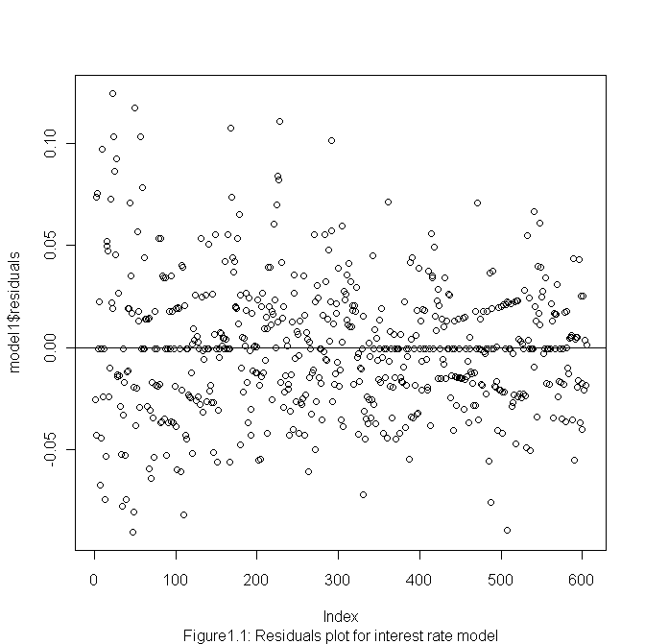

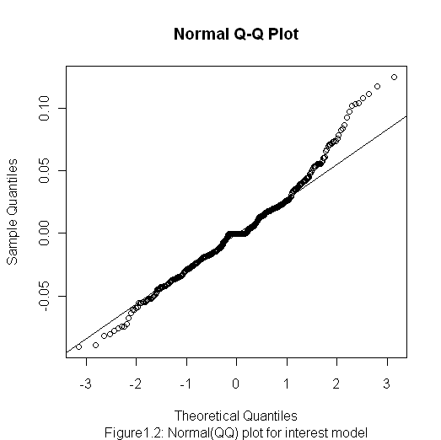

> summary(model1)

Call:
lm(formula = diff(log(unrate)) ~ diff(log(int)))

Residuals:
Min 1Q Median 3Q Max
-0.0905803 -0.0195009 -0.0004292 0.0180711 0.1247339

Coefficients:
Estimate Std. Error t value Pr(>|t|)
(Intercept) 0.0004292 0.0013110 0.327 0.743
diff(log(int)) -0.1446176 0.0338131 -4.277 2.20e-05 ***
---
Signif. codes: 0 ‘***’ 0.001 ‘**’ 0.01 ‘*’ 0.05 ‘.’ 0.1 ‘ ’ 1

Residual standard error: 0.03223 on 603 degrees of freedom
Multiple R-squared: 0.02944, Adjusted R-squared: 0.02783
F-statistic: 18.29 on 1 and 603 DF, p-value: 2.203e-05

Plugging in the parameter estimate, we get
$$\text{Yi}=0\text{.}\text{0004292}+\text{-0}\text{.}\text{1446176}X_{i}$$
(0.0013110) (0.0338131)
The standard errors are in the brackets for each parameter.
The null hypothesis is $β_{1}$ =0, that the interest rate has nothing to do with the unemployment rate. The t-statistic is calculated as$t=\frac{β_{1}−0}{S_{x1}}$.
The t-value of the unbiased estimate is -4.277, which is significantly different from 0; in this case, the F-value is just square of the t-value, which is 18.29. The Adjusted R-Square is 0.02783, very close to 0. Indicating that we have a poor fit. However, this is expected because we using more than 600 data points. The p-value is also very small, 2.20e-05. Therefore, we can reject the null hypothesis that the interest rate has nothing to do with the unemployment rate.

- The Inflation Rate Model

> model2<-lm(diff(log(unrate))~ diff(log(inf)))
> ts.plot(model2$residuals,xlab="Data",ylab="Residuals")
> abline(h=mean(model2$residuals))
> title(sub="Figure1.3: TS plot residuals of inflation model")
> qqnorm(model2$residuals)
> qqline(model2$residuals)
> title(sub="Figure1.4: Normal(QQ) plot for inflation model")

Now we regress the first difference of logarithm of inflation rate on the unemployment rate. First we check the residuals plot; Figure1.3 gives a mean of zero. However, the middle part of the normal (QQ) plot is somewhat strange. It may indicate that the residuals are not normally distributed. However, we will still run linear regression on this model, and we assume the residuals are normally distributed.

> model2<-lm(diff(log(unrate))~ diff(log(inf)))
> ts.plot(model2$residuals,xlab="Data",ylab="Residuals")
> abline(h=mean(model2$residuals))
> title(sub="Figure1.3: TS plot residuals of inflation model")
> qqnorm(model2$residuals)
> qqline(model2$residuals)
> title(sub="Figure1.4: Normal(QQ) plot for inflation model")
> summary(model2)
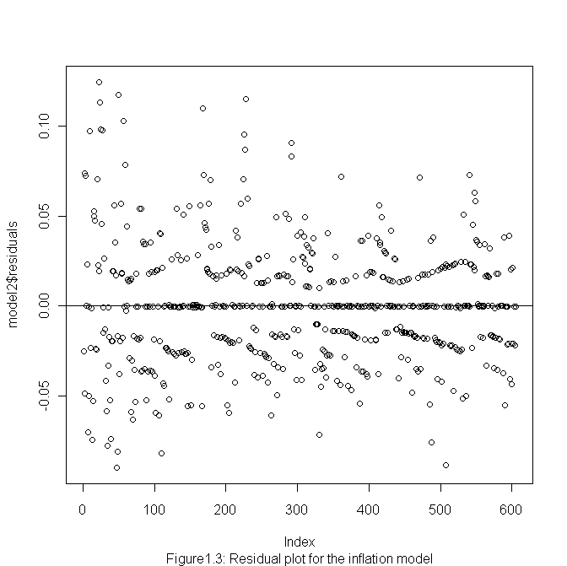

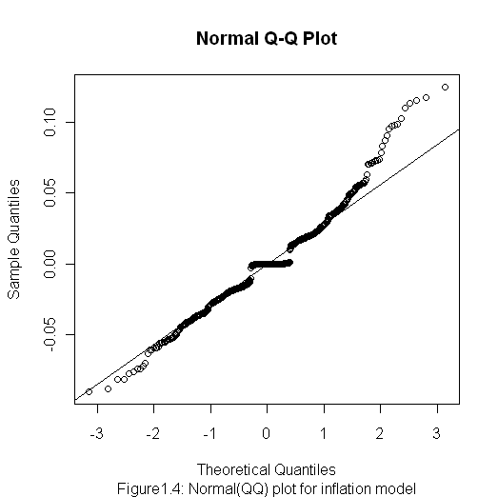
> summary(model2)

Call:
lm(formula = diff(log(unrate)) ~ diff(log(inf)))

Residuals:
Min 1Q Median 3Q Max
-0.0902340 -0.0198098 -0.0002304 0.0183032 0.1246986

Coefficients:
Estimate Std. Error t value Pr(>|t|)
(Intercept) 0.0002304 0.0013297 0.173 0.862
diff(log(inf)) 0.0020074 0.0052100 0.385 0.700

Residual standard error: 0.03271 on 603 degrees of freedom
Multiple R-squared: 0.0002461, Adjusted R-squared: -0.001412
F-statistic: 0.1485 on 1 and 603 DF, p-value: 0.7002

The linear model for the inflation rate is $\text{Yi}=0\text{.}\text{0002304}+0\text{.}\text{0020074}X_{i}$
(0.0013297) (0.0052100)
Standard errors are inside the brackets. The adjusted R-squared is also small. The null hypothesis is $β_{2}$= 0, that the inflation rate has nothing to do with the unemployment rate. The t-value is 0.385 in this case, relatively smaller (in absolute value) compare to the t-value for $β_{1}$ (-4.277). Undoubtedly, the F-value is even smaller in this case, since its value equals the square of t-value. The p-value is 0.7, greater than then 0.05 thresholds. Hence we conclude that we accept the null hypothesis that the inflation rate has little effect on the unemployment rate.

We compare the results of the two models in the table below. Interest rate has a higher t-value and smaller p-value than the inflation rate model does. Therefore the interest rate is more significant in explaining the variation in unemployment rate.

Parameter | Estimate | Standard deviation | t-value | p-value
$$β_{1}$$ | -0.1446176 | 0.0338131 | -4.277 | 2.20e-05
$$β_{2}$$ | 0.0020074 | 0.0052100 | 0.385 | 0.7002

Confidence Interval

We choose the interest rate model for further analysis. We can construct a confidence interval for the interest rate model. The $\text{95}\text{\%}\text{CI}=\text{estimate}±1\text{.}\text{96}\text{se}$= (-0.1446176- 1.96 * 0.03223, -0.1446176+ 1.96 * 0.03223) = (-0.2077884, -0.0814468). It means the true value of the estimate $β_{1}$ will fall within this range with 95% confidence.

Conclusion

It boils down to the fact that interest rate model is more powerful in explaining the variations in unemployment rate than inflation rate model does. One problem we encountered during the estimation process was that the R-square value being very low. Because there are a lot of other factors cause the change in unemployment rate. Regress only the interest rate against unemployment rate is too simple compare to the reality. Other factors such as supply-demand of the job market, minimum wage laws and other regulations may also have impact on the unemployment rate. Those factors should be included in the model under one condition: that the data is available.

Reference:

Regression analysis and Time series: Robert S. Pindyck and Daniel L. Rubinfield, Econometric Models and Economic Forecasts, 4th edition, November 1997, McGraw-Hill/Irwin

Data source:

1)http://inflationdata.com/inflation/Consumer_Price_Index/HistoricalCPI.aspx?rsCPI_currentPage=4
2)http://www.forecasts.org/

