Student project
Regression Analysis
Fall 2009

Introduction
This project studies relationship between crime rates and demographical data for 47 U.S. states in 1960. The data file contains 14 variables, including crime rate and other demographical factors which affect crime rates. The project describes the data in detail in the following sections and examines the factors by regression analysis. The study uses statistical package SAS (version8.1) and SAS procedure “REG” to perform the analysis, the outputs for analysis will presented in the related sections. In the project, we post the following questions:
- Do demographical characteristics have impacts on crime rates?
- If there is relationship between crime rates and demographical data, which factor contributes most to the crime rates?

Data description
The study use crime rates and demographical data for 47 U.S. states which can be found on website:
http://lib.stat.cmu.edu/DASL/Datafiles/USCrime.html
The data was originally collected by FBI and the government agencies to determine how the variable crime rate depends on the other variables. The data set contains 14 variables and 47 observations with one for each state in the U.S. The 14 variables can be described as:
- R: Crime rate: # of offenses reported to police per million population, this is the dependent variable, and the following variables are all independent variables
- Age: The number of males of age 14-24 per 1000 population
- S: Indicator variable for Southern states (0 = No, 1 = Yes)
- Ed: Mean # of years of schooling x 10 for persons of age 25 or older
- Ex0: 1960 per capita expenditure on police by state and local government
- Ex1: 1959 per capita expenditure on police by state and local government
- LF: Labor force participation rate per 1000 civilian urban males age 14-24
- M: The number of males per 1000 females
- N: State population size in hundred thousands
- NW: The number of non-whites per 1000 population
- U1: Unemployment rate of urban males per 1000 of age 14-24
- U2: Unemployment rate of urban males per 1000 of age 35-39
- W: Median value of transferable goods and assets or family income in tens of $
- X: The number of families per 1000 earnings below 1/2 the median income
The data sets contains so many variables, and it should be careful to form the multiple regression model because of the multi-collinear may exist between pairs of variables which leads to low efficiency estimates for regression parameters.

Dependent variable check
At the first step of our project, we examine the statistical characteristics for the dependent variable. For regression analysis, it assumes that the error term is normal distribution if we want to make statistical inference, so is the dependent variable. Here we check the dependent variable by running the SAS procedure “proc univariate”, the output is shown as follow:
The UNIVARIATE Procedure
Variable: R
Moments

N 47 Sum Weights 47
Mean 90.5085106 Sum Observations 4253.9
Std Deviation 38.6762697 Variance 1495.85384
Skewness 1.12469778 Kurtosis 1.19171515
Uncorrected SS 453823.43 Corrected SS 68809.2766
Coeff Variation 42.7321911 Std Error Mean 5.64151375
Tests for Normality

Test --Statistic--- -----p Value------

Shapiro-Wilk W 0.912726 Pr < W 0.0019
Kolmogorov-Smirnov D 0.137517 Pr > D 0.0244
Cramer-von Mises W-Sq 0.179831 Pr > W-Sq 0.0092
Anderson-Darling A-Sq 1.172486 Pr > A-Sq <0.0050
From the above outputs for moments and testing Normality of the dependent variable, it shows high significance of the test results for different test method including Shapiro-Wilk(p-value 0.0019), Kolmogorov-Smirnov(p-value 0.0244), Cramer-von Misses(p-value 0.0092) and Anderson-Darling(p-value < 0.0050) method. Fail to pass the normality test for the dependent variable not means the data is not suitable for regression analysis, it means the study should be more careful about the analysis results because we have not enough data , in the case that inter-state difference exist in the collected data, since we have only one data sample for each state, and can’t verify the inter-state effect in the model at all.

Full model
In this section, we examine regression on all demographical factors for crime rate, there means 13 independent variables. By using SAS procedure “REG”, there are many outputs generated.

Model fitting
For this model the R squared value is 0.7692 and the adjusted R squared value is 0.6783. The R squared value indicates that about 76% percent of the total variation in the dependent variable can be explained by the 13 demographical factors, the left variations remain unexplained and remain in the residual terms.

ANOVA table
Analysis of Variance

Sum of Mean
Source DF Squares Square F Value Pr > F

Model 13 52931 4071.58276 8.46 <.0001
Error 33 15879 481.17275
Corrected Total 46 68809
The ANOVA table shows that the p-value of the whole model is highly significant (P-value < 0.0001), this indicates the 13 independent variables are jointly having effects on the crime rates.

Parameters estimates
Parameter Estimates

Parameter Standard Standardized
Variable DF Estimate Error t Value Pr > |t| Type I SS Type II SS Estimate

Intercept 1 -691.83759 155.88792 -4.44 <.0001 385014 9477.29540 0
Age 1 1.03981 0.42271 2.46 0.0193 550.83962 2911.56961 0.33788
S 1 -8.30831 14.91159 -0.56 0.5812 153.70122 149.37535 -0.10289
Ed 1 1.80160 0.64965 2.77 0.0091 9056.67555 3700.48683 0.52111
Ex0 1 1.60782 1.05867 1.52 0.1384 30760 1109.82951 1.23545
Ex1 1 -0.66726 1.14877 -0.58 0.5653 1530.23860 162.33800 -0.48240
LF 1 -0.04103 0.15348 -0.27 0.7909 611.33902 34.39064 -0.04287
M 1 0.16479 0.20993 0.78 0.4381 1109.99552 296.50493 0.12556
N 1 -0.04128 0.12952 -0.32 0.7520 426.49049 48.87284 -0.04063
NW 1 0.00717 0.06387 0.11 0.9112 141.97340 6.07227 0.01908
U1 1 -0.60168 0.43715 -1.38 0.1780 70.65404 911.49754 -0.28047
U2 1 1.79226 0.85611 2.09 0.0441 2696.62819 2108.84111 0.39136
W 1 0.13736 0.10583 1.30 0.2033 347.47558 810.57288 0.34269
X 1 0.79293 0.23509 3.37 0.0019 5474.23017 5474.23017 0.81794
The p-values of the parameters show that some variables are highly significant such as Age(p-value 0.0193), Ed(p-value 0.0091), U2(p-value 0.0441) and X(p-value0.0019); While other factors show weak significances. Following statements explain the significant variables individually:
- Age: The age variable means the number of citizens between age 14 and 24 per 1000 populations, the parameter for this independent variable is positive means young persons intend to commit more crime activities, this is coincident with out intuition since young people are more energetic and live active life styles;
- Ed: This variable means “Mean # of years of schooling x 10 for persons of age 25 or older”, positive coefficient estimation says more education year lead to higher crime rate. This is contradict to our intuitive, so we should check for co-linearity in our model and removes some “duplicated” variables to make the estimates more stable and conform to our conception about the crime rates.
- U2: The independent variable describes Unemployment rate of urban males per 1000 of age 35-39, the estimation for this independent variable is high, which means high unemployment for elder workers leads to high crime rates. It is reasonable that these people want to raise their families and if they lose jobs, they may commit thefting and robbing from others.
- X: The X variable means the number of low income families, poor families are more likely to commit illegal activities because of the living pressures.

Reduced form model
Since in the full model, there are many independent variables show low significant. By intuition about the multi-collinearity problem, high R squared value and low significant independent variables may be a indicator. We here consider a reduced regression model and remove the low significant variables.
For the reduced model, we choose the independent variables: Age, Ed, Ex1, U2, W, X. Running the SAS “REG” procedure presented in the following.

Model fitting
By the SAS outputs, the R-squared and the adjusted R-squared values for the model are 0.7297 and 0.6892. Comparing with the full model, it can be found that the reduced model is almost the same as the full model in terms of the explained variations in the dependent variable.

ANOVA table
The ANOVA table for the regression model is:
Analysis of Variance
Sum of Mean
Source DF Squares Square F Value Pr > F

Model 6 50210 8368.32364 18.00 <.0001
Error 40 18599 464.98337
Corrected Total 46 68809
The p-value for the model is less than 0.0001, which means independent variable have jointly significant effect for explaining the dependent variable.

Parameters estimates
For each variable, the detailed estimation outputs are:
Parameter Estimates

Parameter Standard Standardized
Variable DF Estimate Error t Value Pr > |t| Type I SS Type II SS Estimate

Intercept 1 -636.60125 111.68203 -5.70 <.0001 385014 15108 0
Age 1 1.14006 0.36318 3.14 0.0032 550.83962 4581.86320 0.37046
Ed 1 1.78983 0.49695 3.60 0.0009 7259.67450 6031.58164 0.51770
Ex1 1 1.07467 0.19346 5.55 <.0001 29485 14348 0.77694
U2 1 0.87907 0.44184 1.99 0.0535 2537.92552 1840.54466 0.19196
W 1 0.18420 0.09607 1.92 0.0623 520.35781 1709.53600 0.45956
X 1 0.86175 0.18717 4.60 <.0001 9856.62304 9856.62304 0.88893
In the reduced model, the P-values for all significant if using a significance level of 10%. The Ex1 and X has the most significance with p-values less than 0.0001, this make us believe policy expenditure and family wealth status have influential impacts on crime rates. But the Ex1 variable may be spurious, since it can also interpreted that the government spend more expenditure on policy because crime rate is high, but here we can’t find the direction of causality for crime rates and expenditures on policy, we just say it is significant here according to parameter estimations.
In the model of less independent variable, the standard errors for the parameters are lower; the estimates are more efficient now. Take variable age for example, the std. decrease from 0.42271 to 0.36318.

Model specification test
Since we present a reduced form of the model by posting several restrictions (removing the low significant independent variables), the resulting R-squared and adjusted R-squared decrease little. Here we perform a test on the restrictions and prove that we should use the reduced form of the regression model by the principal of parsimony. The test can be performed by “REG” procedure in SAS with option “restrict”, the resulting ESS_R = 18599, in the unrestricted model the ESS_UR = 15879, the test F-statistics is (ESS_R-ESS_UR)*(N-k)/(ESS_UR*q) = ((18599-15879)*(47-14))/(15879*7) = 0.8075, with degree of freedom (7, 33); The p-value for the statistics is about 0.4, which is far from significance. So we should use the reduced form of model since it has less parameter number.

Other topics

Series correlation
For regression on time series data, series correlation is an importance issue and should be tested by computing the Durbin-Watson statistics. A DW-statistic around 2 means no series correlations in the data. But in this model, we use cross-sectional data rather than time series data for regression, so we just ignore the series correlation issues here. This does not mean series correlation is not the important issue; it is just not so importance in this project for only one data for each state. If we collect data year by year for the crime rates and demographical data, we should consider about the series correlation.

Residual normality test
For the reduced form model, we draw the qq-plot for the residuals, and the plot is:
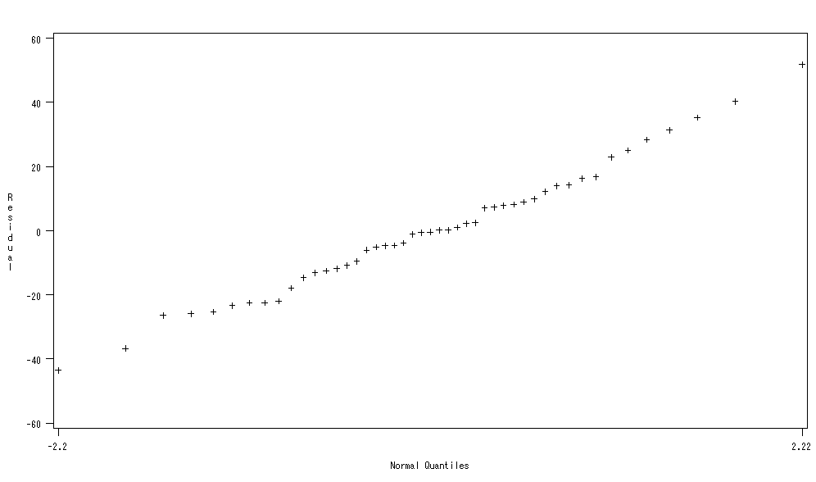
For the definition of qq-plot, if the points present on a line, it can be seen that the residuals satisfy the normality assumption. For some usual test for normality, the SAS gives the following test results, which are:
Tests for Normality

Test --Statistic--- -----p Value------

Shapiro-Wilk W 0.988859 Pr < W 0.9301
Kolmogorov-Smirnov D 0.067817 Pr > D >0.1500
Cramer-von Mises W-Sq 0.030431 Pr > W-Sq >0.2500
Anderson-Darling A-Sq 0.204828 Pr > A-Sq >0.2500
The outputs show none of the four normality tests get a significant p-value for significance level of 10%. So we can’t reject the null hypothesis of normality for the error terms, and think the error terms are normally distributed.

Heteroscedasticity
Here we list all the scatter plots between residuals and independent variables as following:
From the above scatter plots, we can see that the residuals show little heteroscedasticities respect to some variables, such as Age, U2 and X. So, here we consider a weighted least square for the estimation procedure, which generates parameters estimations as following:
Parameter Estimates

Parameter Standard
Variable DF Estimate Error t Value Pr > |t|

Intercept 1 -616.95719 110.53816 -5.58 <.0001
Age 1 1.10529 0.35223 3.14 0.0032
Ed 1 1.76341 0.49767 3.54 0.0010
Ex1 1 1.09256 0.19585 5.58 <.0001
U2 1 0.85588 0.44575 1.92 0.0620
W 1 0.17231 0.09527 1.81 0.0780
X 1 0.82885 0.18374 4.51 <.0001
The regression model fitting statistics and parameters changes a little, since the heteroscedasticity problem is not a serious one here.

Conclusion
In this project, we do following steps for the crime rates regression analysis:
- Model specification investigation: check a full model and a reduced form model with less parameters, the F-test for model restrictions show it is better to use the reduced form model since the full model does not show much better fitting statistics;
- Fitted residuals test: the study uses qq-plot and four usual normality test methods, the Shapiro-Wilk, Kolmogorov-Smirnov, Cramer-von Mises and Anderson-Darling method show acceptance for the normality assumption for the error terms;
- Heteroscedasticity investigation: we present scatter plots to investigating patterns between the residuals and the independent variables, and re-estimate the model by a weighted least square method, which show little change in the parameter estimates and it can be believed that the heteroscedasticity is not a serious problem for this model.
- For the reduced form model, almost all parameters are significant(10% significance level), the explained variations for the model is about 73%, the remained unexplained variations should be accounted to some other variables that not in the field of demography such as economic development status.
- For the two questions posted in the “Introduction” section, we can answer them here: The demographical data has significant impact on the crime rates although we need additional independent variables in other areas to make our analysis perfect; According to the p-values of the parameters estimations, the poor family number has the most impact on the crime rates, that means more poor families lead to higher crime rates.

