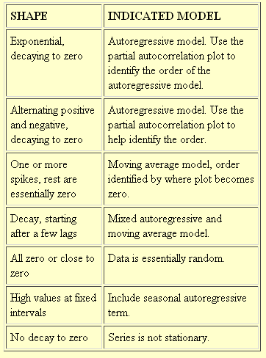

Moving average time series has sample autocorrelations that drop off to a white noise process after its order.

An autoregressive process has geometrically declining autocorrelations for lags greater than its order.

If sample autocorrelation function of a time series does not fall off quickly as k increase, infer that the time series is probably non-stationary.

None of the covariances of a stationary time series can exceed the variance.

For the exponential weighted average model, the forecast any number of periods out will be the same as the forecast one period out.

Optimal ARIMA model has the lowest squared error for its forecasts and the variance of the error terms is estimated from the observed values.

First few residuals may be over-stated.

If sample autocorrelations are close to zero, likely white noise. If high and do not decline to zero, probably random walk. White noise process can have any mean. Random walk has no mean.
White noise process, the mean of the first differences is zero, but their absolute values may be large.
Mean of the residuals of any correctly specified time series should be zero.
White noise can have sample autocorrelation from -1 to +1.
White noise process has a constant variance, NOT a zero variance.

Forecasts of a moving average MA(q) model can move away from the mean of the time series at most for at most q periods.
Forecasts of a stationary autoregressive AR(p) model are mean reverting from the weighted average of the most recent p values.

Which ARIMA models oscillate about their means? Which approach the mean asymptotically? When will it revert and when drift?

ARMA (1,1) with a NEGATIVE phi parameter will oscillate around its mean. Value of theta parameter is irrelevant.
ARMA with value going up has to have positive phi.
Stationary models show mean reversion. If the current value is not the mean, the forecasts eventually move toward the mean..
AR(1), mean reversion is immediate: next period’s forecast between mu and current value.
AR(p), mean reversion may be delayed p-1 periods. The p periods ahead forecast is between mu and the current value.

