xxxxxx xxxxxxx

Regression Analysis Project

Fall 2007

A Study on Light Stress: Red vs. Green Leaves

Executive Summary
The purpose of this project was to show that plants with red leaves are less light-stressed than plants with green leaves over a range of temperatures. A linear regression model was fitted to the data using a dummy variable that took values 0 or 1 depending on the color of the leaves. The model was shown to be a good fit, and a possible additional model parameter was shown to be unnecessary. The model proves, to a high level of significance, that plants with red leaves are under less light stress than those with green leaves.

Description of Data
I received data from Nicole M. Hughes, PhD, a biologist who studies anthocyanin pigment in the leaves of various plants. The data were simplified to fit the purposes of this project. The data were individual measurements of fluorescence (Fv/Fm) vs. ambient temperature (Celsius) for 224 green-leaved plants and 160 red-leaved plants. Higher Fv/Fm measurements correspond to higher light-capture efficiency and lower levels of light stress. (Technically, Fv/Fm is a measure of maximum quantum yield efficiency of photo system 2). I chose to consider temperature as the independent variable (X₃) and fluorescence as the dependent variable (Y). In order to differentiate between green- and red-leaved plants in the regression, I also set up a dummy variable, (X₂) with value 0 for plants with green leaves and 1 for plants with red leaves. The detailed data can be found in the “Data” tab of the accompanying spreadsheet. The data are depicted in the chart below.
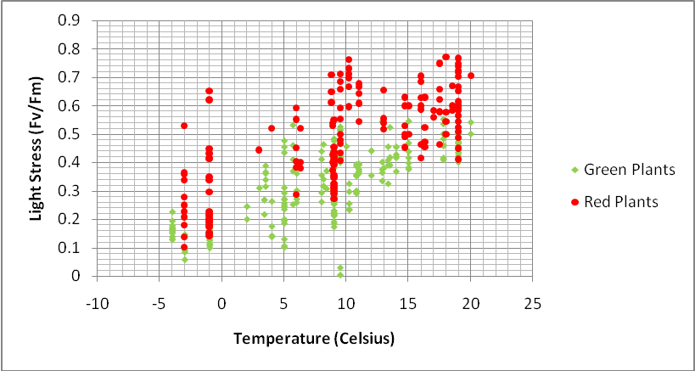

Regression 1
A quick look at the graph of the data points shows that increasing temperature is correlated with decreasing light stress (recall that higher Fv/Fm means lower light stress), and the graph implies a linear model. Also, the red plants appear to be less light-stressed than the green plants, on average.
I first tried a linear regression equation assuming that the implied red and green regression lines would have the same slope. The equation has the form
Y = A₁ + A₂X₂ + A₃X₃,
where A₁, A₂, and A₃ are constants, X₂ is the dummy variable, X₃ is temperature and Y is the fluorescence measurement. Using the linear regression package in Excel, the coefficients were found to be as follows (to three significant digits).
Y = 0.197 + 0.137 * X₂ + 0.0158 * X₃
If one considers the green and red plants separately, this equation can be graphed as two parallel lines. The one for green plants given by setting X₂ = 0:
Y = 0.197 + 0.0158 * X₃,
and the second line, representing red plants, is given by setting X₂ = 1:
Y = 0.334 + 0.0158 * X₃.
The two lines are graphed below.
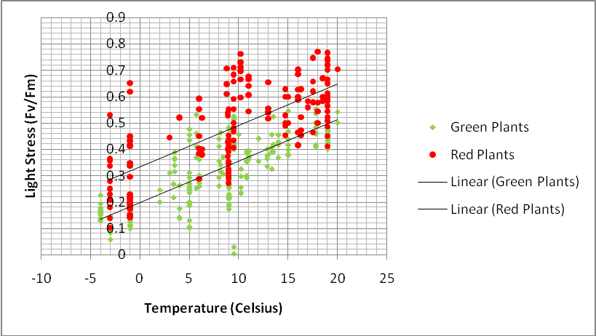
A summary of the statistical results of the regression can be found in the “Regression 1” tab of the accompanying spreadsheet. The R² value for the regression was 0.636, meaning that 63.6% of the variance in the data is explained by the model. This implies that the overall fit of the model to the data is reasonably good.
The p-values for each of the coefficients A₁, A₂ and A₃ are less than 0.00001, implying that these coefficients are nonzero with a very high level of significance. In particular, the p-value of A₂, the coefficient of the dummy variable, is very small, at 1.11 x 10⁻³¹. I conclude that red-leaved plants are less light-stressed than green-leaved plants at the same ambient temperature.

Regression 2
To strengthen the argument, I wanted to test the assumption that greenness vs. redness has no affect on slope. To do this, I used Excel to calculate a second linear regression model, in the form
Y = A₁ + A₂X₂ + A₃X₃ + A₄X₂X₃,
where the coefficient A₄ represents an adjustment to slope for the red-leaved plants only. A summary of the results of this regression can be found in the “Regression 2” tab of the accompanying Excel spreadsheet. Regression 2 found A₁, A₂ and A₃ to be the same as in Regression 1 to four significant digits. The calculated value of A₄ was -0.0000073, with p-value of 0.99622. In addition, the 95% confidence interval around A₄ includes the value zero. I conclude that redness vs. greenness of leaves does not have a significant effect on the slope of the regression.

Conclusion
I’ve shown that the relationship between leaf color, temperature and light stress in plant leaves can be modeled using a linear regression model with a dummy variable to represent leaf color, and that the effect of leaf color on the slope of the line is insignificant. Since the coefficient of the dummy variable had a very low p-value, less than 0.00001, I conclude that greenness vs. redness of leaves is statistically significant in determining the light stress of leaves under various temperatures. In particular, red-leaved plants show lower levels of light stress than green-leaved plants.

