Regression Analysis

Project

Spring 2009

The Cost of Nuclear Power Plant Construction
xxxxxx xxx

Introduction

Advocates of nuclear energy consider the nuclear technology as a remedy of fossil fuel for its cost efficiency and low emission, while others stress the negative impact of nuclear waste and accidents. The economics of nuclear power plants are primarily influenced by high initial investments necessary to construct a plant. In order to understand the impact of the net capacity of nuclear power and the date that construction permit is issued in years on the construction cost of nuclear power plants, the data of the construction of 32 light water reactor plants in the US between late 1960's and early 1970's are used in this study. The data are obtained from http://lib.stat.cmu.edu/DASL/ Stories/NuclearPower.html.

Analysis

The scatter plot of each predictor variable against cost in Figure 1 and the residual plot shown in Figure 2 are insufficient to verify the randomness of the error distribution and the data can be analyzed further for possible modification. Table 1 shows that the correlations between each pair are all less than 0.62, which suggests that the problem of multicollinearity may not exist in the model. As a next step, we need to perform a test to see whether we need to drop any predictor variables that are not fitted for model.

Figure 1) Scatter plot
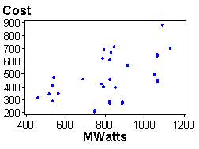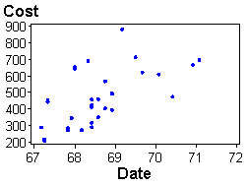

Figure 2) Residual plot

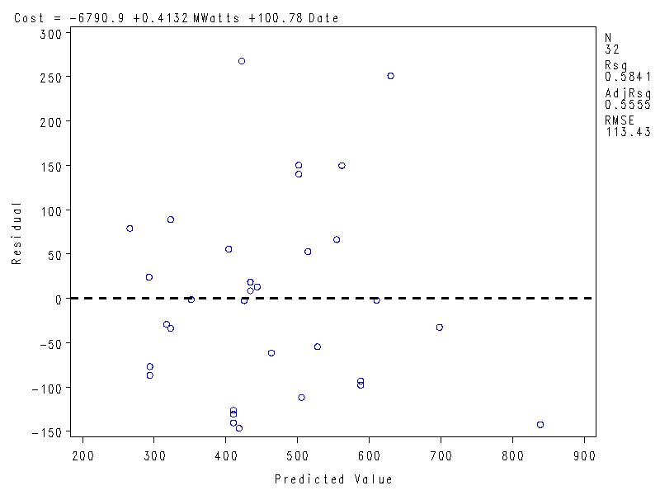

Table 1) Pearson Correlation Coefficient

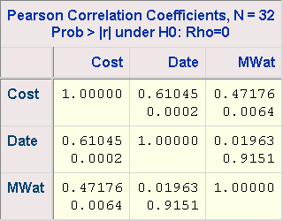

In order to determine whether net capacity and date have predictive analysis of the cost result, ANOVA is used to analyze the relationship between them.
Suppose the regression function
Y = β₀+β₁X₁+β₂X₂
Y is the cost in $100,000, adjusted to 1976 base.
X₁ is the net capacity in Megawatts.
X₂ is the date that construction permit was issued in years after 1900.

Hypothesis
$$\text{Ho}:B_{1}=B_{2}=0$$
$\text{Ha}:B_{j}≠0$ where j=1 or 2

Table 2) ANOVA: F Test

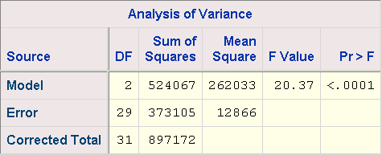

The distribution is F(2,29), which is 3.335, and the probability of observing a value greater than or equal to 20.37 is less than 0.001. This indicates that not all of B₁ and B₂ are equal to zero. Thus, the combination of the two predictor variables can predict the response variable.

ANOVA is displayed in Table 3 below, and the regression function is
Y = -6790.88 + 100.78 Date + .4132 MWatts

We can utilize ANOVA to estimate whether each variable can predict the response variable.

Table 3) ANOVA: T Test

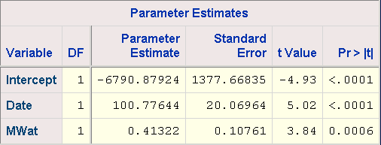

 Question #1: Should we drop predictive variable, MWatts?

Ho : β₁ = 0
Ha : β₁ ≠ 0

The distribution is t _{(0.025,30)} , which is 2.042272, and the probability of observing a value greater than or equal to 3.84 is less than 0.001. The result rejects Ho. It shows that MWatts can be used in the regression model as Date is already in the model.

 Question #2: Should we drop predictive variable, Date?

Ho : β₂ = 0
Ha : β₂ ≠ 0

The distribution is t _{(0.025,30)} , which is 2.042272, and the probability of observing a value greater than or equal to 5.02 is less than 0.001. The result rejects Ho. It shows that Date can be also used in the regression model as MWatts is already in the model.

As a result, we keep the regression model from Table, and R-Square and Adj R-Square of the regression model are shown below:
R-Square | 0.5841
Adj-R-Sq | 0.5555

Transformation

Next, we can use transformation to improve the fit of the regression function.
In Table 4, the comparison of the transformations of B and C shows that the transformation does not improve the regression fit.

Table 4) R-Sq and Adj R Sq after Transformation

 | A | B | C
Variable | Date | Log(Date) | SQRT(Date)
Variable | MWatts | Log (MWatts) | Log (MWatts)
R Sq | 0.5841 | 0.5694 | 0.5686
Adj R Sq | 0.5555 | 0.5400 | 0.5388

Outlier

When the sample size is not large enough and outliers have high influence, then outliers may bias the results. Outliers can be detected by utilizing Residual, Student Residual, and other statistics. Observation row 10 is a possible outlier candidate, due to both highest residual and student residual. If row 10 is omitted from Table 5, the R-Square is significantly increases from 0.5841 to 0.6455.

Table 5) Outlier Test

After these statistic methods, the final regression function Y= -6954 + 102.9 Date + 0.4213 MWatts is shown in Table 6.

Table 6) Final Parameter Estimates

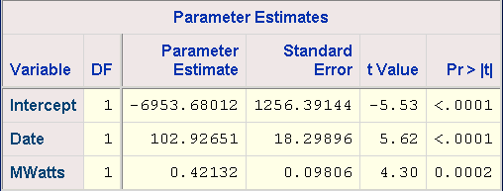

Conclusion

The various nuclear plants construction costs are examined to see if net capacity and permit issued date are able to predict future construction costs. Various statistic analyses were performed to test the significance of variables to explain the data. Both predictive variables add significant predictive power to the regression model and the final fitted regression model is Y= -6954 + 102.9 Date + 0.4213 MWatts.

Appendix

