REGRESSION ANALYSIS PROJECT
SUMMER 2009

INTRODUCTION

Competitive swimming is an aquatic sport that relies on endurance and speed in order to achieve maximum performance. Many factors affect the performance of athletic swimmers, particularly in the least amount of time to finish the race.

This project uses statistics of various local colleges and universities, which monitors the training of its swimmers to determine who will qualify for the inter-collegiate swimming competition. The size of this project is comprised of 50 athletic college swimmers who are training to qualify for the 100 meter butterfly event. Four factors were measured that have a significant influence in the training and improvement of the swimmer’s performance. These factors are nutrition, time spent in the swimming pool for practice or drills, time spent for strength training, and water temperature of the swimming pool.

The objective of this project is to determine, using regression analysis, which of these factors represent the best predictors in determining the amount of time to finish the 100 meter butterfly event. This study will use the Excel Regression Add-In function to determine the best predictors among the four variables.

VARIABLES USED

There will be 4 independent variables and 1 intercept term that will be used in the analysis for this project. These variables are defined as follows:
Y = time to finish the 100 meter butterfly event (measured in minutes)
X1 = nutritional energy consumed per day (measured in kiloJoules)
X2 = number of hours per day spent in the swimming pool for practice /drills
X3 = number of hours per day spent for strength training
X4 = water temperature of the swimming pool (measured in degrees Celsius)
This study will also include an analysis of the R-squared, p-value, t-statistic, and residual variation in order to determine which among the 4 variables will best represent the model.

RESULTS OF THE REGRESSION
A. Four-Variable Model
Fitted Equation : Y = 2.008 – 0.005X₁ – 0.009X₂ + 0.012X₃ +0.006X₄
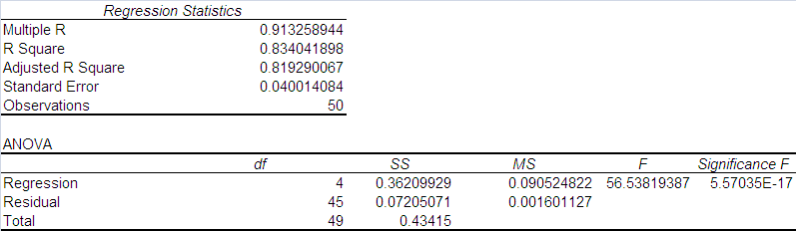
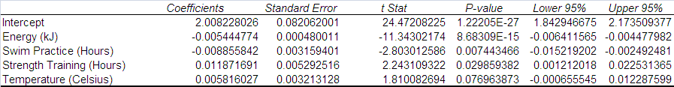
In this 4-variable model, the following variables exhibit significance in predicting the time to finish the 100 meter butterfly : nutritional energy, hours of swimming practice, and hours of strength training. This is reflected by their low p-values, as well as high t-statistic values that exceed the 95% confidence level.

This model also have R-squared and adjusted R-squared values of 0.834041898 and 0.819290067, respectively, which indicates that the independent variables are good predictors. This also indicates that there is minimal residual or error variation (ESS) among the variables, around 17% of total variation.

Water temperature also has a low p-value, but is around 3 times greater than the p-value of strength training. This variable may not be a good predictor and will be removed from the succeeding models.

B. Three-Variable Model

Fitted Equation : Y = 2.141 – 0.005X₁ – 0.010X₂ + 0.012X₃
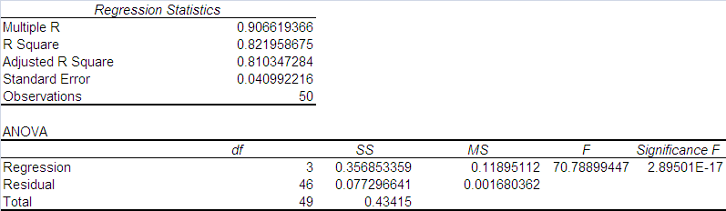

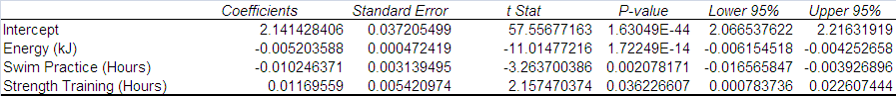

In this 3-variable model, both nutritional energy and hours of swimming practice reflect more predictability due to their low p-values. Their t-statistic values are also well above the 95% confidence level.

The R-squared and adjusted R-squared values of 0.821958675 and 0.810347284, respectively, indicates that the independent variables are good predictors, although they slightly decreased from the previous model by 1.44% and 1.09%, respectively. The residual variation is also minimal and almost the same as the previous model (around 17% of total variation).

The variable of strength training hours also has a low p-value and significant t-statistic, though its p-value is around 17 times more than the p-value of swimming practice hours. This variable may not be a suitable predictor and will also be removed from succeeding models.

C. Two-Variable Model

Fitted Equation : Y = 2.192 – 0.005X₁ – 0.011X₂
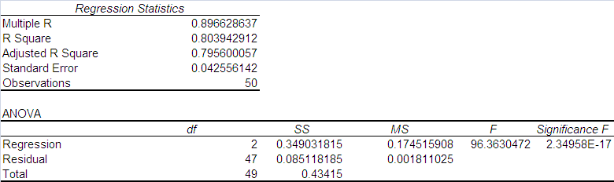

With 2 variables, both nutritional energy and hours of swimming practice remain to be good indicators due to their consistently low p-values, and t-statistics above the 95% confidence level. This is also reflected in their high R-squared and adjusted R-squared values, which decreased though from the 4-variable model by 3.61% and 2.89%. The residual variation is also minimal and around 20% of the total variation.

Although the p-value of swimming practice hours is low enough to be a significant predictor, a one-variable model will be derived to determine the effect on residual variation.

D. One-Variable Model

Fitted Equation : Y = 2.170 – 0.006X₁
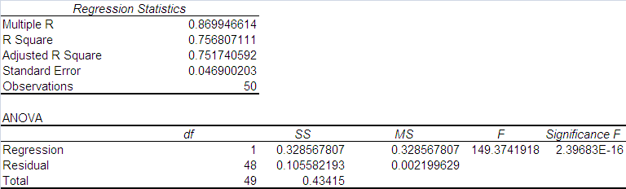

Using only one-variable (nutritional energy) reflects an almost equal value for both R-squared and adjusted R-squared. This model also increases the residual variation to around 25% of the total variation. Although a 25% residual ratio is still considered reasonable, the 2-variable model is more significant with only a 20% residual ratio. The decrease in R-squared is at its highest between the 2-variable and one-variable model, at 5% points, while previous movements of one variable resulted in decreases in R-squared of around 1% point only. Compared to this model, the 2-variable model presents a better fit for the variables.

CONCLUSION

The best model that predicts the amount of time to finish the 100 meter butterfly event is the 2-Variable Model, particularly : Y = 2.192 – 0.005X₁ – 0.011X₂

where Y = time to finish the 100 meter butterfly event (measured in minutes)
X1 = nutritional energy consumed per day (measured in kiloJoules)
X2 = number of hours per day spent in the swimming pool for practice /drills

In conclusion, this project has been made to give important emphasis on good nutrition and practice as a part of an athletic swimmer’s daily routine. Having a good nutrition can give the swimmer the needed energy and strength to speedily navigate through the water. Practicing for swimming competitions is also an important factor in developing and improving technique, as the saying goes, “practice makes perfect”. The combination of these 2 factors can help the swimmer achieve his maximum performance, and even help him win the race.

Strength training includes stretching exercises, gym and weights training, and cardiovascular exercises.

