Predicting Marathon Running Times

Introduction

Regression analysis will be used to determine what runner characteristics and traits best predict marathon race time. The analysis will use data collected from male and female runners of varying types and abilities. A regression model will be constructed to predict each male and female race times using the male and female data respectively. Adjusted R-squared and P-value will be used to construct the most powerful regression model for each. The regression will be conducted at a 95% confidence level.

The independent variables are age, body mass index (BMI), miles, personal performance, experience, and injuries. Miles refers to the number of miles ran during the peak week of training, personal performance is a percentage based on how well the runner feels that they were able to perform during the marathon with 100% indicating a belief of the best performance possible, experience refers to the number of years of running experience, and injuries refers to the number of running related injuries within the last 3 years. The dependent variable is race time in hours.

The initial model will incorporate seven explanatory variables, to include the six independent variables and one constant term. Using adjusted R-squared and P-value, the number of independent variables will be reduced in order to construct the most predictive model with the fewest explanatory variables possible.

The similarity of the regression models for males and females will also be analyzed by performing the F-test on the restricted and unrestricted equation. The unrestricted equation will use a dummy variable with 1 representing females and 0 representing males.

Variables

Y = Race Time
X₁ = Age
X₂ = BMI
X₃ = Miles
X₄ = Personal Performance
X₅ = Experience
X₆ = Injuries

Null Hypotheses

This project will construct the most predictive regression model for each males and females and will also test to see if these two models are the same. The first null hypothesis is that a runner’s BMI and training miles will not predict a runner’s marathon race time. The second null hypothesis is that the male and female regression equations are the same.

Six Variable Equations

Males: Y = 0.0013 X₁ + 0.2561 X₂ - 0.0225 X₃ + 0.0447 X₄ + 0.0006 X₅ + 0.0015 X₆ – 1.5405
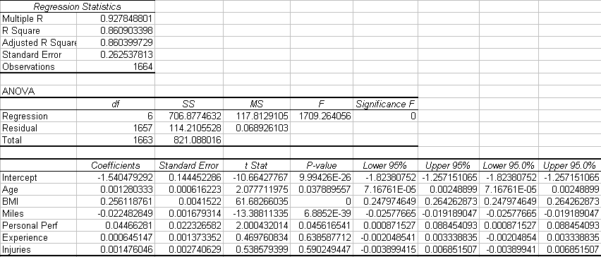

Females: Y = 0.0020 X₁ + 0.2451 X₂ - 0.0143 X₃ + 0.0467 X₄ - 0.0033 X₅ + 0.0036 X₆ – 1.4159
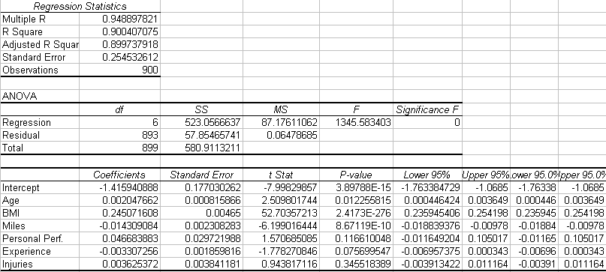

BMI and miles run during training seem to have the largest predictive value in marathon race times for both men and women. The high predictive value of these two runner traits is immediately apparent when observing the very low P-values for each in both models. In fact, the P-value for BMI in the male model is zero, which indicates that one can be 100% confident that the coefficient for this trait is NOT zero.

It is very interesting to note in the female model that a decrease of one in BMI corresponds to a quarter hour decrease in race time. This is a very significant time difference for a marathon. At the same time an increase of five miles per week in peak training only leads to about a four minute decrease in race time, which is not quite as significant for such a large increase in miles. A similar result is seen in the male model, which shows a slightly larger change in race time for each.
The R-squared in the male regression model is .8609 and the adjusted R-squared is .8604, which indicates that the model is a very strong predictor of marathon race times for men. The R-squared for the female regression model is .9004 and the adjusted R-squared is .8997, which again indicates that the model is indeed a very strong predictor of marathon race times for women. However, we will attempt to improve the model and make it simpler.

Experience and injuries seem to be the least predictive traits in the male model and, in fact, with P-values of .64 and .59 respectively, we cannot be 95% confident that the coefficients for these variables are not zero. The same is seen in the female regression model, except that personal performance appears to be slightly less predictive that experience in this model. However, in order to be consistent, experience and injuries will be eliminated from future models for both men and women. This is not an issue since the P-value for experience in the female regression model is .0757, which does not allow one to be 95% confident that the coefficient for this trait is not zero.

Four Variable Equations

Males: Y = 0.0013 X₁ + 0.2559 X₂ - 0.0225 X₃ + 0.0451 X₄ – 1.5287
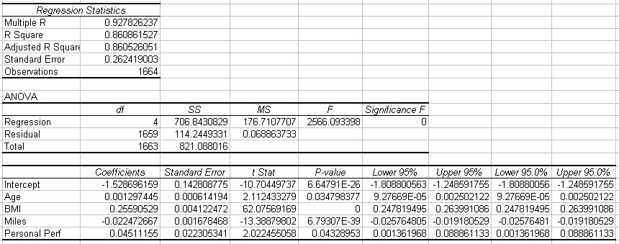

Females: Y = 0.0020 X₁ + 0.2457 X₂ - 0.0142 X₃ + 0.0465 X₄ – 1.4540
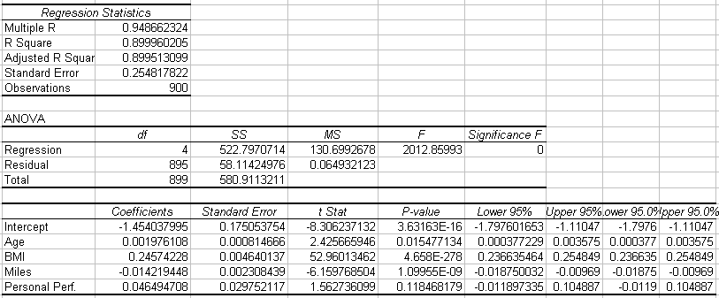

Again, BMI and Miles appear to be the most predictive traits in both models. However, we must compare these models to the previous six variable models in order to ensure that the model has indeed improved. The R-square value will always decrease when explanatory variables are removed from the regression model. The adjusted R-square takes into account the preference of models with fewer explanatory variables. In the male regression model, the adjusted R-square increased slightly which indicates that the new model has more explanatory power. In the female regression model, the adjusted R-square decreased slightly, which should indicate that the previous model is preferred; however, the new model is still favored in order to try to reach 95% significance for all explanatory variables.

Since, the P-value for personal performance in the female regression model continues to be too high in order to be 95% confident that the coefficient for this trait is not zero; we will eliminate this explanatory variable from future models. Additionally, although the P-value for age is low for both models, it seems intuitive that this variable may not predict race times well for individuals outside of the data sample. There are many young runners who are much slower than more mature runners and they would most likely not be included in the data set used for this analysis. It seems more intuitive that training and fitness level are much better predictors of how fast one can run a marathon. Therefore, to further simplify the model, age will be removed from all subsequent models.

Two Variable Equations

Males: Y = 0.2564 X₂ - 0.0228 X₃ – 1.4604
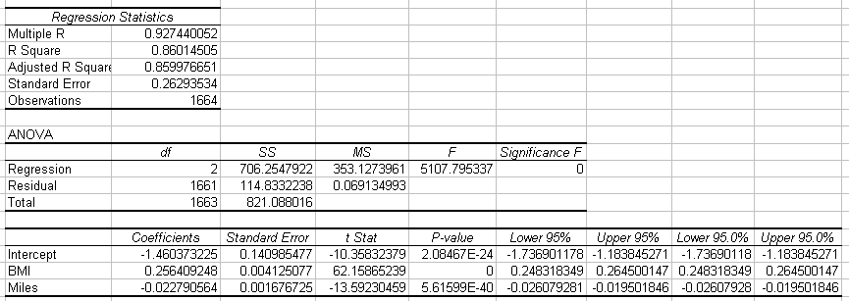

Females: Y = 0.2466 X₂ - 0.0146 X₃ – 1.3674
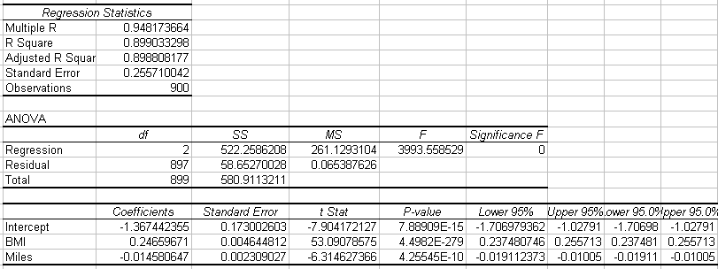

The adjusted R-square in both models has decreased slightly from the previous model; however, all of the P-values are significantly low, indicating that all of the variables are significant to the desired level of 95%. Based on the analysis from the six variable equations to the two variable equations, the two variable equations are the optimal regression models. Although these models do not have the highest adjusted R-square, they do have benefits more significant than the decrease of less than .1% in adjusted R-square.

It is also worth mentioning possible multicollinearity in the model. Although, there is a large correlation between BMI and the number of training miles, it does not seem prudent to remove either of these explanatory variables from the model. This is due to the fact that it would not seem logical to strictly predict marathon race time on either BMI or the number of training miles alone. One cannot say that an individual will have a fast race time because of a low BMI alone, there has to be some explanation of the amount of training including in the prediction. Additionally, one cannot say that training alone can predict marathon race time, there has to be a component of body type or fitness. One could potentially reach 50 miles per week of running during training; however, never reach a pace above a 12 minute mile. In this case, a model based on training alone would incorrectly predict marathon race time.

Based on the analysis, we can reject the null hypothesis that a runner’s BMI and training miles do not predict marathon race time. Therefore, BMI and training miles do predict marathon race times for both men and women. It was demonstrated from the analysis and the optimal regression models that BMI and training miles do indeed predict very closely both female and male runners’ marathon race times.

F-Test

The F-test will now be used to determine if the regression equations do indeed differ for men and women runners. The null hypothesis, as stated above, is that they are the same. The restricted and unrestricted equations to be used are as follows:

Restricted Equation:
Forecast = α₁ + α₂ * BMI + α₃ * Miles + ε

Unrestricted Equation:
Forecast = α₁ + α₂* BMI + α₃ * Miles + (β₁ - α₁) * D + (β₂ – α₂) * D * BMI + (β₃ – α₃) * D * Miles + ε

The D listed in the unrestricted equation is the dummy variable. The dummy variable is used to differentiate between males and females in the data, with a 1 referring to females and a 0 referring to males. It follows that for the restricted equation the coefficients are restricted as follows:

(β₁ – α₁) = 0
(β₂ – α₂) = 0
(β₃ – α₃) = 0

It is evident that there are three restrictions among this equation as compared to the unrestricted equation.

In order to perform an F-test on the null hypothesis, the F-statistic must be created. The F-statistic is defined as follows:

(ESS_{R} – ESS_{UR}) / q
------------------------
ESS_{UR} / (N – k)

In the above equation, ESS refers to the error sum of squares obtained from the regression where the subscript R and UR denote the restricted and unrestricted regression respectively, q refers to the number of restrictions and represents the degrees of freedom in the numerator, N refers to the number of observations, k refers to the number of independent variables with N-k providing the number of degrees of freedom in the denominator.

The restricted error sum of squares is obtained by regressing the restricted equation in excel. The following result is obtained.

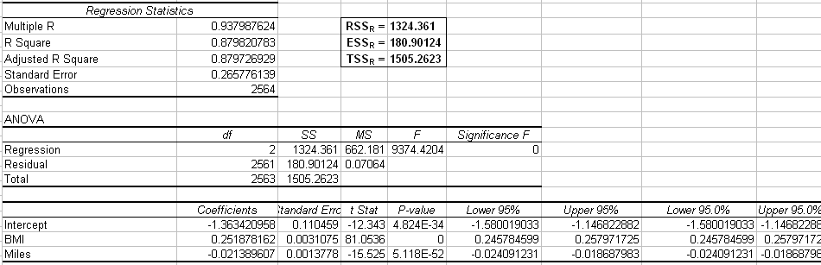

From the results, it is seen that ESS_{R} is equal to 180.90.

The unrestricted error sum of squares is obtained by regressing the unrestricted equation in excel. The following result is obtained.

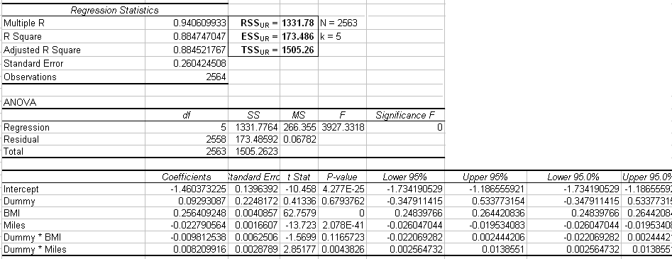

From the results, it is seen that ESS_{UR} is equal to 173.49.

From the discussion above on the restricted equation, the number of restrictions is 3. Therefore, q = 3. The number of observations, N, is 2563 and the number of independent variables, k, is 5. Therefore, N-k = 2558. Thus, there are 3 degrees of freedom in the numerator and 2558 degrees of freedom in the denominator. With this information, the test statistic can be calculated using the above equation.

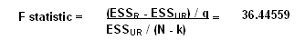
To obtain the P-value of the F-statistic, the FDIST function in excel is used. The equation is FDIST (F-statistic, q, N-k), which equals FDIST (36.44559, 3, 2558). The P-value from this equation is found to be 0, which indicates that the test statistic is significant.

To obtain the critical value used to determine if the null hypothesis should be rejected, the FINV function in excel is used. The equation is FINV (desired significance level, q, N-k), which at the 10% significance level equals FINV (.1, 3, 2558). The critical value from this equation is found to be 2.09. In order to reject the null hypothesis, the F-statistic must be greater than the critical value, which in this case the test statistic (36.44559) is significantly greater than the critical value (2.09). Therefore, the null hypothesis is rejected and it is presumed that at least one of the restrictions is incorrect. That is, at least one of BMI, training miles, or the constant term has a different effect on race times for men versus women.

Conclusion

The optimal regression models to predict marathon running times for men and women respectively are:

Men’s Race Time = 0.2564 * BMI - 0.0228 * Miles – 1.4604
Women’s Race Time = 0.2466 *BMI - 0.0146 * Miles – 1.3674

The men’s model shows that a decrease of 1 in BMI decreases running time by more than 15 minutes, while the women’s model shows that a similar decrease in BMI decreases running time by just less than 15 minutes. In either case, this shows that reducing BMI can greatly increase a runner’s chances of qualifying for prestigious marathons such as the Boston Marathon. Both regression models also indicate that the more running done in training the faster the marathon race time will be which is what was expected.

