NEAS Regression Analysis Course
Student Project
Unemployment and the Exam

Registered for the Winter 2010 Course

In the spring of 2002 I graduated culinary school and was eagerly awaiting the glorious opportunities which lay in my future. Over the next two years I carried 4 different full-time jobs in addition to any odd jobs I could find. Struggled to establish a career in luxury foods during the dot com recession in San Francisco was not what I had in mind on that day of graduation. The area was going through a period of high unemployment and those lucky enough to keep their jobs were often doing so at a reduced salary, leaving little money in the area to fuel the economy of fine cheese and foie gras.

After exploring my limited options following the collapse of my latest job prospects, I realized that a career move might be in my best interest. I did some research and stumbled across the seemingly recession-proof profession of Actuary. I thought I could handle the math, and started to study for exam P.

How many others have had the same experience and been drawn to the actuarial profession as I was? There are not many professional occupations with a similar track record of stability, and an exam structure which gives an obvious starting point into the field. As a regression project, I will look at this question and determine whether the unemployment rate can be interpreted as an explanatory variable on the number of people attempting to enter the profession, as measured by the number of people taking the first actuarial exam. In the course of doing so, other variables relevant to the explanation will also be examined.

Data Definitions and Sources:
Takers: The number of people taking the first actuarial exam (exam P, exam 100, etc) at any one sitting. This data is obtained through the SOA and CAS websites and is available dating back to May 1996.

lnTakers: The natural log of the Takers data series.

Frequency: The number of first actuarial exams offered over prior twelve months. Because the exam schedules have changed periodically, this statistic is necessary to examine that influence.

PassRate: The percentage of Takers to pass an exam. It is possible that a lower PassRate in a sitting may lead to more repeat takers the next sitting. To study this possibility PassRate will be offset one period for the analysis. The PassRate for the first data point will be matched to the second data point when performing the regression, the PassRate for the second data point matched to the third data point, and so on.

TimeIndex: The year of the sitting, measured as the calendar years since 1996 (1997=1, 1998=2, etc)

Three unemployment rate will be examined in this project. All three are obtained through the Bureal of Labor Statistics website, www.bls.gov.

Unemp20: The unemployment rate for all persons 20 years of age and older. This can be considered the general rate. It includes younger persons who may be less likely to be looking professional and long term employment.

Unemp25: The unemployment rate for all persons 25 years of age and older. This rate is a bit more specific, targeting a slightly older population which may be more likely to look for professional employment.

UnempCollege: The unemployment rate for college graduates 25 years of age and older. This rate is the most targeted towards people who may be qualified to be an actuary if they can pass the tests.

All unemployment rates are seasonally adjusted and are measured quarterly.
All data is normalized prior to any analysis to obtain standardized coefficients.
Usable data starts in 1997 (data points from 1996 could not be used as Frequency could not be derived from available data) and consists of 41 data points. This is not considered a large data set and the size of the data set will be considered in the analysis.

Initial Regressions
To get an initial idea of whether the unemployment rate can be used as a stand-alone variable, single variable regressions are performed using Taken as the dependent variable, and using each unemployment rate as the explanatory variable.

The resulting R-Squared measures are:
Explanatory Variable | R Squared
CollegeRate | 0.000
25Rate | 0.008
20Rate | 0.008

Unemployment rates used in isolation of the other potential explanatory variables do not yield significant regressions. It may be best to analyze a regression using the other explanatory variables, and then determine whether unemployment can provide any additional information.

Initial Regression with Other Variables
A multi-variate regression using Taken as the dependent variable, and Frequency, PassRate and TimeIndex as explanatory variables yields the following results

Taken regressed against Frequency, PassRate and TimeIndex

The Beta coefficients of all three explanatory variables are significant at the 95% confidence level, the Adjusted R-Square statistic is 56%, showing that the regression does show some potential explanatory value.

The coefficient of PassRate is the opposite sign of which our potential explanation of a lower pass rate leading to more repeat takers the next sitting would have suggested (as the inverse relationship would suggest a negative coefficient). Further analysis suggests high co-linearity among any pair of these three variables, as seen in the following correlation matrix.

Correlations | Frequency | TimeIndex | PassRate
Frequency | 100% | 72% | 41%
TimeIndex | 72% | 100% | 66%
PassRate | 41% | 66% | 100%

The high co-linearity of PassRate with other explanatory variables, along with the inverse coefficient from which our explanation suggests, gives reason to exclude this variable from the continued analysis and perform a regression using TimeIndex and Frequency.

As seen in the output below, a regression of Taken using Frequency and TimeIndex as explanatory variables yields an Adjusted R-Square of .517. Both Beta coefficients are significant at the 99% confidence level.

Taken regressed against Frequency and TimeIndex

Single Variate Regression
Because of the high correlation between Frequency and TimeIndex, single variate regressions should be looked at.

Regressing Taken against Frequency yields a significant coefficient with 95% confidence, and an R-Squared statistic of 0.197

Taken regressed against Frequency

Regressing Taken against TimeIndex yields a not significant coefficient with 95% confidence, very high P-Value of the coefficient, and an R-Squared statistic of only .007.

Taken regressed against TimeIndex

The multi-variate regression yields a substantially higher Adjusted R-Squared than either single variable regression, and has Beta coefficients significant with 99% confidence. Although it is acknowledged that there is a high degree of co-linearity between Frequency and TimeIndex, the strength of the regression leads to a judgement call of using both variables for the continued analysis.

Multi-Variate with Unemployment
The original stated investigation of this regression was to determine whether the unemployment rate adds explanatory value in addition to other explanatory variables which may contribute. Based on the analysis so far, the other explanatory variables which will be used in the regression are Frequency and TimeIndex. Regressions using Frequency and TimeIndex with each unemployment rate as a third explanatory variable are performed.

Resulting Adjusted R-Squared and P-Values of the coefficients are as follows:
Variable Added | Adjusted R-Squared | Beta Coefficient | P-Value of Beta Coefficient
UnempCollege | .629 | .512 | .0011
Unemp25 | .617 | .534 | .0021
Unemp20 | .615 | .530 | .0023

The additional variable adds value to the original two explanatory variable regression in all three cases. All three have higher Adjusted R-Squared statistics compared to the two variable regression Adjusted R-Squared of .517. All three regressions show the Beta coefficient of the unemployment variable to be significant at the 99% confidence level. It is also worth noting that the Beta coefficients for Frequency and TimeIndex are significant at the 99% confidence level in all three regressions.

Because the results using all three unemployment rates show significance at the 99% confidence level, all three unemployment rates show a standardized Beta coefficient of roughly .5, and all three Adjusted R-Squared statistics are around .6, there is no reason to think that the targeted unemployment rates of UnempCollege and Unemp25 have more value in the regression than the general rate of Unemp20. Therefore, Unemp20 is chosen for further analysis.

Error analysis:
The errors of the linear regression of exam passers with Frequency, TimeIndex, and Unemp20 as explanatory variables show signs of non-normality, as shown by the Normal Probability Plot below.

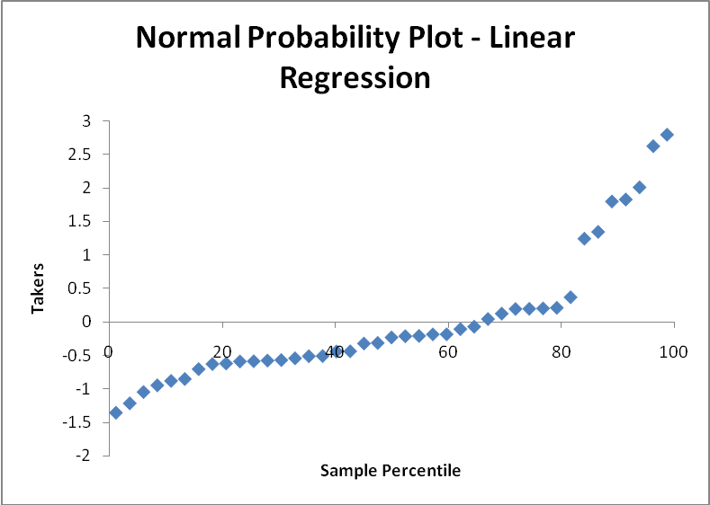

Single Variable Scatter Plots vs. Takers
An examination of the single variable scatter plots of each explanatory variable with exam takers suggests that the single variable relationships are not linear. A log-linear regression may be a better fit and this may yield an error distribution which resembles normal.

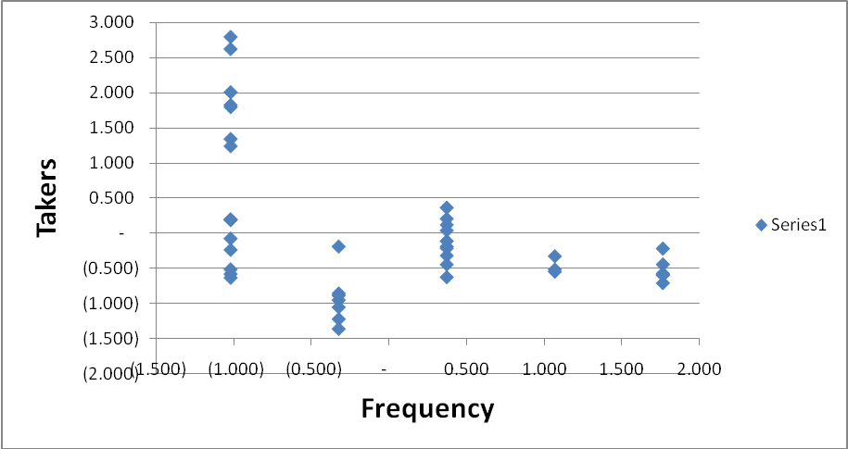
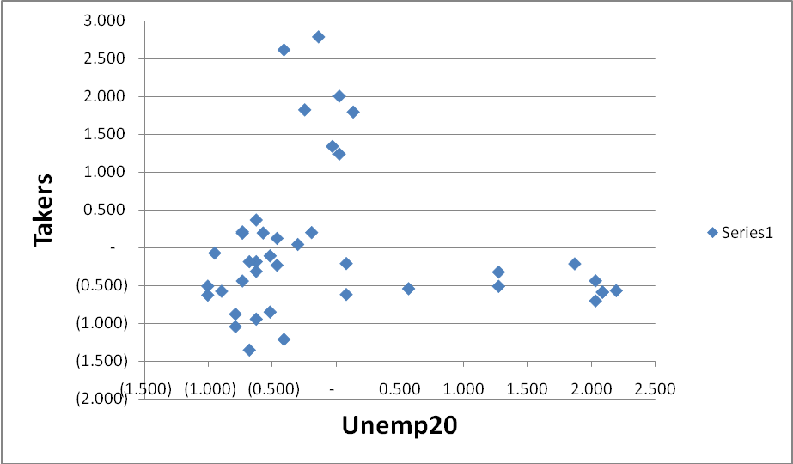

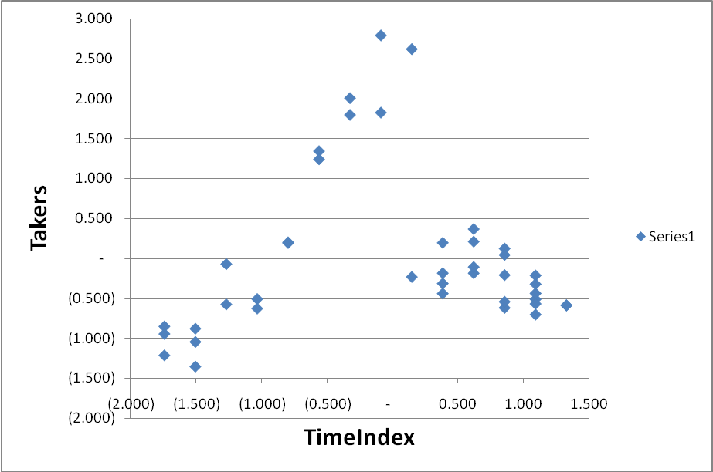

Log-Linear Regression
A multi-variate regression using Frequency, TimeIndex, and Unemp20 as explanatory variables and lnTakers (The natural log of Takers, normalized) as the dependent variable yields the following results:

lnTaken regressed against Frequency, TimeIndex, and Unemp20

The resulting standardized log-linear regression is the chosen regression pending error analysis and takes the form

Where
=Takers
=Frequency
=TimeIndex
=Unemp20

Compared to the linear regression, Adjusted R-Squared is slightly higher, residual standard error is lower, and all Beta coefficients are significant at a 99% confidence level. Pending the error analysis, the log-linear regression may be a better fit.

Error analysis:
The Normal Probability Plot of the LogLinear regression errors suggests that errors still may follow something other than a normal distribution, but they are closer to normal than errors of the linear regression. In addition, the data set for this regression is only 41 points. Considering the limited data set, the fact that the Normal Probability Plot is closer to Normal than with the linear regression, and the significance of the Beta coefficients, the pattern in the Normal Probability Plot does not exclude this regression from further analysis.

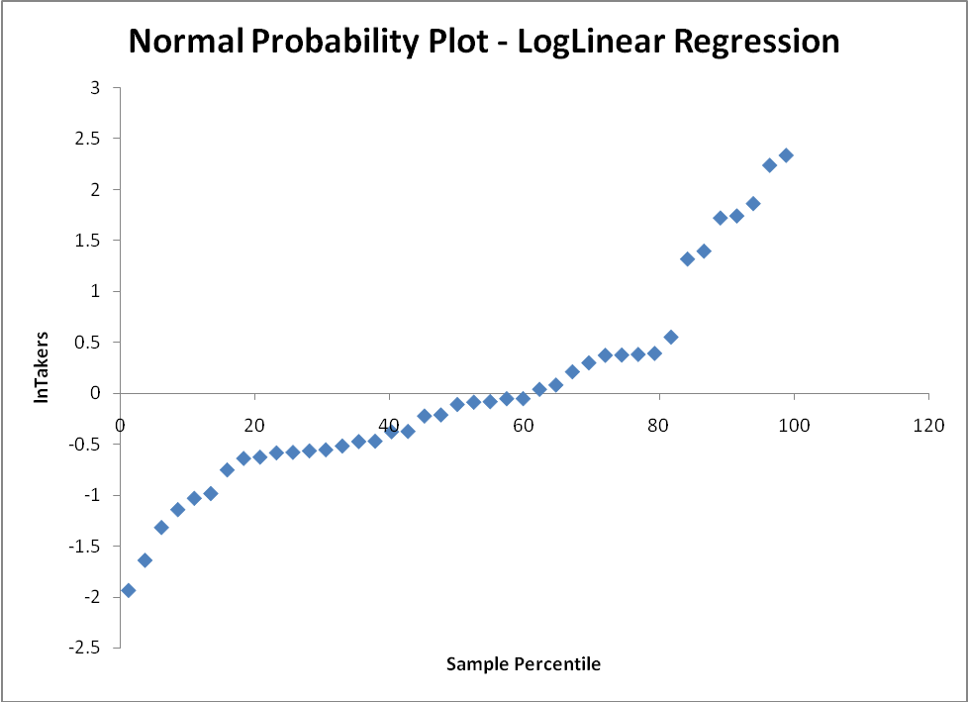

Log-Linear Regression excluding Unemployment:
For comparison to the three variable log-linear regression, a log-linear regression using only Frequency and TimeIndex as explanatory variables should be looked at. In the two variable log-linear regression, the Adjusted R-Squared is .599 and both Beta coefficients are significant with 99% confidence. However, the three variable log-linear regression shows a slightly higher Adjusted R-Squared of .671, and all three Beta coefficients show significance. This suggests that the third variable of Unemp20 adds value to the log-linear regression and should be included.
lnTaken regressed against Frequency and TimeIndex

Further Error Analysis
Multi-Collinearity: The three chosen explanatory variables do show multi-collinearity, as seen in the correlation matrix below. However, the multi-collinearity does not result in the t-test for Beta coefficients showing insignificance at low confidence intervals. In fact, all beta coefficients show significance with 99% certainty. The increase in Adjusted R^2 also suggests that explanatory value is being added in spite of the multi-collinearity.

 | Frequency | TimeIndex | Unemp20
Frequency | 100% | 72% | 79%
TimeIndex | 72% | 100% | 65%
Unemp20 | 79% | 65% | 100%

Residual Plots: Unemp20
Error Variance appears homoscedastic and does not show serial correlation. The residual plot shows a slightly smaller variance among the few points at high rates of unemployment. However there are not enough data points in this range to draw the conclusion of heteroscedasticity.
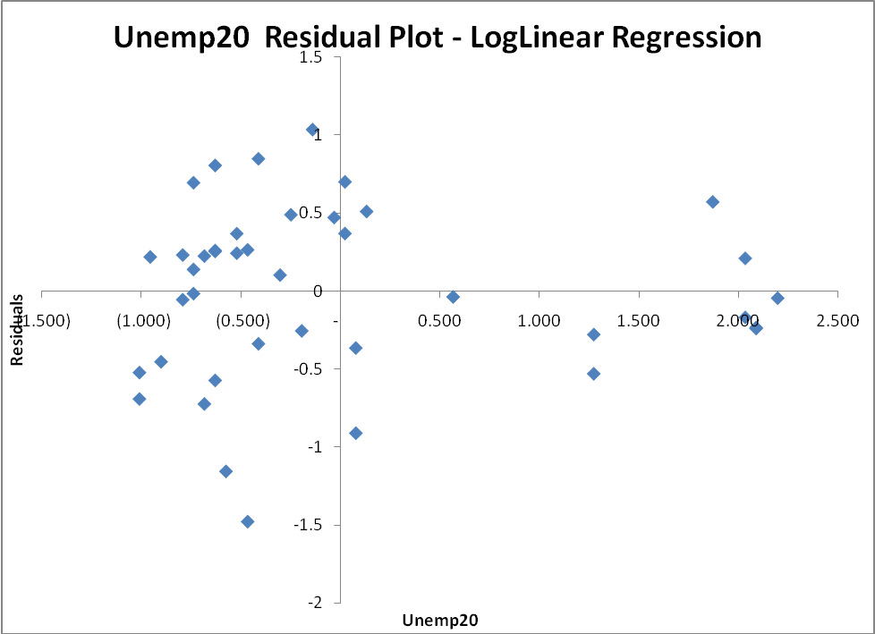

Residual Plots: TimeIndex
Error Variance does show the start of a cyclical pattern with respect to the Time Index. Because our data set is not robust and less than one full cyclical pattern is apparent, it is a judgment that the pattern displayed is not strong enough to disqualify the regression. The residual pattern also does not show serial correlation with respect to TimeIndex.
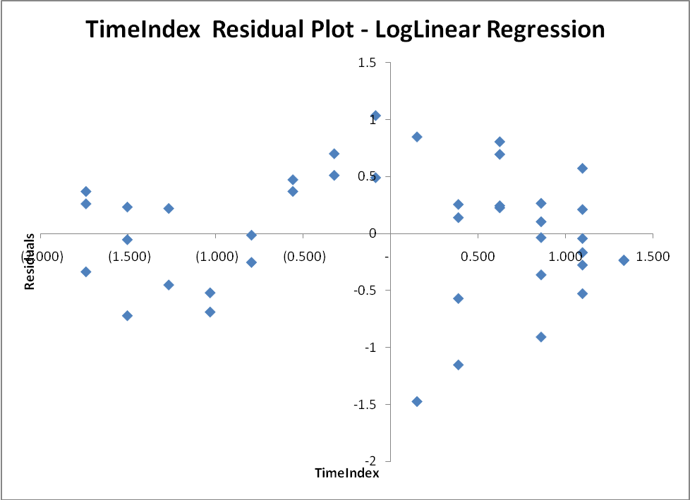

Residual Plot: Frequency
The frequency residual plot does show signs of heteroscedasticity, with a higher error variance at lower frequencies. It is possible that this heteroscedasticity is contributes to the pattern of non-normality seen in the Normal Probability Plot. Serial correlation is not evident.
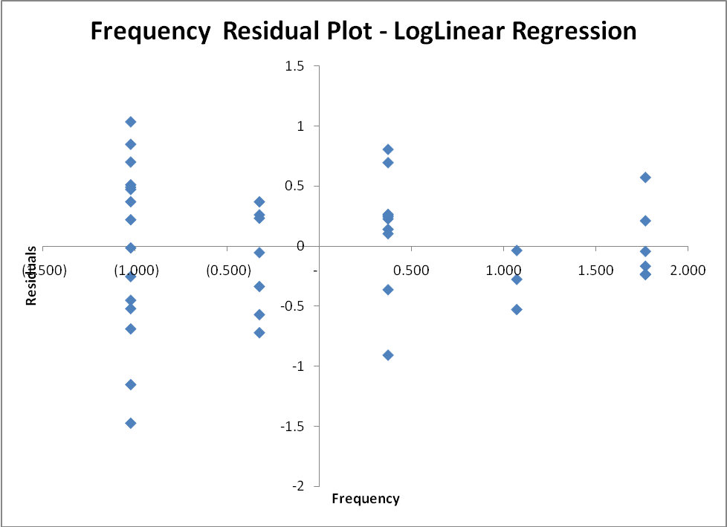

Further analysis: Durbin Watson Test
The Durbin Watson test of serial correlation shows a test statistic of 1.22. This is under the lower bound test statistic of 1.34 (for N=40). The Durbin Watson test rejects the Null Hypothesis that serial correlation is not positive, and shows a violation of the serial correlation regression assumption. It is possible that the significance of the Beta coefficients in the log-linear regression are influenced upwards by the positive serial correlation.

The X-Axis in the serial correlation graph below represents the sequence of tests. This graph and the residual plot against TimeIndex shown above have related information. The difference is that TimeIndex collapses all points within the same calendar year into one Value, where the serial correlation graphs shows a different Value along the X-axis for every data point.
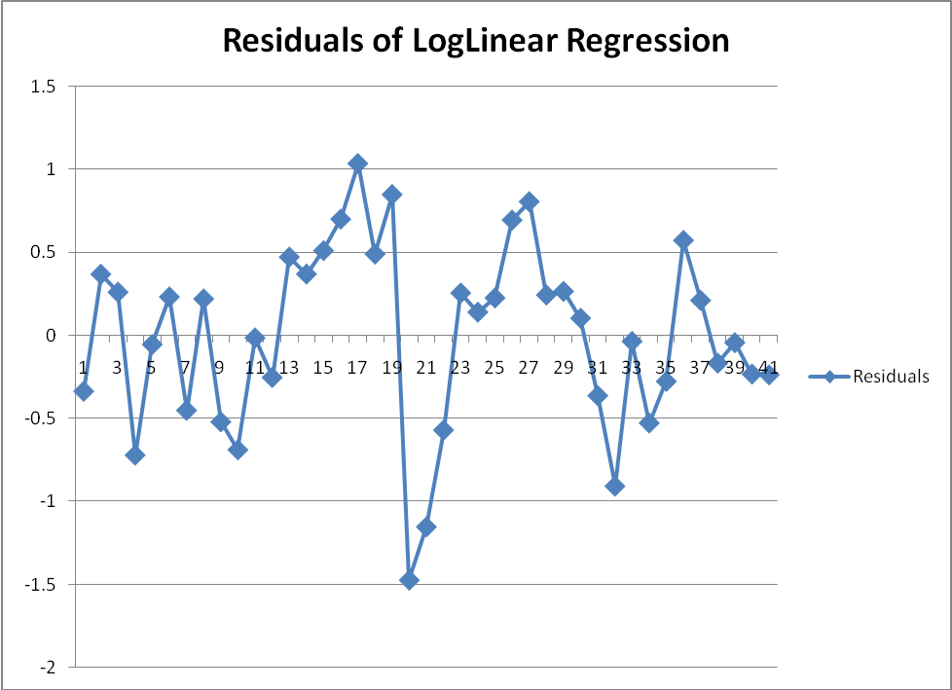

Conclusion
The chosen regression takes the form:

Where
=Takers
=Frequency
=TimeIndex
=Unemp20

The regression analysis shows that the general unemployment rate adds explanatory value to a log-linear regression in conjunction with the Frequency and TimeIndex data series. In addition, the log-linear regression is a better fit using these three explanatory variables than a linear regression.

Specifically addressing the unemployment variable, which was the point of interest of the project, there is a positive relationship between the unemployment rate and people taking the test. An increase in unemployment of one standard deviation has the effect of increasing the predicted value of ln(Takers) by .456 of a standard deviation.

The log-linear regression is standardized, so each coefficient can be thought of as the impact on the deviation of ln(Y_{i}) from a value of the explanatory variable that is one standard deviation away from its mean.

However, the error analysis shows violations which need to be taken into account. Although it is difficult to draw definite conclusions with only 41 data points, the error pattern shows signs of being non-normal. This suggests the possibility of another transformation besides the log-linear regression which may be a better fit. However, the non-normal pattern was not strong enough to reject the log-linear model.

The three explanatory variables used show strong multi-collinearity. However, the effect of this multi-collinearity should be a higher P-Value of the Beta coefficient. The P-Values in the log-linear regression were all very small. The effect of the multi-collinearity is not a strong concern.

Of greater concern is the pattern of positive serial correlation revealed by the Durbin-Watson test. This pattern tends to decrease the standard error of the Beta coefficients which leads to an overstatement of the confidence level associated with the significance of explanatory variables. It is not known by how much the P-Value is affected, so quantification of this effect is not possible.

In summary, the log-linear regression on the limited data available shows that the general unemployment rate has an effect on the number of people taking the first actuarial exam. Confidence in the quantification of this effect is reduced because of the violations of regression assumptions revealed in the error analysis. However, a qualitative assessment of the assumption violations in comparison with the high confidence levels in the beta parameters resulting from the t-tests leads to the judgment call that the unemployment rate does add explanatory value to a regression of the number of exam takers.

Throughout this paper, Beta coefficients will be stated as significant or insignificant as a given confidence level. Unless otherwise stated, this statement is the result of the t-test, as expressed through the P-Value field in Excel’s regression analysis output. Also note that this P-Value is the result of a two sided test. For significance testing, a one sided value is used. Therefore, a P-Value < 10% is interpreted as showing significance at a 95% confidence level, as 100%-10%/2=95%.
See corresponding Excel workbook for complete Excel regression analysis tables

