xxxx xxxxxxxxx
VEE Regression Analysis Spring 2010
Student Project

Introduction:

Many college students question whether attending classes and reading the textbooks is really necessary in order to do well in a class. This dataset obtained from <http://www.jeremymiles.co.uk/regressionbook/data/index.html> examines the relationship between reading the textbook and attending class and getting a good grade in the class. Regression analysis is used in order to test whether the number of books read by students on a statistics course is a good predictor of the final grade in the course, whether the number of lectures attended is a good predictor of the final grade in the course or whether it is the combination of both, books read and lectures attended that truly predicts the final grade. The combination of books read and lectures attended shall be tested first and then each independent variable shall be tested individually to find the best predictor.

Data:

The data contains 40 observations for the number of books read by students on a statistics course, number of lectures students attended and the final grade they received.

Variables:

Y = Final Grade in the course.
X1 = Number of books read by students on a statistics course
X2 = Number of lectures students attended

The Two-Variable Equation:
Y = 37.379 + 4.037X1+ 1.283X2

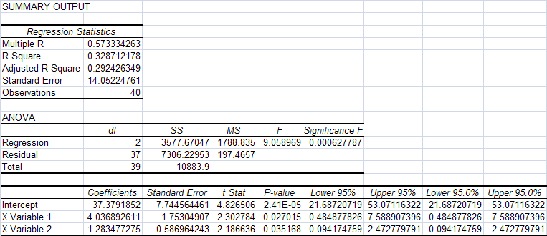

An R-square of 0.3287 and an adjusted R-square of 0.2924, indicate that the combination of the number of books read and lectures attended is a somewhat weak predictor of the final grade received. Apparently if no books are read and no lectures are attended, the student could still get a grade of 37 and not 0, since the intercept is 37.379.

The high standard error at 14.052 also shows that there is much variability in the data. A plot of the residuals supports this finding and reveals that there are many residuals significantly different from zero for both of the independent variables, X1 and X2. The residuals are represented on the y-axis and the independent variables are represented on the x-axis.
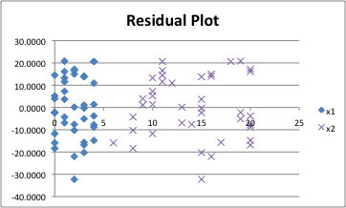

When testing for co-linearity, it turns out that there is actually a moderate degree of co-linearity of 0.4436 between books read and lectures attended. This means that the students who read the books are also more likely to attend the lectures, and the students who attend the lectures are also more likely to read the books. Thus the independent variables should definitely be examined independently as well. The graph below shows the correlation of lectures attended and books read.

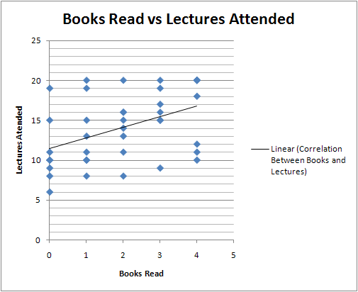

The Single Variable Equation for books:
Y = 52.075 + 5.738X1

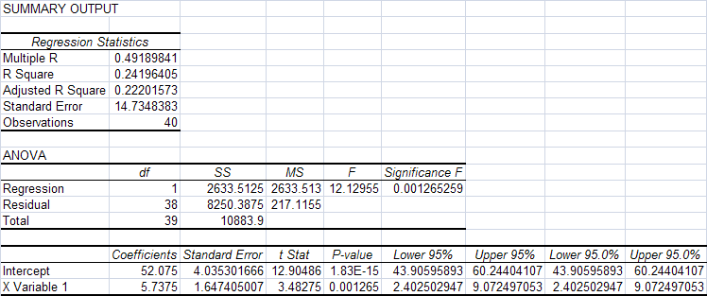

An R-square of 0.242 and an adjusted R-square of 0.222, indicate that the number of books read is an even weaker predictor of the final grade received than the combination of the books read and lectures attended. Since the R-square and the adjusted R-square are lower here than in the two-variable regression, this regression can be rejected. If no books are read, the student can still get a grade of 52, since the intercept is 52.075. The high standard error of 14.735 reveals that the single variable equation for books exhibits the same flaw of high variability as the two-variable equation.

The scatter plot below depicts the relationship between the books read and grade received.

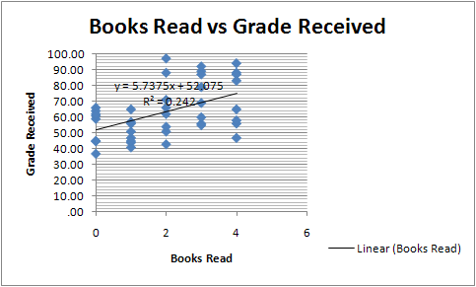

The Single Variable Equation for lectures:
Y = 36.998 + 1.883X2

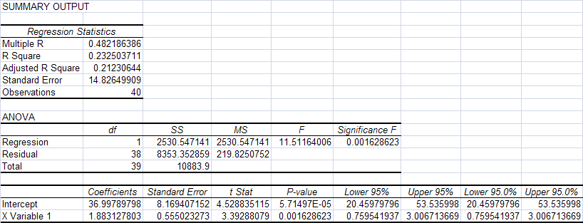

An R-square of 0.2325 and an adjusted R-square of 0.2123, indicate that the number of lectures attended is also a weaker predictor of the final grade received than the combination of the books read and lectures attended. Since the R-square and the adjusted R-square are lower than in the two-variable regression, this regression can be rejected as well. If no lectures are attended, the student can still get a grade of 37, since the intercept is 36.998. The high standard error of 14.826 reveals that the single variable equation for lectures exhibits the same flaw of high variability as the two-variable equation.

The scatter plot below depicts the relationship between the number of lectures attended and grade received.

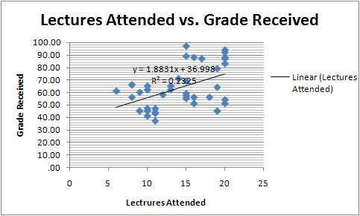

Conclusion:

Based on the tests conducted in this study, the two-variable equation:
Y = 37.379 + 4.037X1+ 1.283X2, which uses the combination of statistics books read and lectures attended seems to serve as the most accurate indicator for final grade received. However even though this equation is the most accurate of the three equations examined above, it still exhibits a relatively weak relationship because of its low R-square of 0.3287. Perhaps other independent variables such as time spent studying for the exams should be tested to add more validity to the results. Also, a larger sample may need to be tested to reduce the variability or the standard error in the data.

