xxxxxxx xxxxxxxx
Spring 2010
Regression Analysis Project

Introduction
The teen death rate in the United States is substantially higher than in many comparable nations. This is in part due to a range of risky behaviors that teens engage in. Car accidents, homicides and suicides among teens can often be linked to drugs or alcohol. This is a disturbing fact, and has become the foundation of my final project.
For my regression analysis project, I am hoping to determine whether there is evidence that the teen death rate for accident, homicide and suicide can be partially explained by specific risky behaviors (namely binge drinking and drug use). I will be looking at individual states within the U.S. to determine whether high drug and alcohol use among teens in certain states corresponds to high death rates.
Data
The data I used in this project was downloaded from the Kids Count Data Center: http://datacenter.kidscount.org. The data for the teen death rate was the number of teen deaths per 100,000 teens ages 15-19 in 2007 by state (statistics for Vermont, Puerto Rico and the Virgin Islands were not provided and so were excluded from this analysis). The data for risky behaviors were the percentage of teens that engaged in each behavior in 2006-2007 by state. I chose to look at 3 categories: binge alcohol drinking, marijuana use and non-marijuana illicit drug use. This data was broken into 2 age groups: 12-17 and 18-25, and so I combined the 2 using a 60%/40% split to get an average 15-19 age group, in order to be comparable to the teen death rate data.
Analysis
The independent variables in my analysis are the percentage of teens that engage in each of the following risky behaviors: binge alcohol drinking, marijuana use and non-marijuana illicit drug use. The dependent variable is the rate of deaths per 100,000 teens. In this project, I will consider five different predictive models to determine which produces the best fit. This determination will be based on the adjusted R² value, the p-value and the t-statistic.
Y= teen death rate per 100,000 by state
X₁ = percentage of teens who engage in binge alcohol drinking
X₂ = percentage of teens who use marijuana
X₃ = percentage of teens who use illicit (non-marijuana) drugs

Scenario 1

For the first scenario, I will consider only binge alcohol drinking as an explanatory variable. Using regression analysis, I fit the following trend line and calculated the following statistics:

Y = -140.1706 * X₁ + 85.2252

Regression Statistics
Multiple R | 0.32012
R Square | 0.10247
Adjusted R Square | 0.08416
Standard Error | 14.08293
Observations | 51

 | Coefficients | Standard Error | t Stat | P-value
Intercept | 85.2252 | 14.0781 | 6.0538 | 0.0000
Binge Drinking Rate | (140.1706) | 59.2617 | (2.3653) | 0.0220

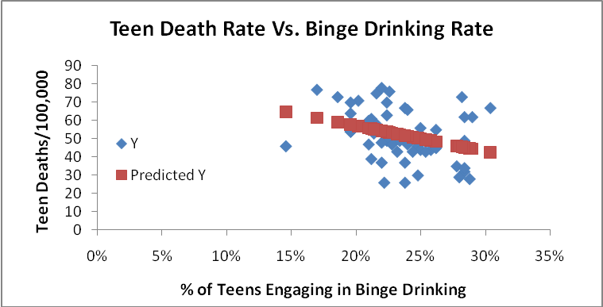

The first thing I noticed is that there appears to be a negative relationship between binge drinking and teen deaths, which does not support my original hypothesis. The adjusted R squared indicates that binge drinking explains only about 8.4% of the teen death rate. The p-value indicates that there would be a 2.2% chance of seeing this same statistic if the X₁ coefficient were actually 0 (no relationship between drinking and teen deaths). We would thus reject this null hypothesis at the 95% level, but not at the 99% level. The t-statistic of -2.365 for Binge Drinking meets the requirement of a two-tailed test at the 95% significance level.

Scenario 2

For the second scenario, I will consider only marijuana use as an explanatory variable. Using regression analysis, I fit the following trend line and calculated the following statistics:

Y= -240.5966 * X₂ + 78.3903

Regression Statistics
Multiple R | 0.3909
R Square | 0.1528
Adjusted R Square | 0.1355
Standard Error | 13.6821
Observations | 51

 | Coefficients | Standard Error | t Stat | P-value
Intercept | 78.3903 | 8.9966 | 8.7133 | 0.0000
Marijuana Use Rate | (240.5966) | 80.9212 | (2.9732) | 0.0046

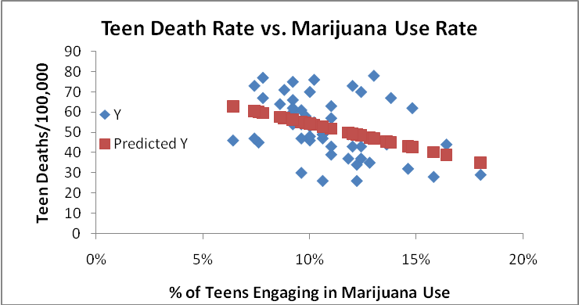

Again, we see that there appears to be a negative relationship between marijuana use and teen deaths, which does not support my original hypothesis. The relationship appears even more negative as compared to the binge drinking rate. The adjusted R squared indicates that marijuana use explains only about 13.6% of the teen death rate. The p-value indicates that there would be a 0.4% chance of seeing this same statistic if the X₂ coefficient were actually 0 (no relationship between marijuana use and teen deaths). We would thus reject this null hypothesis at both the 95% and 99% levels. The t-statistic of -2.973 for Marijuana Use meets the requirement of a two-tailed test at the 95% significance level. There seems to be a stronger correlation here, but in the opposite direction that what we would expect.

Scenario 3

For the third scenario, I will consider only illicit (non-marijuana) drug use as an explanatory variable. Using regression analysis, I fit the following trend line and calculated the following statistics:

Y = 281.704 * X₃ + 34.4025

Regression Statistics
Multiple R | 0.1819
R Square | 0.0331
Adjusted R Square | 0.0134
Standard Error | 14.6171
Observations | 51

 | Coefficients | Standard Error | t Stat | P-value
Intercept | 34.4025 | 13.9356 | 2.4687 | 0.0171
Illicit Drug Use Rate | 281.7048 | 217.5143 | 1.2951 | 0.2014

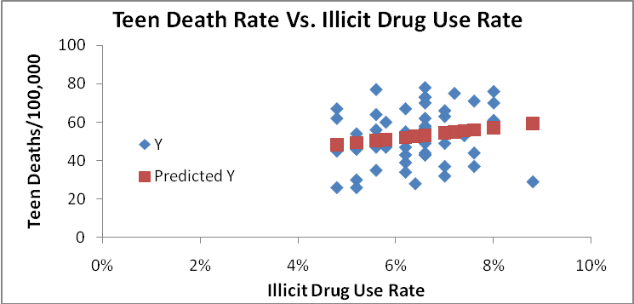
Here, we see there is a positive relationship between teen deaths and illicit drug use (higher illicit drug use corresponds with higher teen death rates). However, the residuals seem to vary pretty widely from the regression line. The adjusted R squared indicates that illicit drug use explains only about 13.4% of the teen death rate. The p-value indicates that there would be a 20% chance of seeing this same statistic if the X₃ coefficient were actually 0 (no relationship between illicit drug use and teen deaths). We thus could not reject this null hypothesis at either the 95% or the 99% level. The t-statistic of 1.2951 for Illicit Drug Use does not meet the requirement of a two-tailed test at the 95% significance level. Although the relationship here is in the direction we would expect, it is a weaker correlation as compared to the first two scenarios.

Scenario 4

For the fourth scenario, I will consider all three independent variables together. Using regression analysis, I fit the following trend line and calculated the following statistics:

Y = -10.4694 * X₁ -335.621 * X₂ + 628.512 * X₃ + 51.3447

Regression Statistics
Multiple R | 0.5429
R Square | 0.2947
Adjusted R Square | 0.2497
Standard Error | 12.7470
Observations | 51

 | Coefficients | Standard Error | t Stat | P-value
Intercept | 51.3447 | 18.3715 | 2.7948 | 0.0075
Binge Drinking Rate | (10.4694) | 66.3878 | (0.1577) | 0.8754
Marijuana Use Rate | (335.6210) | 102.3601 | (3.2788) | 0.0020
Illicit Drug Use Rate | 628.5120 | 218.6376 | 2.8747 | 0.0061

The adjusted R squared here is 25%, significantly higher than the R squared values in the first three scenarios. The p-value for Binge Drinking here is 87.5%, while the p-values for both types of drug use are close to zero. This may suggest that drug use is a more powerful indicator of teen deaths than alcohol use. Thus it makes sense to consider a final scenario, which looks at both types of drug use, without alcohol use.

Scenario 5

This final scenario considers marijuana and illicit drug use as the independent variables. Using regression analysis, I fit the following trend line and calculated the following statistics:

Y = -345.1288 * X₂ + 639.0736 * X₃ + 49.2456

Regression Statistics
Multiple R | 0.5425
R Square | 0.2943
Adjusted R Square | 0.2649
Standard Error | 12.6168
Observations | 51

 | Coefficients | Standard Error | t Stat | P-value
Intercept | 49.2456 | 12.5334 | 3.9292 | 0.0003
Marijuana Use Rate | (345.1288) | 81.8756 | (4.2153) | 0.0001
Illicit Drug Use Rate | 639.0736 | 206.0025 | 3.1023 | 0.0032

The adjusted R squared here is 26.5%, the highest of all the scenarios we have analyzed. The p-values for both types of drug use are close to 0, indicating that the teen death rate is most likely related to drug use. The null hypothesis that teen deaths are not related to drug use would be rejected for both types of drugs at both the 95% and 99% significance levels. The t-statistics for both types of drug use are significant at the 95% level.

Conclusion

After reviewing all five regression models outlined about, Scenario 5 seems to produce the best fit. This suggests that teen deaths are related to the rate of drug use in a population. However, the fact that the relationship is negative for marijuana use and positive for illicit drug use is puzzling. We cannot rule out the possibility that marijuana use does in fact correspond to lower teen death rates, but we must also consider that there may be other factors driving this relationship that we have not yet examined. The fact that the p-values are close to zero for both independent variables indicate that drug use does predict teen death rates to some degree.

We must keep in mind, however, that drug use only accounted for 26.5% of the variation in the dependent variable (as evidenced by the adjusted R squared value). This suggests that while drug use may impact teen death rates, there are almost certainly other factors that contribute to these rates as well. Including these additional factors in our model would most likely improve the fit of the regression. We should also note that marijuana use and illicit drug use are almost certainly correlated to some degree. A future model should explore the relationship between these independent variables. We should also consider the way that we combined the age groups for risky behavior data to create comparable rates to our teen deaths data. Since the risky behavior data included age groups (12-14 and 20-25) that did not appear in our teen deaths data, it is possible that this data may have been influenced by these groups in a way that would not correspond to our teen death rates. Ideally, if we could collect data in the future that was on the same terms, our model could be enhanced even more.

