xxxxxxxx xxxxxx
Regression Analysis
Spring 2010
Student Project
Friday, August 27, 2010

- The Question
Do union members make more money? Arguments in favor of unionized labor include, among other things, better working conditions and higher wages. I will examine the question of whether union members in the USA received higher hourly wages in 1985.
I retrieved a sub-dataset of the 1985 Current Population Survey from Economics Web Institute (http://www.economicswebinstitute.org). (See the following worksheets in the attached spreadsheet: “Info”, “Description”, “Data”.) The sub-dataset includes 534 observations and the following 11 variables:
hourly wage | WAGE | Y
occupational category (Management, Sales, Clerical , Service, Professional, Other) | OCC | D
industry sector (Other, Manufacturing, Construction) | SECTOR | C
union membership (union member, not union member) | UNION | U
years of education | EDU | X1
years of work experience | EXP | X2
age (in years) | AGE | X3
sex (male, female) | SEX | F
marital status (unmarried, married) | MARR | M
race (white, hispanic, other) | RACE | G
region (lives in South, does not live in South) | SOUTH | H

My task is, then, to find a regression equation for wage in terms of the 10 explanatory variables and discover the impact, if any, of union membership. After determining a reasonable regression equation, I will test the null hypothesis H₀: γ(UNION) = 0.
I use Microsoft Excel 2007 for my analysis in the accompanying spreadsheet “RASprojVictoriaVaughn.xlsx”. I should note that Excel does not allow more that sixteen regressors at a time, which limits how I can test interactions of the explanatory variables.
Throughout my analysis, I used confidence intervals of 95% in order to determine p-values.

- The Data Set
  - Correlation
In order to examine the inter-dependencies of the data, I used Excel’s correlation() function to create the matrix below in Table 1. It can be found on the “CorrelationMatrix” worksheet.
1) Correlation Matrix
 | OCC | SECTOR | UNION | EDU | EXP | AGE | SEX | MARR | RACE | SOUTH
OCC | 1
SECTOR | 0.365 | 1
UNION | 0.229 | 0.096 | 1
EDU | -0.206 | -0.189 | -0.024 | 1
EXP | -0.022 | 0.112 | 0.118 | -0.353 | 1
AGE | -0.069 | 0.076 | 0.119 | -0.150 | 0.978 | 1
SEX | -0.221 | -0.171 | -0.157 | 0.002 | 0.075 | 0.079 | 1
MARR | -0.011 | 0.056 | 0.093 | -0.036 | 0.271 | 0.279 | 0.011 | 1
RACE | 0.015 | 0.002 | -0.087 | 0.096 | -0.024 | -0.004 | 0.027 | 0.044 | 1
SOUTH | 0.015 | 0.000 | -0.086 | -0.140 | -0.007 | -0.039 | -0.021 | 0.007 | -0.115 | 1
WAGE | -0.049 | 0.045 | 0.162 | 0.382 | 0.087 | 0.177 | -0.205 | 0.101 | 0.095 | -0.141

Years of experience (EXP) is highly correlated with age (AGE): ρ(exp,age) = 0.9780. This makes sense, because work experience must always be a smaller (positive) number than age. In order to avoid multicollinearity, I will not consider a regression formula with both of these two variables. Since ρ(wage,age) = 0.177 > ρ(exp,wage) = 0.087, I will assume that AGE is a better explanatory variable that EXP and will hence cast out experience.
The other correlations in bold print are ones that I will consider later for interaction terms.

  - Transformations
To determine whether I should transform any of the variables, I looked at the spread of the categorical variables and the skewness of the quantitative variables. In order to simplify calculation, I used built-in Excel functions to calculated the 25th and 75th percentiles for the lower and upper hinges, respectively.

For all qualitative variables except UNION, the spread was improved by using ln(WAGE). The charts below can be found on the worksheet “QualitativeVarsSpread”. Table 2 shows the hinge-spread for each category. Table 3 uses the natural log of the Table 2 values. I assume this to be a reasonable approximation of these measurements for ln(wage).
2) SPREAD using wage | 25th Percentile | Median | 75th Percentile | Hinge-Spread | Difference from Largest Spread
OCCUPATION
4=Service | 3.958 | 6 | 8 | 4.043 | 4.688
3=Clerical | 5.2 | 7 | 9.373 | 4.173 | 4.558
6=Other | 5 | 7 | 10.71 | 5.71 | 3.02
2=Sales | 4.25 | 6 | 10 | 5.75 | 2.98
5=Professional | 7.488 | 11 | 15.095 | 7.6075 | 1.123
1=Management | 7.125 | 11 | 15.855 | 8.73 | 0
SECTOR
2=Construction | 6.5 | 10 | 11.105 | 4.605 | -1.603
0=Other | 5.163 | 8 | 11.193 | 6.03 | -0.178
1=Manufacturing | 5.72 | 9 | 11.928 | 6.208 | 0
UNION
1=Union | 7.6 | 10 | 13 | 5.4 | 0.22
0=Not union member | 5 | 7 | 10.62 | 5.62 | 0
SEX
1=Female | 4.718 | 7 | 9.813 | 5.095 | 1.918
0=Male | 5.988 | 9 | 13 | 7.013 | 0
MARR
0=Unmarried | 4.585 | 7 | 10 | 5.415 | 0.965
1=Married | 5.62 | 9 | 12 | 6.38 | 0
RACE
2=Hispanic | 4.5 | 5 | 7.285 | 2.785 | 3.405
1=Other | 4.665 | 8 | 10 | 5.335 | 0.855
3=White | 5.5 | 8 | 11.69 | 6.19 | 0
SOUTH
1=Person lives in South | 4.525 | 6 | 9.875 | 5.35 | 1.03
0=Person lives elsewhere | 5.62 | 9 | 12 | 6.38 | 0

3) SPREAD using ln(wage) | 25th Percentile | Median | 75th Percentile | Hinge-Spread | Difference from Largest Spread
OCCUPATION
4=Service | 1.376 | 1.705 | 2.079 | 0.704 | 0.152
3=Clerical | 1.649 | 1.981 | 2.238 | 0.589 | 0.267
6=Other | 1.609 | 1.946 | 2.371 | 0.762 | 0.094
2=Sales | 1.447 | 1.732 | 2.303 | 0.856 | 0.000
5=Professional | 2.013 | 2.360 | 2.714 | 0.701 | 0.155
1=Management | 1.964 | 2.363 | 2.763 | 0.800 | 0.056
SECTOR
2=Construction | 1.597 | 1.756 | 1.825 | 1.465 | -0.114
0=Other | 1.507 | 1.655 | 1.829 | 1.567 | -0.011
1=Manufacturing | 1.546 | 1.732 | 1.858 | 1.578 | 0
UNION
1=Union | 2.028 | 2.303 | 2.565 | 0.537 | 0.216
0=Not union member | 1.609 | 1.946 | 2.363 | 0.753 | 0
SEX
1=Female | 1.551 | 1.907 | 2.284 | 0.732 | 0.043
0=Male | 1.790 | 2.188 | 2.565 | 0.775 | 0
MARR
0=Unmarried | 1.523 | 1.872 | 2.303 | 0.780 | 0
1=Married | 1.726 | 2.147 | 2.485 | 0.759 | 0.021
RACE
2=Hispanic | 1.504 | 1.639 | 1.986 | 0.482 | 0.281
1=Other | 1.540 | 2.015 | 2.303 | 0.762 | 0
3=White | 1.705 | 2.079 | 2.459 | 0.754 | 0.009
SOUTH
1=Person lives in South | 1.510 | 1.833 | 2.290 | 0.780 | 0
0=Person lives elsewhere | 1.726 | 2.147 | 2.485 | 0.759 | 0.022

For the quantitative variables, I looked at the skewness and I graphed education and age vs. wage (separately). Table 4, below, from “QuantitativeVars” worksheet, shows the skewness.
4) SPREAD
Variable | 25th Percentile (HL) | Median (M) | 75th Percentile (HU) | (HU - M) / (M - HL) | Skewed?
WAGE | 5.25 | 7.78 | 11.25 | 1.3715415 | Right
EDU | 11.8279 | 12.2527 | 14.9539 | 6.3587 | Right
Note: I jittered the education data to avoid getting a divide by zero by adding a uniform random value from [-0.5, 0.5].
AGE | 28 | 35 | 44 | 1.2857143 | Right

Since WAGE is slightly right-skewed, the log transformation of WAGE down the roots/powers ladder suggested by the qualitative variables’ spreads. I considered also transforming EDU and AGE.
EDU is heavily right-skewed, so it would seem to need more substantial transformation that taking the log. Table 5 (“QuantitativeVars”) shows several transformations that I tried in order to improve the skewness of education. One can see that this data would require a rather large negative power before the ratio of upper hinge minus median to median minus lower hinge (HU - M) / (M - HL) gets close to 1.
5) Transformations: Education
((EDU - 1.5)^p - 1)/p
p | 25th Percentile (HL) | Median (M) | 75th Percentile (HU) | (HU - M) / (M - HL) | Skewed?
0 | 2.3348 | 2.3752 | 2.5993 | 5.5600 | Right
-1 | 0.9032 | 0.9070 | 0.9257 | 4.8813 | Right
-2 | 0.4953 | 0.4957 | 0.4972 | 4.3028 | Right
-3 | 0.3330 | 0.3331 | 0.3332 | 3.8080 | Right
-10 | 0.1000 | 0.1000 | 0.1000 | 1.8002 | Right
-11 | 0.0909 | 0.0909 | 0.0909 | 1.6400 | Right
Note: these are transformations of the education median and hinges above, not medians and hinges from the transformed data.

Moreover, as shown in the graph below (from “QuantitativeVars”), hourly wage and education are largely linear in this data set. Therefore, I chose to use ln(EDU) to keep the linear relation (see additional graph on this page).
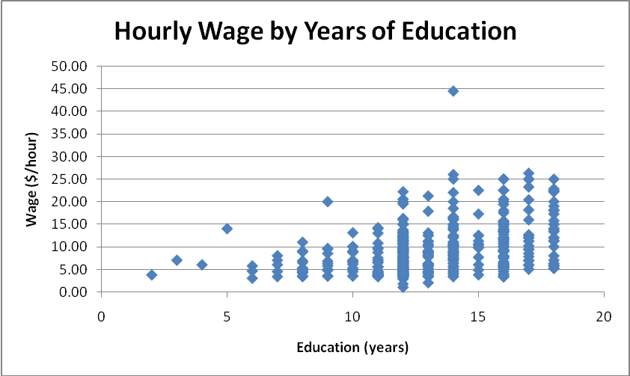

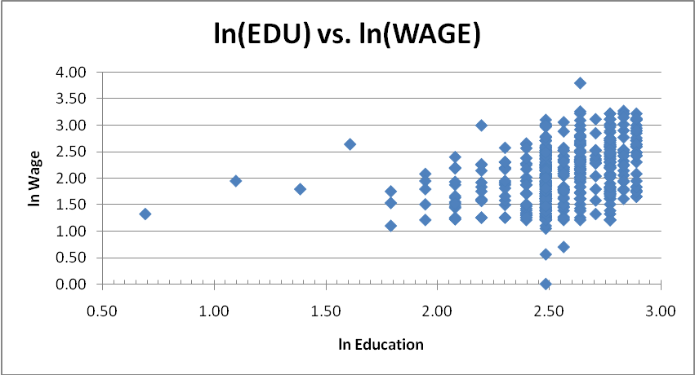
For AGE, which is slightly right-skewed, does not appear to have a very good linear relationship (see graph below from “QuantitativeVars” worksheet), so I saw little to no advantage in transforming it.
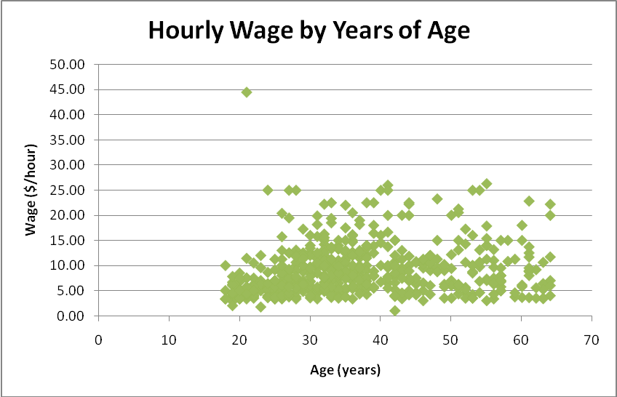

Therefore, I chose to use ln(WAGE) and ln(EDU) in the model and leave all other variables untransformed.

  - ANOVA for Qualitative Variables
Given that Excel can only handle certain variables, I used one-way ANOVA tables for each qualitative variable to determine which ones I could throw out before running any regressions. The results below are also in the “ANOVA Results” worksheet with the summaries from Excel.
Occupation Category
ANOVA
Source of Variation | SS | df | MS | F | P-value | F crit
Between Groups | 2,537.697 | 5 | 507.539 | 23.224 | 4.1E-21 | 2.231
Within Groups | 11,539.001 | 528 | 21.854
Total | 14,076.699 | 533
Industry Sector
ANOVA
Source of Variation | SS | df | MS | F | P-value | F crit
Between Groups | 43.684 | 2 | 21.842 | 0.826 | 0.438 | 3.013
Within Groups | 14,033.015 | 531 | 26.428
Total | 14,076.699 | 533
Union Membership
ANOVA
Source of Variation | SS | df | MS | F | P-value | F crit
Between Groups | 368.363 | 1 | 368.363 | 14.296 | 1.7E-04 | 3.859
Within Groups | 13,708.336 | 532 | 25.768
Total | 14,076.699 | 533
Sex
ANOVA
Source of Variation | SS | df | MS | F | P-value | F crit
Between Groups | 593.714 | 1 | 593.714 | 23.426 | 1.7E-06 | 3.859
Within Groups | 13,482.985 | 532 | 25.344
Total | 14,076.699 | 533
Marital Status
ANOVA
Source of Variation | SS | df | MS | F | P-value | F crit
Between Groups | 142.401 | 1 | 142.401 | 5.437 | 0.020 | 3.859
Within Groups | 13,934.297 | 532 | 26.192
Total | 14,076.699 | 533
Race
ANOVA
Source of Variation | SS | df | MS | F | P-value | F crit
Between Groups | 172.655 | 2 | 86.327 | 3.297 | 0.038 | 3.013
Within Groups | 13,904.044 | 531 | 26.185
Total | 14,076.699 | 533
Geographical Region (South or not)
ANOVA
Source of Variation | SS | df | MS | F | P-value | F crit
Between Groups | 279.982 | 1 | 279.982 | 10.796 | 0.001 | 3.859
Within Groups | 13,796.717 | 532 | 25.934
Total | 14,076.699 | 533

The F-tests show OCC, UNION, and SEX as significant. MARR, RACE, and SOUTH may be significant. SECTOR is not significant, so I will no longer consider it.

  - Dummy Variables
For the six categorical variables remaining, I will employ the following dummy variables scheme:
OCC | D1 | D2 | D3 | D4 | D5
1=Management | 1 | 0 | 0 | 0 | 0
2=Sales | 0 | 1 | 0 | 0 | 0
3=Clerical | 0 | 0 | 1 | 0 | 0
4=Service | 0 | 0 | 0 | 1 | 0
5=Professional | 0 | 0 | 0 | 0 | 1
6=Other | 0 | 0 | 0 | 0 | 0
UNION | U
0=Not union member | 0
1=Union | 1
SEX | F
0=Male | 0
1=Female | 1
MARR | M
0=Unmarried | 0
1=Married | 1
RACE | G1 | G2
1=Other | 1 | 0
2=Hispanic | 0 | 1
3=White | 0 | 0
SOUTH | H
0=Person lives elsewhere | 0
1=Person lives in South | 1

  - Interactions
From the correlation matrix above (Table 1), ignoring EXP and SECTOR, I found four interations to consider.
Variables | |ρ|
AGE and MARR | 0.279
OCC and UNION | 0.229
OCC and SEX | 0.221
OCC and EDU | 0.206

Intuitively, one would expect occupation category (OCC) and union membership (UNION) to interact. For example, some occupations are not unionized. In Table 6 (worksheet “Dummies”), I examined the interaction of these variables by examining the number of observations in each combination of occupation and sector categories and determining the percentage of respondants belonging to a union.
6) OCC and UNION
OCC | COUNT | UNION COUNT | % UNIONIZED | Dummy Variable
1=Management | 55 | 3 | 5% | D1U
2=Sales | 38 | 1 | 3% | D2U
3=Clerical | 97 | 8 | 8% | D3U
4=Service | 83 | 17 | 20% | D4U
5=Professional | 105 | 23 | 22% | D5U
6=Other | 156 | 44 | 28%

Similarly, since some occupations are predominated by one sex, so a occupation-sex interaction is not surprising. Table 7 (“Dummies”) shows the potion of each occupational category that is female.
7) OCC and SEX
OCC | COUNT | * FEMALE COUNT | % FEMALE | Dummy Variable
1=Management | 55 | 21 | 38% | D1F
2=Sales | 38 | 17 | 45% | D2F
3=Clerical | 97 | 76 | 78% | D3F
4=Service | 83 | 49 | 59% | D4F
5=Professional | 105 | 52 | 50% | D5F
6=Other | 156 | 30 | 19%
The other two sets of interactions (AGE-MARR and OCC-EDU) are between categorical and quantitative variables, so they do not lend themselves to the kinds of tables above. Married observations will include a M*X3 term and occupational categories 1 through 5 will include Dj*ln(X1) term.

  - Unusual Data Point
Observation #171 is an 21-year-old with 14 years of education and 1 year of experience whose hourly wage is $44.50. The wage is significantly higher than the second largest hourly wage ($26.29). In addition, the education isn’t much above average (mean(EDU) = 13) and the experience and age are among the smallest values.
Note then, that this value does not have a lot of leverage (since the explanatory variable values are not unusual).

- The Models
The full regression equation is as follows
ln(Y) = β(ln(X1))ln(X1) + β(X3)X3
+ γ(OCC)OCC + δ(OCC * ln (X1))OCC * ln(X1)
+ γ(UNION)UNION + δ(OCC * UNION)OCC * UNION
+ γ(SEX)SEX + δ (OCC * SEX)OCC * SEX
+ γ(MARR)MARR + δ(MARR * X3)MARR * X3
+ γ(RACE)RACE + γ(SOUTH)SOUTH

Where OCC represents the applicable occupation dummy variable (D1, D2, D3, D4, D5, or nothing), SEX represents the applicable sex dummy variable (F or nothing), etc. Unfortunately, since Excel is limited to sixteen regressors, I looked at each interaction separately.
The data used and the results for each regression can be found in the worksheet titled by the respective model number (e.g., “Model 2” for results of Model 2 or “Data_Reg7” for data used for Model 7).
  - Model 1. First, I considered all the marginals with no interactions by regressing ln(WAGE) on ln(EDU), AGE, OCC, UNION, SEX, MARR, SOUTH, and RACE.
SUMMARY OUTPUT
Regression Statistics
Multiple R | 0.5897
R Square | 0.3478
Adjusted R Square | 0.3315
Standard Error | 0.4315
Observations | 534
ANOVA
 | df | SS | MS | F | Significance F
Regression | 13 | 51.6252 | 3.9712 | 21.3280 | 1.2E-40
Residual | 520 | 96.8216 | 0.1862
Total | 533 | 148.4468
 | Coefficients | Standard Error | t Stat | P-value
Intercept | 0.2983 | 0.2783 | 1.0719 | 0.2843
ln(X1) | 0.5634 | 0.1040 | 5.4171 | 9.3E-08
X3 | 0.0098 | 0.0017 | 5.6335 | 2.9E-08
D1 | 0.2499 | 0.0751 | 3.3286 | 0.0009
D2 | -0.1374 | 0.0820 | -1.6759 | 0.0944
D3 | 0.0127 | 0.0637 | 0.1992 | 0.8422
D4 | -0.1723 | 0.0615 | -2.7989 | 0.0053
D5 | 0.2249 | 0.0660 | 3.4059 | 0.0007
U | 0.2045 | 0.0517 | 3.9590 | 0.0001
F | -0.2222 | 0.0418 | -5.3192 | 1.6E-07
M | 0.0611 | 0.0414 | 1.4782 | 0.1400
H | -0.1023 | 0.0421 | -2.4308 | 0.0154
G1 | -0.0729 | 0.0578 | -1.2621 | 0.2075
G2 | -0.0925 | 0.0887 | -1.0427 | 0.2976

The p-values for the RACE dummies G1 and G2 are rather high (0.2075 and 0.02976, respectively), so I discarded this explanantory variable. MARR (M p-value 0.1400) and SOUTH (H p-value 0.0154) can probably be removed as well.
  - Model 2. Next I looked at the interaction between age and marital status by regressing ln(WAGE) on ln(EDU), AGE, OCC, UNION, SEX, MARR, SOUTH, and AGE*MARR.
SUMMARY OUTPUT
Regression Statistics
Multiple R | 0.5874
R Square | 0.3451
Adjusted R Square | 0.3300
Standard Error | 0.4320
Observations | 534
ANOVA
 | df | SS | MS | F | Significance F
Regression | 12 | 51.2237 | 4.2686 | 22.8749 | 7.1E-41
Residual | 521 | 97.2231 | 0.1866
Total | 533 | 148.4468
 | Coefficients | Standard Error | t Stat | P-value
Intercept | 0.1977 | 0.2741 | 0.7213 | 0.4711
ln(X1) | 0.5836 | 0.1015 | 5.7518 | 1.5E-08
X3 | 0.0111 | 0.0028 | 3.9623 | 8.5E-05
D1 | 0.2419 | 0.0748 | 3.2364 | 0.0013
D2 | -0.1363 | 0.0822 | -1.6569 | 0.0981
D3 | 0.0047 | 0.0635 | 0.0745 | 0.9406
D4 | -0.1827 | 0.0612 | -2.9841 | 0.0030
D5 | 0.2182 | 0.0655 | 3.3330 | 0.0009
U | 0.1968 | 0.0514 | 3.8250 | 0.0001
F | -0.2224 | 0.0421 | -5.2877 | 1.8E-07
M | 0.1283 | 0.1288 | 0.9962 | 0.3196
H | -0.1090 | 0.0419 | -2.6019 | 0.0095
X3M | -0.0018 | 0.0035 | -0.5270 | 0.5984

While the R² and adjusted- R² are smaller in this model than in Model 1, the standard error for ln(Y) is not. Moreover, the p-value for X3*M coefficient is rather large (0.5984). Therefore, I discarded the age-marriage interaction term and the marginal marriage term. (I also discarded the regional SOUTH variable at this point.)
  - Model 3. For model 3-5, I looked at each occupation interaction. First, I looked at the effect of occupational category on union membership by regressiong ln(WAGE) on ln(EDU), AGE, OCC, UNION, SEX, and OCC * UNION.
SUMMARY OUTPUT
Regression Statistics
Multiple R |  | 0.5892
R Square |  | 0.3472
Adjusted R Square |  | 0.3296
Standard Error |  | 0.4321
Observations |  | 534
ANOVA
 |  | df |  | SS |  | MS |  | F |  | Significance F
Regression |  | 14 |  | 51.5357 |  | 3.6811 |  | 19.7140 |  | 7.3E-40
Residual | 519 |  | 96.9111 |  | 0.1867
Total | 533 |  | 148.4468
 | Coefficients |  | Standard Error |  | t Stat |  | P-value
Intercept | 0.1232 |  | 0.2662 |  | 0.4628 |  | 0.6437
ln(X1) | 0.6150 |  | 0.1007 |  | 6.1087 |  | 2.0E-09
X3 | 0.0106 |  | 0.0017 |  | 6.2469 |  | 8.7E-10
D1 | 0.2851 |  | 0.0785 |  | 3.6323 |  | 0.0003
D2 | -0.1325 |  | 0.0847 |  | -1.5645 |  | 0.1183
D3 | -0.0034 |  | 0.0680 |  | -0.0504 |  | 0.9598
D4 | -0.2192 |  | 0.0692 |  | -3.1658 |  | 0.0016
D5 | 0.2782 |  | 0.0724 |  | 3.8397 |  | 0.0001
U | 0.2570 |  | 0.0778 |  | 3.3030 |  | 0.0010
F | -0.2081 |  | 0.0419 |  | -4.9637 |  | 9.4E-07
D1U | -0.5096 |  | 0.2686 |  | -1.8973 |  | 0.0583
D2U | 0.1985 |  | 0.4460 |  | 0.4450 |  | 0.6565
D3U | 0.0414 |  | 0.1777 |  | 0.2330 |  | 0.8159
D4U | 0.1611 |  | 0.1405 |  | 1.1466 |  | 0.2521
D5U | -0.2427 |  | 0.1279 |  | -1.8969 |  | 0.0584

Again the R² and adjusted- R² are smaller than in Model 1, the standard error for ln(Y) is not. Moreover, the p-value for the Dj*U coefficients are all rather large. I conclude that OCC * UNION is not useful.
  - Model 4. I next considered the sex-occupation interaction by regressing ln(WAGE) on ln(EDU), AGE, OCC, UNION, SEX, and OCC * SEX.
SUMMARY OUTPUT
Regression Statistics
Multiple R | 0.5905
R Square | 0.3487
Adjusted R Square | 0.3311
Standard Error | 0.4316
Observations | 534
ANOVA
 | df | SS | MS | F | Significance F
Regression | 14 | 51.7600 | 3.6971 | 19.8457 | 4.1E-40
Residual | 519 | 96.6868 | 0.1863
Total | 533 | 148.4468
 | Coefficients | Standard Error | t Stat | P-value
Intercept | 0.2000 | 0.2682 | 0.7458 | 0.4562
ln(X1) | 0.6019 | 0.1010 | 5.9563 | 4.8E-09
X3 | 0.0107 | 0.0017 | 6.3109 | 6.0E-10
D1 | 0.1876 | 0.0896 | 2.0927 | 0.0369
D2 | -0.0445 | 0.1049 | -0.4244 | 0.6715
D3 | -0.1707 | 0.1032 | -1.6548 | 0.0986
D4 | -0.2413 | 0.0835 | -2.8896 | 0.0040
D5 | 0.1479 | 0.0792 | 1.8666 | 0.0625
U | 0.2062 | 0.0514 | 4.0109 | 0.0001
F | -0.3904 | 0.0884 | -4.4161 | 1.2E-05
D1F | 0.2505 | 0.1489 | 1.6824 | 0.0931
D2F | -0.1061 | 0.1663 | -0.6379 | 0.5238
D3F | 0.3446 | 0.1381 | 2.4960 | 0.0129
D4F | 0.2092 | 0.1308 | 1.5988 | 0.1105
D5F | 0.2690 | 0.1222 | 2.2018 | 0.0281

There is little difference in R², adjusted- R², and standard error for ln(Y) versus Model 1. Also, the p-value for the Dj*F coefficients are all rather large. I conclude that OCC * SEX is not useful.
  - Model 5. Lastly, I regressed ln(WAGE) on ln(EDU), AGE, OCC, UNION, SEX, and OCC * ln(EDU) in order to look at the relationship of occupation and education.
SUMMARY OUTPUT
Regression Statistics
Multiple R | 0.5905
R Square | 0.3487
Adjusted R Square | 0.3312
Standard Error | 0.4316
Observations | 534
ANOVA
 | df | SS | MS | F | Significance F
Regression | 14 | 51.7676 | 3.6977 | 19.8502 | 4.1E-40
Residual | 519 | 96.6792 | 0.1863
Total | 533 | 148.4468
 | Coefficients | Standard Error | t Stat | P-value
Intercept | 0.1444 | 0.4050 | 0.3565 | 0.7216
ln(X1) | 0.6098 | 0.1596 | 3.8214 | 0.0001
X3 | 0.0107 | 0.0017 | 6.2945 | 6.6E-10
D1 | -2.5905 | 1.1003 | -2.3543 | 0.0189
D2 | -1.7125 | 1.5645 | -1.0946 | 0.2742
D3 | 1.0725 | 0.9930 | 1.0800 | 0.2806
D4 | 0.3407 | 0.5548 | 0.6140 | 0.5395
D5 | -0.3893 | 0.9084 | -0.4285 | 0.6684
U | 0.2106 | 0.0512 | 4.1135 | 4.5E-05
F | -0.2033 | 0.0420 | -4.8383 | 1.7E-06
D1ln(X1) | 1.0633 | 0.4169 | 2.5502 | 0.0111
D2ln(X1) | 0.6111 | 0.6093 | 1.0030 | 0.3164
D3ln(X1) | -0.4247 | 0.3916 | -1.0846 | 0.2786
D4ln(X1) | -0.2200 | 0.2285 | -0.9631 | 0.3359
D5ln(X1) | 0.2231 | 0.3392 | 0.6579 | 0.5109

R² and standard error for ln(Y) are slightly higher than in Model 1; adjusted- R² slightly lower. The p-values for the Dj*ln(X1) coefficients are all rather large. I conclude that OCC * ln(EDU) is not useful.
  - Model 6. One may notice that the p-values for the OCC dummy coefficients are not very large. Perhaps occupation is not a necessary explanatory variable. I looked at Model 6 with no occupational interactions, but still with the marginal OCC dummies and Model 7 entirely without occupation. By regressing ln(WAGE) on ln(EDU), AGE, OCC, UNION, and SEX, I got the following from Excel:
SUMMARY OUTPUT
Regression Statistics
Multiple R | 0.5773
R Square | 0.3333
Adjusted R Square | 0.3219
Standard Error | 0.4346
Observations | 534
ANOVA
 | df | SS | MS | F | Significance F
Regression | 9 | 49.4805 | 5.4978 | 29.1096 | 4.2E-41
Residual | 524 | 98.9663 | 0.1889
Total | 533 | 148.4468
 | Coefficients | Standard Error | t Stat | P-value
Intercept | 0.1335 | 0.2670 | 0.4998 | 0.6175
ln(X1) | 0.6124 | 0.1011 | 6.0604 | 2.6E-09
X3 | 0.0108 | 0.0017 | 6.4178 | 3.1E-10
D1 | 0.2483 | 0.0751 | 3.3069 | 0.0010
D2 | -0.1371 | 0.0824 | -1.6647 | 0.0966
D3 | -0.0050 | 0.0638 | -0.0787 | 0.9373
D4 | -0.1877 | 0.0615 | -3.0544 | 0.0024
D5 | 0.2246 | 0.0658 | 3.4116 | 0.0007
U | 0.2129 | 0.0515 | 4.1387 | 4.1E-05
F | -0.2144 | 0.0420 | -5.1064 | 4.6E-07

R² and adjusted- R² are smaller than in Model 1, but the standard error for ln(Y) is not. Moreover, the p-values for the Dj coefficients are not tiny. Thereforem, occupation may not be useful to the model.
  - Model 7. The next regression I ran was ln(WAGE) on ln(EDU), AGE, UNION, and SEX. I compared this to Model 1 and Model 6.
SUMMARY OUTPUT
Regression Statistics
Multiple R | 0.5199
R Square | 0.2703
Adjusted R Square | 0.2647
Standard Error | 0.4525
Observations | 534
ANOVA
 | df | SS | MS | F | Significance F
Regression | 4 | 40.1194 | 10.0299 | 48.9792 | 4.7E-35
Residual | 529 | 108.3274 | 0.2048
Total | 533 | 148.4468
 | Coefficients | Standard Error | t Stat | P-value
Intercept | -0.6283 | 0.2391 | -2.6279 | 0.0088
ln(X1) | 0.9098 | 0.0862 | 10.5580 | 8.9E-24
X3 | 0.0121 | 0.0017 | 7.0601 | 5.3E-12
U | 0.2020 | 0.0521 | 3.8762 | 1.2E-04
F | -0.2390 | 0.0400 | -5.9713 | 4.3E-09

Based on R² (or adjusted- R²) this is the best model, so far. (Of course, the standard error is bigger.) All the p-values are tiny (except the intercept), implying that all the regressors (ln(EDU), AGE, UNION, and SEX) are significant.

  - Model 8. The last regression I ran was ln(WAGE) on ln(EDU), AGE, and SEX. I compared this to Model 7.
SUMMARY OUTPUT
Regression Statistics
Multiple R | 0.4995
R Square | 0.2495
Adjusted R Square | 0.2453
Standard Error | 0.4585
Observations | 534
ANOVA
 | df | SS | MS | F | Significance F
Regression | 3 | 37.0426 | 12.3475 | 58.7427 | 8.5E-33
Residual | 530 | 111.4043 | 0.2102
Total | 533 | 148.4468
 | Coefficients | Standard Error | t Stat | P-value
Intercept | -0.6221 | 0.2422 | -2.5683 | 0.0105
ln(X1) | 0.9134 | 0.0873 | 10.4634 | 2.0E-23
X3 | 0.0130 | 0.0017 | 7.5479 | 1.9E-13
F | -0.2651 | 0.0400 | -6.6334 | 8.1E-11

Based on R² (or adjusted- R²) this is the best model. All the p-values are tiny (except the intercept), implying that all the regressors (ln(EDU), AGE, and SEX) are significant.

- The Answer
  - How does union membership effect hourly wages?
The following hypothesis analysis is on worksheet “NullHypothesis”. Since, from Model 7 above, γ-hat(UNION) = 0.2020 > 0 and since the natural log transformation preserves the monotone increasing nature of the relationship, I conlude that union membership has a positive effect on wages.
Consider the null hypothesis H₀: γ(UNION) = 0. The regression coefficient γ-hat = 0.2020 and SE= 0.0521. This gives a t-statistic of t₀ = 3.8762. Therefore, I found that we can reject the null hypothesis at a 5% significance level, with a p-value of 1.2ᵡ10⁻⁴. The 95% confidence interval is (0.0996, 0.3044) supporting the alternative hypothesis H_{a}: γ(UNION) > 0.
We can also examine the standardized coefficients to look at the impact of union membership.
 | Coefficients | Standard Error | Standardized Coefficients
Intercept | -0.6283 | 0.2391 | -0.3320
ln(X1) | 0.9098 | 0.0862 | 0.1732
X3 | 0.0121 | 0.0017 | 4.6E-05
U | 0.2020 | 0.0521 | 0.0233
F | -0.2390 | 0.0400 | -0.0211

Age (X3) appears to have very little effect on wage, union membership and and sex have approximately equal impact in opposite directions, and education has by far the most impact. However, we cannot put much stock into this comparison unless the explanatory variables’ distributions are normal, which they are not.
  - What is the best regression model for hourly wage, given the data?
The best model is either Model 7 or Model 8. Model 7 has a more degrees of freedom, lower standard error for wage and for the intercept, and smaller p-values for F, the intercept, and ln(X1) = ln(EDU). Whereas, Model 8 has lower R² and adjusted- R² and smaller p-values for the other coefficients (X3 = AGE and sex dummy variable F).
It is puzzling that occupation and industry sector do not appear to have a significant impact on wage. I would guess that the kind of job one has would directly effect one’s income. However, the categories chosen may the real culprits here. The way that occupations are divided into categories and the number of categories would logically effect the regression. In addition,
Similarly, I would expect geography to effect hourly wage; but in this sub-dataset, it is merely a indicator of a worker being in a southern state or not. This may not be enough categories to really see the impact of geographic region.
In summary, I found that union membership does appear to have a positive effect on hourly wage. More study with more detailed data is needed to fully understand the role of occupation and geographical region in hourly wage.

