BACKGROUND

In this study, I investigate several different attributes in golf and their importance to scoring as well as making money for golfers in the United States Professional Golfer’s Association. For several years now, there has been a well known cliché circulating in the golf community. This cliché, “Drive for show, putt for dough”, is best described in the following manner. On a par 4, golfer A could blast a perfect drive deep down the middle of the fairway followed by a nice approach shot that lands safely on the green. However, once on the green it takes him three additional shots to make the ball in the cup, finishing for a bogey. Meanwhile, golfer B could miss-hit their drive into some trees on the right followed by a second shot that lands near the green. He then chips the ball within ten feet of the hole and makes his first putt attempt, finishing for par. Essentially, golfer A can hit the ball much further and straighter than golfer B, but golfer B is a much better putter. Three questions arise from the preceding scenario. Which golfer tends to score better, the longer hitter or the better putter? Which golfer tends to make more money on tour, the longer hitter of the better putter? Are there any other attributes that show importance in scoring or in making money on the PGA tour?

DATA

The data used to analyze the above questions was obtained from www.pgatour.com. There are six different golf attributes for which I am skeptical that they may or may not have an influence on scoring and making money on the PGA tour. These attributes are driving distance, driving accuracy, putting ability, chipping ability, sand-trap ability, and iron ability. There are other skills that golfer’s possess, but I believe that these six are the most important. Driving distance is the average distance in yards that a golfer hits his tee shot when using a driver only. This attribute is very straightforward, and is taken directly from the website. Similarly, driving accuracy is the percentage of tee shots with a driver that come to rest in the fairway. This attribute is also taken directly from the website. Putting is measured as the average amount of putts that a golfer hits on each hole. This attribute is also taken directly from the website.
Chipping ability is a little more complicated. The PGA tour records a scrambling statistic as the percentage of times that a player makes par or better when the green is not hit in regulation. This scramble statistic is a measure of a golfer’s chipping ability, but it is also a measure of a player’s putting ability.
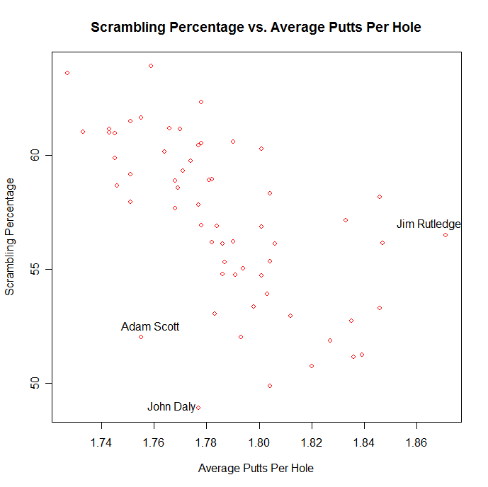

As you can see in the plot on the bottom of the preceding page, there appears to be quite a strong negative relationship between scrambling percentage and the average number of putts per hole. This means that the higher the average number of putts per hole, the lower the scrambling percentage. This makes intuitive sense. To measure chipping ability without measuring putting ability at the same time, I create a new attribute. This attribute, named chipping, is the result of a simple linear regression estimating scramble percentage from putting ability.

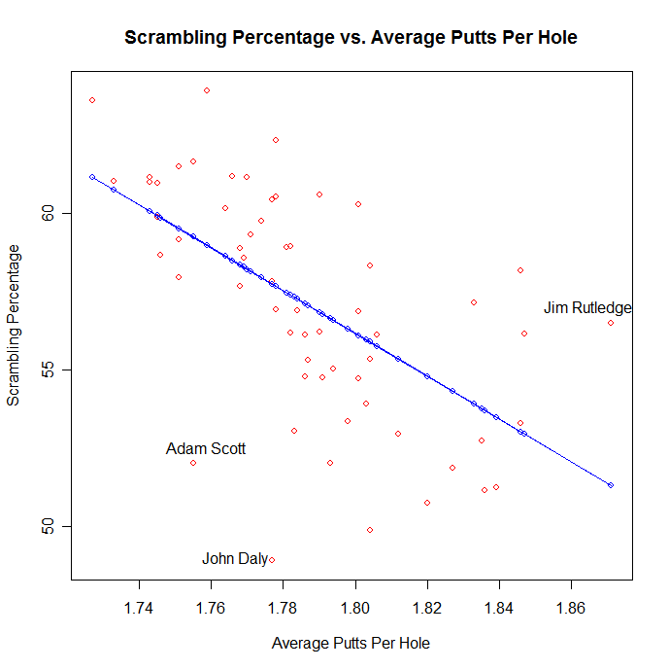

Call:
lm(formula = Scrambling ~ Putts, data = PGA.2007.00)

Residuals:
Min 1Q Median 3Q Max
-8.8254 -1.6013 0.1790 2.0712 5.1977

Coefficients:
Estimate Std. Error t value Pr(>|t|)
(Intercept) 179.35 21.81 8.224 2.58e-11 ***
Putts -68.44 12.21 -5.607 6.00e-07 ***
---
Signif. codes: 0 '***' 0.001 '**' 0.01 '*' 0.05 '.' 0.1 ' ' 1

Residual standard error: 2.951 on 58 degrees of freedom
Multiple R-Squared: 0.3515, Adjusted R-squared: 0.3403
F-statistic: 31.44 on 1 and 58 DF, p-value: 5.999e-07

The simple linear regression output shows that Scramble = 179.35 – 68.44*Putts.
The goal of this simple linear regression is to estimate how much of the scramble statistic is explained by putting ability. The aspect of scramble percentage that cannot be explained by putting ability is chipping ability, which is represented by the residuals of this regression. Therefore, these residuals become my new chipping ability statistic, as long as all assumptions are met.

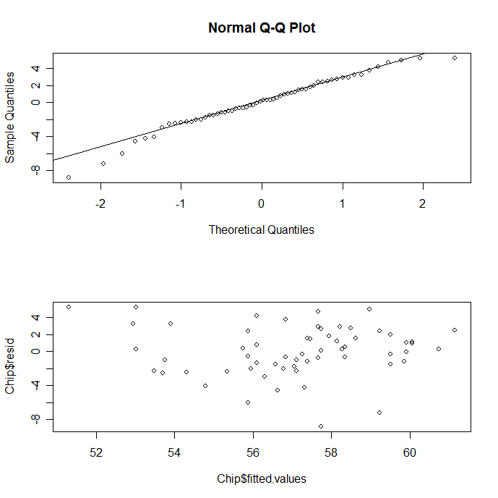

A normal probability plot of the residuals shows normality, although there appears to be a slight deviation from normality in the tails. A plot of the residuals versus the fitted values shows that the residuals appear uncorrelated and seem to have constant variance.

Shapiro-Wilk normality test

data: resid.Chip
W = 0.973, p-value = 0.2033

Ho: The residuals are normally distributed
Ha: The residuals are not normally distributed

A Shapiro-Wilk normality test produces a p-value of .2033, which leads me to fail to reject the null hypothesis that the residuals are normally distributed. Therefore, these residuals become my new chipping ability statistic.

The scenario is similar with the sand-save ability. The PGA tour records the percentage of times that a player saves par when he hits his ball in a green side sand trap. The PGA tour is successful in measuring sand-save ability, but once again they are also measuring putting ability at the same time.

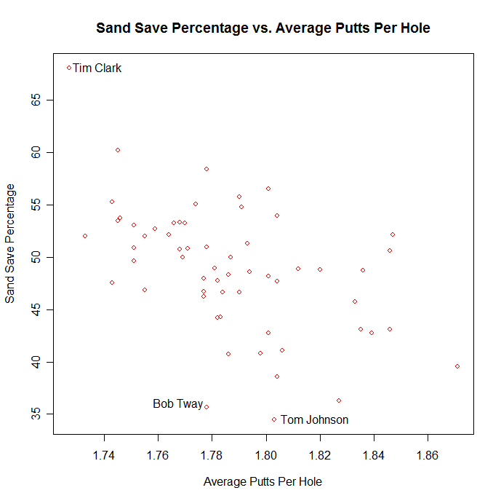

As you can see on the graph on the preceding page, there appears to be a negative relationship between sand save percentage and the average number of putts per hole.
This means that the higher the average number of putts per hole, the lower the sand-save percentage. Once again, this makes intuitive sense. To measure sand-save ability without measuring putting ability at the same time, I create a new attribute named sand ability. Once again, this new attribute is the result of a simple linear regression estimating sand-save percentage from putting ability.

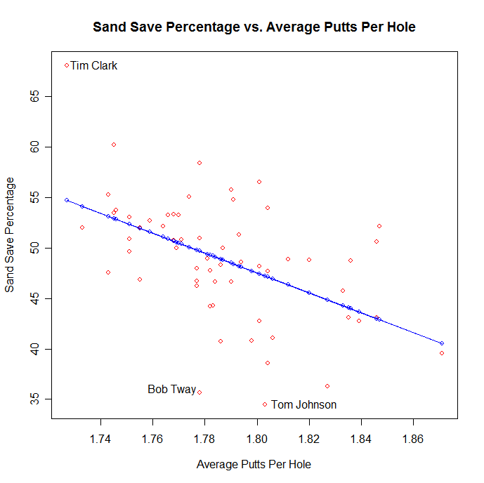
Call:
lm(formula = Sand.Save ~ Putts, data = PGA.2007.00)

Residuals:
Min 1Q Median 3Q Max
-14.0202 -2.4946 0.2819 2.5774 13.3814

Coefficients:
Estimate Std. Error t value Pr(>|t|)
(Intercept) 224.99 39.09 5.756 3.43e-07 ***
Putts -98.60 21.88 -4.506 3.25e-05 ***
---
Signif. codes: 0 '***' 0.001 '**' 0.01 '*' 0.05 '.' 0.1 ' ' 1

Residual standard error: 5.289 on 58 degrees of freedom
Multiple R-Squared: 0.2593, Adjusted R-squared: 0.2466
F-statistic: 20.31 on 1 and 58 DF, p-value: 3.249e-05

The simple linear regression output shows that sand-save percentage = 224.99 – 98.6*Putts. The goal of this simple linear regression is to estimate how much of the sand-save ability is explained by putting ability. The aspect of sand-save percentage that cannot be explained by putting ability is sand ability, which is represented by the residuals of the regression. Therefore, these residuals become my sand ability statistic, as long as all assumptions are met.

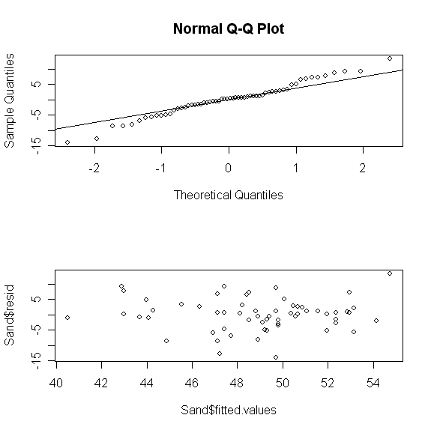

A normal probability plot of the residuals shows slight normality, although there appears to be a slight deviation from normality in the tails. A plot of the residuals versus the fitted values show that the residuals appear uncorrelated and seem to have constant variance. The Shapiro-Wilks normality test will better test whether or not the residuals follow a normal distribution.

Shapiro-Wilk normality test

data: resid.Sand
W = 0.9792, p-value = 0.396

Ho: The residuals are normally distributed
Ha: The residuals are not normally distributed

A Shapiro-Wilk normality test on the residuals produces a p-value of .396, which leads me to fail to reject the null hypothesis that the residuals are normally distributed. Therefore, these residuals become my new sand ability statistic.

Measuring iron ability is even more complicated. The PGA tour does not record a good statistic on iron-ability. Instead, they record the average score on par 3’s for each player. This is a measure of iron ability, since the first shot on par 3’s is generally with an iron. However, this is also a measure of putting, chipping, and sand abilities.

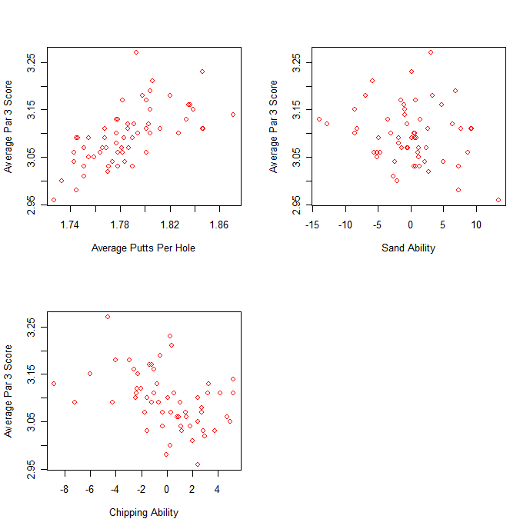

As you can see from the graphs at the bottom of the preceding page, the average score on Par 3’s seems to be dependent on average putts per hole, sand ability, and chipping ability. There is definitely a positive association between the average Par 3 score and average putts per hole, whereas there seems to be a negative association between average putts per hole and both sand ability and chipping ability. This makes sense because the sand ability and chipping ability variables are set up as residuals from a simple linear regression with putting as the explanatory variable.

Call:
lm(formula = Par.3.Avg. ~ Putts + Sand.Ability + Chipping, data = PGA.2007.01)

Residuals:
Min 1Q Median 3Q Max
-0.070008 -0.028923 -0.003497 0.017982 0.130361

Coefficients:
Estimate Std. Error t value Pr(>|t|)
(Intercept) 0.8872722 0.2929248 3.029 0.00371 **
Putts 1.2363425 0.1639530 7.541 4.42e-10 ***
Sand.Ability -0.0005049 0.0010590 -0.477 0.63538
Chipping -0.0080589 0.0018983 -4.245 8.29e-05 ***
---
Signif. codes: 0 '***' 0.001 '**' 0.01 '*' 0.05 '.' 0.1 ' ' 1

Residual standard error: 0.03964 on 56 degrees of freedom
Multiple R-Squared: 0.5874, Adjusted R-squared: 0.5653
F-statistic: 26.58 on 3 and 56 DF, p-value: 8.038e-11

The above multiple regression output shows that sand ability is not a statistically significant variable in predicting the average score on Par 3’s. Therefore, I will remove this variable and re-fit the model.

Call:
lm(formula = Par.3.Avg. ~ Putts + Chipping, data = PGA.2007.01)

Residuals:
Min 1Q Median 3Q Max
-0.066496 -0.028699 -0.003220 0.019195 0.127269

Coefficients:
Estimate Std. Error t value Pr(>|t|)
(Intercept) 0.887272 0.290933 3.050 0.00347 **
Putts 1.236343 0.162838 7.592 3.27e-10 ***
Chipping -0.008393 0.001752 -4.791 1.22e-05 ***
---
Signif. codes: 0 '***' 0.001 '**' 0.01 '*' 0.05 '.' 0.1 ' ' 1

Residual standard error: 0.03937 on 57 degrees of freedom
Multiple R-Squared: 0.5858, Adjusted R-squared: 0.5712
F-statistic: 40.3 on 2 and 57 DF, p-value: 1.235e-11

The above output shows that Par 3 = .887272 + 1.236343*Putts - .008393*Chipping.
The above multiple regression output uses the average score on par 3’s as the predictor variable with average putts per hole and chipping ability as explanatory variables. Both of these variables are statistically significant in this model. The goal of this multiple regression is to estimate how much of the average Par 3 score statistic is explained by putting and chipping abilities. The aspect of the average Par 3 score that cannot be explained by putting ability is iron ability, which is represented by the residuals of this regression. Therefore, these residuals become my new iron ability statistic, as long as all assumptions are met.
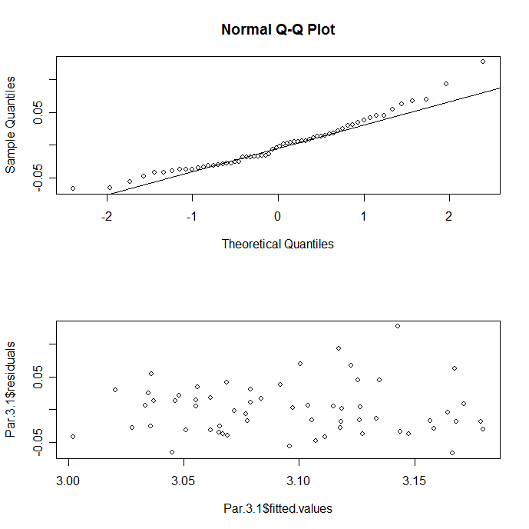
A normal probability plot of the residuals shows slight normality, but there does appear to be a deviation from normality in the tails. A plot of the residuals versus the fitted values shows that the residuals appear uncorrelated and seem to have constant variance. The Shapiro-Wilks normality test will better test whether or not the residuals follow a normal distribution.

Shapiro-Wilk normality test

data: resid.Par3
W = 0.9543, p-value = 0.02486

Ho: The residuals are normally distributed
Ha: The residuals are not normally distributed
A Shapiro-Wilk normality test on the residuals produces a p-value of .02486, which leads me to reject the null hypothesis that the residuals are normally distributed. This is not quite what I was hoping for, but I am still going to allow the residuals from this multiple regression to become my new iron ability statistic.
DESCRIPTIVE STATISTICS

Descriptive Statistics for the Eight Variables
 | Mean | Variance | Min | Max
Distance | 289.268 | 71.53 | 270 | 312.9
Accuracy | 62.89% | 35.19% | 41.86% | 74.37%
Putts | 1.786 | 0.00099 | 1.727 | 1.871
Chipping | 0 | 8.559 | -8.825 | 5.197
Sand | 0 | 27.5 | -1.402 | 13.38
Iron | 0 | 0.00149 | -0.0664 | 12.72
Money | 1734340 | 3.72E+12 | 53763 | 10867050
Scoring | 70.892 | 1.289 | 67.79 | 72.83

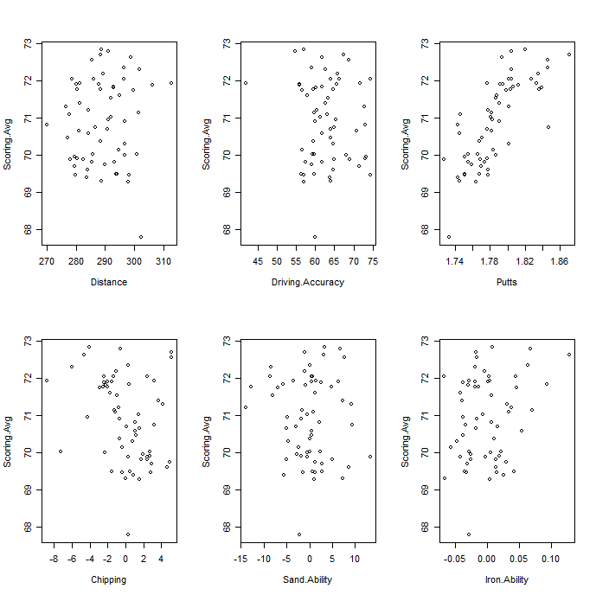

The above table presents some summary numbers to the sample of players for each of the variables. The mean of chipping, sand, and iron abilities are all zero. This makes sense because these variables are composed of the residuals linear regression. The minimum scoring average of 67.79 belongs to Tiger Woods, while the maximum scoring average of 72.83 belongs to Todd Hamilton.

The preceding graphs are scatterplots for each of the six attributes plotted against scoring average. The scatterplot displaying scoring average against average putts per hole appears to have the strongest association, in the positive direction. This makes sense because the more strokes you take on average, the higher the score. Scoring average plotted against distance does not seem to have much association, which seems odd. Perhaps this may hint that the famous cliché is in fact true, however stronger analysis is necessary before drawing any concrete conclusions. Driving accuracy appears to have a moderately strong positive association with scoring average. Chipping and sand abilities seem to have a slight negative association with scoring average, whereas it is quite hard to tell the direction of association between scoring average and iron ability. Below is a correlation matrix for each of the variables, assigning numerical weights to the relevant associations.

Correlation Matrix for the Eight Variables
 | Distance | Accuracy | Putts | Chipping | Sand | Iron | Money | Scoring
Distance | 1 | -0.71634 | 0.09841 | -0.5875 | -0.33827 | 0.03 | 0.09226 | 0.07408
Accuracy | -0.71634 | 1 | 0.05433 | 0.53951 | 0.1446 | -0.0815 | -0.0024 | -0.08552
Putts | 0.09841 | 0.05433 | 1 | 0 | 0 | 0 | -0.05927 | 0.7528
Chipping | -0.5875 | 0.53951 | 0 | 1 | 0.03696 | 0 | 0.0234 | -0.0297
Sand | -0.33827 | 0.1446 | 0 | 0.03696 | 1 | -0.0059 | 0.00623 | -0.00683
Iron | 0.03 | -0.0815 | 0 | 0 | -0.0059 | 1 | -0.0128 | 0.0237
Money | 0.09226 | -2.40E-03 | -0.05927 | 0.0234 | 0.00623 | -0.0128 | 1 | -0.8718
Scoring | 0.07408 | -0.08552 | 0.7528 | -0.0297 | -0.00683 | 0.0237 | -0.8718 | 1

One very interesting thing to notice is that although minimal, distance and scoring are positively correlated. This seems to be the opposite of what one should expect. This says that the further you hit the ball, the higher your resulting score. Do keep in mind though that this correlation is only .07408, which is quite minuscule but positive nonetheless. The correlation between scoring and driving accuracy is negative, which seems to make intuitive sense. Another interesting observation is that the correlation between scoring average and putting ability is .7528, which is a strong positive correlation, as expected. This further illustrates the hint given above. Sand ability appears to be the variable that is least correlated with scoring average.
To further investigate, I need to build linear models using scoring average as the response variable, and the six attributes as the explanatory variables.

ANALYSIS WITH SCORING AVERAGE AS THE RESPONSE VARIABLE

Call:
lm(formula = Scoring.Avg ~ Distance + Driving.Accuracy + Putts +
Chipping + Sand.Ability + Iron.Ability, data = PGA.2007.01)

Residuals:
Min 1Q Median 3Q Max
-1.38833 -0.35891 0.05429 0.39679 0.99664

Coefficients:
Estimate Std. Error t value Pr(>|t|)
(Intercept) 35.342487 5.851165 6.040 1.56e-07 ***
Distance -0.048931 0.014225 -3.440 0.00114 **
Driving.Accuracy -0.025430 0.019271 -1.320 0.19264
Putts 28.719790 2.429236 11.823 < 2e-16 ***
Chipping -0.171470 0.033519 -5.116 4.41e-06 ***
Sand.Ability 0.001062 0.015943 0.067 0.94715
Iron.Ability 6.971156 1.945847 3.583 0.00074 ***
---
Signif. codes: 0 '***' 0.001 '**' 0.01 '*' 0.05 '.' 0.1 ' ' 1

Residual standard error: 0.5736 on 53 degrees of freedom
Multiple R-Squared: 0.7709, Adjusted R-squared: 0.745
F-statistic: 29.72 on 6 and 53 DF, p-value: 2.611e-15

The linear model without any interactions for predicting scoring average from the six attributes is shown above. The adjusted R-squared value is 74.5%. All variables are statistically significant except for sand ability and driving accuracy. Sand ability, with a p-value of .94715, is much less significant than driving accuracy, with a p-value of .19264. Therefore, I will remove sand ability from the model.
Call:
lm(formula = Scoring.Avg ~ Distance + Driving.Accuracy + Putts +
Chipping + Iron.Ability, data = PGA.2007.01)

Residuals:
Min 1Q Median 3Q Max
-1.38554 -0.35799 0.04915 0.39605 1.00848

Coefficients:
Estimate Std. Error t value Pr(>|t|)
(Intercept) 35.41432 5.69764 6.216 7.68e-08 ***
Distance -0.04918 0.01361 -3.612 0.000666 ***
Driving.Accuracy -0.02571 0.01863 -1.380 0.173227
Putts 28.72915 2.40271 11.957 < 2e-16 ***
Chipping -0.17088 0.03201 -5.339 1.91e-06 ***
Iron.Ability 6.96075 1.92160 3.622 0.000646 ***
---
Signif. codes: 0 '***' 0.001 '**' 0.01 '*' 0.05 '.' 0.1 ' ' 1

Residual standard error: 0.5682 on 54 degrees of freedom
Multiple R-Squared: 0.7709, Adjusted R-squared: 0.7497
F-statistic: 36.34 on 5 and 54 DF, p-value: 4.088e-16

The linear model without any interactions for predicting scoring average from all attributes except for sand ability is shown at the bottom of the preceding page.. The adjusted R-squared value has increased from 74.5% to 74.9%, which isn’t substantial by any means. Similar to before, all variables are statistically significant except for driving accuracy. This variable will now be removed.

Call:
lm(formula = Scoring.Avg ~ Distance + Putts + Chipping + Iron.Ability,
data = PGA.2007.01)

Residuals:
Min 1Q Median 3Q Max
-1.18769 -0.35755 0.02544 0.42631 1.06039

Coefficients:
Estimate Std. Error t value Pr(>|t|)
(Intercept) 31.54223 4.99965 6.309 5.08e-08 ***
Distance -0.03792 0.01099 -3.451 0.001081 **
Putts 28.16805 2.38746 11.798 < 2e-16 ***
Chipping -0.17988 0.03159 -5.694 5.00e-07 ***
Iron.Ability 7.20823 1.92889 3.737 0.000445 ***
---
Signif. codes: 0 '***' 0.001 '**' 0.01 '*' 0.05 '.' 0.1 ' ' 1

Residual standard error: 0.5729 on 55 degrees of freedom
Multiple R-Squared: 0.7628, Adjusted R-squared: 0.7456
F-statistic: 44.22 on 4 and 55 DF, p-value: < 2.2e-16

With sand ability and driving accuracy removed, all variables are now highly statistically significant. Average putts per hole has a p-value of 2e-16, while the p-value for driving distance is much larger, at .001081. Although both variables are statistically significant, average putts per hole are much more statistically significant than driving distance. This may notion towards the cliché being true. However, I would like to test all two way interactions among the explanatory variables.

After running all two-way interactions, and including the original models from above, I finished with a total of eighteen models. On top of using adjusted R-squared for comparing models, I will also look at AIC values. AIC, or Akaike’s information criterion, is a measure of the goodness of fit for an estimated statistical model. Essentially, the model with the lowest AIC value tends to be the best.

Model AIC Adj. R Squared
1 Scoring.Model.1 112.122242235365 .745
2 Scoring.Model.2 110.127263703128 .7497
3 Scoring.Model.3 110.207254678382 .7456
4 Scoring.Model.4 110.176641320090 .7566
5 Scoring.Model.5 105.901811302222 .7733
6 Scoring.Model.6 109.333132854456 .76
7 Scoring.Model.7 110.767091278152 .7542
8 Scoring.Model.8 113.976185729734 .7407
9 Scoring.Model.9 114.021983439841 .7405
10 Scoring.Model.10 111.722309295929 .7503
11 Scoring.Model.11 112.726880710767 .746
12 Scoring.Model.12 114.122064612577 .7401
13 Scoring.Model.13 113.942776566127 .7408
14 Scoring.Model.14 108.224394838772 .7644
15 Scoring.Model.15 114.010272713193 .7406
16 Scoring.Model.16 111.641010969573 .7506
17 Scoring.Model.17 113.742872920727 .7417
18 Scoring.Model.18 113.972974647687 .7407

The above table shows the AIC value and adjusted R-squared for each linear model that was built. Model 14 appears to have the smallest AIC and the largest adjusted R-squared value. Below is Model 14.

Call:
lm(formula = Scoring.Avg ~ Distance + Driving.Accuracy + Putts *
Sand.Ability + Chipping + Iron.Ability, data = PGA.2007.02)

Residuals:
Min 1Q Median 3Q Max
-1.241624 -0.316622 0.005389 0.342580 1.239329

Coefficients:
Estimate Std. Error t value Pr(>|t|)
(Intercept) 33.39385 5.68636 5.873 3.06e-07 ***
Distance -0.05186 0.01373 -3.777 0.000409 ***
Driving.Accuracy -0.03385 0.01888 -1.793 0.078724 .
Putts 30.58174 2.46922 12.385 < 2e-16 ***
Sand.Ability 1.88539 0.81320 2.318 0.024390 *
Chipping -0.16004 0.03259 -4.910 9.42e-06 ***
Iron.Ability 7.58843 1.88912 4.017 0.000191 ***
Putts:Sand.Ability -1.05529 0.45534 -2.318 0.024442 *
---
Signif. codes: 0 '***' 0.001 '**' 0.01 '*' 0.05 '.' 0.1 ' ' 1

Residual standard error: 0.5513 on 52 degrees of freedom
Multiple R-Squared: 0.7924, Adjusted R-squared: 0.7644
F-statistic: 28.35 on 7 and 52 DF, p-value: 1.243e-15

As you can see above, this model contains all six explanatory variables as well as an interaction variable between average putts per hole and sand ability. Although driving accuracy would be rejected at the .05 level, the model suffers when it is removed. Therefore I will leave it in the model.

ANALYSIS WITH MONEY EARNED AS THE RESPONSE VARIABLE

Call:
lm(formula = Money ~ Distance + Driving.Accuracy + Putts + Chipping +
Sand.Ability + Iron.Ability, data = PGA.2007.02)

Residuals:
Min 1Q Median 3Q Max
-1831128 -898517 -107662 541386 5214560

Coefficients:
Estimate Std. Error t value Pr(>|t|)
(Intercept) 31963061 13601304 2.350 0.022530 *
Distance 131957 33066 3.991 0.000204 ***
Driving.Accuracy 60042 44797 1.340 0.185858
Putts -40403792 5646871 -7.155 2.54e-09 ***
Chipping 298925 77916 3.836 0.000334 ***
Sand.Ability 20678 37060 0.558 0.579211
Iron.Ability -6364049 4523211 -1.407 0.165272
---
Signif. codes: 0 '***' 0.001 '**' 0.01 '*' 0.05 '.' 0.1 ' ' 1

Residual standard error: 1333000 on 53 degrees of freedom
Multiple R-Squared: 0.5702, Adjusted R-squared: 0.5215
F-statistic: 11.72 on 6 and 53 DF, p-value: 2.575e-08

The linear model without any interactions for predicting money earned from the six attributes is shown above. The adjusted R-squared value is 52.15%. It appears as though driving accuracy, sand ability, and iron ability are all insignificant. Sand ability, with a p-value of .579211 is the least significant, and therefore will be the first variable removed.
Call:
lm(formula = Money ~ Distance + Driving.Accuracy + Putts + Chipping +
Iron.Ability, data = PGA.2007.02)

Residuals:
Min 1Q Median 3Q Max
-1803416 -828192 -247829 556665 5217435

Coefficients:
Estimate Std. Error t value Pr(>|t|)
(Intercept) 33362010 13282709 2.512 0.015038 *
Distance 127185 31737 4.007 0.000189 ***
Driving.Accuracy 54569 43430 1.256 0.214349
Putts -40221556 5601355 -7.181 2.10e-09 ***
Chipping 310510 74618 4.161 0.000114 ***
Iron.Ability -6566710 4479763 -1.466 0.148485
---
Signif. codes: 0 '***' 0.001 '**' 0.01 '*' 0.05 '.' 0.1 ' ' 1

Residual standard error: 1325000 on 54 degrees of freedom
Multiple R-Squared: 0.5677, Adjusted R-squared: 0.5276
F-statistic: 14.18 on 5 and 54 DF, p-value: 7.39e-09

The linear model without any interactions for predicting money earned from all attributes except for sand ability is shown at the bottom of the preceding page. The adjusted R-squared value has slightly increased, from 52.15% to 52.76%. Driving accuracy has the highest p-value among insignificant variables, and will be removed next. On top of this, I will continue to remove variables until all variables are statistically significant. I will once again test all two-way interactions among the explanatory variables. Just as before, I will use both AIC and adjusted R-squared to select the best model. Below is a table of these values.

Model AIC Adj. R Squared
1 Money.Model.1 1871.20648861713 .5215
2 Money.Model.2 1869.55791309801 .5276
3 Money.Model.3 1869.28693073383 .5227
4 Money.Model.4 1869.95604820515 .5099
5 Money.Model.5 1871.29885397538 .5276
6 Money.Model.6 1860.89082302179 .6028
7 Money.Model.7 1870.16571473209 .5364
8 Money.Model.8 1871.97639615547 .5222
9 Money.Model.9 1872.58940048512 .5173
10 Money.Model.10 1872.66904807100 .5167
11 Money.Model.11 1872.53635114273 .5178
12 Money.Model.12 1871.42882761190 .5266
13 Money.Model.13 1873.20248743441 .5124
14 Money.Model.14 1873.10276401181 .5132
15 Money.Model.15 1867.84301842301 .554
16 Money.Model.16 1873.09400511079 .5132
17 Money.Model.17 1871.36104569107 .5271
18 Money.Model.18 1872.79655863669 .5157
19 Money.Model.19 1872.20000767591 .5204

The above table shows the AIC value and adjusted R-squared for each linear model that was built. Model 6 appears to have the smallest AIC and the largest adjusted R-squared value. Model 6 is displayed on the next page.

Call:
lm(formula = Money ~ Distance * Putts + Driving.Accuracy + Chipping +
Sand.Ability + Iron.Ability, data = PGA.2007.02)

Residuals:
Min 1Q Median 3Q Max
-1749514 -801324 -130590 578384 3714658

Coefficients:
Estimate Std. Error t value Pr(>|t|)
(Intercept) -1.190e+09 3.552e+08 -3.350 0.001510 **
Distance 4.368e+06 1.231e+06 3.548 0.000832 ***
Putts 6.470e+08 1.998e+08 3.239 0.002094 **
Driving.Accuracy 7.132e+04 4.095e+04 1.742 0.087429 .
Chipping 2.602e+05 7.187e+04 3.621 0.000666 ***
Sand.Ability 1.430e+04 3.382e+04 0.423 0.674181
Iron.Ability -5.431e+06 4.130e+06 -1.315 0.194305
Distance:Putts -2.384e+06 6.927e+05 -3.442 0.001147 **
---
Signif. codes: 0 '***' 0.001 '**' 0.01 '*' 0.05 '.' 0.1 ' ' 1

Residual standard error: 1215000 on 52 degrees of freedom
Multiple R-Squared: 0.6499, Adjusted R-squared: 0.6028
F-statistic: 13.79 on 7 and 52 DF, p-value: 6.132e-10

As you can see above, this model contains all six explanatory variables as well as an interaction variable between distance and average putts per hole. Although sand and iron ability are both insignificant, the model suffers when they are removed. Therefore, they will be left in the model.

Conclusion

With scoring average as the response variable, there were several statistically significant explanatory variables. However, average putts per hole had by far the smallest p-value in every model fit. The same is true for most models using money earned as the response variable. Although most attributes are important for a golfer scoring well, putting seems to be the most important. Driving distance is not ‘just for show’, however, since this variable was also very statistically significant in all models created using both scoring average and money earned as response variables.
Keep in mind that these results only apply to PGA Tour golfers. The difference between a professional golfer and a lousy golfer does not just lie in their respective putting abilities. But when a golfer does reach the skill level of a PGA professional, putting ability is what mostly separates the good PGA players with the not-so-good ones, as well as the PGA players that make the money with the ones that don’t.
I conclude that the famous cliché “Drive for show, Putt for dough” is mostly, but not fully true. I believe that while putting ability is the most important attribute when it comes to both scoring average and money earned, being able to hit the ball far can also prove to be quite lucrative for golfers on the PGA Tour.

