THE PER-CAPITA GDP OF AFRICAN NATIONS
EXPLAINED AS A FUNCTION OF NON-ECONOMIC DATA
xxxx x. xxx
REGRESSION ANALYSIS, WINTER 2010
11 JANUARY, 2011

TABLE OF CONTENTS

INTRODUCTION (p. 3)
SELECTION OF EXPLANATORY VARIABLES (p. 3)
CAUTIONS AND REMEDIES (pp. 3, 4)
THE FULLY SPECIFIED MODEL (p. 4)
STATISTICS FROM MODELED DATA (pp. 5-13)
ANALYSIS OF VARIANCE AND INCREMENTAL F-TESTS (p. 14)
ENDORSEMENT OF A BETTER MODEL (pp. 15, 16)
CONCLUSION (pp. 16, 17)
APPENDIX (p. 18)

INTRODUCTION
This project will be a rudimentary, cursory analysis on whether the per-capita GDP of the African continent’s national economies can be explained in part by a certain set of individual population characteristics. The centerpiece of the analysis will consist of ANOVA and Incremental F-tests, from which an optimal linear regression will be selected.

SELECTING EXPLANATORY VARIABLES
The selection of component indices to be used as explanatory variables is part-arbitrary and part-intentional: arbitrary, in that there are a great number of population statistics available to choose from and analyze, and it is expedient to choose a small number of them for this analysis; intentional, in that certain suppositions may be made about the indices chosen as to their possible correlation to GDP.
The indices used for this project are listed below, along with a brief explanation as to why each may affect the per-capita GDP. (Data sources, along with the raw data used for the analysis, are listed in the appendix.)
- Life expectancy, considering that a workforce of people with higher life expectancies are more experienced and more efficient, and this improves a nation’s GDP;
- Literacy rate, considering that a literate, educated workforce is more productive than an illiterate, uneducated one;
- Urban population, considering that, perhaps, a strong urban population implies more gross output than a nation with a large rural population; and
- English as an official language, considering that those nations with English as an official language have more readily available opportunities in the global market.
The dependent variable is per-capita GDP, measured in millions of U.S. dollars.

CAUTIONS AND REMEDIES
Some cautions with the data are as follows:
- There are not many data points for the analysis: the number of countries considered as being in Africa are 53, and only 21 of these have English as an official language.
- The per-capita GDP are estimates, and resemble discrete data.
- All the quantitative data are skewed.
The first two concerns have little remedy, as the nature of the experiment itself and the recording of the data are to blame. The third can be more easily handled. Using the heuristic that a ratio
close to 1 reflects a distribution with little skew (more closely normal), and that logit transformations are appropriate for percentage data, the data were transformed as follows:
- Per-capita GDP (in millions of $): Raised to the -.5 power (inverse of square root);
- Life expectancy (in years): Raised to the -1 power (inverse);
- Literacy Rate (percentage): Used the logit function;
- Urban population (percentage): Used the logit function, added a start of 2.5, and applied the natural logarithm.
The transformation for the urban population data, while unwieldy, sufficiently removed the skew.

THE FULLY SPECIFIED MODEL
In terms of variables, the fully specified regression model (with interactions) would be
, where
- the , , , and represent the per-capita GDP, life expectancy, literacy rate, and urban population, respectively, with the units and transformations defined above;
- represents whether or not the official language of the nation is English ( = 1 if English is the official language, and = 0 otherwise);
- and are regression coefficients modifying the explanatory variables; and
- is the random error term.
What follows below are the basic regression statistics for nine separate models, along with a plot comparing residuals to the regression’s predicted values. (The explanatory variables are understood to be transformed as explained above.)

MODEL 1: Fully specified model
 | Intercept | Life Exp. (LE) | Literacy Rate (LR) | Urban Pop. (UP) | English – Off. Lang. (E) | LE x E | LR x E | UP x E
Coefficient | .037359 | .800343 | -.00342 | -.02063 | .00944 | -.44178 | -.00868 | .00926
Standard Error (SE) of Coefficient | .013199 | .697197 | .0028 | .004575 | .020727 | .953966 | .004403 | .007704
t-ratio | 2.8305 | 1.1479 | -1.2225 | -4.5090 | .4555 | -.4631 | -1.9716 | 1.2025
Significance | .6923% | 25.7058% | 22.7871% | .0046% | 65.0965% | 64.5526% | 5.4821% | 23.5443%

 |  |  |  | Sum of Squares | Degrees of Freedom
Standard Error of Regression | .011631 |  | Regression | .008327681 | 7
Coefficient of Determination | 57.77% |  | Residual | .006087871 | 45
Adjusted Coefficient of Determination | 51.20% |  | Total | .014415552 | 52
# of Observations | 53 |  | F-ratio | 8.7937
Residual Deg. Of Freedom | 45 |  | Degrees of Freedom | (7,45)
t-statistic for computing 95%-confidence intervals | 2.0141 |  | Significance | .00009%

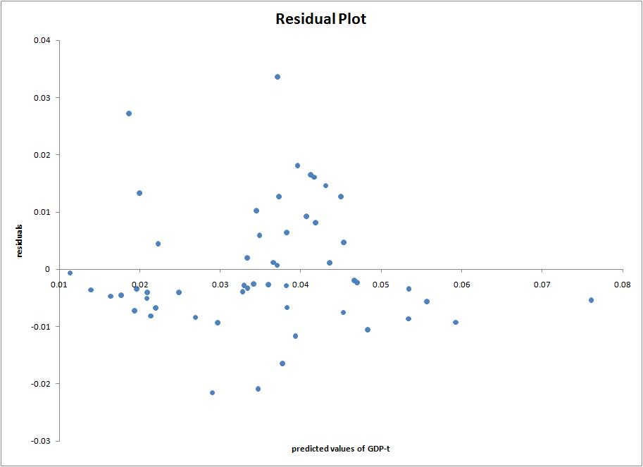
MODEL 2: No Life Expectancy – Official Language interaction
 | Intercept | Life Exp. (LE) | Literacy Rate (LR) | Urban Pop. (UP) | English – Off. Lang. (E) | LR x E | UP x E
Coefficient | .041673 | .564377 | -.00378 | -.02055 | .000409 | -.00809 | .009624
SE of Coefficient | .009271 | .47179 | .002669 | .004532 | .006959 | .004179 | .007599
t-ratio | 4.4952 | 1.1962 | -1.4164 | -4.5336 | .0588 | -1.9363 | 1.2666
Significance | .0047% | 23.7730% | 16.3387% | .0041% | 95.3390% | 5.8984% | 21.1688%

 |  |  |  | Sum of Squares | Degrees of Freedom
Standard Error of Regression | .011532 |  | Regression | .008298667 | 6
Coefficient of Determination | 57.57% |  | Residual | .006116885 | 46
Adjusted Coefficient of Determination | 52.03% |  | Total | .014415552 | 52
# of Observations | 53 |  | F-ratio | 10.4012
Residual Deg. Of Freedom | 46 |  | Degrees of Freedom | (6,46)
t-statistic for computing 95%-confidence intervals | 2.0129 |  | Significance | .00003%

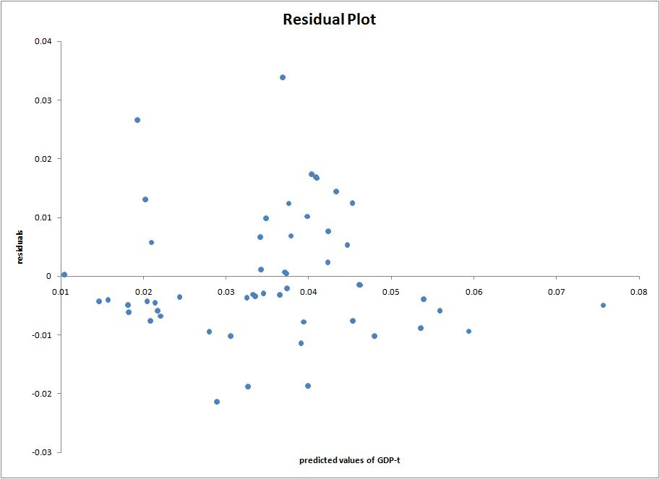
MODEL 3: No Literacy Rate – Official Language interaction
 | Intercept | Life Exp. (LE) | Literacy Rate (LR) | Urban Pop. (UP) | English – Off. Lang. (E) | LE x E | UP x E
Coefficient | .042882 | .471105 | -.00693 | -.01791 | -.00619 | .102575 | .006711
SE of Coefficient | .013297 | .697823 | .002228 | .004497 | .019743 | .941359 | .007829
t-ratio | 3.2250 | .6751 | -3.1122 | -3.9828 | -.3136 | .1090 | .8571
Significance | .2320% | 50.2988% | .3189% | .0240% | 75.5263% | 91.3704% | 39.5808%

 |  |  |  | Sum of Squares | Degrees of Freedom
Standard Error of Regression | .011991 |  | Regression | .007801792 | 6
Coefficient of Determination | 54.12% |  | Residual | .00661376 | 46
Adjusted Coefficient of Determination | 48.14% |  | Total | .014415552 | 52
# of Observations | 53 |  | F-ratio | 9.0438
Residual Deg. Of Freedom | 46 |  | Degrees of Freedom | (6,46)
t-statistic for computing 95%-confidence intervals | 2.0129 |  | Significance | .00016%

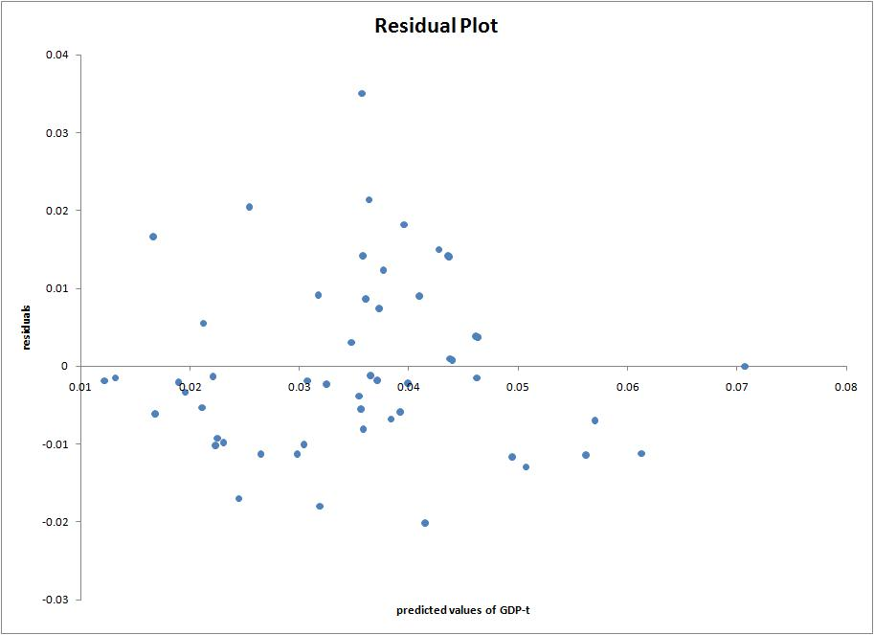
MODEL 4: No Urban Population – Official Language interaction
 | Intercept | Life Exp. (LE) | Literacy Rate (LR) | Urban Pop. (UP) | English – Off. Lang. (E) | LE x E | LR x E
Coefficient | .035997 | .774624 | -.00437 | -.01736 | .017471 | -.55757 | -.00779
SE of Coefficient | .013214 | .70024 | .0027 | .003699 | .019717 | .953685 | .004362
t-ratio | 2.7242 | 1.1062 | -1.6186 | -4.6938 | .8861 | -.5847 | -1.7863
Significance | .9082% | 27.4381% | 11.2367% | .0024% | 38.0177% | 56.1639% | 8.0637%

 |  |  |  | Sum of Squares | Degrees of Freedom
Standard Error of Regression | .011688 |  | Regression | .008132042 | 6
Coefficient of Determination | 56.41% |  | Residual | .00628351 | 46
Adjusted Coefficient of Determination | 50.73% |  | Total | .014415552 | 52
# of Observations | 53 |  | F-ratio | 9.9221
Residual Deg. Of Freedom | 46 |  | Degrees of Freedom | (6,46)
t-statistic for computing 95%-confidence intervals | 2.0129 |  | Significance | .00005%

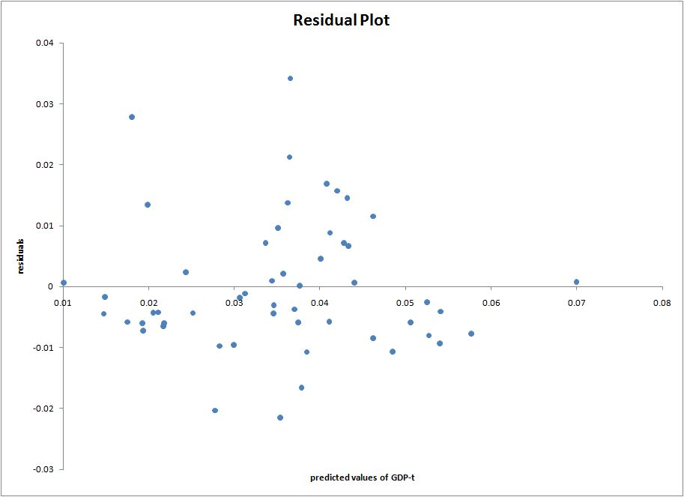
MODEL 5: Without Life Expectancy factor
 | Intercept | Literacy Rate (LR) | Urban Pop. (UP) | English – Off. Lang. (E) | LR x E | UP x E
Coefficient | .051991 | -.00463 | -.02036 | .003028 | -.00788 | .008226
SE of Coefficient | .003415 | .002583 | .00455 | .006636 | .004194 | .007543
t-ratio | 15.2263 | -1.7938 | -4.4738 | .4562 | -1.8782 | 1.0906
Significance | .0000% | 7.9284% | .0049% | 65.0334% | 6.6562% | 28.1002%

 |  |  |  | Sum of Squares | Degrees of Freedom
Standard Error of Regression | .011584 |  | Regression | .008108378 | 5
Coefficient of Determination | 56.25% |  | Residual | .006307173 | 47
Adjusted Coefficient of Determination | 51.59% |  | Total | .014415552 | 52
# of Observations | 53 |  | F-ratio | 12.0845
Residual Deg. Of Freedom | 47 |  | Degrees of Freedom | (5,47)
t-statistic for computing 95%-confidence intervals | 2.0117 |  | Significance | .00001%

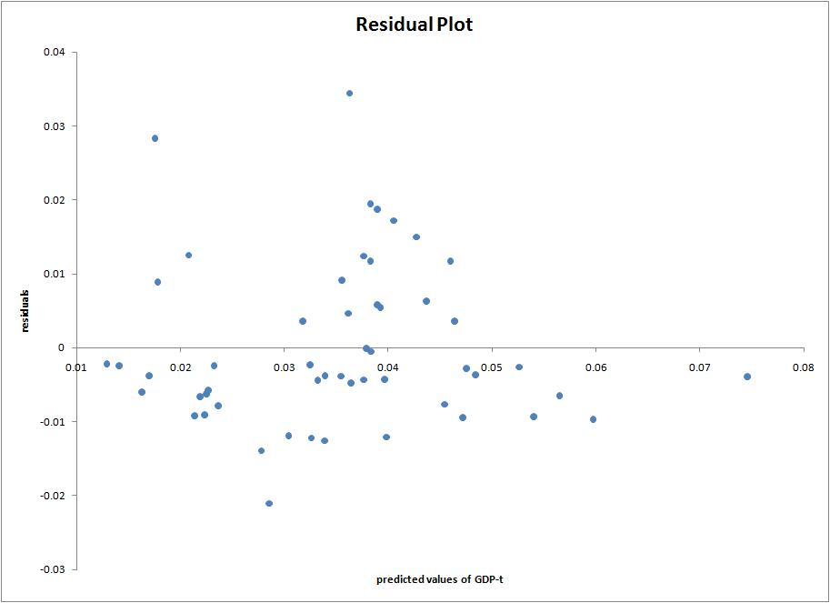
MODEL 6: Without Literacy Rate factor
 | Intercept | Life Exp. (LE) | Urban Pop. (UP) | English – Off. Lang. (E) | LE x E | UP x E
Coefficient | .031974 | 1.121404 | -.02328 | -.00883 | -.25933 | .012295
SE of Coefficient | .013961 | .724718 | .004521 | .02147 | 1.016808 | .008295
t-ratio | 2.2901 | 1.5474 | -5.1487 | -.4115 | -.2550 | 1.4822
Significance | 2.6547% | 12.8483% | .0005% | 68.2612% | 79.9806% | 14.4958%

 |  |  |  | Sum of Squares | Degrees of Freedom
Standard Error of Regression | .013052 |  | Regression | .006409222 | 5
Coefficient of Determination | 44.46% |  | Residual | .00800633 | 47
Adjusted Coefficient of Determination | 38.55% |  | Total | .014415552 | 52
# of Observations | 53 |  | F-ratio | 7.5249
Residual Deg. Of Freedom | 47 |  | Degrees of Freedom | (5,47)
t-statistic for computing 95%-confidence intervals | 2.0117 |  | Significance | .00295%

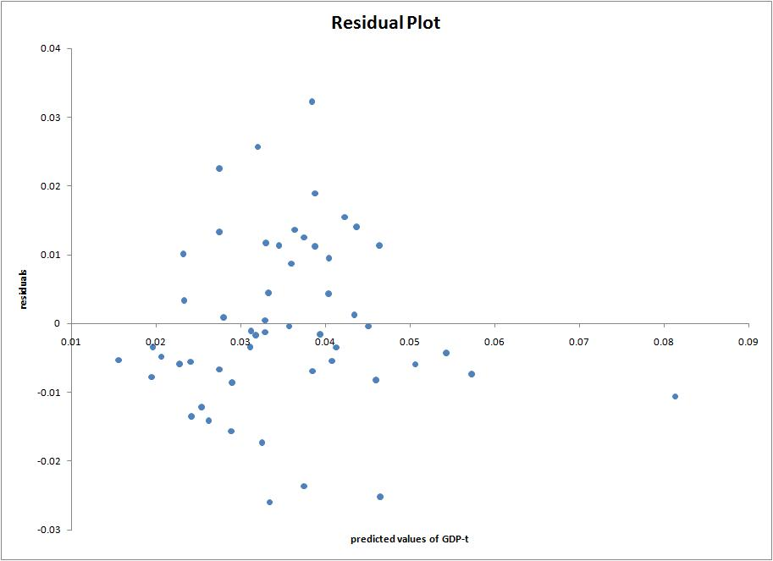
MODEL 7: Without Urban Population factor
 | Intercept | Life Exp. (LE) | Literacy Rate (LR) | English – Off. Lang. (E) | LE x E | LR x E
Coefficient | .028753 | .637933 | -.0094 | .005415 | -.01127 | -.00259
SE of Coefficient | .015789 | .841741 | .002981 | .023519 | 1.138818 | .005076
t-ratio | 1.8211 | .7579 | -3.1543 | .2302 | -.0099 | -.5110
Significance | 7.4958% | 45.2310% | .2803% | 81.8916% | 99.2147% | 61.1736%

 |  |  |  | Sum of Squares | Degrees of Freedom
Standard Error of Regression | .014061 |  | Regression | .005122512 | 5
Coefficient of Determination | 35.53% |  | Residual | .00929304 | 47
Adjusted Coefficient of Determination | 28.68% |  | Total | .014415552 | 52
# of Observations | 53 |  | F-ratio | 5.1815
Residual Deg. Of Freedom | 47 |  | Degrees of Freedom | (5,47)
t-statistic for computing 95%-confidence intervals | 2.0117 |  | Significance | .07229%

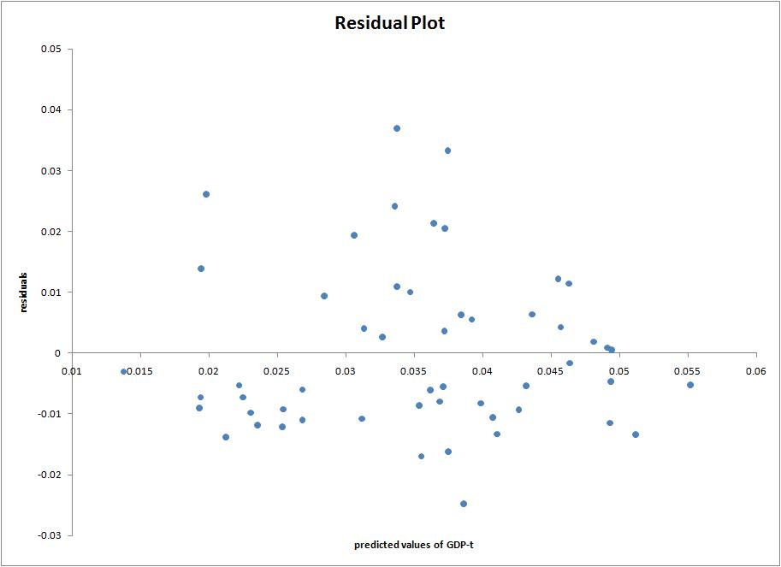
MODEL 8: Without interactions
 | Intercept | Life Exp. (LE) | Literacy Rate (LR) | Urban Pop. (UP) | English – Off. Lang. (E)
Coefficient | .04169 | .463409 | -.00738 | -.01568 | .000515
SE of Coefficient | .009509 | .478281 | .00211 | .003618 | .003943
t-ratio | 4.3844 | .9689 | -3.4981 | -4.3339 | .1306
Significance | .0063% | 33.7450% | .1021% | .0075% | 89.6656%

 |  |  |  | Sum of Squares | Degrees of Freedom
Standard Error of Regression | .011832 |  | Regression | .007696052 | 4
Coefficient of Determination | 53.39% |  | Residual | .0067195 | 48
Adjusted Coefficient of Determination | 49.50% |  | Total | .014415552 | 52
# of Observations | 53 |  | F-ratio | 13.7440
Residual Deg. Of Freedom | 48 |  | Degrees of Freedom | (4,48)
t-statistic for computing 95%-confidence intervals | 2.0106 |  | Significance | .00002%

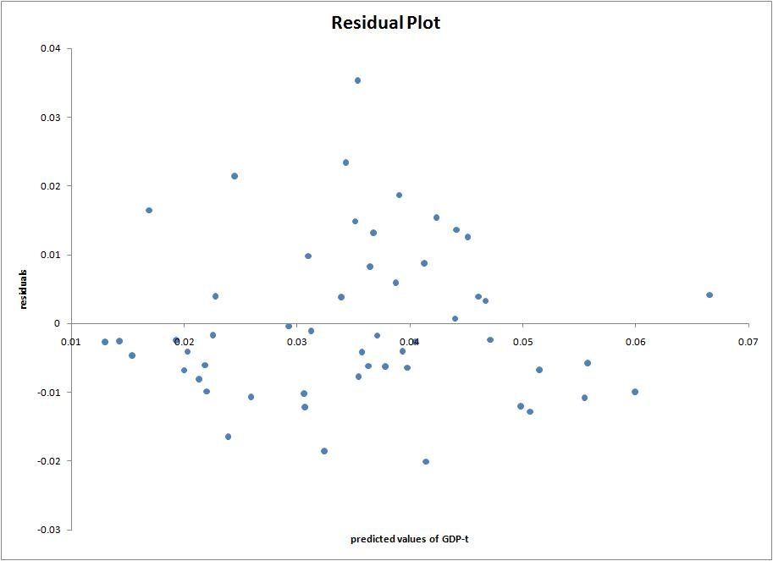
MODEL 9: Without Official Language factor
 | Intercept | Life Exp. (LE) | Literacy Rate (LR) | Urban Pop. (UP)
Coefficient | .041385 | .488173 | -.00725 | -.01575
SE of Coefficient | .009124 | .434649 | .001858 | .003544
t-ratio | 4.5357 | 1.1231 | -3.9039 | -4.4425
Significance | .0037% | 26.6849% | .0289% | .0051%

 |  |  |  | Sum of Squares | Degrees of Freedom
Standard Error of Regression | .011712 |  | Regression | .007693665 | 3
Coefficient of Determination | 53.37% |  | Residual | .006721887 | 49
Adjusted Coefficient of Determination | 50.52% |  | Total | .014415552 | 52
# of Observations | 53 |  | F-ratio | 18.6946
Residual Deg. Of Freedom | 49 |  | Degrees of Freedom | (3,49)
t-statistic for computing 95%-confidence intervals | 2.0096 |  | Significance | .00000%

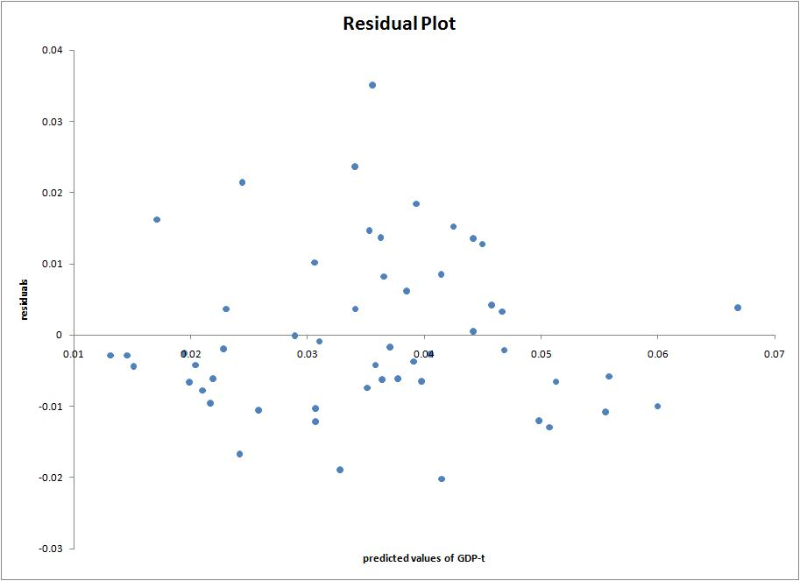

ANALYSIS OF VARIANCE AND INCREMENTAL F-TESTS
Table 1 below shows the regression sums of squares for each of the models used to fit these data. Table 2 is an analysis-of-variance table which also provides the incremental F-tests for each of the terms.

Table 1.
Model | Terms | Parameters | Regression Sum of Squares | Degrees of Freedom
1 | LE,LR,UP,E,LExE,LRxE,UPxE |  | .008328 | 8
2 | LE,LR,UP,E,LRxE,UPxE |  | .008299 | 7
3 | LE,LR,UP,E,LExE,UPxE |  | .007802 | 7
4 | LE,LR,UP,E,LExE,LRxE |  | .008132 | 7
5 | LR,UP,E,LRxE,UPxE |  | .008108 | 6
6 | LE,UP,E,LExE,UPxE |  | .006409 | 6
7 | LE,LR,E,LExE,LRxE |  | .005123 | 6
8 | LE,LR,UP,E |  | .007696 | 5
9 | LE,LR,UP |  | .007694 | 4

Table 2.
Source | Models Contrasted | Sum of Squares | df | F | P
Life Expectancy (LE) | 2, 5 | .000190 | 1 | 1.406567 | .241846
Literacy Rate (LR) | 3, 6 | .001393 | 1 | 10.293525 | .002461
Urban Population (UP) | 4, 7 | .003010 | 1 | 22.245682 | .000023
English – Off. Lang. (E) | 8, 9 | .000002 | 1 | .017643 | .894931
LE x E | 1, 2 | .000029 | 1 | .214459 | .645526
LR x E | 1, 3 | .000526 | 1 | 3.887236 | .054822
UP x E | 1, 4 | .000196 | 1 | 1.446109 | .235444
Residuals | - | .006088 | 45 | - | -
Total | - | .014416 | 52 | - | -

ENDORSEMENT OF A BETTER MODEL
It is evident from the high F-test values and low p-values in Table 2 for Literacy Rate and Urban Population that the contribution made by each explanatory variable is significant. Of the nine models, the ones that didn’t account for Literacy Rate and Urban Population (Models 6 and 7) clearly have the lowest adjusted coefficient of determination, Ř², indicating that those linear regression models explain comparatively little of the variation in the data. The remaining models have nearly the same coefficient of determination. Rather consistently, the coefficients for the intercept, Literacy Rate, and Urban Population are significant at the 95% level. For this reason, there is motivation to propose a Model 10, which would account for only those two factors. The results are below:
MODEL 10: Only Literacy Rate and Urban Population are factors
 | Intercept | Literacy Rate (LR) | Urban Pop. (UP)
Coefficient | .051146 | -.0075 | -.01633
SE of Coefficient | .002787 | .00185 | .003515
t-ratio | 18.3509 | -4.0552 | -4.6463
Significance | .0000% | .0175% | .0025%

 |  |  |  | Sum of Squares | Degrees of Freedom
Standard Error of Regression | .011743 |  | Regression | .007520617 | 2
Coefficient of Determination | 52.17% |  | Residual | .006894935 | 50
Adjusted Coefficient of Determination | 50.26% |  | Total | .014415552 | 52
# of Observations | 53 |  | F-ratio | 27.2686
Residual Deg. Of Freedom | 50 |  | Degrees of Freedom | (2,50)
t-statistic for computing 95%-confidence intervals | 2.0086 |  | Significance | .00000%

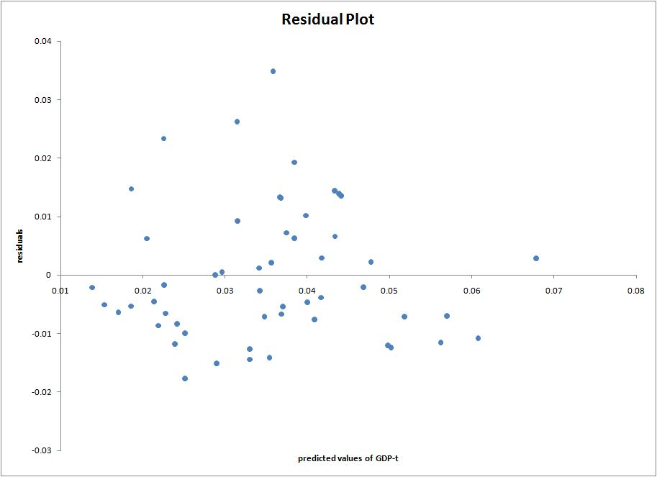
Only roughly half of the variation in the data is explained by this model, but the coefficients are clearly statistically significant. The residuals tend to have greater magnitude away from the tails of the data, which may hint at uneven variance. Nevertheless, restricting the analysis to the explanatory causes first proposed in the beginning, this model seems to be the best option. The full regression model would be
or

.
Because of the transformations, the relationship between literacy rate and per-capita GDP is positive, as is also the relationship between urban population percentage and per-capita GDP.

CONCLUSION
The positive correlations between literacy rate and per-capita GDP and between urban population percentage and per-capita GDP were confirmed, while life expectancy and having English as an official language were not shown to have much explanatory power on it. It should be expected that a large-scale nationwide macroeconomic measure such as GDP would be better explained by more relevant economic data, and even characteristics that cannot be legitimately quantified (such as type of government, economic policy, and general business stability). Furthermore, there are bigger flaws for this regression as a predictive model: literacy rates and urban population percentages near 100% are not unheard of in some nations, nor is inflation taken into account. Nevertheless, it may be safely conjectured that an increase in a literate population and the presence of a strong urban population is not detrimental to a nation’s GDP. It would be interesting to see how strong the relationship held for countries in other continents.

APPENDIX
The data were found and gathered from two different sources. In retrospect, it perhaps would have been better practice to confine the analysis to one source than “cobble together” data from both, as this already sets the information on uneven ground.

From the CIA’s “The World Factbook”:
https://www.cia.gov/library/publications/the-world-factbook/fields/2102.html
https://www.cia.gov/library/publications/the-world-factbook/fields/2103.html?countryName=&countryCode=&regionCode=s
https://www.cia.gov/library/publications/the-world-factbook/fields/2212.html?countryName=&countryCode=&regionCode=%C3%82
https://www.cia.gov/library/publications/the-world-factbook/fields/2195.html
https://www.cia.gov/library/publications/the-world-factbook/fields/2098.html

From the UN’s “Human Development Report”:
http://hdr.undp.org/en/media/HDR_2009_EN_Complete.pdf, Table H

The raw data are attached as an Excel file.

