xxxxxxxx xxxx
Time Series
Fall 2010
Student Project

National Unemployment Rate

Introduction & Objective:
Unemployment rate has been the focus of many discussions since the start of the “Great Recession”, and it continues to be the focus of many economists.

The report utilizes the monthly Unemployment Rate from 1948 through 2010 gathered from the Bureau of Labor Statistics (http://www.bls.gov/data/#unemployment). The goal is to fit various time series model to the data through the following analysis,
- Stationarity & Autocorrelation Function
- Model Estimation
- Durbin-Watson Test
- Box and Pierce Q Statistic

Data:
I obtained the monthly unemployment rate from 1948 through 2010 through. Both the unadjusted and seasonally adjusted rates are included. Figure 1 shows the plot of the unadjusted unemployment rate on the Y-axis and the date on the X-axis.

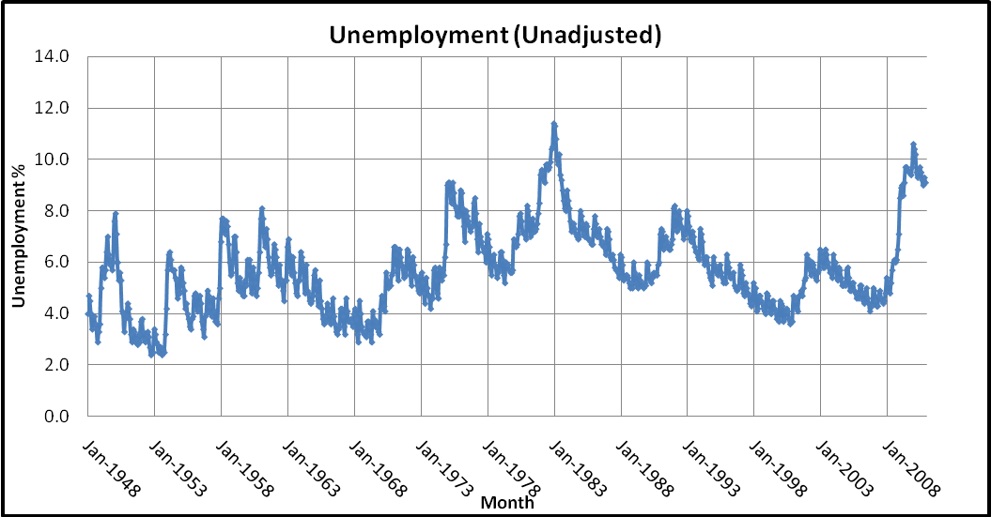
Figure 1
The unadjusted unemployment data exhibits seasonal patterns—For example, the unemployment rate hits its highest point in January 1983 then declines over the next six years. However, the small peaks are clearly visible.

Figure 2 is a plot of the seasonally adjusted unemployment rate from 1948 through 2010. With the seasonally adjusted unemployment rate, the plot is much smoother. The Bureau of Labor Statistics utilizes an ARIMA model (named the X-12-ARIMA seasonal adjustment program) to adjust the published unemployment rate for seasonality.

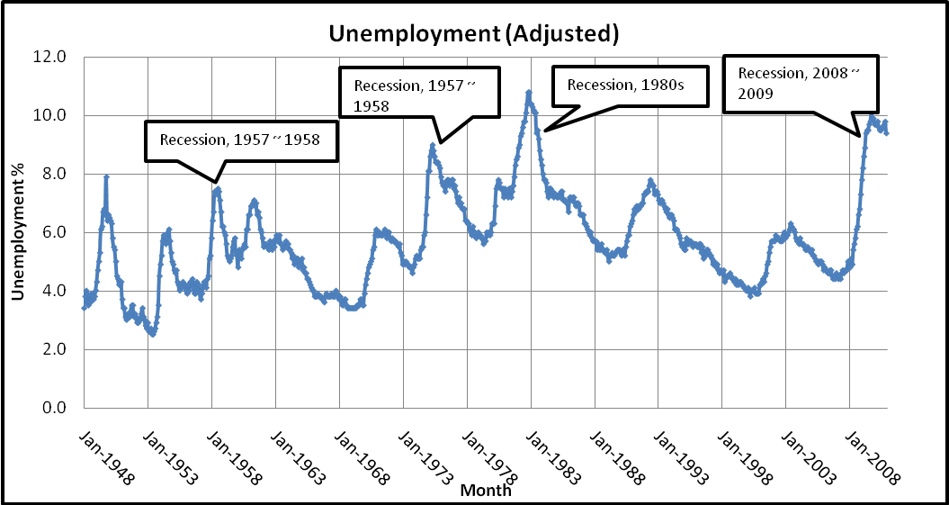
Figure 2
By using the seasonally adjusted data, I do not have to account for seasonality.

Stationarity and Autocorrelation Function:
One method to determine if the data is stationary is to examine the sample autocorrelation; for comparison purpose, I graphed the correlograms of both the unadjusted (Figure 3) and seasonally adjusted (Figure 4) unemployment rates.

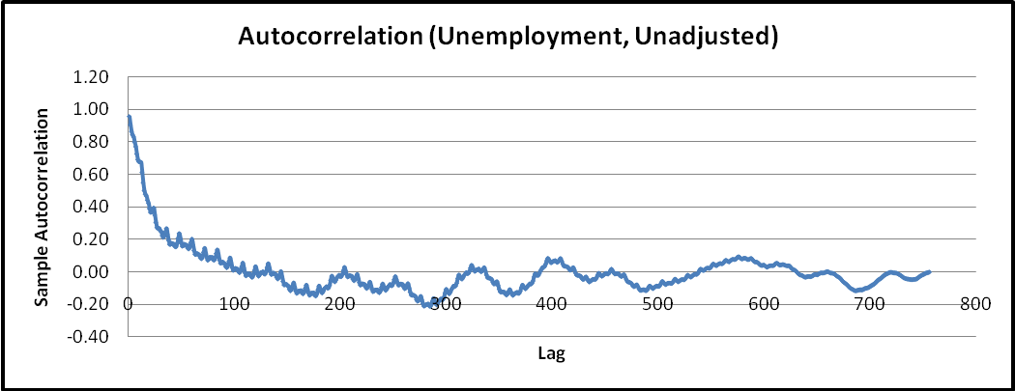
Figure 3
In Figure 3, the sample autocorrelation function of the unadjusted unemployment data decreases quickly but contains peaks due to seasonality. Figure 4 shows a very similar pattern. However, the peaks are not visible in this graph. Given that Figure 4 seems to be approaching zero as lag increases, we can safely assume that the time series is stationary, which permits us to perform regression analysis on the data.

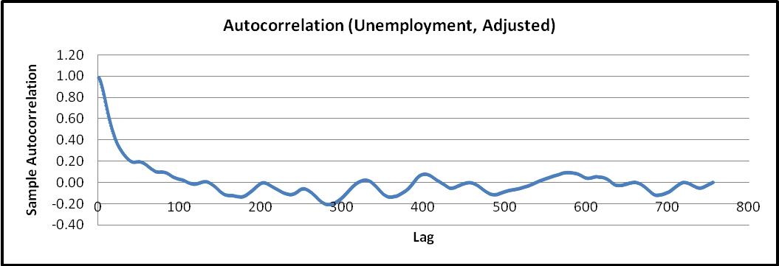
Figure 4
Out of curiosity, I also graphed the First Difference (Figure 5) of the seasonally adjusted data and the corresponding correlogram (Figure 6). The various recession periods (as indicated in Figure 2) are not as easy to identify in Figure 5. Furthermore, it turns out that the autocorrelation function of the first difference decreases even faster than the other two autocorrelation functions and fluctuates around zero as well. Seeing this, I will try to model the first difference and compare the result to that of the adjusted data.

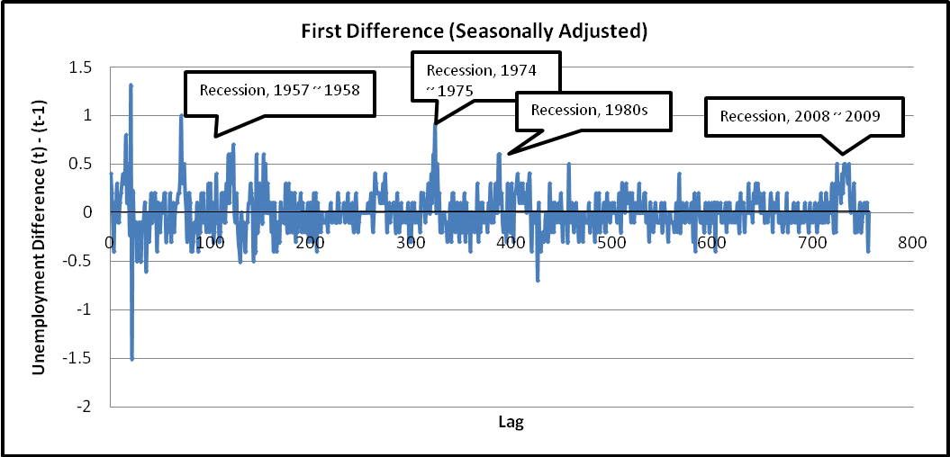
Figure 5
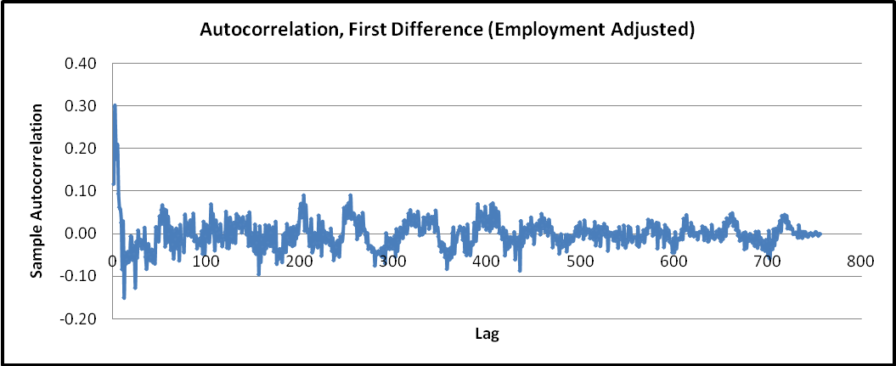
Figure 6
Model Estimate:
I will first fit an AR(1) process to the seasonally adjusted unemployment rate. An AR(1) model has the general form,
Using Excel, I obtained the following,
R Square | 0.98231
Adjusted R | 0.98228
Intercept | 0.04697
X Variable | 0.99317

R square is very high, indicating that the process may be a good fit. An AR(2) process is unlikely to improve the fit further while increasing the complexity of the model

Using Excel, I obtained the following information for fitting an AR(1) model to the first difference,

R Square | 0.01380
Adjusted R | 0.01249
Intercept | 0.00649
X Variable | 0.11721

The R Square value is quite low, and the model does not look like a good fit. As such we proceed to try AR(2) and AR(3) model which have the following general forms and results from Excel,

R Square | 0.09678
Adjusted R | 0.09437
Intercept | 0.00409
X Variable 1 | 0.08136
X Variable 2 | 0.29072

R Square | 0.12805
Adjusted R | 0.12456
Intercept | 0.00336
X Variable 1 | 0.02944
X Variable 2 | 0.27769
X Variable 3 | 0.18211
Both the AR(2) and AR(3) models show improvement over the AR(1) for fitting the first difference.

Durbin-Watson Test:
The Durbin-Watson test is performed to test the Null Hypothesis: No serial correlation for the regression.

Model | Durbin-Watson Stat. | Result
Adjusted Data – AR(1) | 1.749 | Accept
First Difference – AR(1) | 2.071 | Accept
First Difference – AR(2) | 2.102 | Accept
First Difference – AR(3) | 2.026 | Accept

For all cases, we accept that there is no serial correlation.

Box-Pierce Q Statistic:
The Box-Pierce Q Statistic test is performed to determine whether the time series is a white noise process. Ata 10% significant level, the critical X-squared value is 540.93 for 500 degrees of freedom. At K = 500, we have the following,

Model | Box-Pierce Q Stat. | Result
Adjusted Data – AR(1) | 623 | Reject
First Difference – AR(1) | 828 | Reject
First Difference – AR(2) | 376 | Cannot Reject
First Difference – AR(3) | 350 | Cannot Reject

We reject the notion that both AR(1) processes are white noise processes. Between the AR(2) and AR(3) processes for modeling the first difference, the AR(3) process has a lower Box-Pierce Q Statistic and higher R Square. It may be the better fit.

Model vs. Actual:
Since both AR(1) processes failed the Box-Pierce Q Statistic tests, there are excluded in this section. Below, I plotted the forecasted first difference from the two processes and the actual first difference of the seasonally adjusted data.

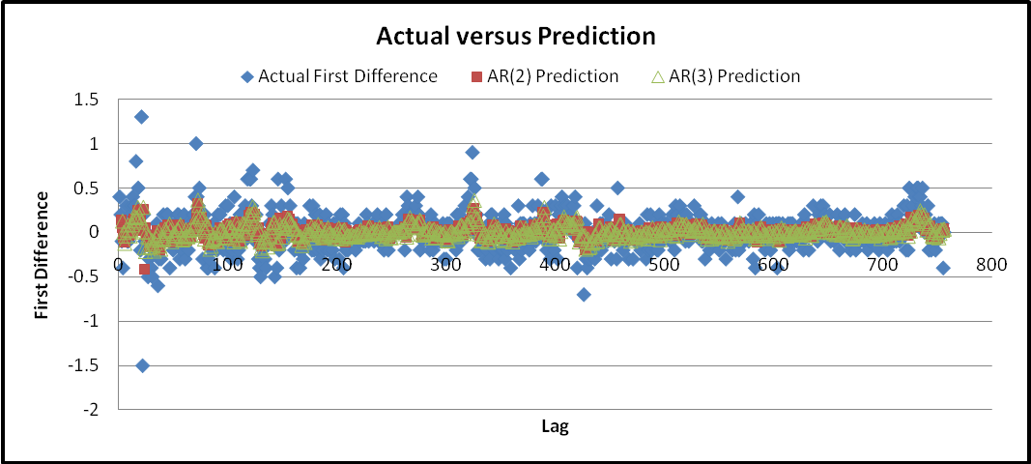
Figure 7

The predicted values fall within a much smaller range than the actual differences. The two processes are also unable to forecast large changes in the first difference. I also included the residual plot below, which shows that for the most part, the forecasted values are within the range of -0.5 to 0.5. Again, there are some significant deviations (above 1 and below -1) from the actual first difference.

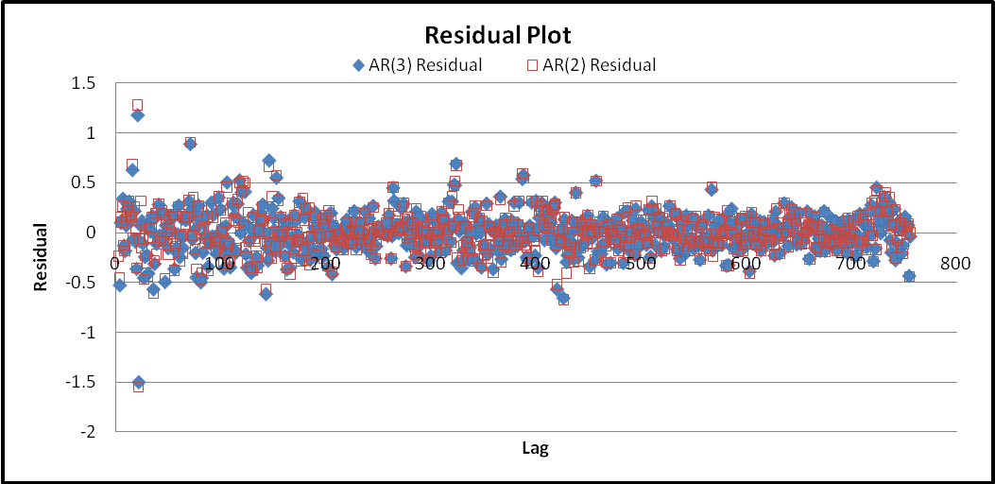
Figure 8
The graph below shows the result of fitting both models to the adjusted unemployment rate; it is very hard to determine which process fits better.

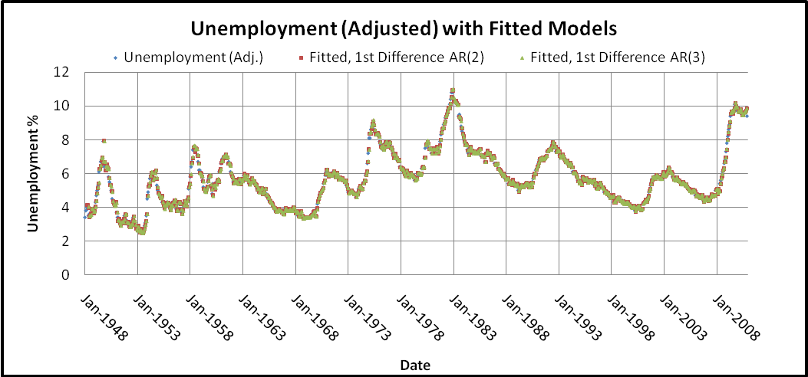
Figure 9
The next graph focuses on the last five years instead of the full data. It may not be obvious given the graph below, but the AR(3) model seems to trace the actual data better. There also appears to be a visible lag between the forecasted values and the original series.
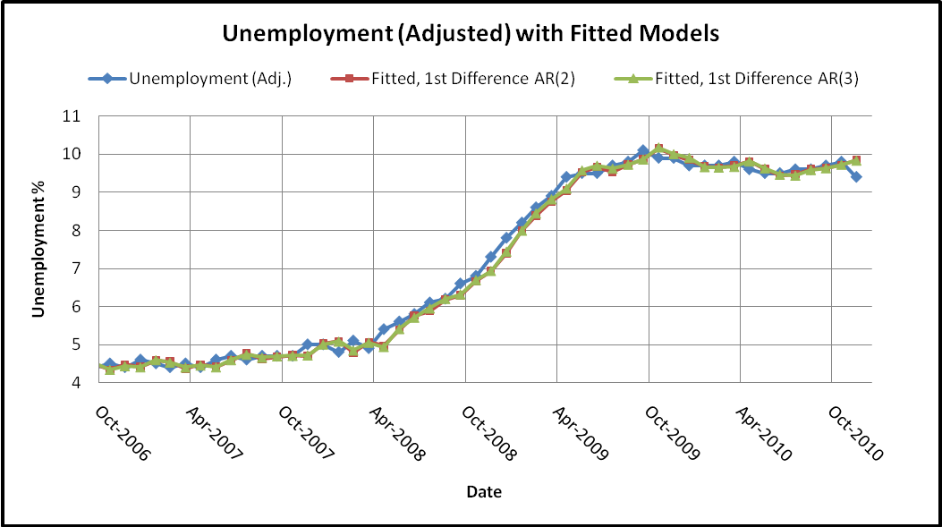
Figure 10
Conclusion:
In conclusion, I deduce that the best model is an AR(3) process fit to the first difference of the seasonally adjusted unemployment rate. Given the statistical tests and regression analysis performed, an AR(2) process is also appropriate for fitting the first difference. However, neither of the AR(1) processes should be used.

Seasonal Adjustment. http://www.bls.gov/cps/eetech_seas.pdf

