xxxx xxxxx
Winter 2011
VEE – Regression Analysis
Student Project

OSTEOPOROSIS

Introduction

Osteoporosis is a disease of the bone where the bone mineral density is low, thereby causing to an increased risk of fracture on the hips and spine. This is a “silent” disease because oftentimes, one does not know he or she is afflicted until he or she suffered from fracture or injury.

I chose this for my student project because I have been diagnosed to be at high risk for osteoporosis, being with low bone mass. In this regards, I would like to understand better which of the potential risk factors: race, gender, and physical activity may lead to an increased chance of having osteoporosis.

Data used for the analysis are sourced from the following:
- National Osteoporosis Foundation
< http://www-958.ibm.com/software/data/cognos/manyeyes/datasets/prevalence-of-osteoporosis-in-the-/versions/1.txt>

- Physical Activity in the US by Gender and Race (Year 2007 National Average) <http://apps.nccd.cdc.gov/PASurveillance/DemoCompareResultV.asp#result>

Analysis

The explanatory variables in the analysis are:
- X1 - Race, which may have any of the following values:

1 – Caucasian
2 – Asian
3 – Hispanic
4 – Black

- X2 - Gender, which could either be:

1 – Female
2 – Male

- X3 - Physical activity, which is measured in terms of inactivity or spending less than 10 minutes total per week of moderate or vigorous intensity lifestyle activities (i.e., household, transportation, or leisure-time activity)

The response variable is:
- Y - Prevalence or percentage of the U.S. population having osteoporosis.
In this project, I will analyze different models to determine which one is the most predictive based on the adjusted R² value and the p-value.

Scenario 1: I ran a regression on all explanatory variables (X1: Race, X2: Gender, X3: Inactivity) using Excel’s Regression add-ins.

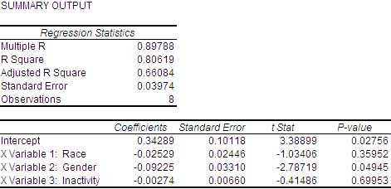

Based on the results, the regression equation would be:

Y = 0.34289 - 0.02529 X1 - 0.09225 X2 - 0.00274 X3

The adjusted R² is 66.08%, indicating that this regression equation explains about 66.08% of the variation in the dependent variable. Of the explanatory variables, X3: Inactivity has a very high p-value, which implies that it may not be a good predictor of the prevalence of osteoporosis in the US population. Its t-statistic of -0.41 does not meet the requirement of a two-tailed test at the 95% significance level. The F-statistic is 5.55.

Scenario 2: I removed X3: Inactivity from the model, I ran a regression on the two remaining explanatory variables (X1: Race, X2: Gender) using Excel’s Regression add-ins.

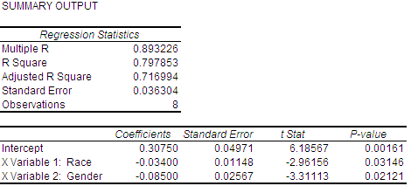

Based on the results, the regression equation would be:

Y = 0.3075 - 0.034 X1 - 0.085 X2

The adjusted R² increased from Scenario 1, now @ 71.70%, indicating that this regression equation explains about 71.70% of the variation in the dependent variable. Both explanatory variables have low p-values, thus both play significant role in predicting the prevalence of osteoporosis. The t-statistics of -2.96 and -3.31, respectively, do not meet the requirement of a two-tailed test at the 95% significance level. The F-statistic increased from 5.55 to 9.87, indicating a stronger test.

The graph shows that since both explanatory variables could be good predictor, I ran two more regression on each variable only to see which of the two could best predict the prevalence of osteoporosis in the US population.

Scenario 3: Regression on X1: Race shows the following results with a regression equation of:

Y = 0.18 – 0.034 X1

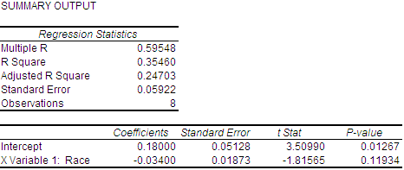

The adjusted R² is only 24.7%. Hence, the regression equation only explains about 24.70% of the variation in the dependent variable. The p-value increases from Scenario 2, i.e., from 0.03 to 0.11, indicating that when considered alone, race may not be as significant in predicting the prevalence of osteoporosis. The t-statistics of -1.82 does not meet the requirement of a two-tailed test at the 95% significance level. The F-statistic decreased from 9.87 to 3.30, indicating a weaker test.

Now, let us take a look at the next scenario, regressing on gender alone.

Scenario 4: Regression on X2: Gender shows the following results with a regression equation of:

Y = 0.2225 – 0.085 X2

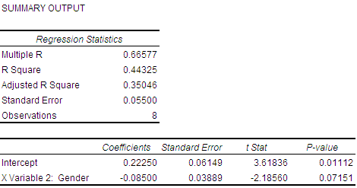

Compared to Scenario 3 which regresses on race alone, the p-value is lower at 0.07, which implies that gender could be a better predictor than race. The adjusted R² is slightly higher at 35.05%, indicating that this regression equation explains about 35.05% of the variation in the dependent variable. The t-statistic of -2.18 does not meet the requirement of a two-tailed test at the 95% significance level. The F-statistic increased from 3.30 to 4.78, indicating a better test.

Conclusion

Based on the foregoing analysis of the four scenarios, it is apparent that Scenario 2 could be the best predictor of the prevalence of osteoporosis. Regression on both race and gender yields the highest adjusted R² indicating that the regression line for this model is a better fit than what we had in the single explanatory variable models nor in the three explanatory variable model. The two explanatory variables explain about 71.70% of the variation in the dependent variable. Further, this model shows the lowest p-value for both explanatory variables, which implies that they are good predictors of the response variable, the prevalence of osteoporosis. This adjusted R² also suggests that there are likely other factors that influence the prevalence of osteoporosis and can explain the other 28.30% of the variation in the dependent variable. It is imperative that these other factors be identified, included, and analyzed together with race, gender, and inactivity in order to improve the model significantly.

