NEAS VEE Student Project
Regression Analysis
xxxx xxxxxx
Course Taken Summer 2009
Section 1 – Abstract
The purpose of this study is to quantify the effects of variables such as age, gender, height, and smoking status on Forced Expiratory Volume (FEV), also known as Forced Vital Capacity (FVC). FEV is defined as the volume of air that can be blown out after full inspiration and is measured in liters. Particularly, we will attempt to either support or reject the following hypothesis:
- Hypothesis 1:
  - Null Hypothesis: H1₀ = Smoking decreases FEV
  - Alternative Hypothesis: H1₁ = Smoking increases or has no effect on FEV
- Hypothesis 2:
  - Null Hypothesis: H2₀ = Age increases FEV
  - Alternative Hypothesis: H2₁ = Age decreases or has no effect on FEV
Additionally, we will explore a good regression model for FEV.

Section 2 – Data
The data for this study was obtained from a population in the area of East Boston in the 1970’s. The data contains 654 observations of youth people ages 3 to 19. The variables available in the dataset are Age, Forced Expiratory Volume, Height, Gender, and Smoking Status. To review the dataset, please follow the link below:
http://www.sci.usq.edu.au/staff/dunn/Datasets/applications/health/fev.html
The data mentioned above will, for the purpose of this analysis, suffice. However, there are known limitations of the data that may cause the results to differ from a larger, more current dataset. The first known limitation is the time period during which the data was obtained. Any trends or changes in the environment since the 1970’s will not be reflected in the analysis below. Secondly, the amount of data collected is not sufficient in size for certain analysis. The limitation of 654 records of data causes certain breakouts of the data to be insufficient in size to make any significant or highly probable conclusions. For example, if we wanted to eliminate the effects of age on FEV in order to better determine the effect of the other variables, we would want to split the data by age, and would end up with 15 sets of data with somewhere around 45 observations each–none of which would not produce highly credible results.
For the purpose of this analysis I will define the variables as follows:
Y = FEV
X1 = Dummy Variable for Smoking Status (1 = smoker; 0 = non-smoker)
X2 = Dummy Variable for Male Gender (1 for male; 0 for female)
X3 = Dummy Variable for Female Gender (1 for female; 0 for male)
X4 = Age (years)
X5 = Height (inches)

Section 3 – Analysis
Subsection 3a - Data Review
The first step in my analysis is to inspect the graphical relationship between FEV and the relevant variables. This will provide guidance in determining the correct variables to include in my analysis.
Analysis of Age (X4)
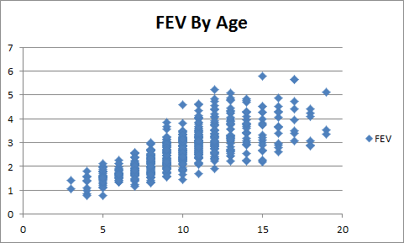
From the graph above, I suspect that there is a positive relationship between FEV and Age. This makes sense because between the ages of 3 to 18, a majority of physical development occurs, which, of course, includes physical development of lung size and therefore capacity.
Although there appears to be a relationship between Age and FEV, there is also a trouble item that we must watch out for. If we compare the FEV of smokers and the FEV of non-smokers when the mean age of the smokers is significantly higher than the mean age of non-smokers we will be less likely than we should to conclude that smoking reduces FEV. This must be taken into account in our analysis. To determine the significance of this issue at a glance, I created two distributions. Distribution 1A is the distribution of smokers by age. Distribution 1B is the distribution of non-smokers by age.
Distribution 1A
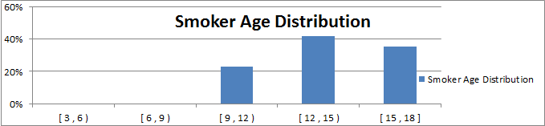

Distribution 1B
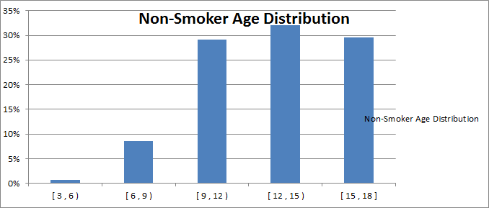
Upon inspecting Distribution 1A and Distribution 1B it is apparent that the above mentioned issue will affect the results to a moderate extent. Particularly, non-smokers were observed in the age buckets 3 to 6 and 6 to 9, while there were no smokers observed in these buckets. Additional analysis shows that the mean age of smokers is 13.5; whereas, the mean of non-smokers is 9.5. My decision is to truncate the data, eliminating participants age 8 and younger. The resulting mean age of smokers is 13.5, and the mean age of non-smokers is 11.1. This difference is more acceptable.
Analysis of Height (X5)
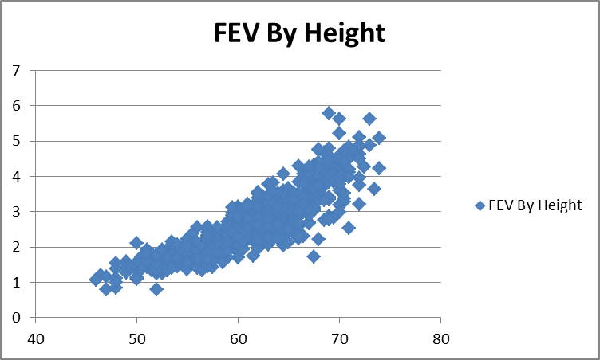
The graph above clearly indicates that there is strong positive relationship between FEV and Age.
We know a priori that there is some degree of multicolinearity between the independent variables X4 (Age) and X3 (Height). I suspect that the best course of action will be to compare the results of the regressions on Y = B3*X3 and Y = B4*X4, pick the variable that produces the best fit, and throw away the other.
Analysis of Gender (X2 and X3)
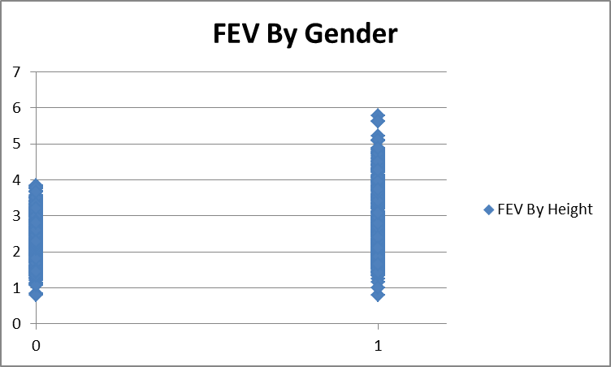
Given the graph above, it is difficult to form any hypothesis. A distribution by Gender and FEV Bucket would help shed some light on the relationship between Gender and FEV.
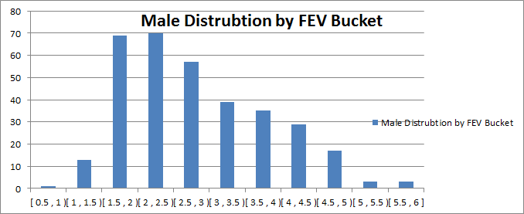

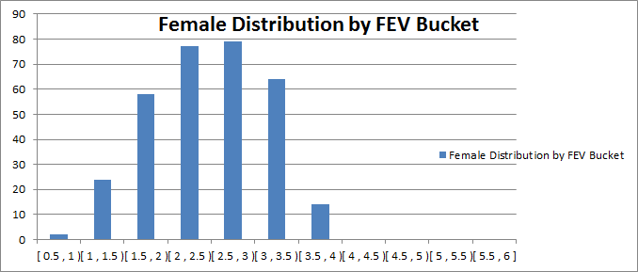
It appears that there is also some relationship between Gender and FEV. Hence, we will include these two dummy variables in the analysis.
Analysis of Smoking Status (X1)
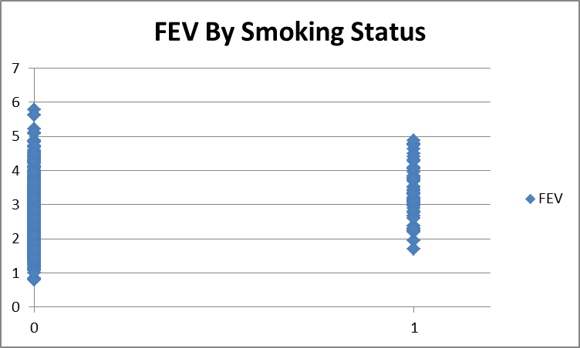
At a glance, this graph is surprising. I would expect that we would see some increase in FEV given smoking status. Again, it is hard to come to any conclusions, so a different break out of this data will be helpful.

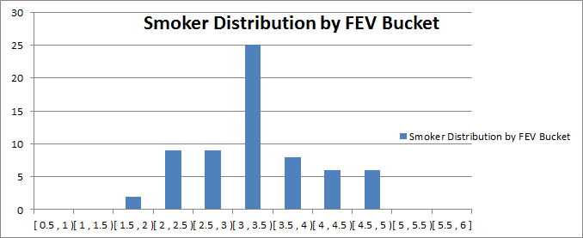

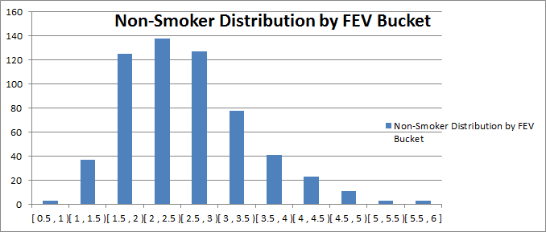
Surprisingly the mean FEV for smokers is higher. We have already seen at least one potential contributing factor (in particular, age). Another factor is on that has not yet been discussed. It turns out that in our data, smokers are more frequently male than female. Given that the distribution of FEV by gender has more weight on higher FEVs for males, it is also likely that this is a second factor in the larger weight on higher FEVs for smokers.
Subsection 3b – Initial Modeling
My strategy is to perform a regression on individual variables. This will give us a clue as to the significance the variables under consideration and additional information as to whether they should be included in the model.
X1 (Smoking Status)
Again, surprisingly, the significance of the smoking status dummy variable is not what we expect. We have our first piece of objective information with which to test our first hypothesis H1. The t-statistic on X1 is 2.97. First of all, it is important to note that the coefficient on X1 is positive. It follows that if we do not reject the estimate of B1 at 0.30, we would have a non-disconfirmed null hypothesis (say, H1*₀) that smoking increases FEV. Looking on a t-table, we would reject H1*₀ at the .005 level of significance (t value 3.1) but not at the .001 level of significance (t value 2.6). Since we see that it takes a very low p-value to reject H1*₀ , we do not reject H1*₀ , which contradicts H1₀. As a result, we might conclude that smoking does not decrease FEV. But as we have seen, there are other variables in this mix which have a larger impact on FEV. Before I come to any conclusions about the effects of smoking on FEV I would need to remove the effects of these other variables. For example, run regressions on multiple sets of data, where each set is composed of people who are the same age.
X2 & X3 (Male/Female Dummy Variables, Respectively)
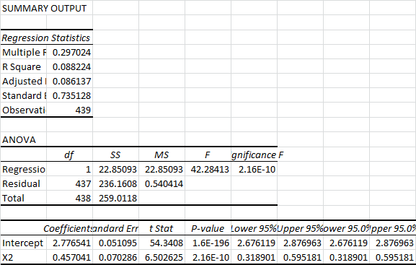
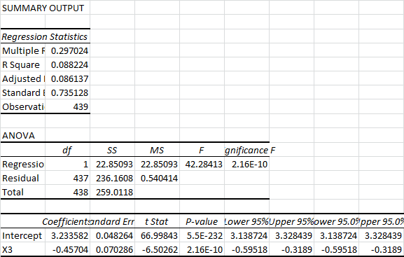
We see from the coefficients that Males tend to have a higher FEV, and Females tend to have a lower FEV. We see that the R Square is very low, so we see that this model is not a good explanatory variable by itself, but due to the significance of the t-statistic, I think these variables should be included in a regression model for FEV.

X4 (Age) and X5 (Height)
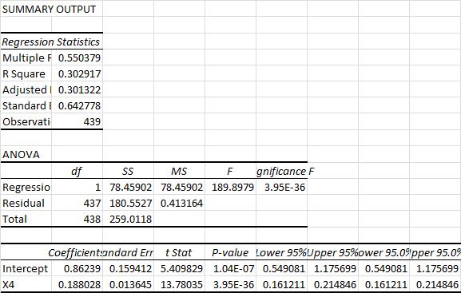
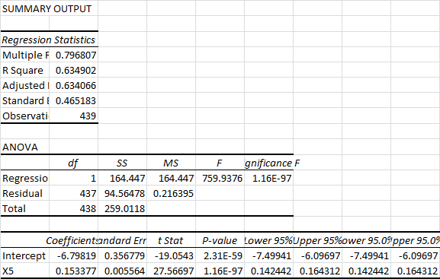
Earlier, I decided that we would eliminate either X4 or X5 in favor of the variable that more strongly predicts FEV. My reasoning was that these two variables have a high degree of multicolinearity. Looking at the results above, it is clear that height (X5) wins the spot in our regression model. The R Square is significantly higher and the t-statistic shows a much higher level of confidence.
Regarding our second hypothesis, that FEV increases as age increases, we are able to support this hypothesis with the regression results above. We see that our lower and upper 95% CI limits on the coefficient of Age are .16 and .21. Thus we have 95% confidence that FEV increases as age increases. We could also argue this at the .001 confidence level, but .05 is sufficient.
Subsection 3c – Revised Modeling
We have decided to include X2, X3, and X5 in our regression model. We will explore the results of the model below, and decide whether it sufficiently explains FEV.
Y = B0 + B2*X2 + B3*X3 + B5*X5
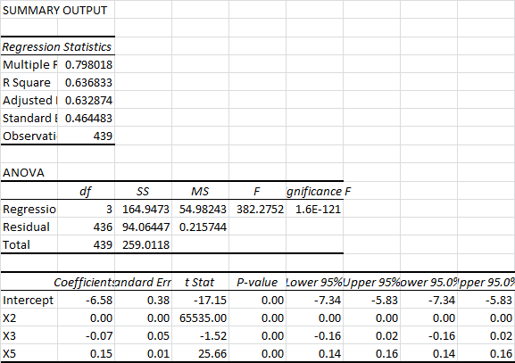
The results above show that gender does not have a significant impact in the regression model. I decide to exclude these variables from the model and use height (X5) as the main explanatory variable in the regression model.
Comparing the results above to the other models, we conclude that the best model for FEV on youths age 3 to 18 is a very simple model:
Y = B0 + B5*X5
We see that the proportion of variability is decently explained by the model above with an R Square of .635. Also, our coefficient has an extremely high t-statistic and therefore p-value. We settle on this model as the best model given our limited data.
Conclusion
Concerning our first hypothesis, that smoking decreases FEV, we have seen that our data is too muddied by variables that have a stronger effect on FEV in order to make any significant conclusions. The data is insufficient for our needs. Should I look into this further, I would find stratified data to remove the effects of age, height, etc. on FEV. This is a rather disappointing result, but it is better to come to no conclusion that a conclusion with a high probability of being incorrect.
We were able to support the second hypothesis, that FEV increases as age increases. We saw that our lower and upper 95% CI limits on the coefficient of Age are .16 and .21. We decided that at the 95% confidence level, we do not reject the second hypothesis
For our final model, we decided on Y = B0 + B5*X5 as the best explanatory model. The other variables seemed to have insignificant impact relative to the effects of height on FEV. Perhaps other models could be explored, but Y = B0 + B5*X5 proved to be reasonable.

