Fertility Rates and Socio-Economic Factors

Introduction:
The Total Fertility Rate (TFR) of a population is the average number of children that would be born to a woman over her lifetime if:
- she were to experience the exact current age-specific fertility rates (ASFRs) through her lifetime, and;
- she were to survive from birth through the end of her reproductive life.
The TFR shows the potential for population change in the country. A rate of two children per woman is considered the replacement rate for a population, resulting in relative stability in terms of total numbers. Rates above two children indicate populations growing in size and whose median age is declining. Conversely, rates below two children indicate shrinking populations whose median age is increasing.
In this project I will aim to discover the relationship between the TFR and broad socio-economic factors such as income, education levels and life expectancy. This might be useful in forecasting future TFRs based on countries’ expected future socio -economic environment.

Data and Considerations:
For this project, I had to employ data transformations for all the variables since they all exhibited significant skewness and non-linearity. In order to choose which transformation to use, I carried out graphical analysis of the data using scatter plots and histograms.
In addition I tried to minimize the number of factors used in order to reduce potential collinearity between the variables. The factors used and their transformations are elaborated below:
Total Fertility Rate (TFR): The TFR is the dependent variable in this regression analysis. The distribution for the TFR shows a significant positive skew. The TFR for most countries lies between 1 and 3 children per woman. However the right tail goes up to over 7 children per woman (Niger has the highest TFR with 7.6 children per woman).
In order to correct the positive skew, I tried various transformations such as ln(x), √x and x^{1/3}. Out of these transformations, the most appropriate is the ln(x) transformation. I have therefore used the natural logarithm of the TFR as the response variable.
GDP per Capita: I have used the GDP per capita in order to measure the economic well being of a country’s citizens. After graphically examining the data, I decided to omit two countries from the data as outliers since their GDPs per capita were much higher than the other countries (Liechtenstein and Qatar, with GDPs per capita of $141,100 and $179,000 respectively).
The GDP per capita exhibits positive skewness and non-linearity with respect to the TFR. I tried various transformations in order to make GDP per capita more symmetric and non-linear. As with TFR, the most appropriate transformation was the ln(x) transformation. I have therefore used the natural logarithm of GDP per capita as an independent variable.
Education Index: In order to measure the level of education in the country I decided to use the United Nations’ Education Index, which is a weighted average of the adult literacy rate and the ‘gross enrolment ratio’ (GER). The adult literacy rate gives an indication of the ability to read and write, while the GER gives an indication of the level of education from kindergarten to postgraduate education.
The Education Index exhibits a negative skew and some non-linearity with respect to the TFR. In order to counter this, I tried various transformations such as x², x³, x⁴ etc. From graphical analysis of the scatter plot, I decided to use the x⁴ transformation.
Life Expectancy: I have used life expectancy as a measure of the mortality and health levels of the country. The life expectancy distribution is negatively skewed and slightly non-linear. The x⁴ transformation is appropriate in correcting the skewness and non-linearity.

Full Regression Model and Results:
The full regression model is:
Y_{i} = α + β₁X_{i1} + β₂X_{i2} + β₃X_{i3} + ε_{i}
Where:
Y_{i} = Natural logarithm of the TFR of country i
X_{i1} = Natural logarithm of the GDP per capita of country i
X_{i2} = Fourth power of the Education Index of country i
X_{i3} = Fourth power of the life expectancy of country i
ε_{i} = Normal random variable with mean 0 and constant variance

This model gives the following results:
Regression Statistics
R² | 0.70994
Adjusted R² | 0.70491
Standard Error | 0.25736
Observations | 177

 | Coefficient | Standard Error | T Statistic (β=0) | P - Value
Α | 2.10×10⁰ | 2.01×10⁻¹ | 10.46136 | 3.72×10⁻²⁰
β1 | -5.78×10⁻² | 2.96×10⁻² | - 1.95236 | 5.25×10⁻²
β2 | -6.19×10⁻¹ | 1.21×10⁻¹ | - 5.10708 | 8.57×10⁻⁷
β3 | -1.47×10⁻⁸ | 3.03×10⁻⁹ | - 4.84039 | 2.86×10⁻⁶

The p – values for β₂ and β₃ are extremely low, providing strong evidence against the null hypothesis (H₀: β = 0).
The p – value for β₁ is 0.0525, which means that under a confidence level of 95%, there would be insufficient evidence to reject the null hypothesis.
Considering this stark difference in p- values, I would like to compare the adjusted R² of this regression model with one which excludes X₁ in order to see whether X₁ (GDP per capita) appreciably increases the predictive capacity of the model or not.

Sub – Model (excluding X₁) and Results:
This model is identical to the full model except that X₁ has been omitted. The results of this model are:
Regression Statistics
R² | 0.70355
Adjusted R² | 0.70014
Standard Error | 0.25943
Observations | 177

 | Coefficient | Standard Error | T Statistic (β=0) | P - Value
α | 1.72E×10⁰ | 4.79×10⁻² | 35.91811 | 2.14×10⁻⁸²
β2 | -7.36×10⁻¹ | 1.06×10⁻¹ | - 6.91025 | 8.78×10⁻¹¹
β3 | -1.75×10⁻⁸ | 2.70×10⁻⁹ | - 6.47478 | 9.36×10⁻¹⁰
The adjusted R² for the sub-model is almost the same as that of the full model, meaning that the introduction of X₁ does not appreciably increase the predictive power of the model. Again the low p-values are evidence of the fact that X₂ and X₃ have a linear relationship with TFRs.

Conclusion:
From the analysis carried out, we can be very confident that education level (Education Index) and life expectancy have inverse relationships to fertility rates. In fact, the very low p values might indicate a causal link rather than just correlation. There is comparatively less evidence indicating that wealth (GDP per capita) has any such a relationship with TFR.
The full model and sub model both have Adjusted R² equal to about 70%. This indicates that both models are about as good at explaining the variation in TFRs. This shows that while the Education Index and the life expectancy of a country can be used to predict the TFRs of a country, the GDP per capita does not appreciably either increase or decrease the predictive ability.
As a next step, perhaps we should look at incorporating more socio-economic factors into the model. This might result in a higher adjusted R², thereby increasing the predictive capacity of the model. However, even the simple “sub-model” with the transformed Education Index and life expectancy variables does provide us with some predictive ability.

Appendix A: Data Sources
Total Fertility Rate: https://www.cia.gov/library/publications/the-world-factbook/rankorder/2127rank.html
GDP per Capita: https://www.cia.gov/library/publications/the-world-factbook/rankorder/2004rank.html
Education Index: http://hdrstats.undp.org/en/indicators/93.html
Life Expectancy: https://www.cia.gov/library/publications/the-world-factbook/rankorder/2102rank.html
Appendix B: Correction of skewness and non-linearity through transformations
Total Fertility Rate (TFR)
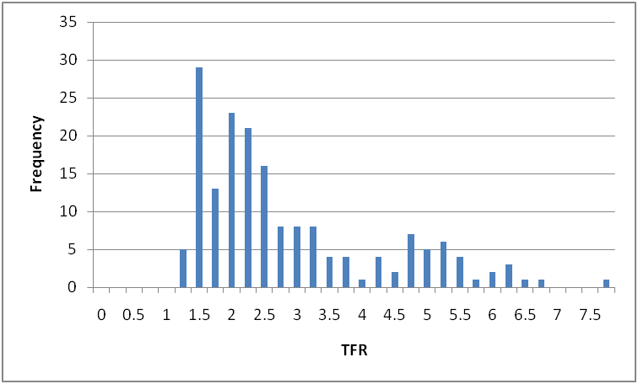
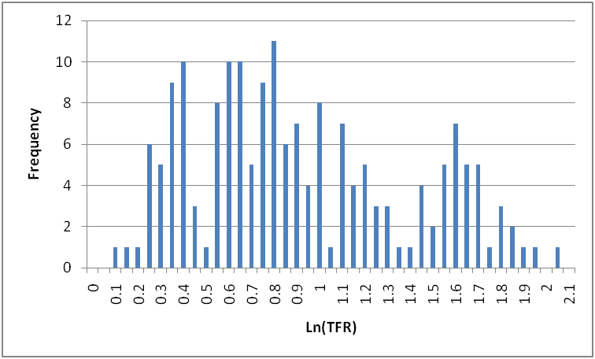

GDP Per Capita:
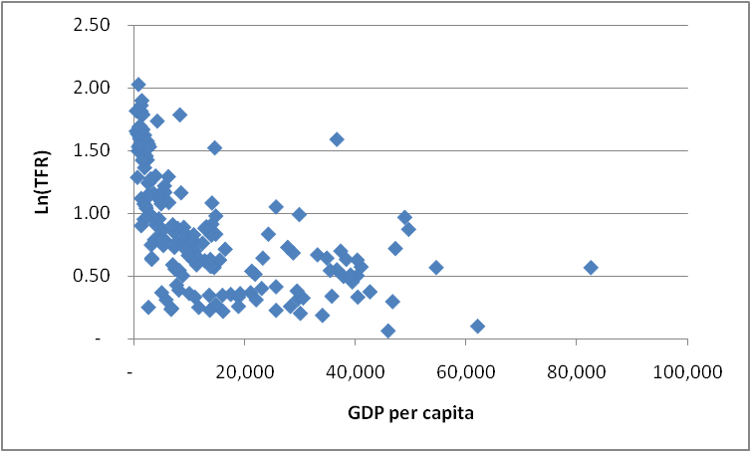
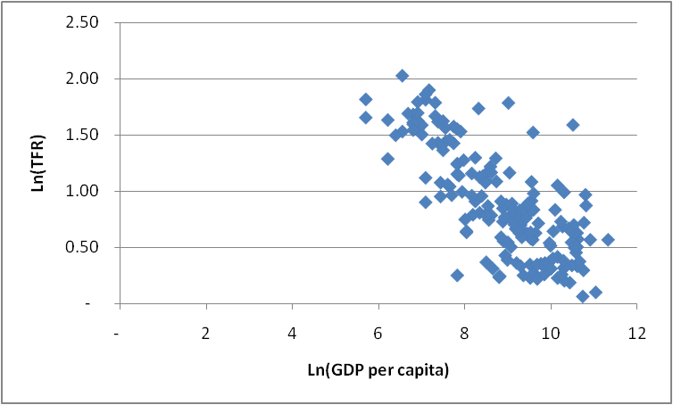

Education Index:
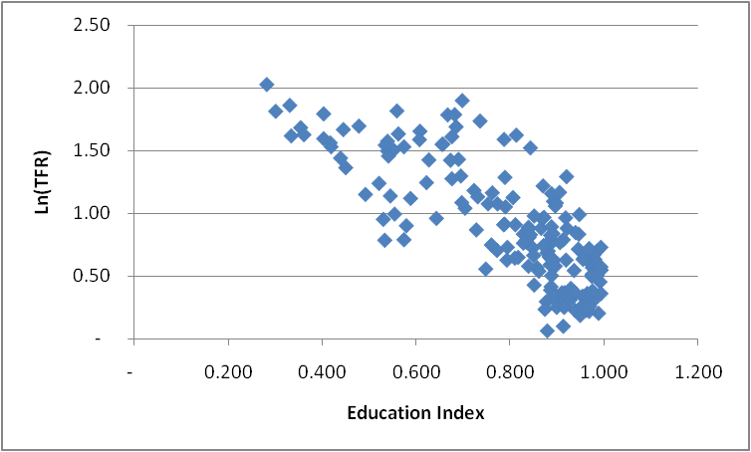
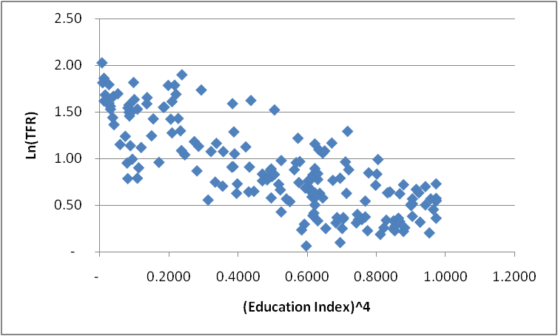

Life Expectancy:
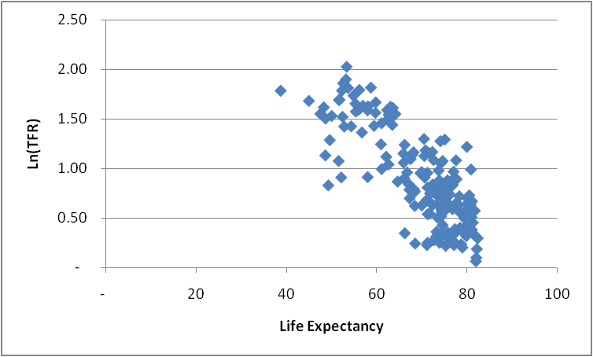
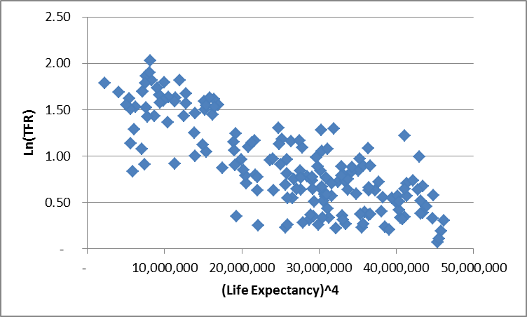

See Appendix A for the sources of the data
See Appendix B for the graphical analysis of data and transformed data

