What Pro Golfer’s Statistics Best Predicts Their Money Earnings

Introduction
It is often said in golf that you “drive for show and putt for dough” meaning that the most important part of the game of golf is putting. Having played golf most of my life it is of interest for me to investigate what aspects of the game is the strongest indicator of success. Success on the PGA tour is often measured in the amount of money a player earns during a year. This regression analysis is designed to analyze the relationship between the total money winnings of the top 189 players in the 2010 PGA tour season and a variety of their corresponding statistics. The regression model has 8 explanatory variables: Greens in Regulation Percentage (GIR), Scrambling Percentage, Putting Average, Putts per Round, 3-Putt Avoidance Percentage, Total Putting, One Putt Percentage, and Ball Striking. These variables will be used along with Excel’s regression analysis tool to determine the ideal number of explanatory variables that should be used for this model.
Data Sources
The data used for this project was compiled from the official statistics of the 2010 PGA Tour Season. The data is compiled in the corresponding tabs in the Excel file. The link to the PGA Tour’s website is: http://www.pgatour.com/r/stats/.
Equation and Variables
The equation and variables for the complete model is:
Y = α + β₁X₁+ β₂X₂+ β₃X₃+ β₄X₄+ β₅X₅ + β₆X₆+ β₇X₇+ β₈X₈
A description of the variables is the following:
Y = Total money earnings in a year (dollars)
α = Intercept
β_{i} = Least Square Coefficients
X₁ = GIR (The percent of time a player goes for the green with the first shot on a par 4 or the second shot on a par 5 on a hole where it is a viable option (at least one player went for the green on that hole). A player is assumed to be going for the green if the first shot on a par 4 or second shot on a par 5 lands on or around the green. If the second shot on a par 5 lands in the water, it is included as well. Note: 'Around the green' indicates the ball is within 30 yards of the edge of the green; the shot must be determined by a laser to be included).
X₂ = Scrambling Percentage (The percent of time a player misses the green in regulation, but still makes par or better).
X₃ = Putting Average (The average number of putts for all holes played (total putts / total holes played).
X₄ = One Putt Percentage (The percent of time a player 1-putts (total 1-putts / total holes played).
X₅ = Putts Per Round (The average number of putts per round played).
X₆ = 3-Putt Avoidance (The percent of time 3 or more putts were taken for a hole (total 3-putts, 4-putts, etc./ total holes played).
X₇ = Total Putting (Total Putting is computed using 6 putting stats Putting from 3-5', Putting from 5-10', Putting from 10-15', Putting from 15-20', Putting from 20-25' and Three Putt Avoidance from > 25'. Each statistic is given a numerical weighting based on the frequency of putts attempted from each distance. The players rank in each of the statistics used is multiplied by the corresponding weigh factor, totaled, and divided by the number of statistics used to produce the Total Putting Value).
X₈ = Ball Striking (Ball Striking is computed by totaling a player's rank in both Total Driving and Greens in Regulation).
Hypothesis
The null hypothesis is that all least squares coefficients are zero, β₁ = β₂= β₃ = β₄ = β₅ = β₆ = β₇ = β₈ = 0.
8-Variable Regression Full Model
Y = 9119255.43 + 12315.22X₁ + 26821.68X₂+ 2570755.86X₃ - 524531.46X₄+ 68962.69X₅ - 2272.81X₆ + 62922.61X₇ - 3548.25X₈
It is surprising that Ball Striking has the lowest P-value of all the explanatory variables. However, it is not surprising that GIR has a low P-value due to the fact that one of the variables used for the calculation of Ball Striking is GIR. Although, it is important to note that Ball Striking has a negative coefficient and GIR has a positive coefficient. At this moment it is not clear what the reason for this result is.
The R Square and Adjusted R Square demonstrates that this model is not a great predictor of how much money you can make on the PGA tour, however, we will continue to modify the model to make it simpler while not sacrificing its predictive power. In order to achieve this we will remove the statistic with the highest P-value. In this case it is 3-Putt Avoidance.
It could be surprising that 3-Putt Avoidance is eliminated first but if you dig deeper there could be a clear reason as to why this occurs. 3-Putt Avoidance measures the % of times a player has putted 3 or more times in a hole. You would expect this variable to be a good predictor of money winnings but this variable does not distinguish between putting 1 or 2 times in a hole. This means that while you maybe not putting more than 3 times (which is good) you may putting twice most of the time(which in not great). In the PGA tour the top player are great and this means making many birdies that correlate directly to making one putts. So in this case 3-Putt Avoidance does not show us who the great players are.
7-Variable Model
Y = 4587372.58 + 12851.25X₁ + 26458.10X₂+ 2203617.31X₃ – 375222.65X₄ – 1980.91X₆ + 86570.37X₇ – 3515.30X₈
As before Ball Striking remains the most powerful predictor of money winnings and again followed by GIR. Also, it is counter intuitive for the coefficient of Ball striking to be negative. One would expect that as your ball striking improves (increases) then your money winnings would increase as well. In this model this relationship shows a negative correlation. However, the P-value is much lower than the other variables thus it is proper to keep Ball Striking in the model.
The 7-variable model has retained the same R Square and Adjusted R Square, thus we have effectively eliminated a variable with sacrificing predictive power.
In out next regression we will remove Putt per round since it has a very high P-value.

6-Variable Model
Y = -6616276.22 + 12870.88X₁ + 29961.25X₂+ 931439.96X₃ – 2369.41X₆ + 142276.51X₇ – 3384.10X₈
In the 6-Variable model we have retained almost the same R Square and Adjusted R Square while removing one variable.
Ball Striking still remains the variable with lowest P-value, but GIR is not the second lowest P-value anymore. Total Putting and One Putt Percentage have decreased their P-value dramatically. This signals that putting is taking a more important role in predicting money winnings as one would expect even though Putting Average statistic has the highest P-Value.
In our next regression we will eliminate Putting Average while retaining our predictive power in the model.
5-Variable Model
Y = -5676470.35 + 13089.59X₁ + 26401.72X₂ – 2043.76X₆ + 161798.09X₇ – 3706.03X₈
In the 5-Variable model we notice as before that we retain our R Square and Adjusted R Square value. Also, our trend of putting statistics lowering in P-values continues.
Scrambling Percentage now has the highest P-value. This is expected because if you are scrambling in the first place it means that the player is not making quality shots to the green, thus loosing opportunities to make birdies. In our next regression we will remove this variable.
4-Variable Model
Y = -4491272.17 + 10332.93X₁ – 2265.17X₆ + 178192.63X₇ – 4083.70X₈
In the 4-Variable we notice as before that we retain our R Square and Adjusted R Square value. Also, our trend of putting statistics lowering in P-values again continues. Although this model has the same predictive power as before we still have to remove the GIR statistic to make the P-values closer to zero.
3-Variable Model
Y = -4469940.823 – 1842.18X₆ + 191110.02X₇ – 4552.18X₈
The R Square and Adjusted R Square values have gone down slightly in this model. But, similar to the 4-Variable model the Total Putting statistic has to be removed in order to make all P-value close to zero.
2-Variable Model
Y = -6103574.33 + 224889.79X₇ – 4477.89X₈
In the 2-Variable Model we have achieved to create a regression model with close predictive power as the all variables model. In addition all of our t-Stats are very high showing that our values are significant to the 95%. Also, all the P-values are close to zero.
It is interesting to note that One-Putt Percentage is influenced directly by how close to the whole your shot to the green is. It can be argued that Ball striking and One Putt Percentage are correlated since your ability to strike the ball influences how close to the hole you will be once on the green. Due to this relationship we will observe separate one-variable models for One Putt Percentage and Ball Striking.
1-Variable Model (One Putt %)
Y = -5257270.87 + 178182.86X₇
One Putt Percentage model has lost some of its predictive power compared to the 2 variable model. This decline is enough to reject this model because of the decrease in R Square.
1-Variable Model (Ball Striking)
Y = -1681398.124 – 2229.49X₈
The Ball Striking model has lost most of its predictive power with an R Square of 0.044. We can reject this model.
It is interesting to investigate as to why there is a negative correlation between Ball Striking and money winnings. In order to explain this we need to understand that the way players earn money is if they make the cut in a tournament. Once a player has made the cut then they are awarded money depending on their where they place, specifically there is a disproportionate amount of money awarded for the winner of a tournament. This means that if you win a tournament you are probably already in top 25 money winners for that year in the tour. So even if you have no struck the ball well all year you can hit a hot streak of 4 rounds and win a tournament and be in the top of the money list. This variability in results means that you do not have to be a good ball striker to make money, but you do have to be a good ball striker to consistently make money.
The following regression is made using the Top 25 players in money winnings in the tour for 2010. It should be expected that these players are consistently good and thus will show a positive correlation between their money winnings and Ball Striking.

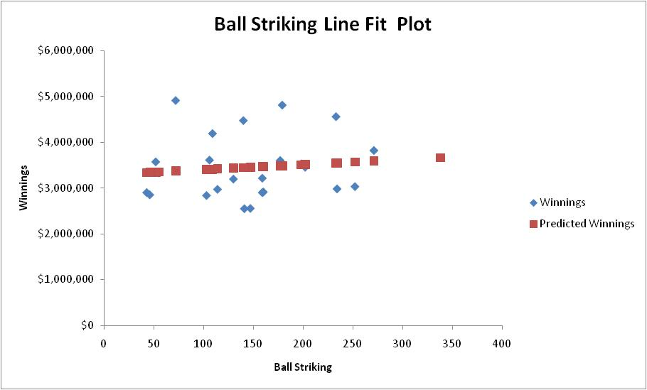
Now, we see a positive a correlation between Ball Striking and money winnings. As, expected we can confidently say that to be consistently earning money in the tour you need to strike the ball well.
Conclusion
The chosen “best model” to predict a PGA tour player’s money winnings is the 2-variable model.
Y = -6103574.33 + 224889.79X₇ – 4477.89X₈
Y = Money winnings
X₇ = One Putt Percentage
X₈ = Ball Striking
The resulting R-square value of our “best model” is 0.4356. This indicates that our model is decent in predicting money winnings of a player. In reality, due to the quality of player on the tour, it is very hard to pinpoint one or more parts of the game in which a player can become very good at in order to be successful. Your best bet is to be very good at every aspect of the game. For any person who has played golf this is obviously easier said than done.
It was expected that putting statistics would have a greater impact on our model; however this was not completely true. A combination on how a player hits his drive, approach shot, and first putt where the variables that best predict a players earnings. This in reality makes more sense because of two reasons. First, no matter how good a putter a player is, your putting does not matter if you cannot reach the green safely with good ball striking. Second, the caliber of player in the PGA tour is extremely skilled in every aspect of the game, this means that the putting abilities of the players of the tour does not differ from player to player greatly. In fact, out of the all the players in the data set, the difference between the best player and worst player in the putts per round category were 3.03 strokes.
Although this model predicts a negative correlation between money winnings and ball striking, the P-values and R-square values make this model the best predictor of money winnings. The project’s goal to eliminate as many variables while simultaneously keeping R-square close to the full model as possible and lowering the P-values to within 95% confidence interval was achieved.

