Internet Users Population Percentage (IUPP)

Introduction:
The Internet Users Population Percentage (IUPP) is the internet users divided by the population in the country.
In this project I will aim to discover the relationship between the IUPP and some factors such as income, education levels and population.
Data and Considerations:
For this project, I had to employ data transformations for all the variables since they all exhibited significant skewness and non-linearity. In order to choose the transformation to use, I carried out graphical analysis of the data using scatter plots and histograms.
In addition I tried to minimize the number of factors used in order to reduce potential collinearity between the variables. The factors used and their transformations are elaborated below:
Internet Users:
This entry gives the number of users within a country that access the Internet. Statistics vary from country to country and may include users who access the Internet at least several times a week to those who access it only once within a period of several months.
Population:
This entry gives an estimate from the US Bureau of the Census based on statistics from population censuses, vital statistics registration systems, or sample surveys pertaining to the recent past and on assumptions about future trends.
After graphically examining the data, I decided to omit two countries from the data as outliers since their Population (Per Million) were much higher than the other countries (china and India, with Population (Per Million) of 1,336.72 and 1,189.17 respectively).
Internet Users Population Percentage (IUPP):
The IUPP is the dependent variable in this regression analysis. The distribution for the IUPP shows a significant positive skew. The IUPP for most countries lies between 5% and 35% of population per country. However the right tail goes up to over 95% (Iceland has the highest IUPP with 97% of the population use the internet).
In order to correct the positive skew, I used the √x square root of the IUPP as the response variable transformation.
GDP per Capita:
I have used the GDP per capita in order to measure the economic well being of a country’s citizens. After graphically examining the data, I decided to omit two countries from the data as outliers since their GDPs per capita were much higher than the other countries (Liechtenstein and Qatar, with GDPs per capita of $141,100 and $179,000 respectively).
The GDP per capita exhibits positive skewness and non-linearity with respect to the TFR. I used the natural logarithm of GDP per capita as an independent variable transformations in order to make GDP per capita more symmetric and non-linear.
Education Index:
In order to measure the level of education in the country I decided to use the United Nations’ Education Index, which is a weighted average of the adult literacy rate and the ‘gross enrolment ratio’ (GER). The adult literacy rate gives an indication of the ability to read and write, while the GER gives an indication of the level of education from kindergarten to postgraduate education.
The Education Index exhibits a negative skew and some non-linearity with respect to the TFR. In order to counter this, I decided to use the x⁴ transformation.

Full Regression Model and Results: (see the attached excel, spread sheet called Regression)
The full regression model is:
Y_{i} = α + β₁X_{i1} + β₂X_{i2} + β₃X_{i3} + ε_{i}
Where:
Y_{i} = Square root of the IUPP of country i
X_{i1} = Natural logarithm of the GDP per capita of country i
X_{i2} = Fourth power of the Education Index of country i
X_{i3} = Natural logarithm of Population per Million of country i
ε_{i} = Normal random variable with mean 0 and constant variance

This model gives the following results:
SUMMARY OUTPUT
Regression Statistics
Multiple R | 0.7054
R Square | 0.4975
Adjusted R Square | 0.4904
Standard Error | 0.1928
Observations | 216
ANOVA
 | df | SS | MS | F | Significance F
Regression | 3 | 7.8011 | 2.6004 | 69.9765 | 1.71103E-31
Residual | 212 | 7.8780 | 0.0372
Total | 215 | 15.6791
 | Coefficients | Standard Error | t Stat | P-value | Lower 95% | Upper 95%
Intercept | 0.0919 | 0.1207 | 0.7612 | 0.4474 | -0.1460 | 0.3297
X Variable 1 | 0.0782 | 0.0097 | 8.0772 | 4.95109E-14 | 0.0591 | 0.0973
X Variable 2 | 0.2619 | 0.0460 | 5.6952 | 4.07913E-08 | 0.1713 | 0.3526
X Variable 3 | -0.0254 | 0.0052 | -4.8719 | 2.16181E-06 | -0.0357 | -0.0151

The p – values for β₁ ,β₂ and β₃ are extremely low, providing strong evidence against the null hypothesis (H₀: β = 0). This means that under a confidence level of 95%, there would be sufficient evidence to reject the null hypothesis.

Conclusion:
From the analysis carried out, we can be very confident that education level (Education Index), Income (GRP per capita) and population have inverse relationships to internet users population percentage. In fact, the very low p values might indicate a causal link rather than just correlation.
The full model has Adjusted R² equal to about 50%. This indicates that the model is about as good at explaining the variation in IUPPs.
Appendix A: Data Sources
Internet Users: https://www.cia.gov/library/publications/the-world-factbook/rankorder/2153rank.html
GDP per Capita: https://www.cia.gov/library/publications/the-world-factbook/rankorder/2004rank.html
Education Index: http://hdrstats.undp.org/en/indicators/93.html
Population: https://www.cia.gov/library/publications/the-world-factbook/rankorder/2119rank.html
Appendix B: Correction of skewness and non-linearity through transformations
Internet Users Population Percentage (IUPP): (see excel spread sheet called IUPP Graphs)
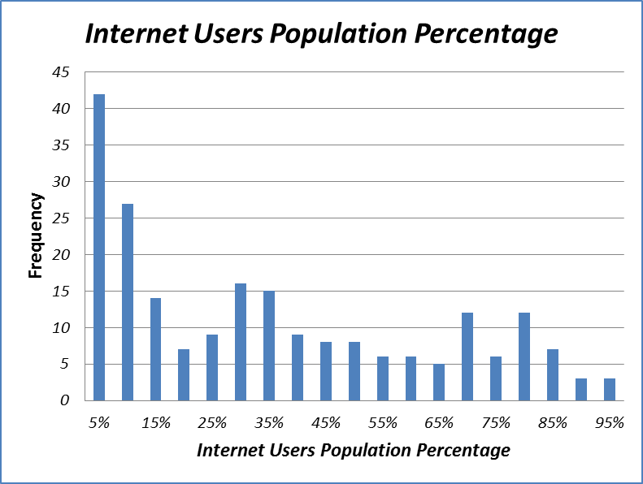

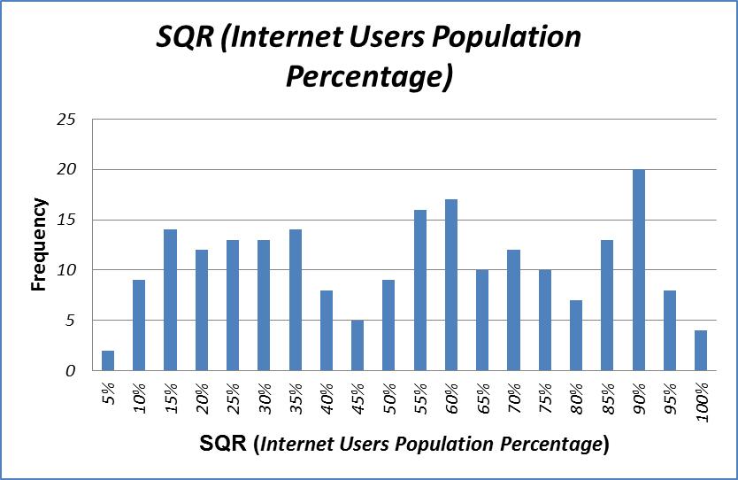

GDP Per Capita: (see excel spread sheet called GDP - per capita Graphs)

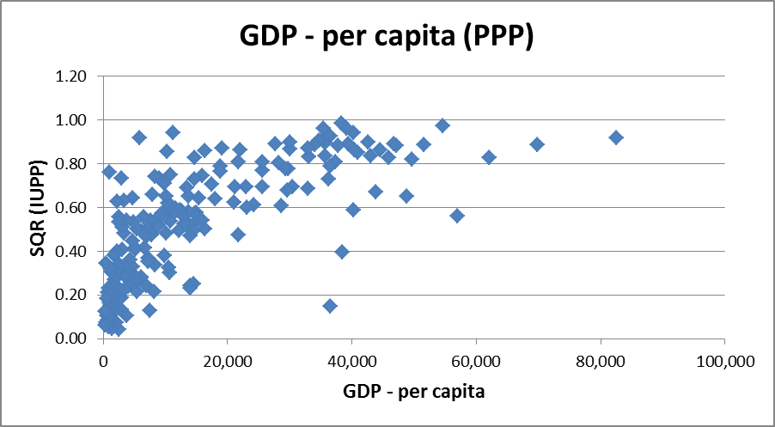

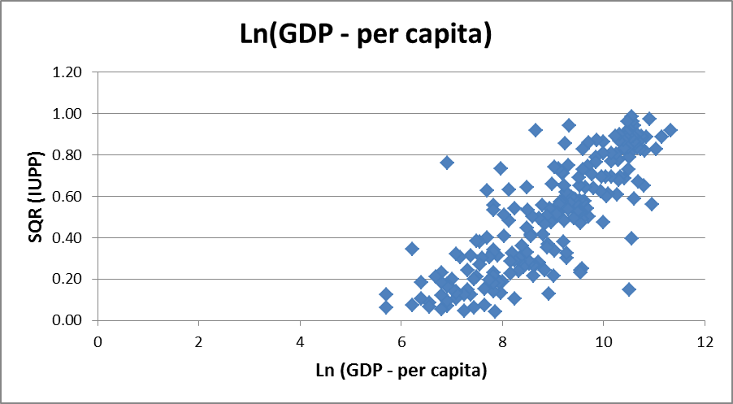

Education Index: (see excel spread sheet called Education Index Graphs)
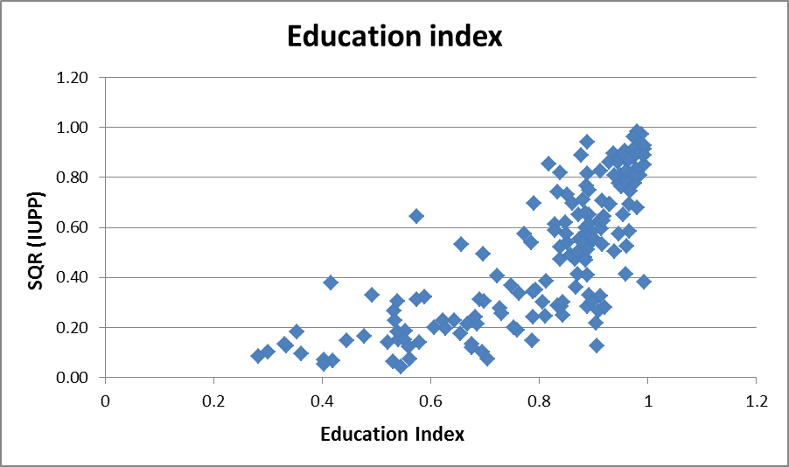

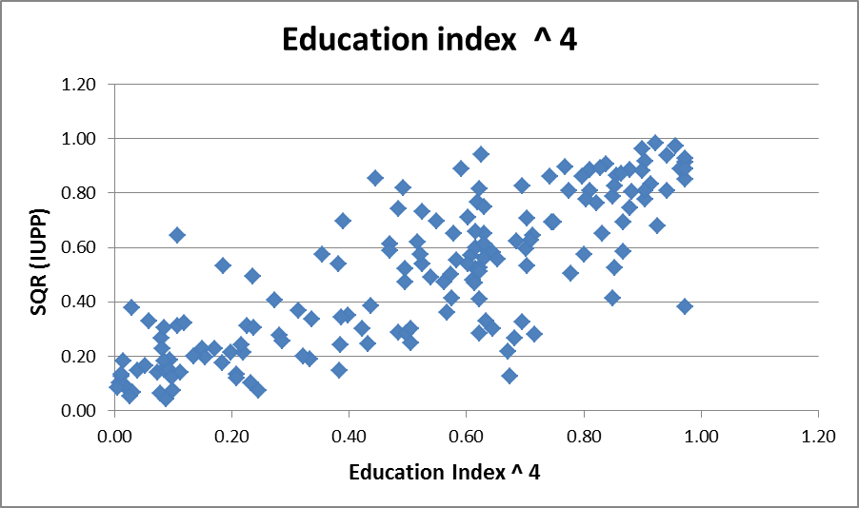

Population per million: (see excel spread sheet called Population Graphs)

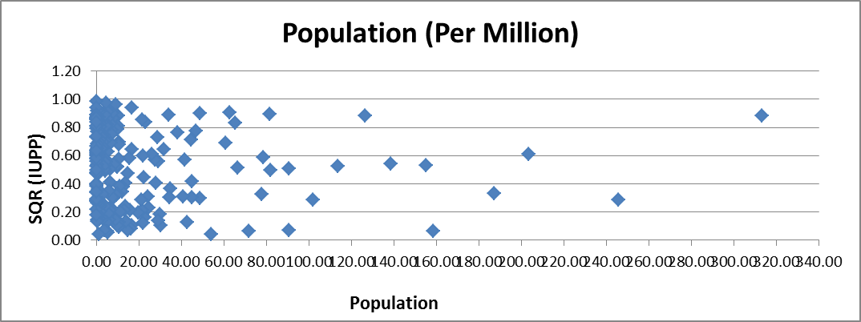

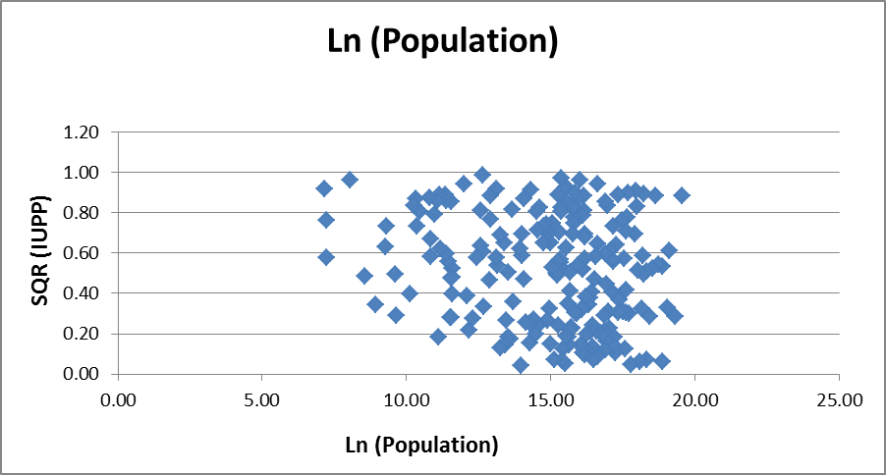

See Appendix A for the sources of the data
See Appendix B for the graphical analysis of data and transformed data

