Introduction
Fantasy Football has and will continue to consume the lives of millions of sports fans in America. The game is simple. A fantasy league draft is held where fantasy teams take turns picking NFL players until their fantasy rosters are complete. When the NFL players score touchdowns, catch passes, or accumulate yards, the fantasy teams score points. Going into the draft, a good fantasy team owner will have ranked some players based on their projected fantasy points. This project will look at one player in particular, Jamaal Charles, and use basic time series techniques to forecast his projected fantasy points on a weekly basis. Please see “Time Series Project - Jamaal Charles_PSH.xlsx” for data and calculation support as referred to throughout this paper.

Scoring System
While there are many scoring systems out there, I have chosen to use a simple point-per-reception system for my analysis:
Reception 1 point
Touchdown 6 points
Rushing or receiving yard 0.1 point
Fumble -2 points
Fumble recovery 1 point
Data

Using the scoring system above and data from www.cbssports.com, I calculated Jamaal Charles’ fantasy points on a weekly basis. Thirty weeks of data were available, from November 15, 2009 to mid-October 2011 (includes playoff games). I decided to use the first 21 weeks of data for my analysis in order have some data left over to use during my ex post forecast. Jamaal Charles’ fantasy point production by week is as follows:

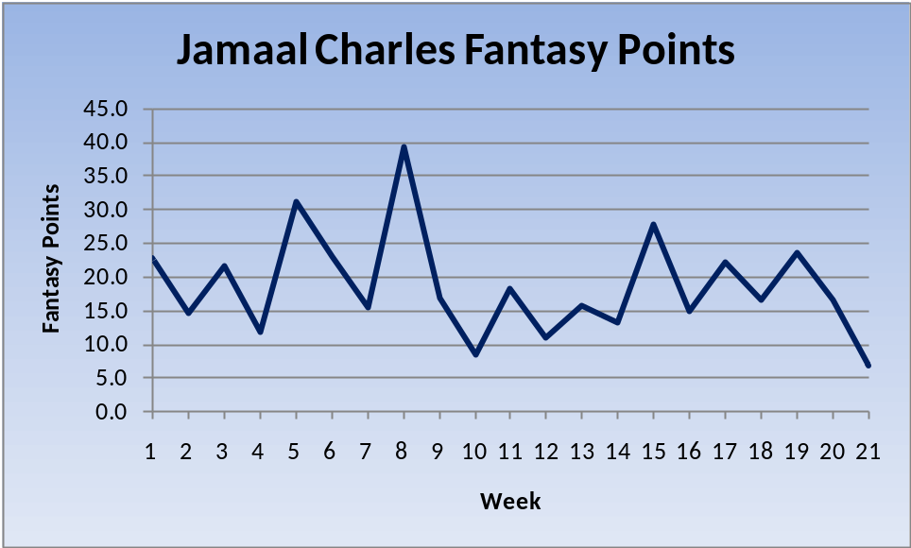
Jamaal averages 18.7 points per week. His production is volatile (standard deviation = 7.7) and there does not appear to be a trend in the data. I have assumed that no seasonality exists, although one could make the argument that the data is inherently seasonally adjusted in the sense that weeks are excluded when no games are played (such as during the summer).

Please see “Data” and “Fantasy Points” tabs on the given spreadsheet for complete details on the data and calculation of fantasy points.

Autocorrelations
Using the autocorrelation function (see below), I constructed correlograms (plots of these autocorrelation functions) using original data, first differences, second differences, and third differences. In doing this, I hope to find a stationary time series that can be used to fit autoregressive models to.

Sample autocorrelation function:
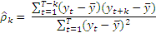
Autocorrelation – Fantasy Points
The correlogram below confirms non-stationarity of Jamaal Charles’ fantasy points (i.e., that there is no trend in the original data). This is because the plot does not quickly trend toward zero. While there is some oscillation around zero, the absolute value of the sample autocorrelation at lag 13 is far too large for the series to be considered stationary. In fact, lags 4, 6, and 13 all have lags that are further from zero than lag 1.
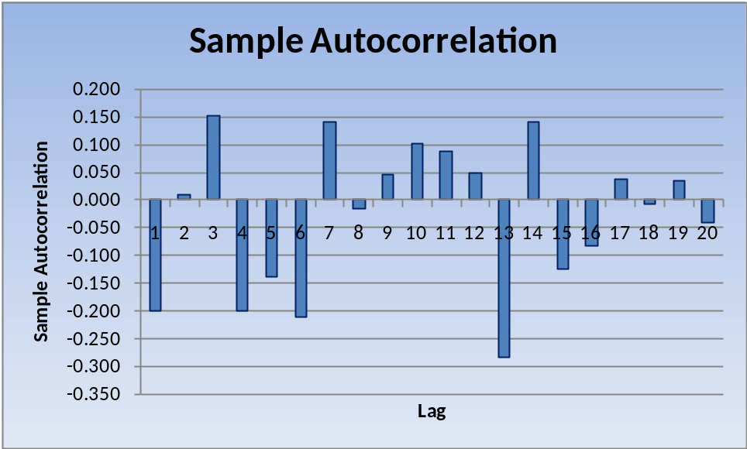
See “Autocorrelation” tab of the given spreadsheet for complete data and calculation support.
Autocorrelation – First Differences
Taking first differences of the original data appears to result in a stationary time series. Despite lags 12-15 being further from zero than an ideal plot, there is a clear and almost immediate trend toward zero. None of the lags beyond lag 1 have a sample autocorrelation that is even half of what the sample autocorrelation is at lag 1.

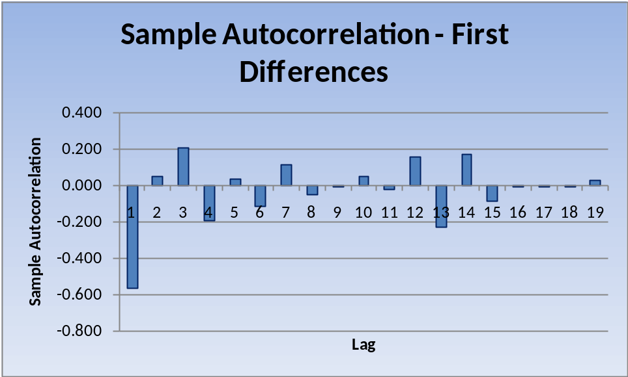

Out of curiosity, I also constructed correlograms of second and third differences to see how they compare to the correlogram of first differences. See “Appendix A: Autocorrelation – Second and Third Differences” at the end of this paper for details.

For the remainder of this analysis, I assume stationarity of the first differences data series and will use this data to determine an appropriate autoregressive model to use for forecasting.

See “Autocorr – First Diff” tab of the given spreadsheet for complete data and calculation support.

Models
While a more complicated approach (such as ARIMA) might result in a better fit, I have chosen to fit autoregressive models to the data using first differences in an effort to select a simple and appropriate model. For my analysis, I use Microsoft Excel’s Regression tool, part of the Data Analysis Add-In.

Autoregressive model AR(p):
,
where is the mean of the stochastic process, are coefficients, and is the error term.

My approach will be to start with AR(1) and look at AR(2), AR(3), etc. until I find a maximum Adjusted R^2. I will then consider the Durbin-Watson and Box-Pierce Q statistics in addition to the Adjusted R^2 statistic in order to select a model to forecast with (see Model Comparison section of this paper).
AR(1) – First Differences
Using Excel’s regression feature, I obtain the following equation for AR(1):

The sum of the coefficients is -1.182, which is less than one. The absolute value of is also less than one. These two conditions are both necessary for stationarity, which we have assumed.

Using the equation for AR(1), I have plotted the predicted first differences of Jamaal Charles’ fantasy points against actual first differences:

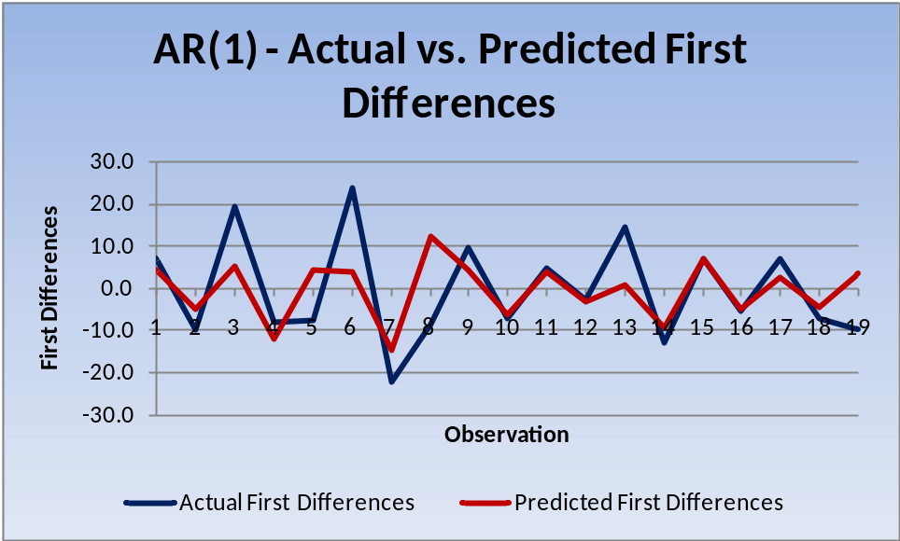

As you can see, there are observations where the predicted first differences align very closely with actual first differences (10-12, 15-16) and there are also observations that are way off (3, 5-6, 8, 13, 19). Only observations 5, 8, and 19 are directionally different.

See “AR(1) – First Diff” tab of the provided spreadsheet for the predicted values, residuals, and unrounded coefficients of AR(1).
AR(2) – First Differences
Using Excel’s regression feature, I obtain the following equation for AR(2):

The sum of the coefficients is -2.107, which is less than one. The absolute values of are both less than one. Again, these conditions are both necessary for stationarity. Had they not been met, our assumption of stationarity (and thus our use of autoregressive models) would be nullified.

The predicted first differences using the equation for AR(2) are shown below as plotted against actual first differences:
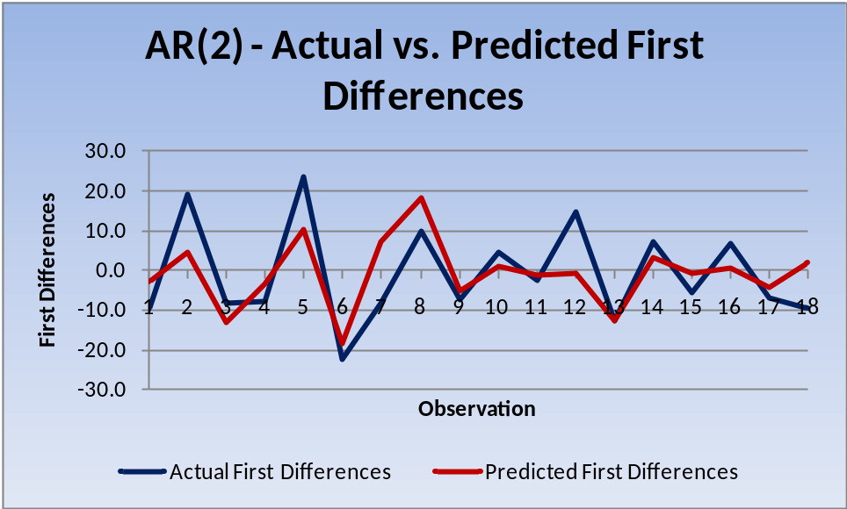

At first glance, it is tough to tell whether AR(2) is a better fit than AR(1). AR(1) had five observations that were spot on, but AR(2) only has one (13). On the other hand, AR(1) had six observations that were way off, but AR(2) only has five (2, 5, 7, 12, and 18). AR(2) has three observations that are directionally different (7, 12, and 18) as does AR(1).

It seems as though AR(1) fits some data points extremely well and others horribly, while AR(2) smoothes some of this volatility out. Based on this, I would lean toward using AR(2) at this point, but more analysis will be necessary.

The Adjusted R^2 is higher for AR(2) than AR(1) so we will continue to look at AR(3) in case it improves further. Details on this will be provided in the Model Comparison section of this project.

See “AR(2) – First Diff” tab of the provided spreadsheet for the predicted values, residuals, and unrounded coefficients of AR(2).
AR(3) – First Differences
Using Excel’s regression feature, I obtain the following equation for AR(3):

The sum of the coefficients is -1.895, which is less than one. The absolute values of are all less than one. Once again, these conditions are both necessary for stationarity, which we have assumed.

First differences as predicted by AR(3) are plotted against actual first differences below:
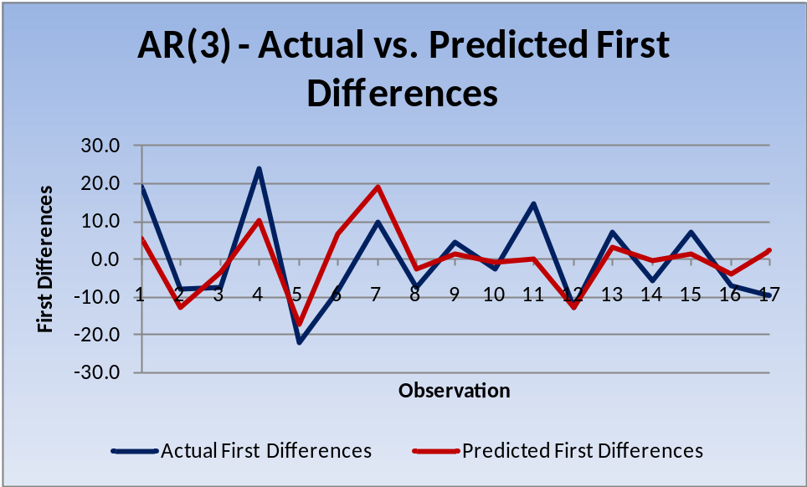

Again, it is tough to tell at first glance whether AR(3) is an improvement over AR(2). Only observation 12 is spot on. Observations 1, 4, 6, 11, and 17 are way off. Observations 6, 11, and 17 are directionally different.

The Adjusted R^2 is lower for AR(3) than AR(2), so we will not continue to analyze AR(4) since the maximum Adjusted R^2 is at AR(2). Details will follow in the Model Comparison section of this paper.

See “AR(3) – First Diff” tab of the provided spreadsheet for the predicted values, residuals, and unrounded coefficients of AR(3).

Model Comparison

The three statistics I focus on in choosing a model are Adjusted R^2, the Durbin-Watson statistic, and the Box-Pierce Q statistic.

Adjusted R^2 ranges from zero to one and helps to determine which model is a better fit. A higher Adjusted R^2 is a better fit (0 means the model does nothing to explain the variation in the dependent variable and 1 means that all sample points lie on the regression line).

The Durbin-Watson statistic also helps to determine which model is a better fit and ranges from zero to four. The closer the Durbin-Watson statistic is to 2 is a better fit (values from zero to two indicate positive serial correlation, values from two to four indicate negative serial correlation, and values near two indicate no first-order serial correlation, which is desired of our model).

The Box-Pierce Q statistic tests whether the residuals are a white noise process. The statistic must be compared to a critical value of the Chi-Squared distribution at a given significance level, which I have chosen to be 10%. The null hypothesis is that the residuals are a white noise process, so if the Box-Pierce Q statistic is less than the corresponding critical value then we fail to reject this null hypothesis.

Results for the three autoregressive models are summarized below:
Model | Adj. R^2 | Durbin-Watson | Box-Pierce Q | χ2 (10%) | Deg. Freedom
AR(1) | 0.303352 | 2.415 | 8.959 | 24.769 | 18
AR(2) | 0.419387 | 1.904 | 7.610 | 23.542 | 17
AR(3) | 0.376966 | 1.556 | 8.641 | 22.307 | 16
As previously determined, AR(2) has the highest Adjusted R^2. It also has the best Durbin-Watson statistic (closest to 2). For all three models, the Box-Pierce Q statistic is less than the critical value of the Chi-Squared distribution, which means we fail to reject the null hypothesis that the residuals are a white noise process.

The above analysis reveals that AR(2) is the most appropriate autoregressive model to use for our forecast. The following section uses AR(2) to forecast the first differences on both an ex post and ex ante basis. The forecasted differences are then used to calculate forecasted fantasy points for Jamaal Charles’ 2011-12 season.

Statistics were calculated using Excel’s Regression tool as well as formulas that are based on those provided in the NEAS spreadsheet “TimeSeriesTechniques.xls”. See “Model Comparison and Forecast” tab for more details.

Forecast

Using the AR(2) equation, I determined the first differences as forecasted by the model. I then calculated forecasted fantasy points based on the forecasted first differences.

As previously stated in the Data section of this paper, the first 21 weeks of data were used to select the model. The remaining 9 weeks of data are left to use during the ex post forecast (so that actual data can be compared to model output to check how well it works). The ex ante forecast is the forecast for the future, when we don’t have data yet.
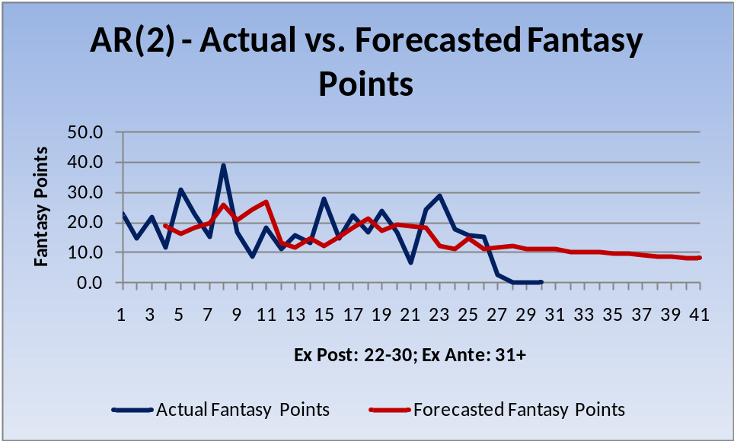
The graph above shows Jamaal Charles actual fantasy points for his first 30 games in blue. Forecasted fantasy points based on AR(2) are shown in red. Note that the first forecasted value is during week 4. Because we are using first differences and an AR(2) model, three weeks of data are necessary to obtain our first forecasted value.

As you can see, the model is not a very good fit. During the ex post forecast, only two weeks (25-26) fell within 5 fantasy points of actual values. Jamaal actually got injured during week 27, which resulted in a pitiful 2.7 points. He is likely out for the season. Clearly, our model does not take into account injury risk, or many of the other factors inherent to fantasy football. These other factors include strength of opponent, location of game (home/away), weather, changes to team personnel, and much more.

See “Model Comparison and Forecast” tab of the provided spreadsheet for the calculation of the forecasted first differences as well as the derivation of fantasy points from these forecasted first differences.

Appendix A: Autocorrelation – Second and Third Differences

Since the correlogram of first differences indicates sample autocorrelations that are slightly less than ideal for lags 12-15, I decided to construct correlograms for second and third differences to see if these lags became closer to zero.
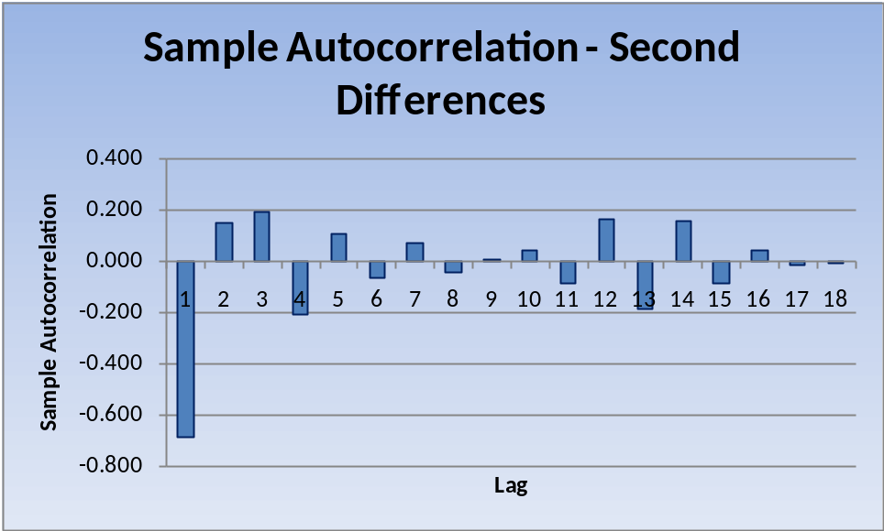
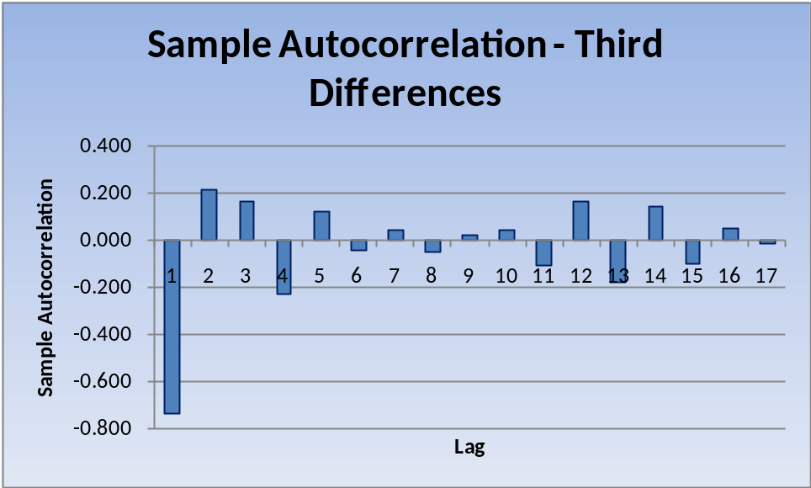

As shown above, the sample autocorrelations at lags 12-15 do move closer to zero by taking second and third differences. However, lags 11 and 16 move further from zero.

See “Autocorr – Second Diff” and “Autocorr – Third Diff” tabs of the given spreadsheet for complete data and calculation support.

