Time Series Student Project: Analysis of the Baby Name – Ryan
Prepared By: xxxxxxxxx xxxxxxx

Introduction:
My husband and I are expecting our second child in January and are in the process of selecting a name. There are many considerations when selecting a name (e.g., meaning, family tradition, ease of pronunciation and spelling, past associations, popularity, etc.). One of our primary concerns is selecting a name that is not trendy and not extremely popular. Both my husband and I have names that were ranked in the top 10 baby names when we were born so growing-up there was always at least 1 other child with the same name as us in our classrooms, etc. We both found this irritating and what to try to avoid the same fate for our child.
Of course, there are many factors that impact the popularity of a given name. A stochastic event (or events) in current events could cause jumps in popularity for the names of people associated with those events. For example, a popular movie or TV series may result in the number of babies named after characters or actors associated with the media. Alternatively, and popular government official or athlete my inspire more babies to be named similarly.
Therefore, I hypothesize that the popularity of a baby name can be modeled by an autoregressive model. Below is my analysis and attempt to fit an autoregressive model to the popularity of the baby name Ryan, which is one of our current favorites for our unborn son.
Data:
I obtained historical data on the percentage of baby boys named Ryan from the website http://babynamesworld.parentsconnect.com/popularity_of_Ryan.html. This website provided an easy to use listing of the percentage of baby boys born each year named Ryan using data from the Social Security Administration database. I found using the secondary source for this data easier to use than looking it up on the Social Security Administration website. The data is only available for years during which the name Ryan was in the top 1,000 ranked names and excludes years prior to the formation of the Social Security Administration. The data used also excludes anyone who did not apply for a Social Security number (e.g., neo-natal fatalities, etc.) and excludes anyone who did apply but had missing information in the record (e.g., location of birth was not on file) or was born in a US territory.
In Figure 1 below, sixty-five years of yearly data, from 1946-2010, were collected for the male name Ryan. Although there was data available for the year 1906 as well, it was ignored since data for the name Ryan was not available for the intervening years of 1907-1945 (presumably because Ryan was not in the 1,000 most popular names during those years or because the Social Security Administration simply did not have any data for those years). A large spike in popularity can be observed beginning in the year 1970, and peaking at year 1985.
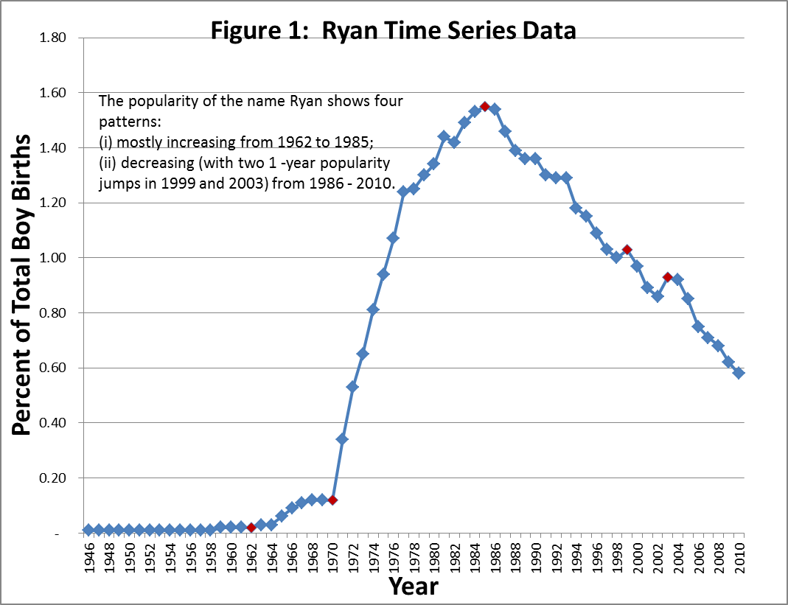

Test of Stationarity:
Figure 2 below shows the graph of the autocorrelation function of the Time Series. The graph indicates that the time series is not stationary because it is u-shaped about zero. The below graph also does not indicate that there are any “patterns” or seasonality associated with the time series. Therefore, I determined that no seasonality adjustments were necessary.
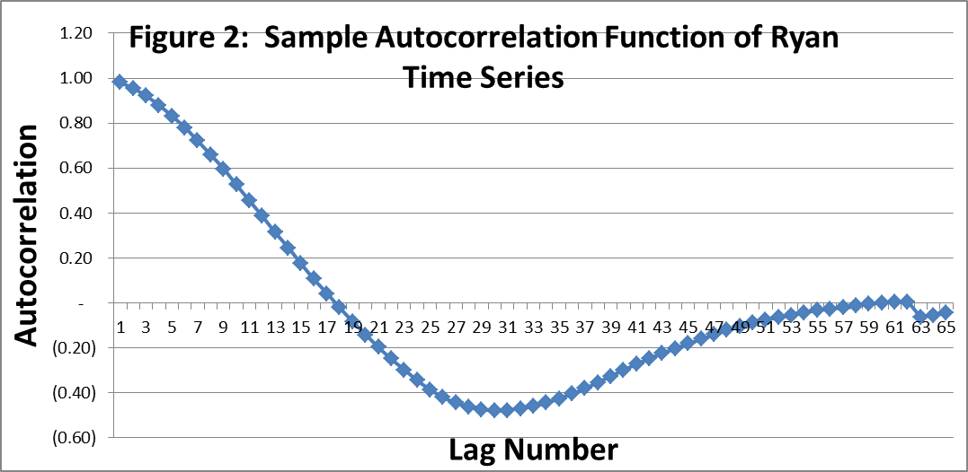

To create a stationary time series and remove the trend of the original time series, I took the first differences of the time series data. The 1st difference is calculated by taking the percentage of baby boys named Ryan in year (X+1) minus the percentage of baby boys named Ryan in year X. Figure 3 below shows the graph of the autocorrelation function of the 1st difference of the time series. The transformed is a stationary series which declines more rapidly to zero and then remains close to zero.
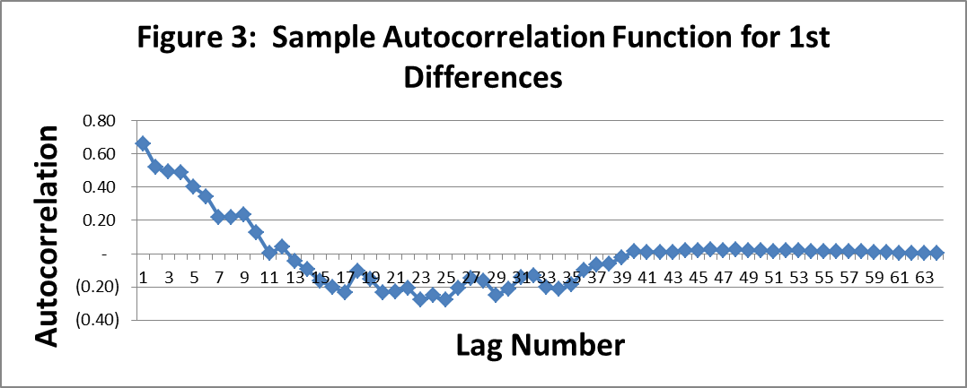
I also considered the transformed series using 2nd differences, but as shown below in Figure 4 I did not see a drastic improvement in the correlogram for 2nd differences compared to 1st differences. Therefore the rest of my analysis focuses on using the 1st differences transformed time series.
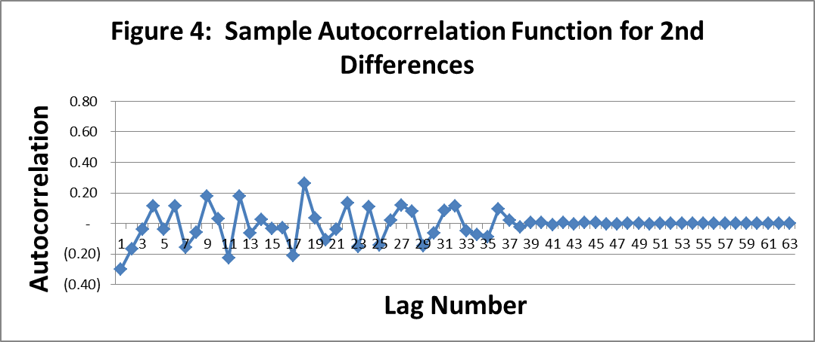

Process for Data Modeling:
The sample autocorrelation function for the times series data for the popularity of the name Ryan as a percent of total boy births shows that there are correlations for up to seventeen years. This indicates that there is a gradual decay in the popularity of the name Ryan which makes selecting an autoregressive model a better fit than selecting a moving average time series model. Although there may be a moving average component to the Time Series, it would likely have a small impact on the model results.
Model Estimation:
I used linear regression in Excel to fit autoregressive models to the transformed series of first differences. The below models were fit to the transformed series of first differences of the percentage of baby boys named Ryan:
AR(1):
AR(2):
AR(3):
AR(4):
AR(5):
For each of the above five models, I tested the fit using the model diagnostics summarized below:
 | AR(1) | AR(2) | AR(3) | AR(4) | AR(5)
Durbin-Watson Statistic | 0.03216 | 0.03210 | 0.03229 | 0.03235 | 0.03252
Box Pierce Statistic (Q*) | 36.74996 | 35.73044 | 30.45715 | 25.18478 | 25.04391
Chi-Square p-value (10% confidence) | 19.76800 | 18.93900 | 18.11400 | 17.29200 | 16.47300

The Durbin-Watson statistic is used to check the residuals for serial correlation. A Durbin-Watson statistic value of 0 indicates perfect positive correlation. A Durbin-Watson statistic value of 4 indicates perfect negative serial correlation. A Durbin-Watson statistic value of 2 indicates no serial correlation. The results of the Durbin-Watson test show that all the models generated on the transformed time series have positive serial correlation since the statistics shown above are very close to 0.
The Box-Pierce statistic is used to determine whether or not to reject the null hypothesis that the residuals are a white noise process. Models with Box-Pierce Q* statistics lower than their critical chi squared values (at the 10% significance level) indicate that the residuals of these models form a white noise process. As shown above, all the models have Q* in excess of the associated Chi-Square p-value and therefore we reject the null hypothesis that the residuals form a white noise process.
Since both the Durbin-Watson statistic and Box-Pierce statistic indicate that none of the models are a good fit for the transformed (1st differences) time series, Bartlett’s test was not performed.

Model Evaluation:
To confirm the findings of the model diagnostic statistics discussed above, I compared the graph of the transformed (1st differences) time series to the forecasted values for each of the models. None of the models produced values that fit the actual data, as shown in Figure 5:
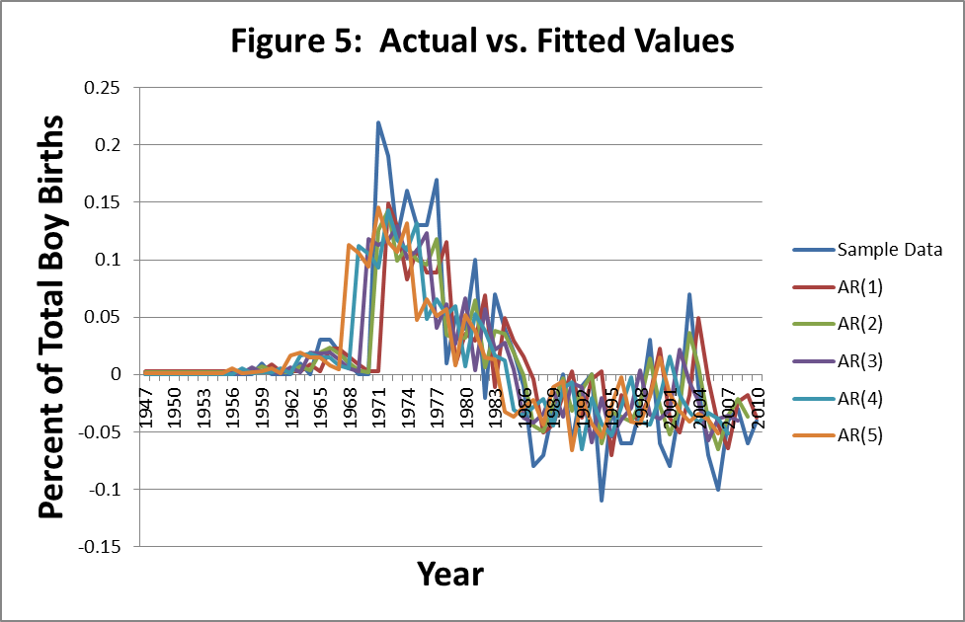
Conclusion:
As a result of my analysis, I have determined that the popularity of the name Ryan for boys cannot be effectively modeled using a simple autoregressive model. A more robust model appears to be needed which is beyond the scope of this project.
It is important to recall that the popularity of baby names can be change over time due to many factors. Family traditions, religion, fond memories of childhood stories or TV shows may necessitate that a much higher order autoregressive model be used to model the popularity of the name Ryan.
Selecting the name for a baby can be a complex decision (the first of many as a parent) and each parent selects the name for their child based on different criteria. As shown above, these complexities cannot be effectively modeled using a low-order autoregressive model to fit the popularity of the name Ryan.

