Time Series Project
Winter 2011
xxxxxxx xxxxxxx

Source of data: http://robjhyndman.com/TSDL/miscellaneous/
Data used: Number of acres burned in forest fires in Canada, 1918-1988. Source: Hipel and Mcleod (1994).

Forest fires are a naturally occurring phenomenon all over the world. When a severe drought or heat wave takes place, a fire can be ignited quickly due to the flammability of dried-out plants. Simple lightning can be the cause of a forest fire in the right environment. Not all forest fires damage the environment. In fact, they are a crucial part of a forest’s lifecycle. Fire brings warm air to the top of trees, which dries the cones and causes them to split, releasing their seeds. In the past, The US government ordered all forest fires to be extinguished. Recently however, the positive effects of forest fires have become known.

Understanding our environment is crucial in order to do our best to protect our Canadian forests, while not interfering excessively and causing them more harm than good.

I’ve chosen Canadian Forest Fire data for my time series project as I am Canadian and am interested in how these seemingly harmful fires, when controlled, are actually beneficial to the environment.

The data consists of the yearly number of acres burned in forest fires in Canada between 1918 and 1988.

My project will analyze this annual data, determine whether or not it is stationary, transform it if necessary to make it stationary, assess seasonality, choose an appropriate model that fits the data, analyze its residuals, and finally predict future values.

Graphing the Data

Exhibit 1 below is a time series plot of the yearly number of acres burned in forest fires in Canada:

The data appears to be random at first glance, with no apparent trend. There are however 2 substantially high values between 1960 and 1985.

Exhibit 2 shows the autocorrelation function (ACF) and partial autocorrelation function for yearly acres burned in forest fires in Canada:

From these graphs, the series appears to have stabilized. From my partial ACF, we can see that there are no lines exceeding the confidence interval, which means that there is no PACF at any of the lags. Therefore, our untransformed time series is stationary.

However, I will have a look at some transformed ACFs as well. I have graphed the differentiated ACF below:

Differentiated ACF & PACF

Here we see that actually the differentiated time series is not stationary as there are values outside the confidence interval.

We will now determine if the log-transformed TS is stationary.

Below is the autocorrelation and partial autocorrelation functions of the log-transformed time series:

Log Transformed ACF and PACF
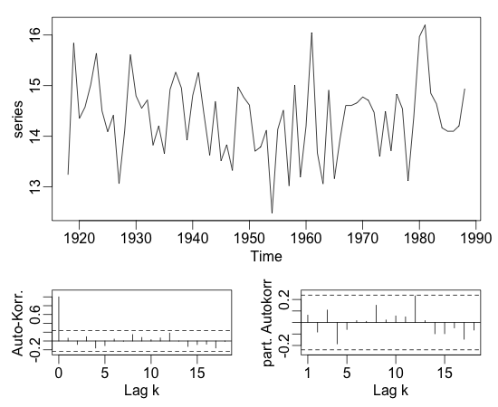

The log-transformed TS looks more stable than the original untransformed TS. Based on this, we’ll fit a few models to both the original TS and the log-transformed ACF.

Periodicity

Before continuing with choosing the best model, I will first determine if there is any seasonality in my data.

The ‘stl’ function in R stands for seasonal decomposition of Time Series by Loess: it is used to analyze seasonal trends, and irregular components in the data. The script is as follows:

stl(dts)

Error in stl(dts) : series is not periodic or has less than two periods

Since the function returned the error above, we can confirm that our data is not periodic, hence has no seasonality. Therefore we can rule out any seasonal arimas when choosing our model.

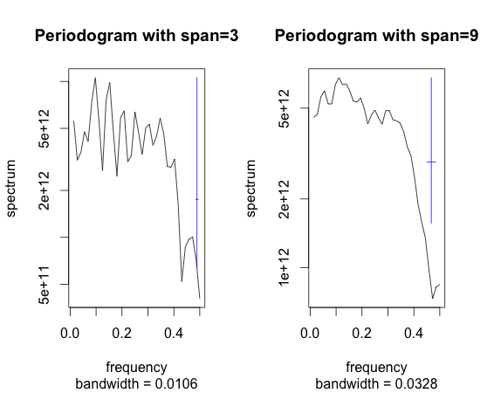

MODEL FIT

Let’s first start by assuming the original TS corresponds to an MA(1). I attempt to fit the model:

> fit.arima011 <- arima(dts,order=c(0,1,1))
>
> fit.arima011$code

[1] 0

For the above two lines of code, if the result/value returns zero, then your time series converges, i.e. it is stationary.

Since it converges to zero, our original untransformed time series is stationary.

> fit.arima011

Call:
arima(x = dts, order = c(0, 1, 1))

Coefficients:
ma1
-1.0000
s.e. 0.0591

sigma^2 estimated as 4.217e+12: log likelihood = -1118.91, aic = 2241.83

We can see however that the aic (an information criterion) is quite high at 2241.83. The lower the aic value, the better the chosen model fits the data.

We do the same for our log-transformed time series to determine the goodness of fit:

fit.arima011 <- arima(log(dts),order=c(0,1,1))
fit.arima011$code
[1] 0

The above code shows that our log-transformed TS is actually stationary as well.
fit.arima011

Call:
arima(x = log(dts), order = c(0, 1, 1))

Coefficients:
ma1
-1.0000
s.e. 0.1035

sigma^2 estimated as 0.5887: log likelihood = -82.91, aic = 169.83

Fitting the arima0,1,1 on the log-transformed data, we get an aic of 169.83, which is much lower than the aic of the original data, indicating that our log-transformed TS is a better choice compared to the original non-transformed TS.

Conclusion: Our log-transformed data should be used.

Box-Pierce Test

The Box-Pierce test is used to determine whether a time series consists simply of random values (or white noise).

Running the Box-Pierce test for the regular untransformed TS, we get:

Box.test(dts, lag=1, type=c("Box-Pierce", "Ljung-Box"), fitdf=0)

Box-Pierce test

data: dts
X-squared = 1.8904, df = 1, p-value = 0.1692

Now, we run if for our log-transformed TS:

Box.test(log(dts), lag=1, type=c("Box-Pierce", "Ljung-Box"), fitdf=0)

Box-Pierce test

data: log(dts)
X-squared = 0.2907, df = 1, p-value = 0.5898

Other Models

The Arima(0,1,1) model looks good for our log-transformed data. However, let us compare the Arima(0,1,1) with the ARIMA(1,1,1) and determine the most appropriate one:

- ARIMA(1,1,1)

fit.arima111 <- arima(log(dts),order=c(1,1,1))
fit.arima111$code
[1] 0

fit.arima111

Call:
arima(x = log(dts), order = c(1, 1, 1))

Coefficients:
ar1 ma1
0.0812 -1.0000
s.e. 0.1218 0.0683

sigma^2 estimated as 0.5863: log likelihood = -82.69, aic = 171.38

Our model could be used, and the aic is more or less the same as the aic for the ARIMA(0,1,1) model. However, if 2 models are equally good, then we should choose the simplest one, therefore my choice is the ARIMA(0,1,1).

RESIDUAL PLOTTING

f.acf(resid(fit.arima011))

- f.acf(resid(fit.arima011))

RESIDUAL PLOT: Original Data ARIMA (0,1,1)

Here, we are plotting the residuals of our chosen model. We are checking if the residuals are correlated or not. Residuals should be random, so if we see some correlation, it means that our model is not good. For or model to be good, our residuals need to be uncorrelated.
Now, if you look at the graph of the residuals, we can see that they are not correlated at all, so our model could be good.

Now, we plot the residuals of our log-transformed ARIMA model>

RESIDUAL PLOT: LOG-TRANSFORMED DATA ARIMA(0,1,1)

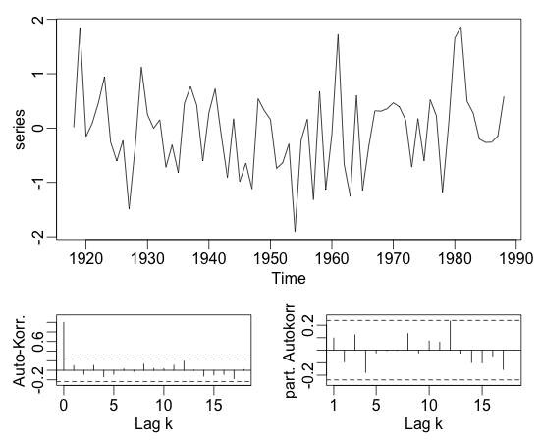

Now, if you look at the graph of the residuals, we can evidently see that they are not correlated at all, so our model is also good. As we’ve decided to us our log-transformed data earlier since our aic value was lower for it, we will choose the log-transformed data on which to fit our model.

QQ-PLOTS

Here we graph the normal QQ plot of the model, which indicates if the error of the model is normally distributed. If the points are all on the same line, this means that indeed, the error is normally distributed.

R command for QQ Plot:
qqnorm(fit.arima011$resid)
qqline(fit.arima011$resid,lty=2,col='orange')

Below is the Q-Q plot for our chosen model:

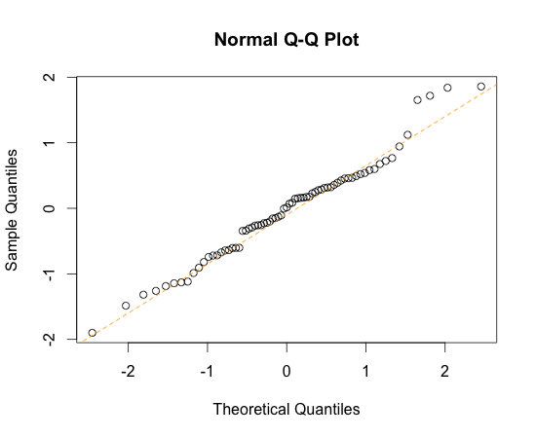

The tail is a little off, but we can still state that the error is normally distributed.

PREDICTION

pred <- predict(fit,n.ahead=30)

fit <- arima(log(dts),order=c(0,1,1))
pred <- predict(fit,n.ahead=30)

# plot time series with predictions and 95%-confidence interval:
plot(window(log(dts), start=1960),xlim=c(1960,1918+71+30),ylim=c(12,18))
lines(pred$pred, col='red')
lines(pred$pred+1.96*pred$se,col='red',lty=2)
lines(pred$pred-1.96*pred$se,col='red',lty=2)

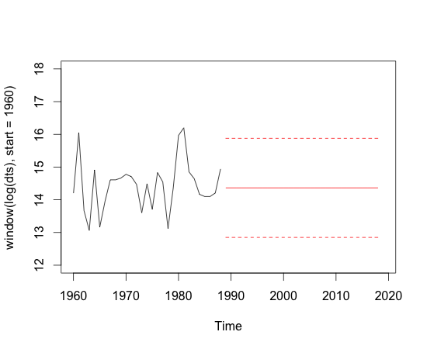

Our prediction for future values is an average indicated by the continuous straight line, within the confidence interval indicated by the dotted lines above and below.
This concludes our Time Series analysis. In this paper, I’ve shown that there can exist several good models that fit the data, therefore it is important to look into the data further to try to choose the most appropriate model. If two models are equally good, then selecting the simplest one is best.

