Peter Thies
Regression Analysis Project

Introduction

The purpose of this project is to analyze data the determining factors behind the caloric count of the items available at Burger King. Based on this analysis, one may make better personal nutritional choices or those who develop Burger King's foods could adjust their products.

Data

The data were obtained from the fastfoodnutrition.org website:
http://www.fastfoodnutrition.org/r-nutrition-facts/Burger%20King-so.html
The explanatory variables to be investigated are saturated fat (X₁), cholesterol (X₂), sodium (X₃), carbohydrates (X₄), fiber (X₅), sugars (X₆), and protein (X₇).

Seven Variable Analysis

An initial regression of all seven variables (found in the 'All Variables Analyzed' tab), yielded the following results:
The overall r-squared value was 0.965, which implies strong predictive power for this model. Based upon the sizes of the coefficients, saturated fat and carbohydrates appear to have the strongest influence upon calorie content. Those variables also have the lowest p-values. The large p-values for cholesterol and fiber imply that they have a minimal effect on calorie count. As such, a second analysis was then performed without those two variables.

It is noted that, like fiber, which will be removed from further analysis, sugar has a negative coefficient. This will be explored further below.

Ignoring Cholesterol and Fiber

A second regression (found in the 'No Cholesterol, Fiber' tab) using only saturated fat (X₁), sodium (X₃), carbohydrates (X₄), sugars (X₆), and protein (X₇) was performed with the following results:

The overall r-squared value was negligibly reduced to 0.963. However, with the exception of sugar, all of the other explanatory variables' p-values were markedly reduced, implying this to be a superior model than the seven-variable regression.

It is noted that sugar continues to have a negative coefficient. Further, its p-value was more than doubled in the change from seven explanatory variables to five. Therefore, sugar warrants further investigation.
Sugar

When attempting to make foods healthier, or at least seem healthier, a manufacturer will often advertise it as sugar-free or fat-free. However, because consumers are largely driven by taste, a reduction in sugar in a food is often countered by an increase in fat, or vice versa. The result is often no net increased health benefit. As the University of Illinois writes, "Many sugar-free foods contain more fat and salt than regular foods in order to enhance flavor." (http://efed.aces.uiuc.edu/101/faq.html)

Further, consider the following chart from the National Institute of Health (http://www.nhlbi.nih.gov/health/public/heart/obesity/lose_wt/fat_free.htm):

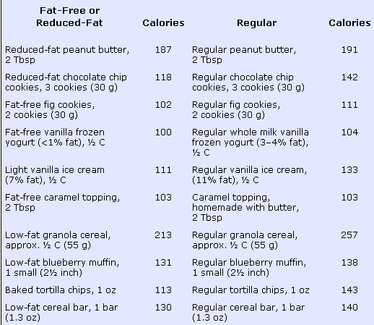

As one case see, the product with less fat generally has a comparable caloric content.

Given this information, One must consider whether the fat and sugar contents of the foods are correlated, i.e., whether a reduction in one is generally accompanied by an increase in the other. An analysis (found in the 'Fat and Sugar' tab) revealed an r-squared value of only 0.069 between the two variables, implying little correlation. However, a graph of sugar versus fat reveals that although low-sugar foods can have high or low fat contents, only the lowest-fat foods had high sugar contents.

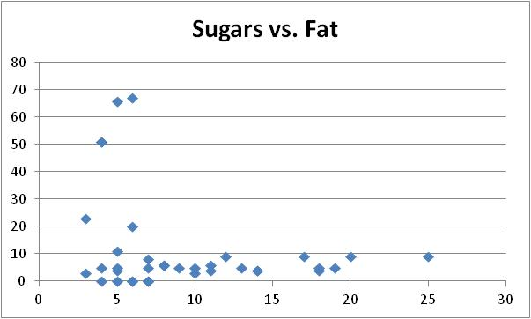

Dessert

Reviewing the information in the 'Source Data' tab, it was found that the five foods with the abnormally high amounts of sugar (over 20 grams) were all desserts. As such, the data were reanalyzed without the desserts.

An initial regression of all seven variables (found in the 'All Variables Analyzed (2)' tab), yielded the following results:

The overall r-squared value was 0.969, a slight improvement over the initial seven-variable value of 0.965. More importantly, sugar no longer has a negative coefficient. As before, the largest p-values were found with cholesterol and fiber.

Performing a regression without those two explanatory variables (found in the 'No Cholesterol, Fiber (2)' tab), yielded the following results:

The overall r-squared value was negligibly reduced to 0.968. However, all of the other explanatory variables' p-values, including that of sugar, were markedly reduced, implying this to be a superior model than the seven-variable regression.

Because there were only 5 dessert items, as compared to 31 non-dessert items, further analysis was performed only on the non-dessert items, five data point being judged as insufficient for further analysis.

Sodium

One may be tempted to remove sodium from consideration as an explanatory variable, given its coefficient is an order of magnitude lower than the others. However, one must consider that the values for the measurements of sodium are one to two orders of magnitude larger for sodium. As such, its coefficient is significant. Nonetheless, in the interest of thoroughness, an analysis (found in the 'No Sodium' tab) was performed with sodium eliminated.

The overall r-squared value was 0.950, a notable reduction. Further, as shown below, the p-values for two variables were increased, thus supporting the earlier statement that sodium is an important explanatory variable.

Predictive Power

As a final check of the model, it was used to predict the calorie contents of the 31 non-dessert foods based on their saturated fat, sodium, carbohydrate, sugar, and protein contents. The result (found in the 'Predictive Power' tab) was a linear relationship between the given and modeled calorie counts with an r-squared value and a slope both equal to 0.968.

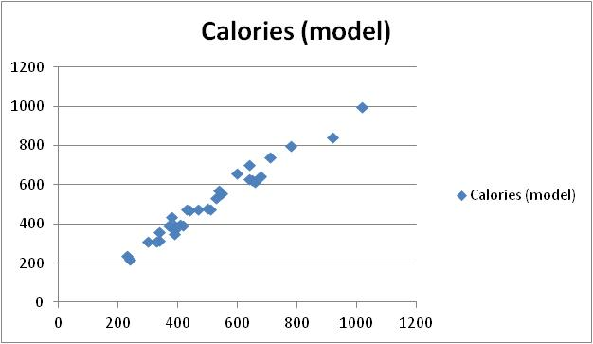

Conclusion

For non-dessert food produced by Burger King, the calorie count can be modelled according to the following equation:

Calories = -42.15413953
+ (Saturated Fat content) * 13.7811876
+ (Sodium content) * 0.117797896
+ (Carbohydrate content) * 5.071234649
+ (Sugar content) * 3.164758394
+ (Protein content) * 4.08340651

Of the five explanatory variables, fat and sodium are the strongest predictors, remembering that sodium is measured with valued two orders of magnitude larger than the other explanatory variables. Such predictive power could be of use to both consumers and to those who plan Burger King's menu.

