xxxxx xxxxxxx
Winter 2011-2012

Regression Analysis – Student Project
Prosperity Rankings vs Religious Adherents and Suicide

In researching the student project, I was very interested to read the project from the winter 2010 where the student regressed five variables (infant deaths, violent crime, gross state product, unemployment rate, and federal funding) to see what had the largest impact on population in any given state. Inspired by that project, I decided to do a similar project using data from the US census bureau to see if I could find the most likely predictors of personal income based on the fifty states ranked in order where all regression analysis will be conducted at a 95% confidence interval.
The analysis will be done by evaluating a model I designed from Census bureau data using the following seven explanatory variables (six explanatory and one constant term) and this model will then be improved upon by analyzing the resulting R², t-statistic, and P-Value. Based on the results of the regression output, the model will be adjusted to be more predictive with the overall goal to find the most predictive model of what contributes to an increase of personal income. The following table shows the variables used with the adjusted R² value (see "Individual Regressions" tab for full data) from a simple regression of the constant term with each explanatory term. As the greater the R² term is, the higher the correlation there is, the table below is also the order of most correlated. This can be seen as well in the following scatter charts of Variables X₁-X₃ and X_{7.}

Variables¹: | Adjusted R²
Y = Personal Income | N/A
X₁ = % of Persons above poverty line | 0.553
X₂ = % with Higher Ed | 0.521
X₃ = Public School Teacher average salary | 0.411
X₄=Homeownership Rate | 0.187
X₅=Violent Crime | -0.013
X₆ = Unemployment | -0.014
X₇ = Federal Aid per Capita | -0.020
All data is from http://www.census.gov/compendia/statab/rankings.html

The following charts show the relationship of the top three variables above as well as the bottom variable X₇ where no apparent relationship exists between the states with the greatest personal income and Federal Aid received.
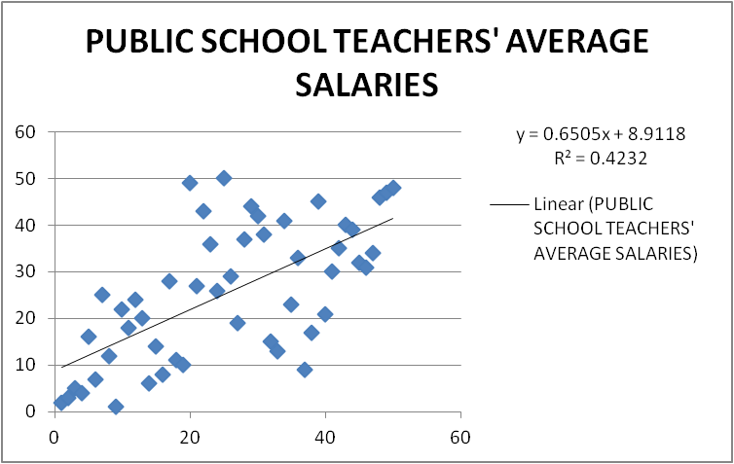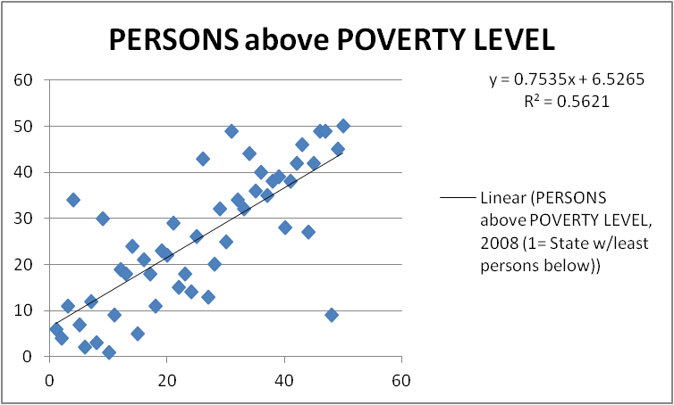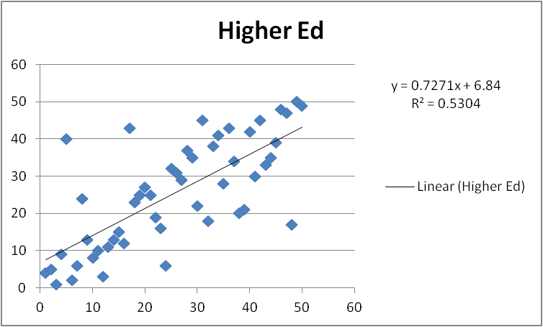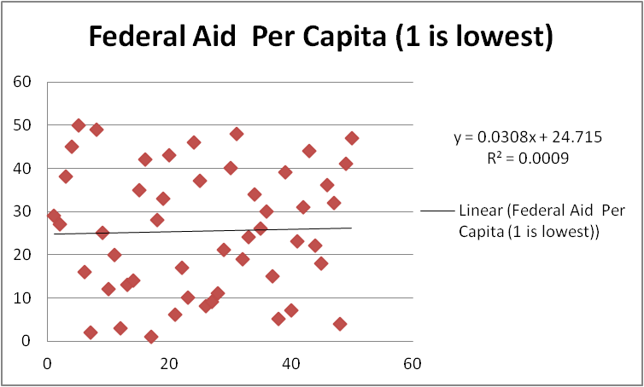

Regression #1
The following is a regression the total module which in mathematical terms is:
Y = α + β₁X₁ + β₂X₂ + β₃X₃ + β₄X₄ + β₅X₅ + β₆X₆ + β₇X₇
As can be seen from the results above, the Adjusted R² was .769 which indicates the proportion of total variation on all the explanatory variables where one is perfect correlation and zero in none. Furthermore, the P-value (with 95% confidence) for several of the indicators is greater than .05 which indicates which variables are the least correlated. A further interesting insight is that Homeownership has a small P-value but and a large negative t-Stat indicating it is negatively correlated, ie this implies states with lower Homeownership rates have higher Personal Income. All multi-variable regressions can be found in the attached Excel workbook by Regression # in the "Regression Output" tab.
Regression #2
To attempt to improve the model, the following is a regression removing Unemployment:
As can be seen above, by removing Unemployment from the regression, the Adjusted R squared declined somewhat from .769 to .766, however, the P- Value for all but two (Higher Ed and violent crime) are now below 3%. Let's remove both Higher Ed and Violent Crime.

Regression #3
The Adjusted R squared has now dropped again slightly from .766 to .745. However, now all P-values are less than 1%. Also, the negative t-Stat of Homeownership is still apparent. I will perform one more regression leaving out the Homeownership rate and see what happens:
Regression #4

Now the Adjusted R squared has dropped from .745 to .688 which is a significant drop. The t-Stats are now improved both being above 4.

Conclusion
After having performed the four above regressions as well as regressing each explanatory variable by the constant term, Personal Income, it seems none of the models are very good as I would have hoped to have an R squared above .95. That said, Regression #3 is the best model where persons above the poverty rate, highest public school teachers salary, and the homeownership rates were regressed against personal income. The adjusted R squared is only slightly less than that of the full regression in Regression #1 and all the P-values are less than 1%. This leads me to conclude that states with lower personal income should work to increase public school teacher salaries and work to bring more people out from below the poverty level. Also, homeownership is a detriment to higher income so states should consider reallocating the resources used to encourage homeownership toward a different goal . Also, despite my initial hypothesis, unemployment, violent crime, and federal Aid have little or no effect on personal income.

