xxxx xxxxxx xxxxxx
Regression Analysis (Fox)
Winter 2011

STUDENT PROJECT WRITE-UP
INTRODUCTION AND DATA:
I am an avid surfer living in San Diego, CA (in fact, I took surf break immediately after data collection). Because I read on the NEAS website that the student project is fairly open ended, I figured it would be fun to analyze some data regarding surfing conditions in Southern California and Northern California. As a project template, I have used the summer 2011 project related to basketball that was posted on the NEAS Discussion Forums.
Regression analysis determines which explanatory variables were most influential in an observed outcome. In this case, I have gathered data on what I believe to be explanatory variables that predict the rating of surfing conditions for a given surf spot at a given time. Specifically, I will use data collected online from the website “Magic Seaweed,” http://magicseaweed.com/San-Diego-Surf-Report/297/ (MSW).
As an introduction, I will describe some factors that affect surfing conditions. Wind affects how “bumpy” the water will seem to an average surfer. A surfer will prefer smooth water to rough water. Swell power can be measured in the dimensions of wave height (feet) as well as the period between waves (seconds). Large, powerful winds produce high waves with a long period between each wave. A surfer will prefer a more powerful swell. Swell direction and wind direction affects how a specific surf spot will be affected by winds and swells. Depending on the local sand bars and reefs, swell direction can play a large role in how “rideable” a wave will feel to a surfer. Likewise, the wind direction can play a large role on the affect of wind on the conditions. A strong offshore wind will produce a smooth, surfable surface, whereas even a moderate onshore wind will be rough and barely rideable. For some spots, tide plays a large role in how much power is delivered in each wave. Finally, besides the variable conditions, the local characteristics of a surf spot play an enormous role in the rating of s surf spots overall conditions. Bottom type, underwater canyons, offshore islands and sandbars, cliffs, and other static factors play a constant role in the surf conditions.
On the MSW website the following explanatory variables are available for use in the regression analysis: swell height, swell period, swell direction, wind speed, and wind direction.
On the MSW website, the response variable (dependent variable), swell rating is given on a scale of 1 – 5 Stars. Because this variable can be quantitative or qualitative I will examine both a linear regression and logistic regression models to determine which fits best. Because I am still learning about logistic regression models, please excuse any lack of rigor associated with my results.
Finally, to capture differences in static local characteristics, I will introduce one other variable called “Location.” This variable will be either “S” for southern California or “N” for Northern California.
In addition to the significant variables that affect surfing conditions, variables such as air temperature and water temperature are available online but, I would expect them to be insignificant.
HYPOTHESIS:
I hypothesize that a linear model for surfing conditions (response variable: swell rating) using one or more of the explanatory variables swell height, swell period, swell direction, wind speed, wind direction, and or location will produce a statistically significant result.
DATA COLLECTION:
I collected data on four San Diego / Orange County surf spots (Southern California) and four Monterey / Santa Cruz surf spots (Northern California) for a period of 10 days. Data with no rating are excluded. Data with Grey stars are ignored. There are 156 data points.
A Sample of the data is given below.
Srating | Prob | Height | Period | SwellDir | WindSpeed | GustSpeed | WindDir | WindQual | WindDir | Weather | AirTemp | Loc
5 | 1.00 | 5 | 15 | 279 | 3 | 4 | SSE | Offshore | 151 | Sunny | 57 | S
3 | 1.00 | 4.5 | 14 | 278 | 6 | 6 | WSW | Onshore | 250 | Sunny | 59 | S
4 | 1.00 | 4 | 14 | 278 | 2 | 2 | WSW | Onshore | 246 | Clear | 56 | S
3 | 1.00 | 3 | 13 | 280 | 9 | 9 | ENE | Offshore | 58 | Sunny | 59 | S
2 | 0.75 | 2.5 | 13 | 281 | 3 | 3 | NNW | Cross/onshore | 338 | Sunny | 69 | S
2 | 0.90 | 2 | 12 | 282 | 4 | 5 | ENE | Offshore | 65 | Clear | 71 | S
1 | 1.00 | 1.5 | 12 | 286 | 6 | 7 | ENE | Offshore | 62 | Sunny | 59 | S

ASSUMPTIONS:
To conduct a linear regression, I must assume that the error term for each variable is normal, linear, constant variance, independent, and measured without error and independent of the value. Below is a box plot of the major variables.
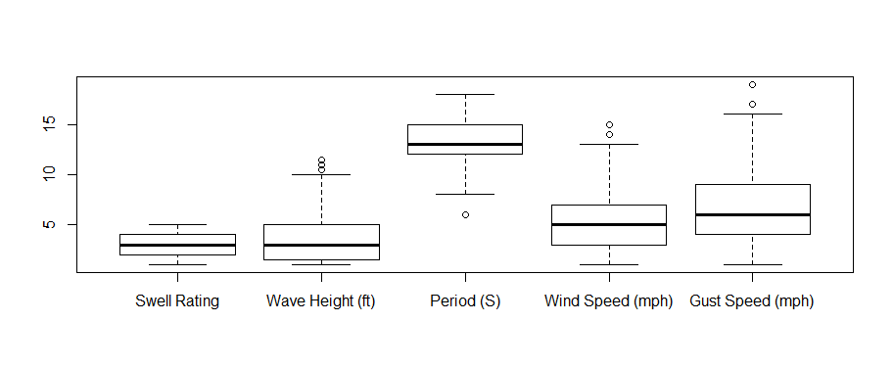
Each variable looks roughly symmetrically skewed with the exception of wave height. Wave height has a strong positive skew suggesting a transformation may be in order. Using the discussion in Regression Analysis I will look at transforming wave height down the ladder of powers and roots. Below are box plots lot of X^.5, and Ln(X), where X = wave height.
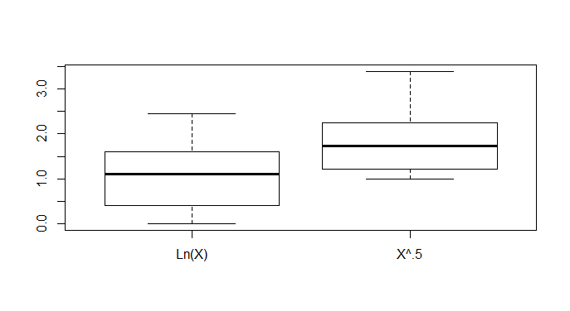
For my project I will use Ln(wave height) as an explanatory variable.
PLAN:
I will try conducting a linear regression with various combinations of explanatory variables. I will use R² as an indicator of the responsiveness for each model. The R² value for the overall regression model indicates the percentage of variation of the response variable (swell rating) that is captured by each regression. A high value of R² indicates that a model is nearly complete. For each model, I will record the F- value of regression and degrees of freedom.
F-values test the null hypothesis that each regression coefficient is zero. A large F-value indicates that explanatory variables affect the response variable. During model, I will pay close attention to the p-value associated with each explanatory variable and use a significance level to determine which ones to keep and which to remove. A low P-value indicates that a variable is significant. Once I have determined which explanatory variables I want to keep, I will form a regression equation with least square coefficients.
I want to find out whether offensive explanatory variables, such as points allowed or assists, or defensive explanatory variables, such as blocks or steals, are more influential. Then I will be able to statistically identify which of the two sides of basketball is more important in winning games. For reference, here is a table identifying which explanatory variables I have deemed “Offensive” and which I have deemed “Defensive”:
Changing Conditions Explanatory Variables | Geographic Explanatory Variables | NEITHER
Wave Height (ft) | Location (N or S) | Air Temperature (F)
Log (Wave Height) |  | Weather
Period (S)
Wind Direction
Wind Speed (mph)
Wind Quality
Gust Speed (mph)

As discussed in the introduction, I would expect some of these explanatory variables to be positive correlated with swell rating (wave height and period). However because locally strong winds produce bumpy, poorly formed waves, I would expect wind speed and gust speed to be negatively correlated with swell rating.
ANALYSIS:
Similar to Fox’s analysis on page 139, I have calculated the regression sum of squares and R² for 7 models. Besides these models, I also looked at a large number of other factors that I deemed insignificant.
Model | Terms | RSS | df | R² | RegSS | TSS
1 | P, WQ x GS | 224.092 | 144 | 0.3044 | 98.06 | 322.16
2 | H, SD, WQ x GS | 79.37 | 143 | 0.7537 | 242.88 | 322.25
3 | P, SD, WQ x GS | 175.52 | 143 | 0.4552 | 146.65 | 322.17
4 | H, P, WQ x GS | 49.36 | 143 | 0.8468 | 272.83 | 322.19
5 | H, P, SD | 93.62 | 152 | 0.7094 | 228.54 | 322.16
6 | H, P | 94.81 | 153 | 0.7057 | 227.34 | 322.15
7 | H, P, SD, WQ x GS | 48.36 | 142 | 0.8499 | 273.83 | 322.19
H = Log(Wave Height)
P = Wave Period
WQ = Wind Quality (Qualitative)
GS = Gust Speed (mph)
SD = Swell Direction

As you can see above, Model 7 has the highest value of R², indicating that it fits the data best. Model 4 also has a very high value of R². Of significance, gust speed and wind quality were found to have little affect on improving the model unless an interaction was modeled. Two explanatory variables are said to interact in determining a response variable when the partial effect of one depends on the value of another. As discussed in the interaction, wind makes conditions bumpy. However, this bumpiness depends on the direction of the wind, so these explanatory variables interact.
To determine the significance excluding various explanatory variables from a model, I conducted an analysis of variance similar to Fox’s analysis on page 139. I determined that all explanatory variables in model 7 are significant because of the high associated F values and low P values. Swell direction does not play as important of a role as the other explanatory variables. Swell direction is measured using degrees from 180 to 360. In California, swells generally come from the south or northwest due to the presence of tropical storms in the south or artic storms in the Gulf of Alaska. Swell direction is not normally distributed because it is multi-modal. Perhaps if I had introduced swell direction as a categorical variable, my model would have been more significant.
Source | Models | Sum of | df | F | P
 | Contrasted | Squares
Height | 3-7 | 127.15 | 1 | 373.34 | <.0001
Swell Dir | 4-7 | 0.99 | 1 | 2.9172 | 0.089
Period | 2-7 | 31 | 1 | 91.029 | <.0001
WQ x Gust Speed | 5-7 | 45.26 | 10 | 13.29 | <.001
Residuals |  | 117.75 | 143
Total |  | 322.15 | 156

Below I have included the results for coefficients and P-values of Model 7.
Call:
lm(formula = Srating ~ log(Height) + Period + SwellDir + as.factor(WindQual) *
GustSpeed)

Residuals:
Min 1Q Median 3Q Max
-1.72592 -0.35478 0.03069 0.34357 1.75122

Coefficients: (1 not defined because of singularities)
Estimate Std. Error t value Pr(>|t|)
(Intercept) -2.877932 0.759285 -3.790 0.000222 ***
log(Height) 1.730792 0.089576 19.322 < 2e-16 ***
Period 0.260248 0.027277 9.541 < 2e-16 ***
SwellDir 0.003008 0.001761 1.708 0.089824 .
as.factor(WindQual) Cross/offshore -0.139812 0.596320 -0.234 0.814967
as.factor(WindQual) Cross/offshore -0.368005 0.639541 -0.575 0.565918
as.factor(WindQual) Cross/onshore -0.260979 0.427393 -0.611 0.542422
as.factor(WindQual) Offshore -0.231045 0.403258 -0.573 0.567588
as.factor(WindQual) Onshore 0.377007 0.395876 0.952 0.342545
GustSpeed -0.077295 0.053396 -1.448 0.149937
as.factor(WindQual) Cross/offshore:GustSpeed 0.063660 0.073228 0.869 0.386125
as.factor(WindQual) Cross/offshore :GustSpeed NA NA NA NA
as.factor(WindQual) Cross/onshore :GustSpeed -0.017168 0.058758 -0.292 0.770577
as.factor(WindQual) Offshore :GustSpeed 0.042311 0.057016 0.742 0.459258
as.factor(WindQual) Onshore :GustSpeed -0.145727 0.058007 -2.512 0.013116 *
---
Signif. codes: 0 ‘***’ 0.001 ‘**’ 0.01 ‘*’ 0.05 ‘.’ 0.1 ‘ ’ 1

Residual standard error: 0.5836 on 142 degrees of freedom
Multiple R-squared: 0.8499, Adjusted R-squared: 0.8361
F-statistic: 61.84 on 13 and 142 DF, p-value: < 2.2e-16

As expected, the values for Beta are positive for both wave height and period. This indicates a higher swell rating when waves are larger and more powerful. Additionally, swell direction has a somewhat significant P-value and is positively correlated with swell rating. As discussed earlier, swells arriving in California come from the Northern Pacific (NW, ~315 degs) or the Tropics (S, ~200 degs). Because California is located closer to the Northern Pacific and it is currently winter in CA, it is reasonable that the NW swell would be correlated with a higher swell rating.

Finally, there is one statistically significant explanatory variable with a negative Beta, this is the factor of onshore interacting with gust speed. As discussed throughout this paper, onshore winds produce bumpy waves, so we would expect a lower swell rating. The results are consistent with this expectation.

In addition to examining my hypothesis, I thought of some other interesting questions along the way. For instance, does the location affect the swell rating? Below are the results for this dichotomous factor.

Call:
lm(formula = Srating ~ as.factor(Loc))

Residuals:
Min 1Q Median 3Q Max
-2.7590 -0.8493 0.1507 1.1507 3.1507

Coefficients:
Estimate Std. Error t value Pr(>|t|)
(Intercept) 3.7590 0.1188 31.63 <2e-16 ***
as.factor(Loc)S -1.9097 0.1737 -10.99 <2e-16 ***
---
Signif. codes: 0 ‘***’ 0.001 ‘**’ 0.01 ‘*’ 0.05 ‘.’ 0.1 ‘ ’ 1

Residual standard error: 1.083 on 154 degrees of freedom
Multiple R-squared: 0.4397, Adjusted R-squared: 0.436
F-statistic: 120.8 on 1 and 154 DF, p-value: < 2.2e-16

As you can see, location is clearly significant. It is currently winter in California, and most swells are coming from the Northwest. Northern California receives most of this energy because it is closer to the Gulf of Alaska. However R-squared for this is much lower than R-squared in Model 7.

To demonstrate the difference between an empirical relation and a structural relation, I will form a regression of swell rating based upon air temperature and weather conditions. Because it is generally cooler and more overcast in Northern California, I would expect that there is statistical significance to this linear model, but in no way does this imply causality. Below are my results from this model.

Call:
lm(formula = Srating ~ AirTemp + as.factor(Weather))

Residuals:
Min 1Q Median 3Q Max
-2.56575 -0.93963 0.07185 0.86634 3.10626

Coefficients:
Estimate Std. Error t value Pr(>|t|)
(Intercept) 5.39330 1.31890 4.089 7.1e-05 ***
AirTemp -0.07346 0.02154 -3.410 0.000838 ***
as.factor(Weather)Clear 1.73928 0.69045 2.519 0.012836 *
as.factor(Weather)MClear 2.10040 0.71631 2.932 0.003904 **
as.factor(Weather)Mcloudy 3.41153 1.01139 3.373 0.000950 ***
as.factor(Weather)MSunny 2.13921 0.75363 2.839 0.005174 **
as.factor(Weather)Sunny 1.42216 0.70001 2.032 0.043994 *
---
Signif. codes: 0 ‘***’ 0.001 ‘**’ 0.01 ‘*’ 0.05 ‘.’ 0.1 ‘ ’ 1

Residual standard error: 1.321 on 147 degrees of freedom
(2 observations deleted due to missingness)
Multiple R-squared: 0.1804, Adjusted R-squared: 0.147
F-statistic: 5.394 on 6 and 147 DF, p-value: 4.601e-05

As you can see above the model is clearly significant, but it would be absurd to suppose that cold, overcast weather produces great swells as this model indicates!

SUMMARY AND FUTURE WORK
In summary, I have shown that my hypothesis is indeed correct. It is possible to generate a statistically significant model for swell rating based upon the explanatory variables height, period, gust speed, and wind quality.
There are a number of ways this model could be improved.
First, I only collected the minimum amount of data that I believed would be necessary to create a statistically significant result. Data collection over a longer period of time would be useful to further refine the model and validate the model.
Second, I purposely examined surf breaks in Southern California and Northern California because both coasts are generally west facing. This allowed my to use Swell Direction as an explanatory variable. However, if I had wished to compare surf spots in other regions of the world, I would have had to account for the differing sources of swell. My model is extensible only to west facing beaches. A categorical variable such as swell source might alleviate some of these concerns, but would not account for the fact that the direction beaches face is an important factor in swell rating. Perhaps a more accurate quantitative variable would be swell offset (offset = swell direction – beach facing direction).

