xxxxxxx xxxx
Time Series
Fall 2011
Student Project

Sunspots

Introduction

Sunspots are an interesting natural phenomenon which increase and decrease over the years in a periodic manner. I was able to gather data on the yearly number of sun spots since 1900 and am interested in seeing if there is an ARIMA model can be selected to accurately describe the number of sunspots.

Data

My source of data is from “Wolf’s Sunspot Numbers, Tong (1991),” retrieved from the following site: <http://robjhyndman.com/tsdldata/data/sunspot.dat>. The data set provides the annual number of sunspots from 1700 to 1988. I limited the data used in this analysis to 1900-1988.

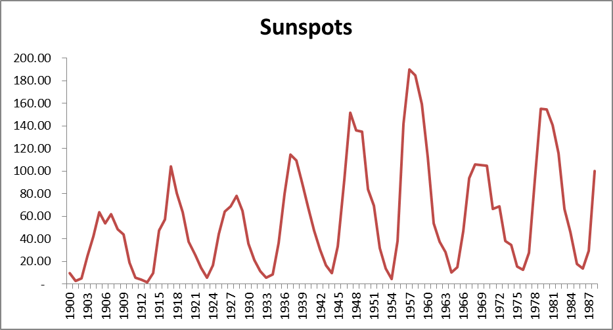

Model Selection

The first step in selecting a model for the first difference is to look at the sample autocorrelations. These autocorrelations were calculated in the same way as the homework. The graph below shows the sample autocorrelations at various lags for the original series, the first difference and the tenth difference:

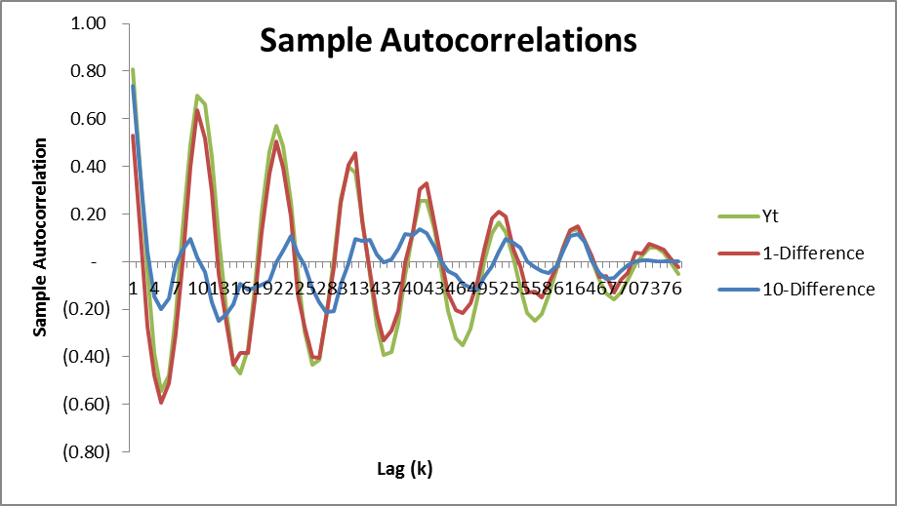
The original series and the first difference have sample autocorrelations that oscillate around zero and decrease very slowly as the lag increases. This indicates that these series are not stationary. The tenth-difference has a more reasonable autocorrelation function. For this series, r₁=0.737, r₂=0.399, and r₃=0.043. The sample autocorrelations at greater lags show some variation around zero, but much less than the original series. This indicates that the tenth difference is a relatively stationary series and that it may be possible to model it with an ARIMA process. The graph below shows the 10-Difference series over time:

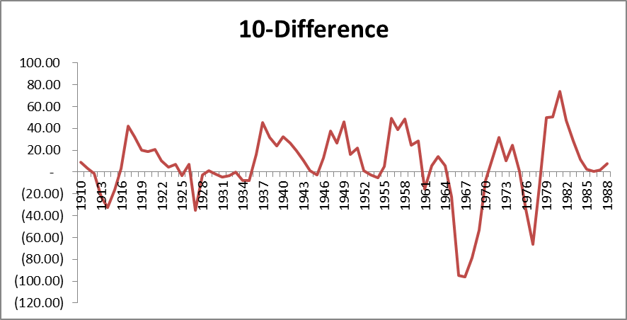

Model Selection

Using Excel, I tested the autoregressive models AR(1), AR(2), and AR(3) using the 10-Difference series. Below are the fitted models along with their descriptive statistics.

AR(1):

W_{t} = 1.5865 + 0.7375W_{t-1}

Regression Statistics
Multiple R | 0.737497865
R Square | 0.543903102
Adjusted R Square | 0.537901827
Standard Error | 20.96167432
Observations | 78
ANOVA
 | df | SS | MS | F
Regression | 1 | 39822.63074 | 39822.63074 | 90.63125808
Residual | 76 | 33393.77606 | 439.3917902
Total | 77 | 73216.40679
 | Coefficients | Standard Error | t Stat | P-value
Intercept | 1.586541165 | 2.420198633 | 0.655541716 | 0.514098578
W_{t-1} | 0.737465469 | 0.077464493 | 9.520045067 | 1.35507E-14

AR(2):

W_{t} = 2.1918 + 0.9725W_{t-1} - 0.3184W_{t-2}

Regression Statistics
Multiple R | 0.768392596
R Square | 0.590427181
Adjusted R Square | 0.579357645
Standard Error | 20.12913697
Observations | 77
ANOVA
 | df | SS | MS | F
Regression | 2 | 43223.23272 | 21611.61636 | 53.33802607
Residual | 74 | 29983.47949 | 405.1821552
Total | 76 | 73206.71221
 | Coefficients | Standard Error | t Stat | P-value
Intercept | 2.191818404 | 2.345389344 | 0.934522198 | 0.353074125
W_{t-1} | 0.972531925 | 0.11019149 | 8.825835121 | 3.54835E-13
W_{t-2} | -0.31837041 | 0.110199519 | -2.88903631 | 0.005066092

AR(3):

W_{t} = 2.8426 + 0.8856W_{t-1} - 0.0541W_{t-2} - 0.2712W_{t-3}

Regression Statistics
Multiple R | 0.787679118
R Square | 0.620438393
Adjusted R Square | 0.604623326
Standard Error | 19.63720634
Observations | 76
ANOVA
 | df | SS | MS | F
Regression | 3 | 45384.57693 | 15128.19231 | 39.23084202
Residual | 72 | 27764.63084 | 385.6198727
Total | 75 | 73149.20776
 | Coefficients | Standard Error | t Stat | P-value
Intercept | 2.842580203 | 2.31619524 | 1.227262777 | 0.223721528
W_{t-1} | 0.885632659 | 0.11343908 | 7.807121332 | 3.5115E-11
W_{t-2} | -0.05405949 | 0.154040503 | -0.35094336 | 0.72665564
W_{t-3} | -0.27122461 | 0.113408039 | -2.39158189 | 0.019390033

We look at a number of different statistics in order to select among these models. The first statistic is the R Squared. The AR(1) model has R Square = 0.544, indicating that 54.4% of the variance is due to the W_{t-1} variable. The AR(2) and AR(3) models have R Squared values of 0.590 and 0.620, which are higher, but not significantly.

A high F statistic indicates that the null hypothesis (H₀: B = 0) should be rejected. The F statistic of 90.6 is highest for the AR(1) model. This indicates that the variable W_{t-1} is significant in predicting W_{t}. The other models have lower F statistics.

The Durbin-Watson Statistic indicates whether there is serial correlation inherent in the model. A value of two indicates no serial correlation. The AR(1) model has a Durbin Watson Statistic of 1.53, which is further from two than the other models.

Model | Durbin Watson Statistic
AR(1) | 1.528865
AR(2) | 2.172859
AR(3) | 1.937317

Taking into account the R squared, F statistic and Durbin Watson Statistic, I would select the AR(1) model as the best model to fit the 10-difference data. The other may have higher R squared values, but looking at the F statistic and Durbin Watson Statistic, it seems that these models over-fit the data. They do not add much predictive power and it is important to remember parsimony when selecting a model.

After selecting the AR(1) model, I used the Box-Pierce Q statistic to test whether the residuals from the model are a white noise process. The null hypothesis for this test is that the residuals are a white noise process. The residual autocorrelations are tested for large values of lag k. At a lag of 30, the Box-Pierce Q Statistic is 14.3. This is compared with the Chi Squared Statistic with a significance level of 10% and 29 degrees of freedom, 39.1. Since the Box-Pierce Q statistic is lower than the threshold, the null hypothesis is not rejected.

After examining the different statistics for selecting and validating models, I conclude that the AR(1) model is appropriate for modeling the W_{t} series. The next step is to test the model’s accuracy in forecasting.

Forecasting

I retrieved more recent sunspot data for years 1989 – 2009 from the NOAA in order to test the forecasting ability of the selected model. I performed both a 1-Year and 3-Year forecast. The graph below shows how these forecasts correspond with the actual number of sunspots. As expected, the 1-Year forecast tracks better, but the 3-Year forecast exceeded my expectations. There are two main points of divergence, 1998-1999 and 2008-2009.
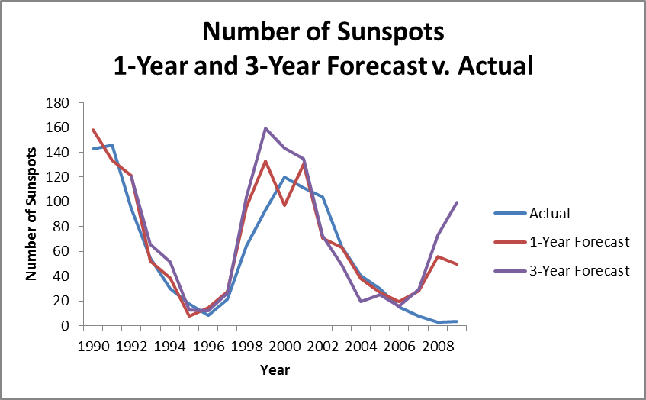

Conclusion

I am quite pleased with the Forecasting results of the selected model. The model was only created with data through 1988, so the data for the years in the Forecasting exercise were not previously “known” to the model. Overall this was an interesting project and I enjoyed being able to use the knowledge in this course to arrive at a model that has some real predictive power in forecasting.

