NEAS Regression Analysis Student Project
Monthly Natural Gas Rig Count Regressed on Price, Storage Deviation from Average, and Production

xxxx xxxxx
Fall 2011

Introduction
Data from the EIA (Energy Information Administration – see Links) was used to regress the number of Natural Gas drilling rigs in operation on price, deviation of stored natural gas from a 5-year average, and production. All data is monthly starting in January 1998 and ending October 2011. The dependent variable is rig count and the others explanatory. Analysis of regression results will be used to select the best model. It seems reasonable that there should be a correlation between rig count and the chosen explanatory variables.

Data
The data is plotted as monthly time series in Charts 1-4 below.

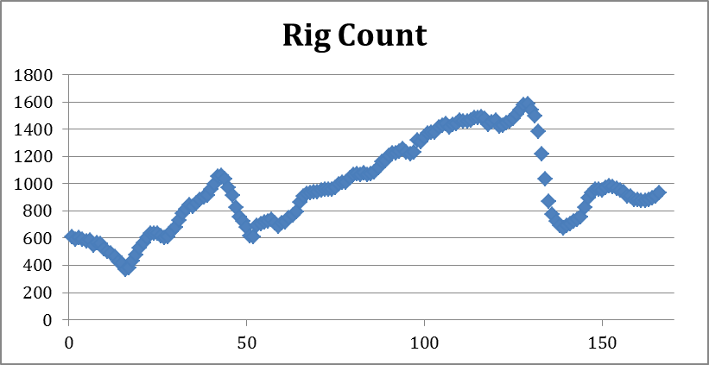
Chart 1: Dependent Variable Rig Count

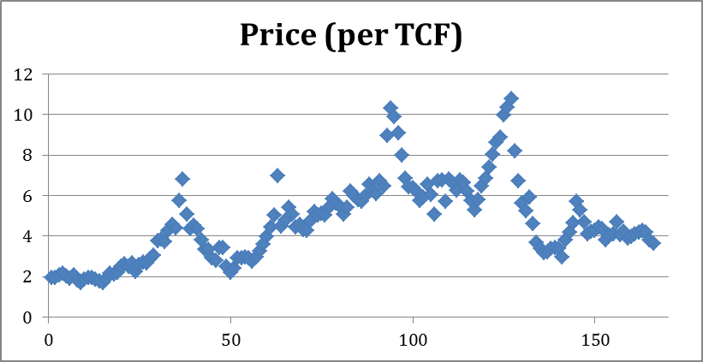
Chart 2: Explanatory Variable 1 – Price per Thousand Cubic Feet

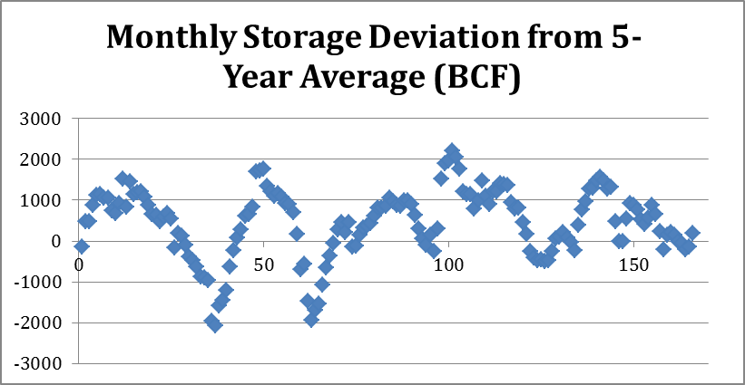
Chart 3: Explanatory Variable 2 – Storage Deviation Billion Cubic Feet

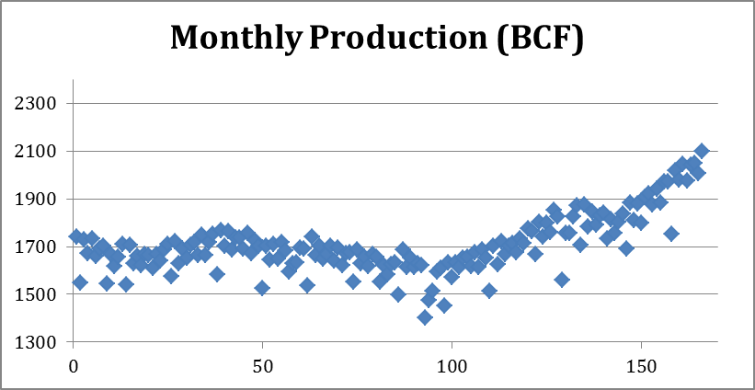
Chart 4: Explanatory Variable 3 – Production Billion Cubic Feet

Each explanatory variable was plotted versus the dependent variable to check if the data needed to be transformed. Chart 5 below is rig count versus price.

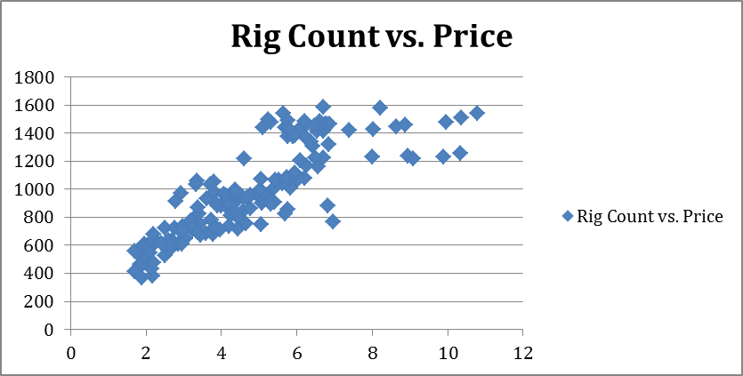
Chart 5: Rig Count vs. Price

I decided to transform price down the ladder of transformations because it seems there is more spread at higher price and the data appears bowed to the upper left. Chart 6 shows Rig Count vs. ln(Price). This shows a less bowed relationship and less variable spread so ln(price) was used instead of price as an explanatory variable. Chart 7 shows Rig Count versus storage deviation. No transformations were made after examining this plot. Chart 8 shows Rig Count versus production and no transformation were made after examining this chart. From looking at the charts it appears the ln(price) should be the most useful explanatory variable.

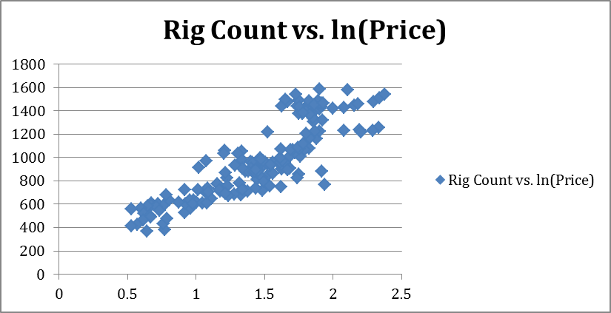
Chart 6: Rig Count vs. ln(Price)

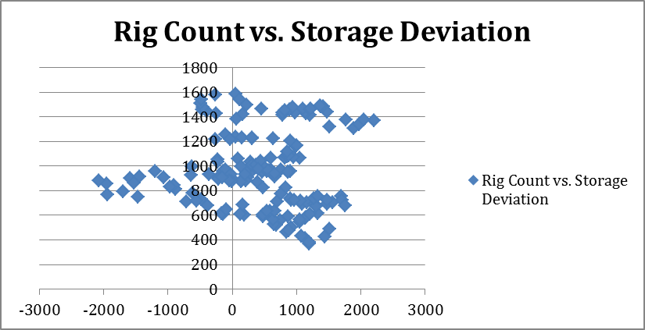
Chart 7: Rig Count vs. Storage Deviation

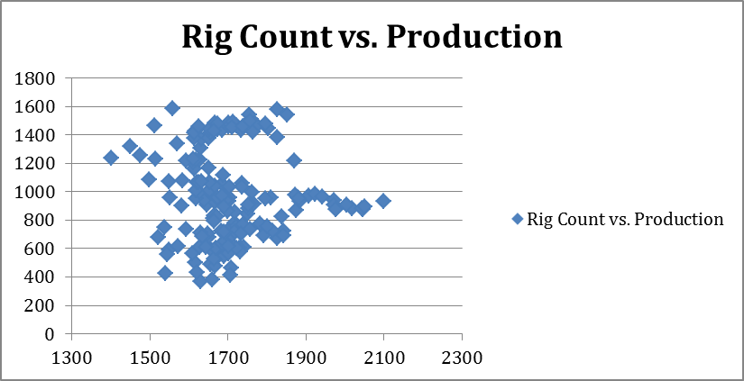
Chart 8: Rig Count vs. Production

Regression Analysis

Before performing regression analysis we will check the correlation of the explanatory variables. This was done in Excel. The correlation of ln(price) with storage deviation is -.247, the correlation of ln(price) with production is -.05, and the correlation of storage deviation with production is -.138. None of these are high enough to give pause and we therefore proceed.

The result of regressing Rig Count on all three explanatory variables is below in Table 1.
Regression Statistics
Multiple R | 0.891837653
R Square | 0.795374399
Adjusted R Square | 0.791585036
Standard Error | 144.5496107
Observations | 166
ANOVA
 | df | SS | MS | F | Significance F
Regression | 3 | 13157110.07 | 4385703.357 | 209.8965983 | 1.40418E-55
Residual | 162 | 3384923.574 | 20894.58996
Total | 165 | 16542033.64
 | Coefficients | Standard Error | t Stat | P-value | Lower 95%
Intercept | -251.3805465 | 170.8600353 | -1.471265917 | 0.143159039 | -588.7805491
X Variable 1 | 667.8979275 | 26.63761506 | 25.07348822 | 1.19752E-57 | 615.2962095
X Variable 2 | 0.093577762 | 0.014094552 | 6.639286229 | 4.52851E-10 | 0.065745029
X Variable 3 | 0.118702041 | 0.094413196 | 1.257261121 | 0.210468628 | -0.067737185
Table 1: Regression Results with 3 Variables.
There is an adjusted R-square of about .792 and an F test significance of 1.4E-55 so the results are significant. Examining the individual variable statistics shows that the first two are high significant but the third perhaps could be ignored with a p value of .21. The regression equation using all three variables is

$$\text{RC}=\text{251}\text{.}\text{38}+\text{667}\text{.}\text{898}\text{*ln}(\text{Pr}\text{ice})+\text{.}\text{0936}∗\text{StorageDeviation}+\text{.}\text{1187}\text{*Pr}\text{oduction}$$

Eliminating the last variable and regressing rig count on ln(price) and storage deviation only provides the regression results in Table 2 below.

Regression Statistics
Multiple R | 0.890717563
R Square | 0.793377777
Adjusted R Square | 0.790842535
Standard Error | 144.8068688
Observations | 166
ANOVA
 | df | SS | MS | F | Significance F
Regression | 2 | 13124081.88 | 6562040.938 | 312.9396626 | 1.5379E-56
Residual | 163 | 3417951.768 | 20969.02925
Total | 165 | 16542033.64
 | Coefficients | Standard Error | t Stat | P-value | Lower 95%
Intercept | -43.14366943 | 42.03560809 | -1.026360064 | 0.306242598 | -126.1482146
X Variable 1 | 664.9604588 | 26.58217832 | 25.01527342 | 1.08861E-57 | 612.4706359
X Variable 2 | 0.090816911 | 0.013947217 | 6.511472003 | 8.80413E-10 | 0.063276394
Table 2: Regression Results with 2 Variables (ln(price) and storage deviation)

This regression has an adjusted R-square of .791 and an F test significance of 1.54E-56. It seems evident that the production explanatory variable is extraneous when comparing with the three variable results. As the most significant variable is ln(price), we will also perform a regression using that as the only explanatory variable. The results are below in Table 3. The 2 variable regression fit equation is

$$\text{RC}=\text{43}\text{.}\text{14}+\text{664}\text{.}\text{96}\text{*ln}(\text{Pr}\text{ice})+\text{.}\text{091}∗\text{StorageDeviation}$$

Regression Statistics
Multiple R | 0.860018357
R Square | 0.739631575
Adjusted R Square | 0.738043962
Standard Error | 162.0565855
Observations | 166
ANOVA
 | df | SS | MS | F | Significance F
Regression | 1 | 12235010.39 | 12235010.39 | 465.8766827 | 8.64319E-50
Residual | 164 | 4307023.251 | 26262.3369
Total | 165 | 16542033.64
 | Coefficients | Standard Error | t Stat | P-value | Lower 95%
Intercept | 58.95430562 | 43.64776295 | 1.350683326 | 0.178657621 | -27.22970987
X Variable 1 | 622.1832211 | 28.82589549 | 21.58417667 | 8.64319E-50 | 565.2654948
Table 3: Regression Results with 1 Variable (ln(price))

The results are still significant with F test significance of 8.64E-50 and the adjusted R square is still fairly high at .74, but in comparison to the 2 variable regression results where the adjusted R square is .791 it appears the 2 variable model is best. The single variable regression fit equation is

$$\text{RC}=\text{58}\text{.}\text{954}+\text{622}\text{.}\text{183}\text{*ln}(\text{price})$$

It appears that roughly 80% of the variance in rig count is explained by price and storage deviation while the amount of natural gas produced isn’t that important. This is perhaps a testament to the fact that what is important is the balance of supply and demand rather than one or the other. Chart 9 below shows Rig Count and the predicted Rig Count from the two-equation regression equation.

Chart 9 appears to show that the predicted Rig Count might be more accurate if the price was lagged by a few months. This makes intuitive sense because one would expect Rig Count to follow price. Chart 10 shows Rig Count versus the fitted rig count from the 2-variable regression. It appears fairly linear with roughly constant spread.
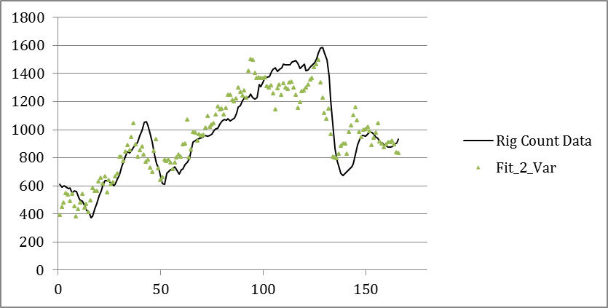
Chart 9: Rig Count Data and Fitted Rig Count

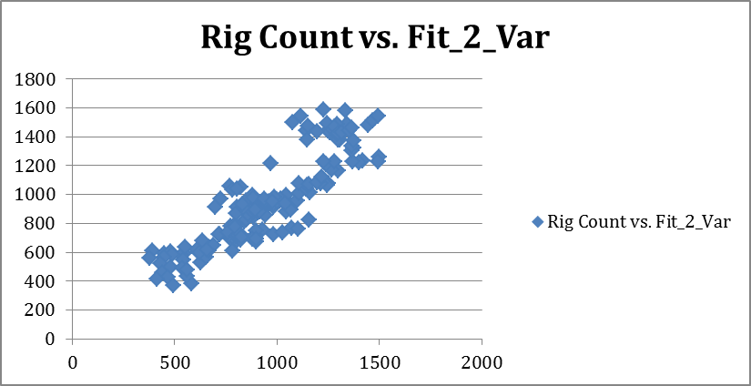
Chart 10: Rig Count versus Fitted Rig Count

Conclusion
The number of natural gas Rigs in operation during a month was regressed using several models. Using the adjusted R square and statistical tests it was determined that using ln(price) and storage deviation as explanatory variables is the best model and is highly significant with an F test significance of 1.54E-56 and adjusted R square of .791.

Links

Weekly working natural gas storage (data was processed to get monthly deviation):
http://tonto.eia.gov/dnav/ng/hist/nw_epg0_sao_r48_bcfw.htm

Monthly wellhead price:
http://tonto.eia.gov/dnav/ng/hist/n9190us3m.htm

Monthly production:
http://tonto.eia.gov/dnav/ng/hist/n9050us2m.htm

Natural Gas Rigs in Operation:
http://tonto.eia.gov/dnav/ng/hist/e_ertrrg_xr0_nus_cm.htm

