Introduction
I just recently paid my dues on my credit card and it includes my purchase of my study manual for my Actuarial Exam billed in U.S. Dollar. I am from the Philippines and am earning Philippine Peso and I don’t have a U.S. dollar account, so I have to pay for it in Philippine Peso. Remembering my student project, I decided to look at ask prices for U.S. Dollar vs. Philippine Peso. For this project, I will examine average weekly ask prices.
Data
After spending a couple of minutes surfing in the internet for data, I found the website below that provides historical ask prices for a wide number of currencies. I will be using the average weekly ask prices for the past 5 years (1/28/2007 - 1/15/2012)
http://www.oanda.com/currency/historical-rates
Model Specification
After gathering the data, I plotted and analyzed the graph of the average weekly ask prices.
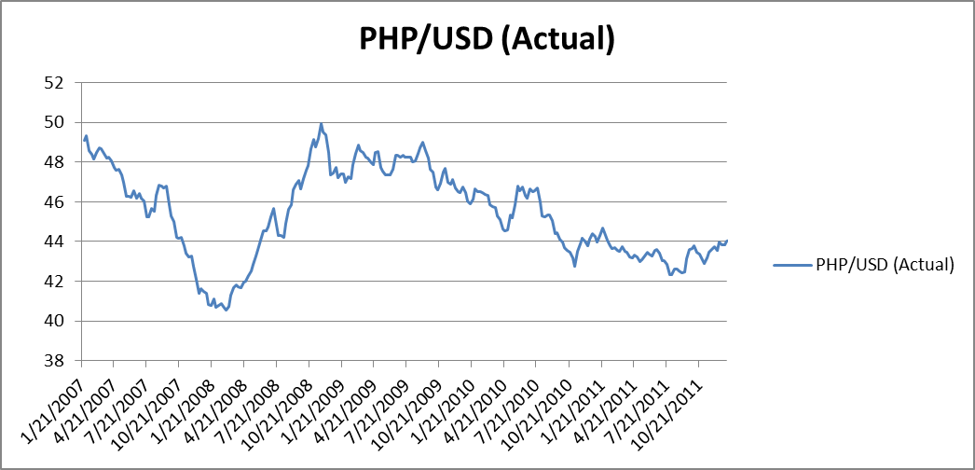
We can see from the graph above that there is a long period of continuous appreciation of the value of peso relative to dollar from January 2007 to April 2008, started to depreciate until January 2009 and trended back to appreciating after then. This has been caused by a lot of economic factors between the two countries. For this project, we are just concerned with fitting an appropriate model to estimate the actual average weekly ask prices. One might guess that this time series is non-stationary, to validate this claim let us take a look at its correlogram.

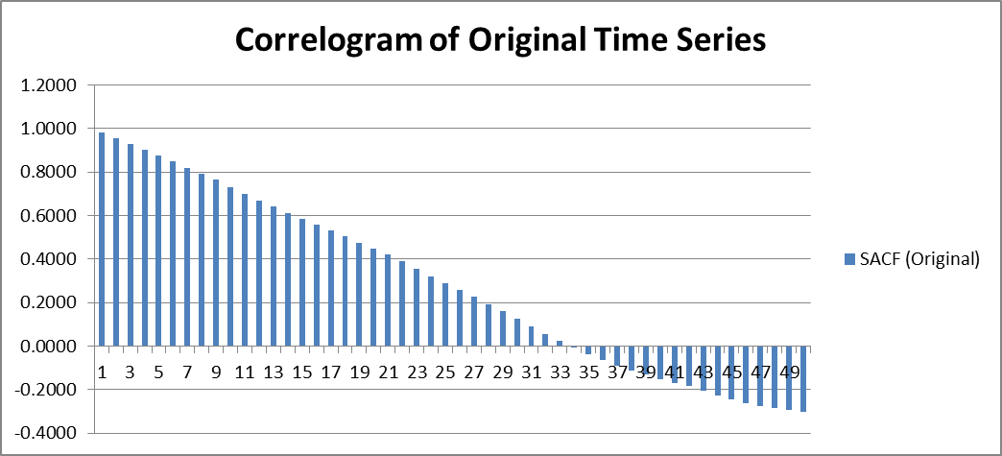
For a moving average (MA) process, the sample autocorrelation function (SACF) cuts off after lag q. For an autoregressive (AR) process and autoregressive moving average (ARMA) process, SACF tails off or declines geometrically. Analyzing the correlogram, the SACF of the original time series seems to decrease linearly until around lag 28 in contrast to an AR model where the SACF dies rapidly to 0 with few lags. Apparently, this does not depict a correlogram for an MA model because most of the sample autocorrelation are significantly different from 0. Hence, we can say that this time series is not stationary. We now consider getting the first difference of this time series and see if it is stationary. Below is the graph of the transformed time series. Notice that the time series is now seems to be a stationary process. Let’s take a look at its correlogram
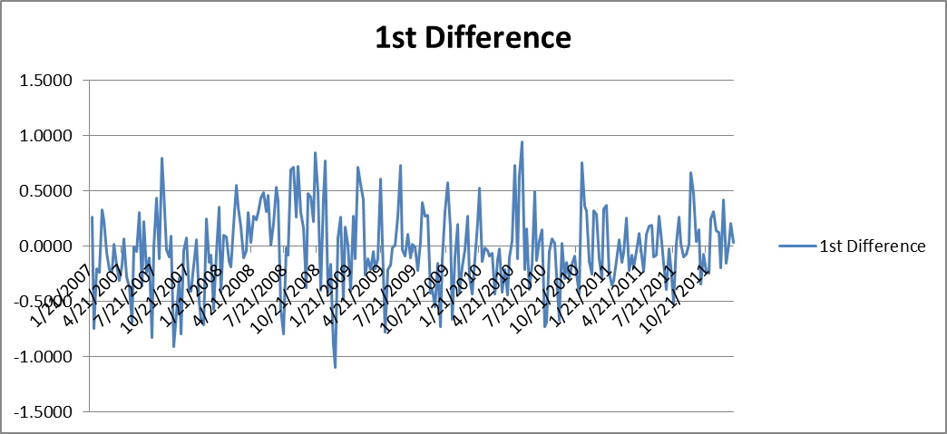

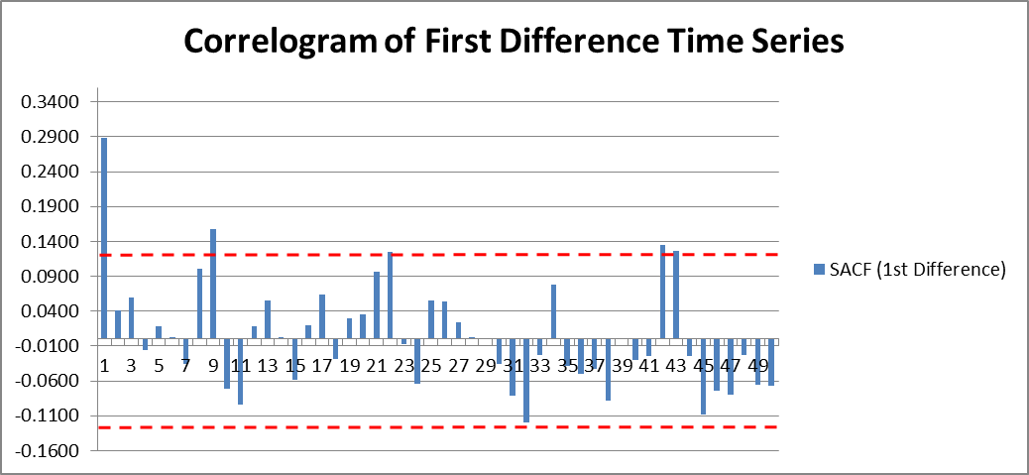
The correlogram shows only lag 1 to be significantly different from 0. The broken red lines indicate the standard error of the SACF, which is . Autocorrelations at lag 22, 42 and 43 lie outside the bounds of the standard error. We can still consider these autocorrelations to be insignificant. For model specification of the first difference time series, I decided to compare an and an models and test which of the two fits better in our actual time series.
Parameter Estimation
Using the method of least square estimation, we estimate the parameters of our AR(1) and MA(1) models. For the MA(1) model, we use the recursive definition of residuals and use non-linear regression of Excel’s Solver add-in to estimate the θ parameter, which results to the least sum of squared residuals.
Assuming , we have and . From here, we minimize the function .
Solver returns the result . Refer to sheet “MA(1)” Cell E4. Additional note is that since , the first difference time series is invertible.
For the AR(1) model, we use Excel’s Regression add-in to estimate the φ parameter. Here are the summary results.

SUMMARY OUTPUT
Regression Statistics
Multiple R | 0.289228772
R Square | 0.083653283
Adjusted R Square | 0.080073803
Standard Error | 0.346581467
Observations | 258
ANOVA
 | df | F | Significance F | SS
Regression | 1 | 23.37023748 | 2.31E-06 | 2.807203
Residual | 256 |  |  | 30.75039
Total | 257 |  |  | 33.55759
 | Coefficients | Standard Error | t Stat | P-value
 | -0.014794404 | 0.021608864 | -0.68465 | 0.494187
Φ | 0.288904588 | 0.059761691 | 4.834277 | 2.31E-06

With 95% confidence interval, we estimate the φ parameter to be .2889. Note that , the first difference time series is again validated to be stationary.
Model Diagnostics
After identifying ARIMA(1,1,0) and ARIMA(0,1,1) models for our original time series, we are now concerned with the goodness of fit of our models. To do this, we examine the residuals of our models. Our residuals must have nearly the properties of a white noise process, i.e. independent, identically distributed normal variables with zero mean and common standard deviation. To determine if the residuals do not have serial correlation, we use the Durbin-Watson Test Statistic and to further validate that the residuals are a white noise, we use the Box-Pierce Q Statistic. The following results show the comparison between the two models.

 | AR(1) | MA(1)
Durbin-Watson Test Statistic | 1.937405591 | 1.998328543
Box-Pierce Q Statistic (lag 100) | 115.6735542 | 104.3881366
Chi-Square Test Statistic (lag 100) | 117.4068832 | 118.4980038

Let’s interpret the results. Both AR(1) and MA(1) models have Durbin-Watson statistic of approximately 2 which means there are no serial correlation among the residuals. The Box-Pierce Q Statistic tested at lag 100, which is considerably large enough, produces lesser values than the Chi-Square Test Statistic at the same lag for the 2 models. This means that we cannot reject the null hypothesis that the residuals are white noise process. We might want to see the fit of the models versus the actual data. Here are the graphs.
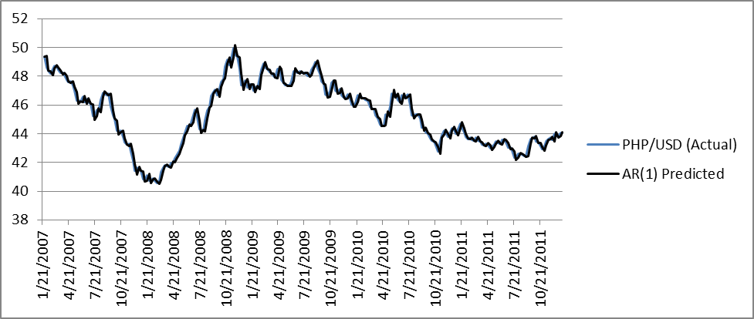
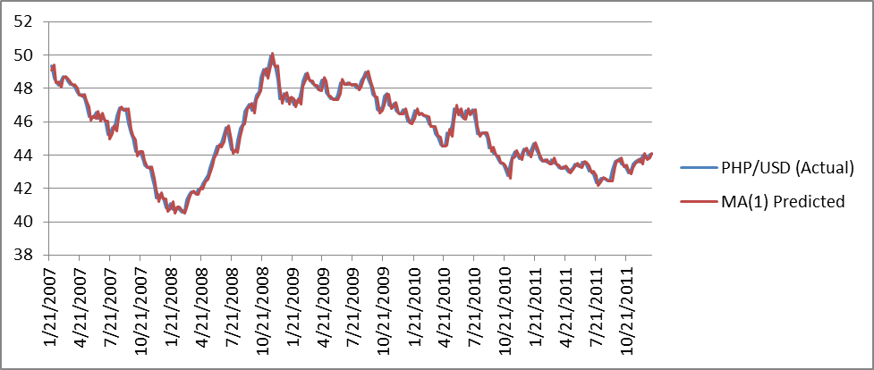
Conclusion
Our ARIMA(1,1,0) and ARIMA(0,1,1) models both have excellent goodness of fit. The ARIMA(0,1,1) however produces better results with respect to our model diagnostics. Perhaps, we may look at another model, ARIMA(1,1,1), and see if this produces better results though taking into consideration the principle of parsimony. For this project, I am choosing the ARIMA(0,1,1) model for the average weekly ask prices of PHP/USD for the last 5 years.

