xxxxxxx xxxxx
Regression Analysis (Fox)
Fall 2011

STUDENT PROJECT WRITE-UP
INTRODUCTION AND DATA:
I am interested in determining whether certain relationship characteristics can predict how happy couples will feel about their relationship at least 1 year into their relationship. I used a study done by the Inter-University Consortium For Political and Social Research called How Couples Meet and Stay Together (HCMST), Wave I 2009, Wave II 2010, United States. Among their questions, researchers asked respondents to rate (on a scale of 1 – 5) the quality of their relationship at the time of the survey, in which the higher number indicated higher satisfaction. Of the over 4,000 observations (sets of answers given by participants), I have randomly selected 250 data points belonging to participants that indicated they were in a relationship at the time of the survey after eliminating data points with missing answers for one or more of the variables I initially set out to use (Parental Approval, Age Difference, Length of Relationship, Difference in Education Years, Number of Children, and Combined Household Income).
Regression analysis determines which explanatory variables were most influential in an observed outcome. It is possible that something as subjective as happiness cannot be predicted by explanatory variables. I attempted this analysis with this potential outcome in mind.
HYPOTHESIS:
I hypothesize that a linear model for relationship happiness (response variable: relationship satisfaction) using one or more of the explanatory variables Parental Approval (PA), Age Difference (AD), Length of Relationship (LE), and Household Income (HHI) will produce a statistically significant result.
DATA COLLECTION:
I have selected 250 unique cases from the HCMST study. A Sample of the data is given below.
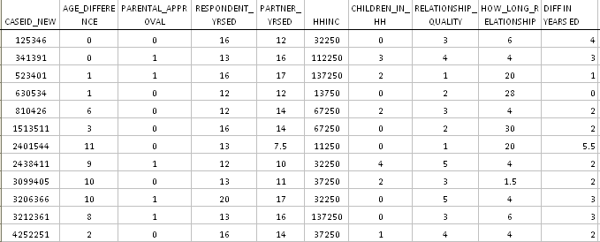
ASSUMPTIONS:
To conduct a linear regression, I must assume that the error term for each variable is normal, linear, constant variance, independent, and measured without error and independent of the value. Below is a box plot of the major variables.
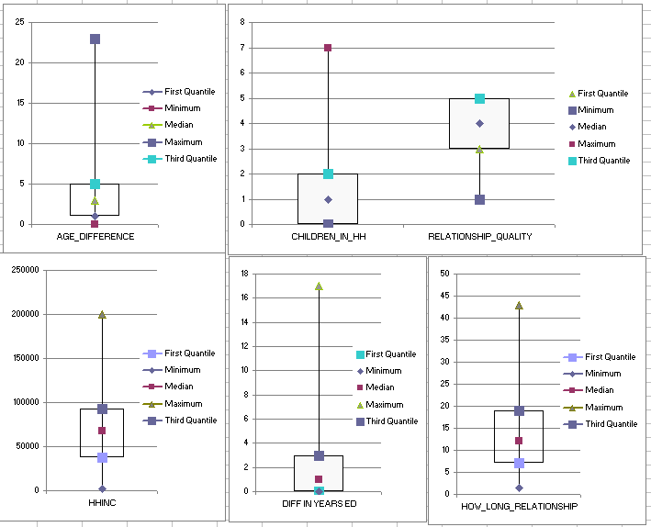
Please note that Parental Approval (PA) is a dichotomous variable (1 = Approve, 0 = Not Approve). None of the variables look acceptable as-is. In fact, Difference in Years Education and Number of Children in Household were so positively skewed that none of the transformations I tried yielded satisfactory results. These variables were eliminated. Transformations for the remaining variables yielded better results:
Age Difference: AD ^ 0.25
Household Income (HHI): HHI ^ 0.5
Relationship Quality: RQ ^ 5
Relationship Length: LEN ^ 0.15
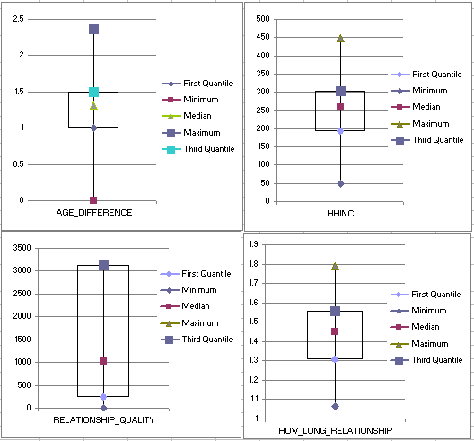
From this point, any references to Age Difference, Household Income, Relationship Length and Relationship Quality (Happiness) use transformed values.
PLAN:
I will try conducting a linear regression with various combinations of explanatory variables. I will use R² as an indicator of the responsiveness for each model. The R² value for the overall regression model indicates the percentage of variation of the response variable (relationship happiness) that is captured by each regression. A high value of R² indicates that a model is nearly complete. For each model, I will record the F- value of regression and degrees of freedom.
F-values test the null hypothesis that each regression coefficient is zero. A large F-value indicates that explanatory variables affect the response variable.
ANALYSIS:
Similar to Fox’s analysis on page 139, I have calculated the regression sum of squares and R² for 10 models.
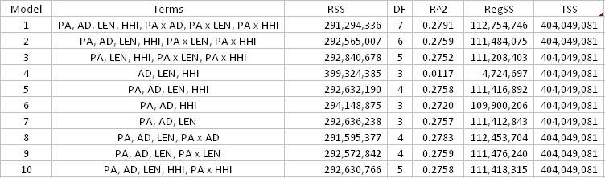
PA = Parental Approval (Yes, No) HHI = Household Income (in US Dollars)
AD = Age Difference between couple (in Years) LEN = Relationship Length (in Years)
The R^2 values are very low for all 10 models considered. This tells me that much of the variance seen in my response variable is NOT explained by my explanatory variables. I can, however, look at the relative R^2 values among the 10 models to draw some conclusions.
Model 1 has the highest value of R², indicating that it fits the data best among all of the models (it’s not a good model, but this is on relative terms). Removing variables HHI, LEN, and AD (and their interactions with the dichotomous variable PA) did little to reduce the R^2 value.
To determine the significance excluding various explanatory variables from a model, I conducted an analysis of variance similar to Fox’s analysis on page 139. I determined that of the explanatory variables considered, only Parental Approval (PA) is significant because of the (relatively) high associated F value. I was also surprise to find that how much the couple made (HHI) and its interaction with Parental Approval (PA) does not seem to impact relationship satisfaction at all.
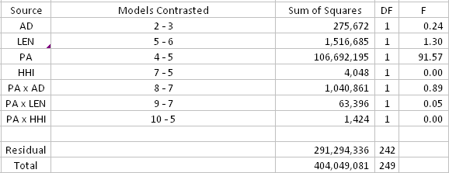
Below I have included the results for coefficients of Model 1.
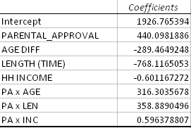
As expected, the values for Beta are positive for Parental Approval. This indicates a couple is happier when parents approve. Age Difference has a negative Beta, suggesting large differences in age may lead to less satisfying relationships. What is surprising is that Household Income has a negative Beta, suggesting more money in fact detracts from relationship happiness. Finally, a negative Beta for Relationship Length suggests relationship satisfaction may decline over time. We know from looking at the R^2 values and F-values that our regression model is not a very good one, so the implications from the signs of the Beta values should be taken with a degree of skepticism.

SUMMARY
In summary, I have shown that my hypothesis is incorrect. It is not possible to generate a statistically significant model for relationship happiness based upon the explanatory variables Parental Approval, Household Income, Age Difference, and Length of Relationship.
I am not convinced trying different or additional variables could improve the model – happiness by its nature cannot be quantitatively defined (a rating of a 4 can mean different things between respondents). This was an interesting exercise but I would not recommend further attempts at regression analysis on happiness.

