xxxxxxxxxxx xxxxx
Time Series VEE Student Project
Fall 2011

New Jersey Unemployment

Introduction

In recent years, a heightened importance has been placed on monitoring the unemployment rate, as it is one of the most important indicators of overall economic strength. The goal of this project is to model the monthly unemployment rate in New Jersey from January 2001 to December 2010. I’ll then use this model to predict 2011 monthly unemployment rates and compare them to rates that were actually seen during this past year. First and second differences of the data set will be examined, and three different models will be contemplated.

Data

The data used for this project comes from the Bureau of Labor Statistics website (http://data.bls.gov/timeseries/LASST34000003). This data has already been adjusted for seasonality. All analysis for this project has been performed in Excel, using the Regression add-in feature.

Analysis

The graph below shows the monthly unemployment rate in New Jersey from January 2001 to December 2010. Notice that, like most states, New Jersey has experienced noticeably higher unemployment rates during the recent economic downturn.

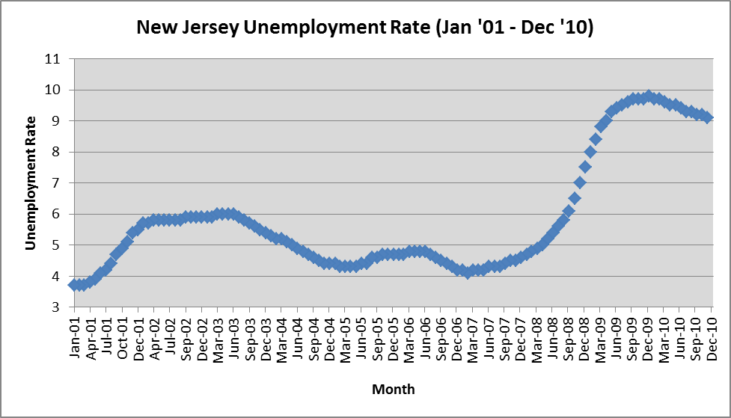
To test for stationarity, we examine the autocorrelation function shown below.

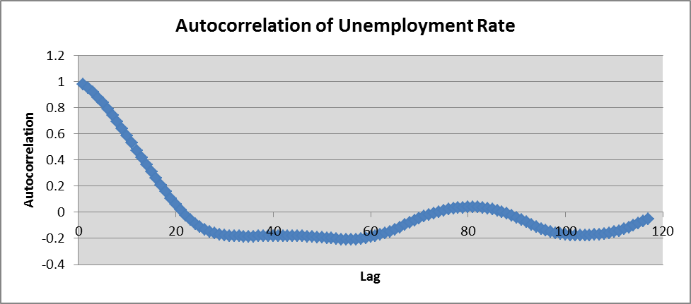

Since the autocorrelation function does not immediately decay to zero, unemployment rates are highly correlated, and the time series lacks stationarity. To find a better data set to model, I examined the first and second differences of NJ unemployment rates. Their respective autocorrelation functions are shown below.

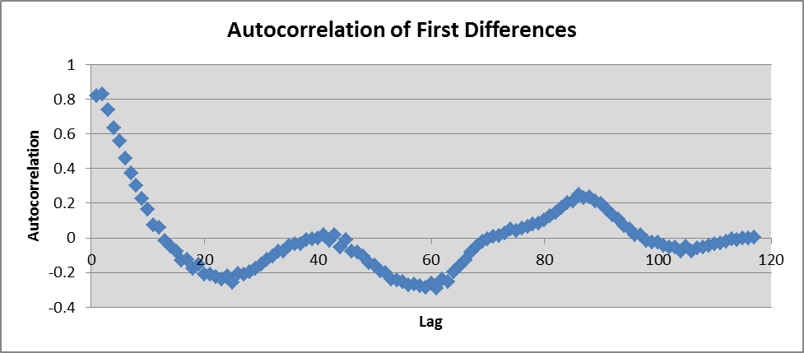

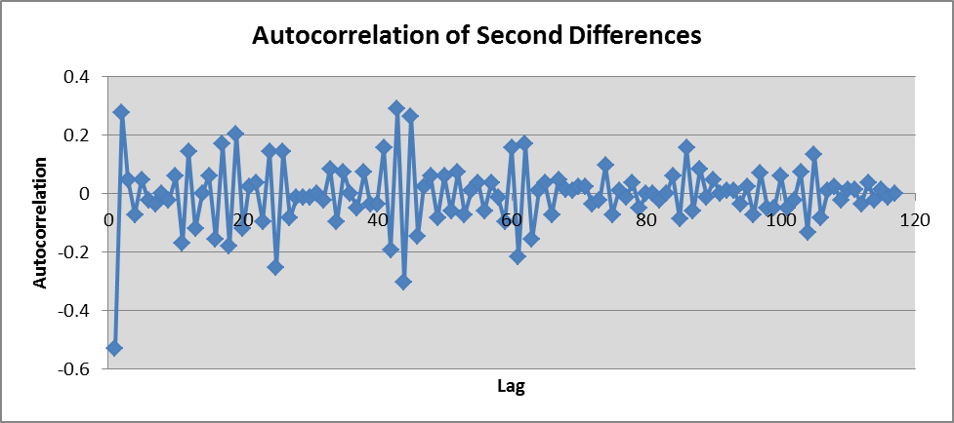

You can see that the autocorrelation of first differences is similar to that of the original data set. It takes several lags to approach zero. The autocorrelation of second differences, however, decays immediately. Because of this, it can be considered a stationary time series, and we will focus on this data set when building our models.

Modeling

I used the second differences of New Jersey monthly unemployment rates to construct three different models: ARIMA(1,1,0), ARIMA(2,1,0) and ARIMA(3,1,0). Results generated by the Excel Regression add-in feature are shown below.

ARIMA(1,1,0)

The model becomes Y(t) = -0.0008547 – 0.5365854*Y(t-1) + e(t)

ARIMA(2,1,0)

The model becomes Y(t) = -0.0017255 – 0.5373966*Y(t-1) – 0.001547*Y(t-2) + e(t)

ARIMA(3,1,0)

The model becomes Y(t) = -0.0020968 – 0.5456507*Y(t-1) + 0.13432258*Y(t-2) + 0.27057331*Y(t-2) + e(t)

A summary table is provided below for comparison purposes.

Although the R-squared and adjusted R-squared values are slightly higher for the ARIMA(3,1,0) model, all three models have similar fits. In interpreting the Box-Pierce statistics, I used the first 110 lags and tested at the 10% significance level. Since the Box-Pierce statistics are lower than the chi-squared critical values, we cannot reject the null hypotheses that the residuals are comprised of strictly random components (white noise). The Durbin-Watson statistics for all three models are very close to 2.0, which provide strong evidence against the existence of autocorrelation in the residuals.

Model Validation

An additional way of validating which model provides the best fit is to compare each model forecast with actual unemployment rates during 2011. You can see that each of the ARIMA models produces a very similar forecast.

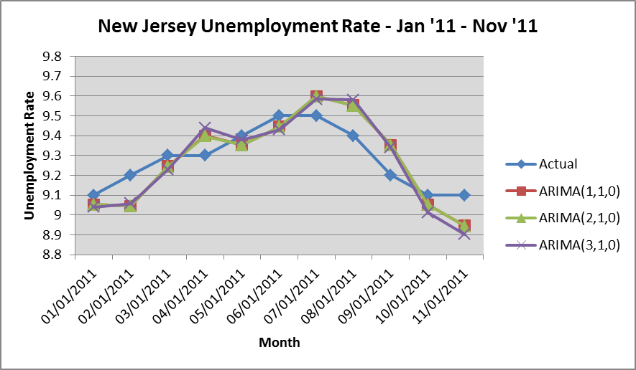

Conclusion

Because of the forecast results, and because of the very similar adjusted R-squared values, Box-Pierce statistics, and Durbin-Watson statistics, I would choose the ARIMA(1,1,0) model. This selection is consistent with the principle of parsimony, which advocates the use of the simplest model (fewest parameters) that adequately represents the time series.

