xxxxxx xxxxx
Time Series
Fall 2011
Student Project

Water flow (Discharge) of Colorado River near Dotsero, CO
Introduction
The amount of water flow in rivers can be an important item to forecast as it can impact decisions related to irrigation, valve settings for dams, and even fish and wildlife management projects. This project considers ARIMA models for forecasting the water flow (discharge) in cubic feet per second of the Colorado River near Dotsero, CO.
Data
The data used for this project is from the Unites States Geological Survey website. The link below was used to access the data. While more years were available, this analysis considers water flow data from 1/1/2000 to 12/31/2010. It should be noted that the discharge amounts are the mean discharge amounts for the day and are expressed in cubic feet per second. While an audit of the data was not performed, it was validated that there were no missing days in the data.
http://waterdata.usgs.gov/nwis/dv?cb_00060=on&format=html&begin_date=2000-01-01&end_date=2012-02-01&site_no=09070500&referred_module=sw
The graph below (GRAPH 1) shows the water flow on a daily basis over the 11 year period.
GRAPH 1
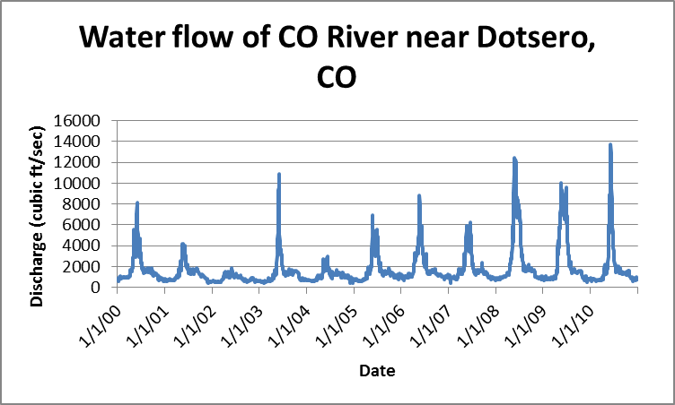
As can be seen from the graphical representation of the data, there is a seasonal pattern to the data. This seasonality is strongly impacted by the runoff from the snow pack in the mountains. The volatility in the increase during the runoff period is greatly impacted by the amount of snow pack. This analysis does not attempt to measure the relationship between snowpack, runoff, and water flow amounts.
Seasonality Adjustment
Although the seasonality of the data is insightful, it will be removed for this analysis in order to develop an ARIMA model to forecast water flow on consecutive days. In order to remove the seasonality from the data, a multi-year centered moving average was calculated for each day of the year. It should be noted that leap days were excluded from these averages and their exclusion is not expected to have a significant impact on the results. For illustrative purposes, consider the sample of such calculations as shown in the table below (TABLE 1).
TABLE 1
MMDD | Year |  |  |  |  |  |  |  |  |  |  | 5 Day Avg
MMDD | 2000 | 2001 | 2002 | 2003 | 2004 | 2005 | 2006 | 2007 | 2008 | 2009 | 2010 | 5 Day Avg
0105 | 720 | 684 | 610 | 656 | 716 | 781 | 1150 | 1140 | 920 | 648 | 898
0106 | 570 | 721 | 648 | 609 | 712 | 771 | 1060 | 1090 | 956 | 721 | 896
0107 | 610 | 694 | 675 | 646 | 712 | 701 | 1080 | 1060 | 914 | 962 | 883 | 812
0108 | 800 | 645 | 653 | 609 | 746 | 721 | 1150 | 1170 | 878 | 1000 | 635
0109 | 910 | 606 | 651 | 573 | 737 | 759 | 1040 | 1220 | 896 | 1030 | 628

For each data point, the calculated average was then subtracted (leap days using the average for February 28th). The resulting value was then used as the seasonally adjusted data point for subsequent analysis.
Model Specification
In considering which ARIMA model to use, the seasonally adjusted data was first reviewed to assess if it was stationary. The first graph below (GRAPH 2) simply graphs the seasonally adjusted data points. What we can observe is that the data appears to have an average of zero and it certainly seems bounded. However, when the autocorrelation of the data is considered (see the second graph below – GRAPH 3), it can be seen that the data does not meet the expected characteristics of an ARIMA model (an autocorrelation function that either drops quickly to zero or that decays quickly).

GRAPH 2
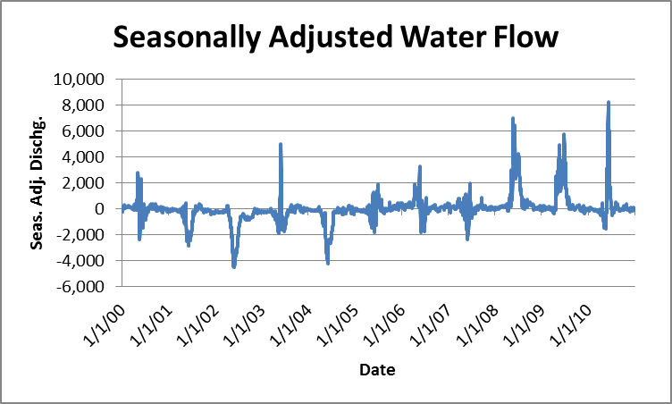
GRAPH 3
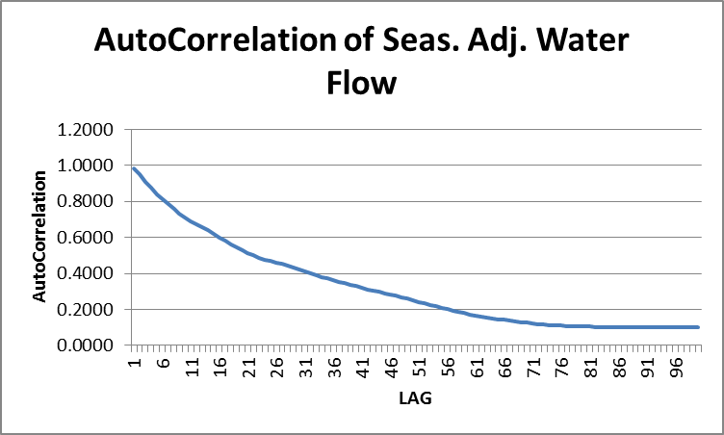
It was decided to then consider the first and second differences of the data points. The graphs below show the autocorrelation for the first differences (GRAPH 4) and second differences (GRAPH 5). At this point, it does not appear that using the second difference would add any additional value to the analysis as it closely reflects the first difference.

GRAPH 4
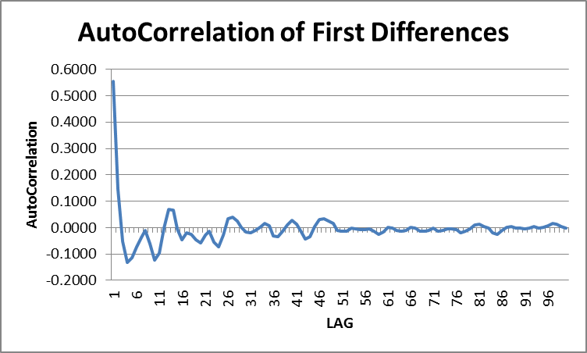

GRAPH 5
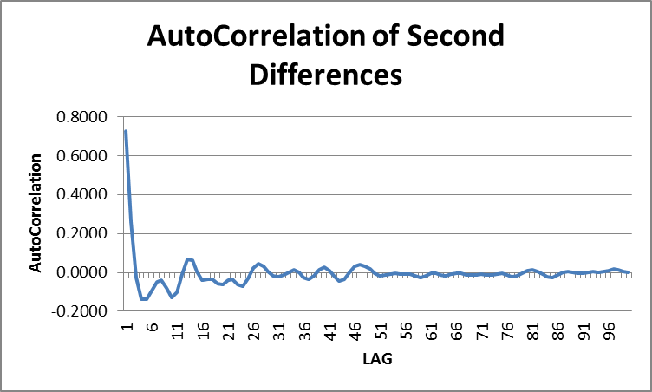

Proceeding with an analysis of first differences, ARIMA(1,1,0), ARIMA(2,1,0), and ARIMA(3,1,0) models were considered. Using the Regression tool available in Microsoft Excel, the following key statistics (TABLE 2) were calculated and compared. A review of these statistics shows a lower than expected R-square value for all three models. It was determined at this point to test these three models on second differences. The key statistics for the second differences are shown in TABLE 3.

TABLE 2
Key Statistics of First Differences
Model | R-Square | P-value
Model | R-Square | Intercept | X1 | X2 | X3
ARIMA(1,1,0) | 0.309 | 0.986 | 0.000 | N/A | N/A
ARIMA(2,1,0) | 0.347 | 0.992 | 0.000 | 0.000 | N/A
ARIMA(3,1,0) | 0.348 | 0.994 | 0.035 | 0.000 | 0.000

TABLE 3
Key Statistics of Second Differences
Model | R-Square | P-value
Model | R-Square | Intercept | X1 | X2 | X3
ARIMA(1,2,0) | 0.527 | 0.998 | 0.000 | N/A | N/A
ARIMA(2,2,0) | 0.681 | 0.998 | 0.000 | 0.000 | N/A
ARIMA(3,2,0) | 0.709 | 1.000 | 0.000 | 0.000 | 0.000

It can be seen that the second differences produce a higher R-square value and P-values for the intercept. Within the second differences, the ARIMA(3,2,0) model does not appear to produce vastly improved results over the ARIMA(2,2,0) model. In accordance with the principle of parsimony (the idea that one should use the most accurate model with the fewest parameters), subsequent work in this analysis will use the ARIMA(2,2,0).
Model Validation
To test the validity of using the ARIMA(2,2,0) model the Box-Pierce Q statistic and Durbin-Watson statistic were calculated. These statistics are shown in the table below (TABLE 4).
TABLE 4
Additional Statistics of the Selected ARIMA(2,2,0) Model
Statistic | Value
Durbin-Watson | 1.66
Box-Pierce Q | 72
Chi-Square at 95% | 259

From the Box-Pierce test, a comparison of the model’s calculated value against the Chi-Square at 95% value should show whether the tested group of autocorrelations in the time series is different from zero. The test above was performed on the first 300 residual autocorrelation values. As the Box-Pierce Q test value is significantly less than the threshold set by using the Chi-Square distribution with appropriate degrees of freedom at 95% credibility level, the validity of the model cannot be rejected, and the residuals from the ARIMA(2,2,0) model has no autocorrelation.
The Durbin-Watson statistic also provides a measure of whether there is autocorrelation among the residuals. A value of 2 would indicate no autocorrelation. As the model produces a value that is not far from 2, but still not very close, it seems reasonable to question whether some autocorrelation exits, although the Box-Pierce Q test seemed to indicate otherwise. If there is correlation, then perhaps the residuals are more than white noise and other models or other modifications should be considered. Considering that one of the coefficients produced by the model is greater than 1 (see the model formula below), there is some indication that the model does not meet stationary requirements still.
For further visual validation, the seasonally adjusted data points were compared to the forecasted model values (GRAPH 6). Using the parameters determined by the same regression work that produced the results for the ARIMA(2,2,0) model in TABLE 3, the ARIMA(2,2,0) model is:
Y(t) = -0.00831 - 0.57153 * Y(t-1) + 1.140722 * Y(t-2) + e(t)
GRAPH 6
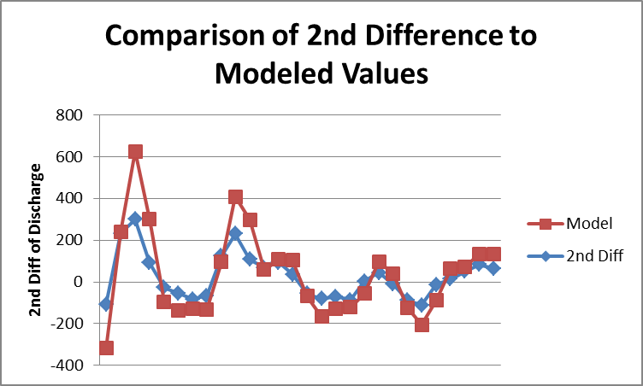
Conclusion
While the evaluated ARIMA(2,2,0) model of Y(t) = -0.00831 - 0.57153 * Y(t-1) + 1.140722 * Y(t-2) + e(t) produces reasonable results and meets certain validation tests, other tests appear to show that this model may not be the best for forecasting the water flow of the Colorado River. Other models should be explored and perhaps a moving average parameter would help explain some of the correlation that may exist in the residuals.

