Time Series Modeling of the Supply/Demand Component of Gold Price Fluctuation
New England Actuarial Seminars – Time Series Project – Winter 2010
xxxx xxxxx

I. Introduction

The price of gold is impacted by the relative strength of its purchasing currency to the U.S. Dollar (since gold, like other commodities is denominated in U.S. Dollars), as well as the supply of and demand for gold. As the U.S. Dollar strengthens, the price of gold appears to decline, and vice versa. This project will attempt to isolate the growth of the price of gold over a 28-year period from December 1978 through November 2011 to the supply/demand component by normalizing out the relative currency strength by using inflation as a gage for the relative strength of the U.S. Dollar and then creating a time series model to project future growth.

II. Data

Monthly average gold prices were obtained for the 33-year period from December 1978 through November 2011 from the following website:
www.gold.org/investment/statistics/gold_price_chart.

Additionally, the price of gold was inflation-adjusted by the monthly Consumer Price Index for All Urban Consumers (CPI-U) change over that same period. CPI-U data was obtained from the following website: http://wikiposit.org/w?filter=Economics/CPI%20and%20Inflation/United%20States%20CPI%20Data/

Figure 1 displays both the market price and the inflation-adjusted price of gold over the 33-year period.

Although it is slightly difficult to discern with the granularity provided by the plot in Figure 1, the data does not show indication of any significant seasonality.

III. Stationary Time Series

In order to develop a time series model with fixed coefficients, the underlying process must be stationary. For a stationary series, as the number of lags becomes large, the autocorrelation function diminishes. The autocorrelation with lag k is defined as:
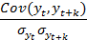

For a stationary process, the denominator becomes the variance of the stochastic process since the variance at time t equals the variance at time t+k.

Figure 2 shows the plot of the sample autocorrelation (correlogram) of the monthly average gold price. “Market” denotes the unadjusted monthly average gold price, whereas “Real” denotes the inflation-adjusted market price of gold.

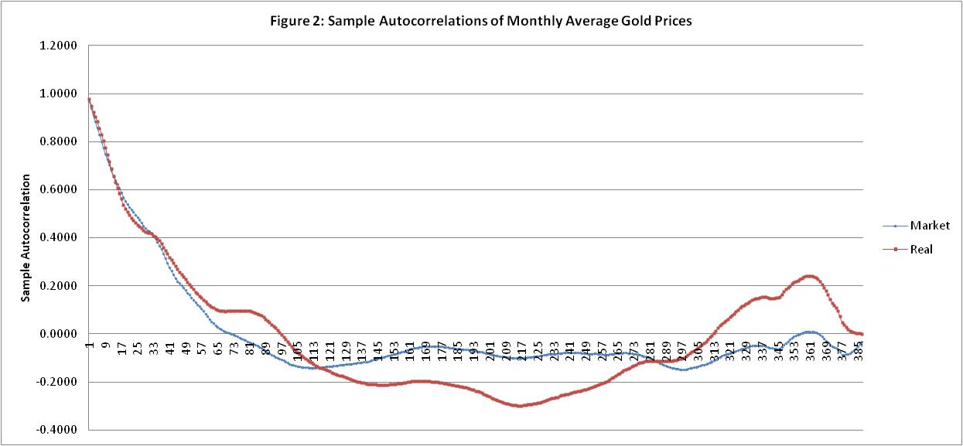

As can be seen in Figure 2, the autocorrelation function does not quickly diverge to zero, implying that the series is nonstationary. As a result, the sample autocorrelation of the first differences in monthly average gold prices was plotted, as shown in Figure 3.

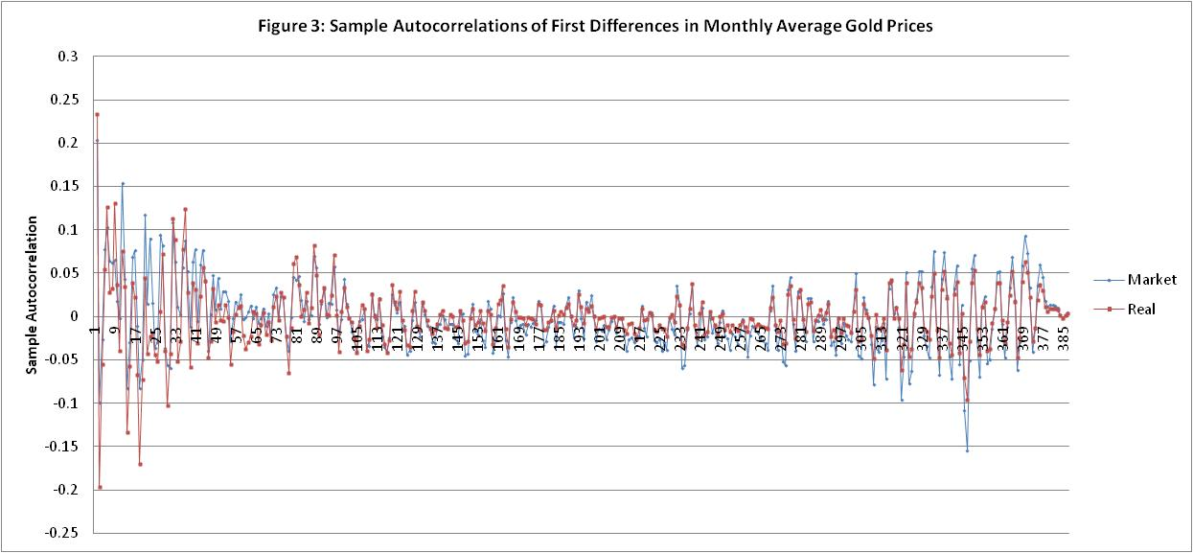

Figure 3 shows a quick decline to zero in the first handful of lags and only small fluctuations around zero for the remainder of lags, which is a good indicator of stationarity.

IV. Model Parameterization and Selection

Observing Figure 3, the sample autocorrelation of the first differences in monthly average gold prices does not show any significantly sharp increases or decreases, which indicates the absence of a moving average component of the model.

Therefore, the autoregressive model with orders 1, 2, and 3 (AR(1), AR(2), and AR(3)) were tested using Microsoft Excel’s build in Regression tool in the Data Analysis Add-in. The results follow:

AR(1):

Regression Statistics
Multiple R | 0.231107056
R Square | 0.053410471
Adjusted R Square | 0.050938958
Standard Error | 15.54621212
Observations | 385

 | Coefficients | Standard Error | t Stat
Intercept | 0.378911383 | 0.792765607 | 0.477961429
t-1 | 0.230774941 | 0.049642873 | 4.648702404

AR(2):

Regression Statistics
Multiple R | 0.345620571
R Square | 0.119453579
Adjusted R Square | 0.114831288
Standard Error | 15.01540048
Observations | 384

 | Coefficients | Standard Error | t Stat
Intercept | 0.472440693 | 0.766960671 | 0.615990769
t-1 | 0.290344294 | 0.049360047 | 5.882172188
t-2 | -0.265556809 | 0.049328756 | -5.383407823

AR(3):

Regression Statistics
Multiple R | 0.352407161
R Square | 0.124190807
Adjusted R Square | 0.117258281
Standard Error | 15.01125991
Observations | 383

 | Coefficients | Standard Error | t Stat
Intercept | 0.449437035 | 0.768125368 | 0.58510896
t-1 | 0.310573679 | 0.05123209 | 6.062092738
t-2 | -0.28606211 | 0.051602399 | -5.54358159
t-3 | 0.072916883 | 0.051176882 | 1.424801206

The table below gives a summary of some of the regression statistics and test statistics used in selecting the model.

 | R Square | Adjusted R Square | Durbin-Watson Statistic | Box-Piece Q-Statistic | Chi-Squared 10%
AR(1) | 0.0534 | 0.0509 | 1.8796 | 171.57 | 416.78
AR(2) | 0.1195 | 0.1148 | 1.9586 | 128.09 | 415.73
AR(3) | 0.1242 | 0.1173 | 1.9991 | 120.71 | 414.68

Adjusted R Square. It can be seen that the adjusted R Square value is highest for the AR(3) model, suggesting that, of the three models, the data best fits into the AR(3) model.

Durbin-Watson Statistic. The Durbin-Watson Statistic is very near 2.0 for each of the three models, suggesting that there is no serial correlation among the residuals for any of the three regressions.

Box-Pierce Q-Statistic. With the appropriate degrees of freedom applied, all three autoregressive models have Box-Pierce Q-Statistics that are significantly less than the Chi-Squared critical value at a ten percent significance level. Therefore, the null hypothesis that the residuals are a white noise process cannot be rejected.

Model Selection. Based upon the test-statistics produced, the autoregressive time series model of order 3 was selected as an appropriate model for the first differences of the monthly average inflation-adjusted gold price.

V. Forecast

Figure 4 shows the actual monthly average inflation-adjusted price of gold versus the price as forecasted by the autoregressive model of first differences for the six months ending in November 2011.

As can be seen, the AR(3) model roughly follows the pattern of the inflation-adjusted price of gold. In March and April, there were large and nearly equivalent actual first differences of $13.29 and $13.25, respectively, which were essentially offset by the opposite signs and nearly equivalent magnitudes of the t-1 and t-2 components of the model, leaving the small coefficient of t-3 and intercept as the drivers of the forecasted price for May. Since the t-3 first difference was $2.72 (and further dampened by the t-3 coefficient), whereas the actual price change in May was $10.33, the AR(3) model neglected to forecast the large increase. This pattern continued for the remainder of the forecast period, which can be seen in Figure 4 by noting that the AR(3) time series model continually delays its response to swift large swings in actual price because of the t-1 and t-2 components of the time-series model. Additionally, the effects of the large price changes between July and October are dampened because of the coefficient of the t-3 term. This model is most likely more suitable for long term trend forecasting rather than individual monthly spot forecasting.

