TIME SERIES VEE COURSE
FALL 2011
CANDIDATE: xxx xxxxxxx xxxxx

COCOA BEANS PRICES(US$/MT)

Introduction
Cocoa is the main cash crop grown by farmers in the West Africa sub-region. Farms range from medium to large scale, and attracts migrant workers all over the sub-region. The income derived from cocoa exports affect economic activity in the sub-region especially Ghana and Cote Ivoire. The price of cocoa beans on the world market fluctuate, and many farming families and migrant workers are uncertain about their future. Being able to predict future cocoa price through regression and time series will help better understand the trends that cocoa beans prices exhibit.

Data
The data used for carrying out this project was taken from the website: http://www.indexmundi.com/?commodities=cocoa&month=360.
The source contain monthly data for the last 27 years (1984 to 2011).For this project, eleven year period was selected from January 1995 to December 2005. The data from January 2006 to December 2011 is used to test the accuracy of the model. The graph below is the plot of the monthly data.
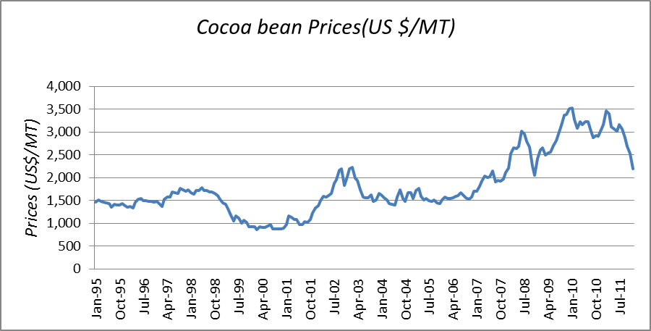

The plot of monthly cocoa beans price data does not show any seasonal trend.

Stationarity Test
The data is examined for stationarity by analyzing the sample autocorrelation. To perform this test, I need to show that the autocorrelation function is not time dependent.
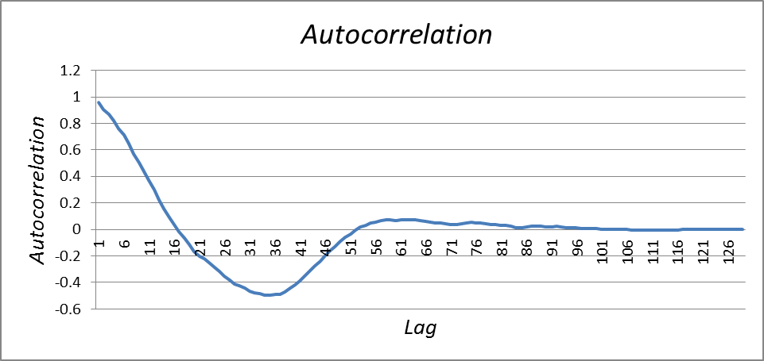

The above plot show that the series is not stationary as the autocorrelation function is positive shows a strong linear relationship for the first 21 lags, after which it decline below zero up to lag 46 and fluctuate just above and toward zero. The monthly price data is highly correlated and not stationary.
First Difference
The original data for the process is not stationary, the first difference of the data is now examined. The graph of first difference is below
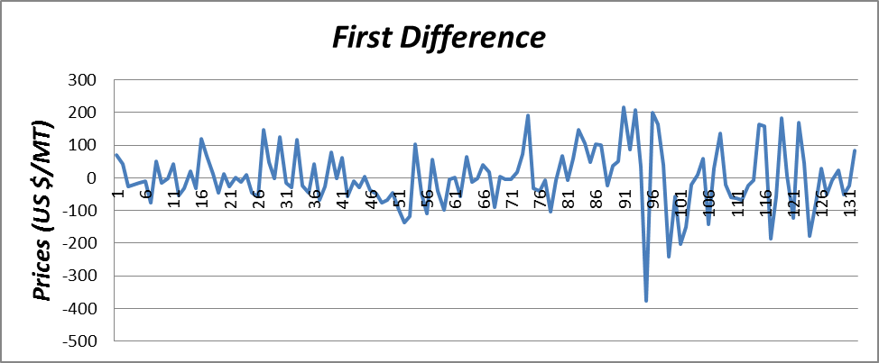
The graph of first difference show trends than the original data. The graph below is the correlogram of the first difference and is examined for stationarity.

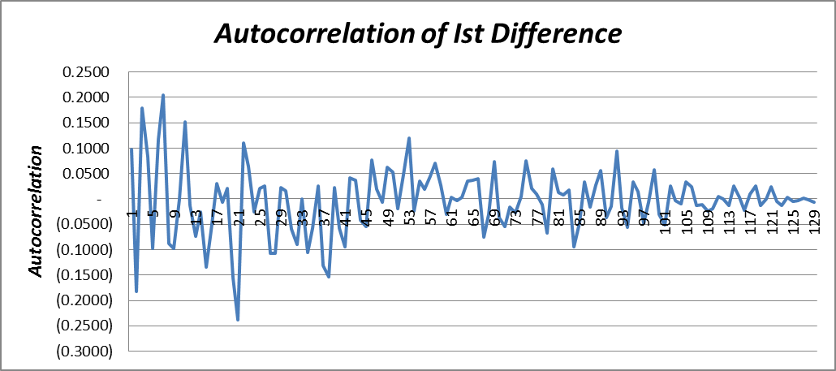

The correlogram of the first difference has a random fluctuation of positive and negative values centered towards zero . The plot also do not show any dependence on time, thus the first difference of the data indicate a stationary process. This is further confirmed by Bartlett test where only four observation lies outside 95% confidence interval.
Model Parameterization
The first difference is stationary, we fit the data to an autoregressive model (AR(p)) with p=1,2 and 3.This is equivalent to ARIMA(p,1,0) model.
Using Excel regression add-in the following is the summary of AR equations and regression outputs:

AR(1): Y₍=0.310798+0.97391Y₍-₁+ε₍
Regression Statistics
Multiple R | 0.097305
R Square | 0.009468
Adjusted R Square | 0.00179
Standard Error | 90.95906
Observations | 131

 | Coefficients | Standard  Error | t Stat
Intercept | 0.3108 | 7.9472 | 0.0391
X Variable 1 | 0.0974 | 0.0877 | 1.1104

AR(2): Y₍=0.1238+0.1145Y₍₋₁−0.1947Y₍₋₂+є₍
Regression Statistics
Multiple R | 0.215625
R Square | 0.046494
Adjusted R Square | 0.031478
Standard Error | 89.86596
Observations | 130

 | Coefficients | Standard Error | t Stat
Intercept | 0.1238 | 7.8819 | 0.0157
X Variable 1 | 0.1145 | 0.0873 | 1.3114
X Variable 2 | (0.1947) | 0.0871 | (2.2350)

AR(3) : Y₍=0.0909+0.1595Y₍₋₁-0.2208Y₍₋₂+0.2314Y₍₋₃+є₍
Regression Statistics
Multiple R | 0.311699
R Square | 0.097156
Adjusted R Square | 0.075488
Standard Error | 88.11548
Observations | 129

 | Coefficients | Standard Error | t Stat
Intercept | 0.0909 | 7.7586 | 0.0117
X Variable 1 | 0.1595 | 0.0873 | 1.8275
X Variable 2 | (0.2208) | 0.0862 | (2.5614)
X Variable 3 | 0.2314 | 0.0871 | 2.6566

The table below is the summary of the result from the auto regression
 | Sum of Coefficients | R² | Adjusted R² | Durbin-Watson Statistic | Box-Pierce Q Statistic | χ² @ 10%
AR(1) | 0.4082 | 0.0095 | 0.0018 | 1.9589 | 74.4455 | 147.8048
AR(2) | 0.0436 | 0.0465 | 0.0315 | 1.9031 | 66.3763 | 146.7041
AR(3) | 0.2610 | 0.0972 | 0.0755 | 1.9915 | 57.6566 | 145.643

From the above table, each AR model has the sum of coefficient being less than one, suggesting the models are stationary. The Durbin-Watson statistics is approximately two for each, suggesting no serial correlation. The Box-Pierce Q statistics are lower than χ² critical value. We therefore, cannot reject the null hypothesis that the residuals are formed by a white noise process.
Model Selection and Forecasting
To decide the best fit for the three AR models, I will examine Adjusted R² statistic, the Durbin-Watson Statistic and Box-Pierce Q statistic.
I selected the AR(3) model since it give the lowest Box-Pierce Q statistic for a given χ² critical value, higher adjusted R² and a Durbin-Watson statistic of 2.
The accuracy of the selected model is tested by comparing it to actual data for the period January 2006 to December 2011. The plot is below:

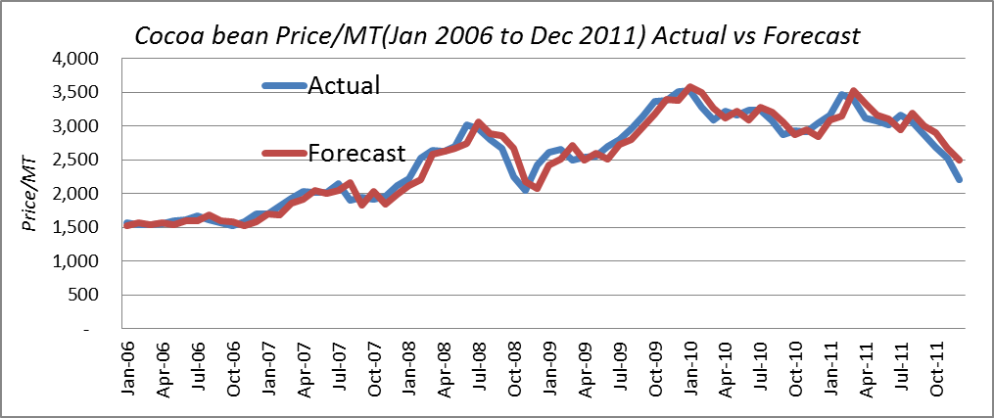

Conclusion:
The forecasted values fit closely with actual data for most periods with small downward deviation in year 2009.Also the shape of the two series are similar. There are many factors that affect the price of Cocoa beans such as global economic conditions, climatic conditions and wars and insurrection in sub-regions where cocoa crop is grown. Even though my model fit the data very well, additional factors if included as regressors can improve the model.

Appendix
Time Series of Monthly Cocoa beans prices (US$/MT)
The Excel spreadsheet ccbeants.xls consist 4 worksheets
Worksheet Name | Detail
Data Summary | Data extract from www.indexmundi.com and plots of monthly price data and sample autocorrelation.
1st Difference | Developed the 1st difference of monthly price data, the plot of 1st difference and the correlogram.
DWS-BPQS | Excel regression-add in output for AR(1),AR(2) and AR(3). Durbin-Watson and Box-Pierce Q statistics for the AR models
Actual vs Forecast | Plot of actual versus forecast.
.

