xxxxx xxxxxx
Regression Analysis
Fall 2011
Electricity Usage
Introduction
This project attempts to regress annual electricity usage on various characteristics of household composition. The data is from a random survey of households in 2005. I obtained the data from this website: http://www.eia.gov/emeu/recs/recspubuse05/pubuse05.html. This website contains an enormous amount of data with hundreds of possible explanatory variables I could have chosen. For the sake of a manageable student project, I am only using five explanatory variables: region, type of home, number of household members, age of householder, and household income.

Transformations
Before proceeding with the regression, my first step was to check the response variable (electricity consumption) for possible skewness. Since the data appeared to be positively skewed I descended the ladder of powers to find a function for which the value of (HU-M)/(M-HL) was close to 1.00.
Based on this analysis, it looks like taking the log of electricity usage will correct the skewness.
Variables
The following explains the numerical variables in my regression analysis:
Y: log of annual kilowatt hours of electricity used, in thousands
X1: number of household members (HMEM)
X2: age of householder (AHH)
X3: household income (HI)
The variables “region” (RG) and “type of home” (TH) are categorical. The tables below summarize the dummy variables for these factors.
Region | X4 | X5 | X6
Northeast | 1 | 0 | 0
Midwest | 0 | 1 | 0
South | 0 | 0 | 1
West | 0 | 0 | 0

Type of Home | X7 | X8 | X9 | X10
Mobilehome | 1 | 0 | 0 | 0
Single-Family Detached | 0 | 1 | 0 | 0
Single-Family Attached | 0 | 0 | 1 | 0
Apartment with 2-4 Units | 0 | 0 | 0 | 1
Apartment with 5 or More Units | 0 | 0 | 0 | 0

Full Model
Here is the output of the regression for the full model (all variables):
The R² and adjusted R² are not very good for this regression (.37). It looks like the variables that I chose are not good predictors of electricity consumption. Interestingly, variables X2 and X3 (age of householder and household income) have coefficients very close to zero, suggesting that they do not affect electricity usage. The coefficient for variable X4 (Northeast region) is also close to zero, with a high p-value, suggesting that this variable is not significantly different from zero. Since the “West” region is the base region, “Northeast” may have the same affect on electricity usage as “West.”

ANOVA
I ran the regression for five more models, eliminating one characteristic each time. Here are the resulting regression sums of squares:

Here is an ANOVA table:

All of these models have high F values (and low p-values). This suggests to not reject the null hypothesis, that there is no difference in average energy consumption in different regions, different housing types, etc. Age of householder has the lowest F statistic, but even then the p-value is still low.

Residuals
Here is a plot of standard residuals against fitted Y values: 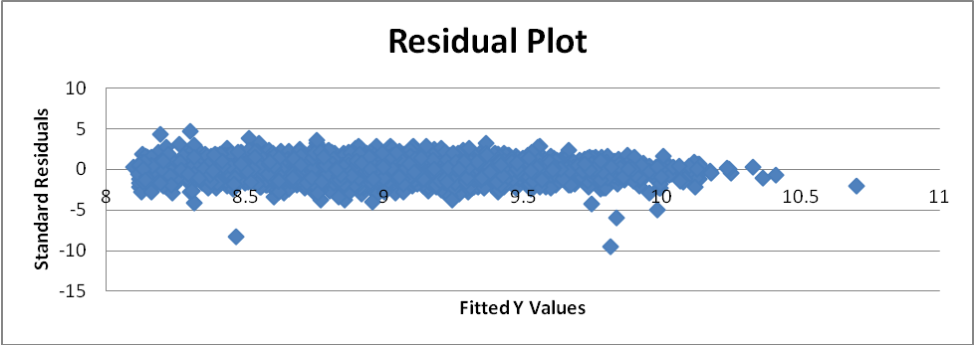

The residuals appear to be symmetric around 0, with most of the data points within two standard errors of 0. However, the variation in residuals seems to be a bit higher for lower fitted values of Y. With the exception of a few outliers, it looks like high fitted Y values have lower variation in the residuals. This suggests that the residuals may not be white noise because they might not have constant variance.

Conclusion
Overall, it looks like I was not able to produce a linear regression model that is a good fit for these variables. Though most of the variables appear to be significant, most of the differences in y-values from the mean y-value cannot be explained by the x-values (low R² value). Perhaps I could have gotten a better fit using different characteristics from that website, such as number of hot/cold days, dishwasher use, whether electricity is used for heating, etc.

