xxxxx xxxxxxxx
Regression Analysis VEE
Summer 2010
Student Project

Temperature and Precipitation: Overall Effect on the Water Level of Lake Travis

Introduction:

I live in Austin, Texas, where for the past several years, we have experienced regular droughts. The lack of rainfall during the summer of 2011 meant yet another drought for Austin and heavy water restrictions throughout the city. I would like to study the precise effect of rainfall and temperature on the water level of Lake Travis. By studying the water level of this large body of water, we can get an understanding of the drought status in the city as a whole.

Hypothesis:

Precipitation by itself, while a key variable in the study of droughts, cannot accurately predict the water level of Lake Travis. For example, if Austin experiences a length of time without precipitation, a storm or shower may not be as effective. Also, a torrential downpour may not affect water levels as much as a steady rain. We could explore several factors in the development of a model to predict water level, but because of the lack of specific data available, we cannot accurately gauge each one. Historical precipitation, together with temperature can predict the water level of Lake Travis.

Data:

In order to prove my hypothesis, I gathered data on the historical water levels of Lake Travis, average precipitation (in inches), and average temperature (in degrees Fahrenheit) on a monthly basis. In addition to the average monthly water levels of Lake Travis, I obtained maximum and minimum lake levels for each month. I will study year 1998 through 2011. My source for the historical water levels of Lake Travis is http://www.lcra.org/water/conditions/historical.html, and for precipitation and temperature is http://www.srh.noaa.gov/images/ewx/aus/ausmontemp.pdf and http://www.srh.noaa.gov/images/ewx/aus/ausmonrain.pdf.

Below is a sample of my data:

Variables for Regression Analysis

I have chosen the following variables for the regression analysis:

Y = Water Level of Lake Travis
X1 = Average Precipitation
X2 = Average Temperature

Regression Analysis Results

Analysis 1 – Two variables on Water Level

I will use the two X variables to predict the level of Lake Travis using the equation Y = α + β1X1 + β2X2. Using the Excel Regression Add-In (results in the “Regression Reg-AvgWaterLvl” Excel tab) I obtain the following results. The regression equation becomes

Y = 677.11 + (0.568)X1 + (-0.153)X2

The adjusted R^2 is 0.0172 indicating that this model is doing a very poor job predicting water levels.

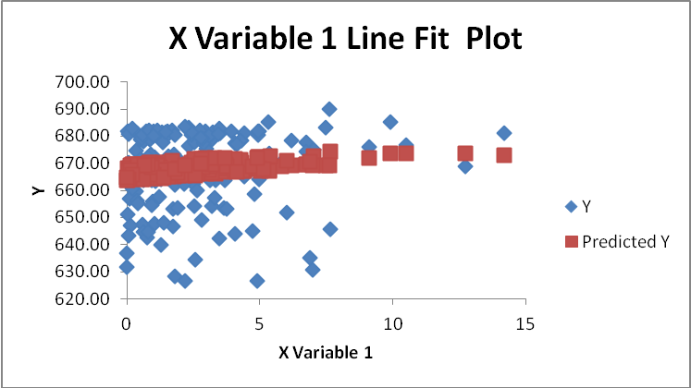
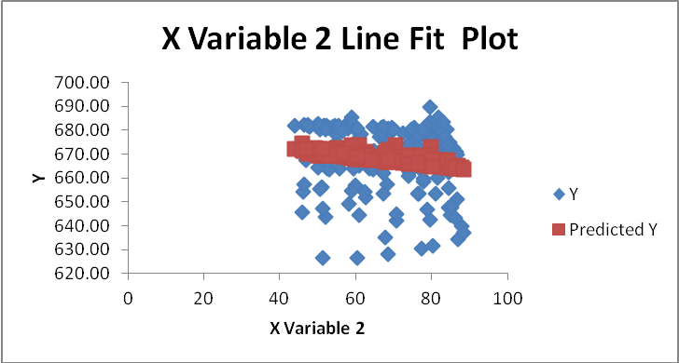

Based on the regression output and the Line Fit Plots for both variables, I need to change my model. Instead of looking at the water level, I will measure the change in water level. This will be a better response variable since it shows the actual effect.

Analysis 2 – Two Variables on Change in Water Level

Next, I will use both variables and have Y be the change in water level. The equation is Y = α + β1X1 + β2X2. Using the Excel Regression Add-In (results in the “Reg-ChangeInAvgWaterLvl” Excel tab) I obtain the following results. The regression equation becomes

Y = 8.257 + (0.747)X1 + (-0.154)X2

The adjusted R^2 improves to 0.312.

This is a massive improvement, but it is still not a very good R^2 value. We will check the Line Fit Plots once more.

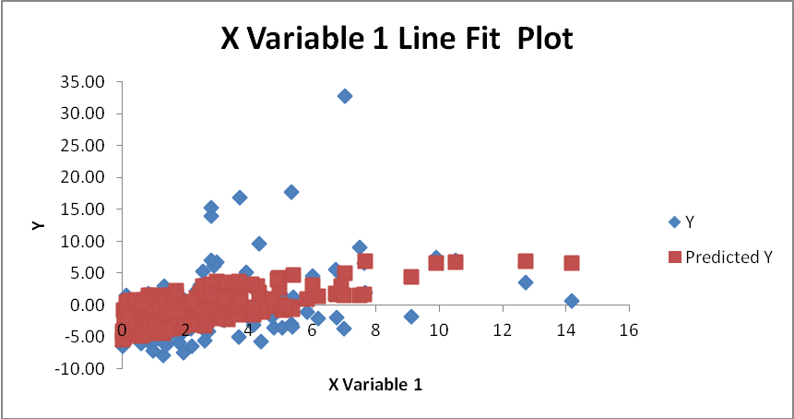

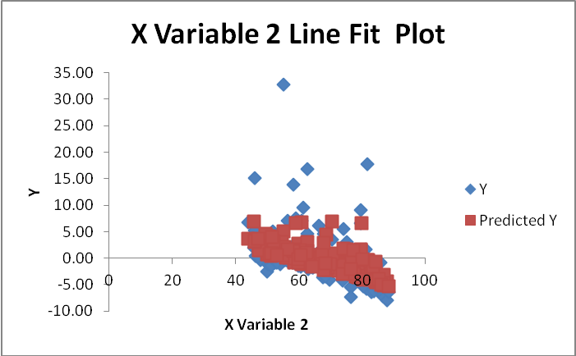

We can remove outliers to try to improve the model. For example, during November 2000, Austin experienced a flood. The water level of Lake Travis rose almost 33 feet, which is double the next highest change. I will remove this outlier and other similar outliers from the data.

Analysis 3 – Two Variables on Change in Water Level – Remove Outliers

Next, I will use both variable to predict change in water level, removing five outliers, using the equation Y = α + β1X1 + β2X2. Using the Excel Regression Add-In (results in the “Reg-ChangeInAvgWaterLvl,Outlier” Excel tab) I obtain the following results. The regression equation becomes

Y = 6.682 + (0.544)X1 + (-0.132)X2

The adjusted R^2 improves again to 0.456, and while this is not a “good” model, it predicts the change in the water level of Lake Travis relatively well for only using two variables. By adding other variables, we could substantially improve the model. Because of data availability restraints, this would not be within the scope of this project.

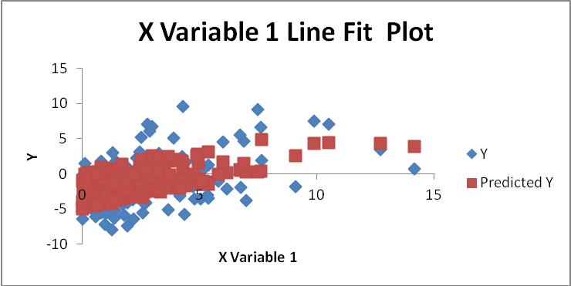

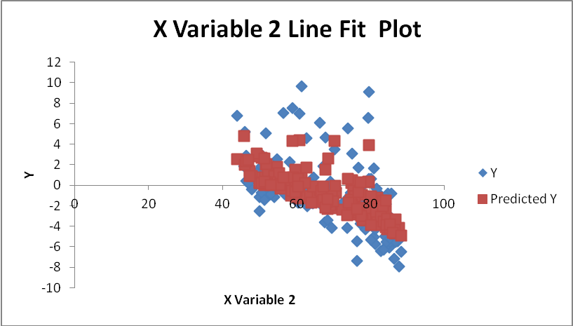

Conclusion

My conclusion is that both precipitation and temperature (among other unmeasured factors) predict the change in water level of Lake Travis. Rainfall is the more intuitive measure and does seem to be better at predicting lake levels. The last analysis performed produced the better model, and the Line Fit Plot for variable one shows that it can predict Y much better than temperature.

