New Auto Sales
Introduction:
The aim of this paper is to forecast the monthly retail sales for new car dealers within the United States. The data utilized is available from the U.S. Census Bureau’s Monthly and Retail Trade data. The data compiled is row 15 of the Excel file titled Retail and Food Service Sales (http://www.census.gov/retail/). Data from January 1st 1992 to November 30th, 2011 has been utilized for this analysis.
Objectives of the Study:
- Determine how the sales at new auto dealers are influenced by prior months.
- Find a time series model that best estimates future auto sales.
Data:
The initial data set is composed of 239 entries with representing the estimated auto sales for new car dealers within the U.S., in millions of dollars. Initial analysis of the data, provided in the following graph, shows an increasing function over most of the time span.
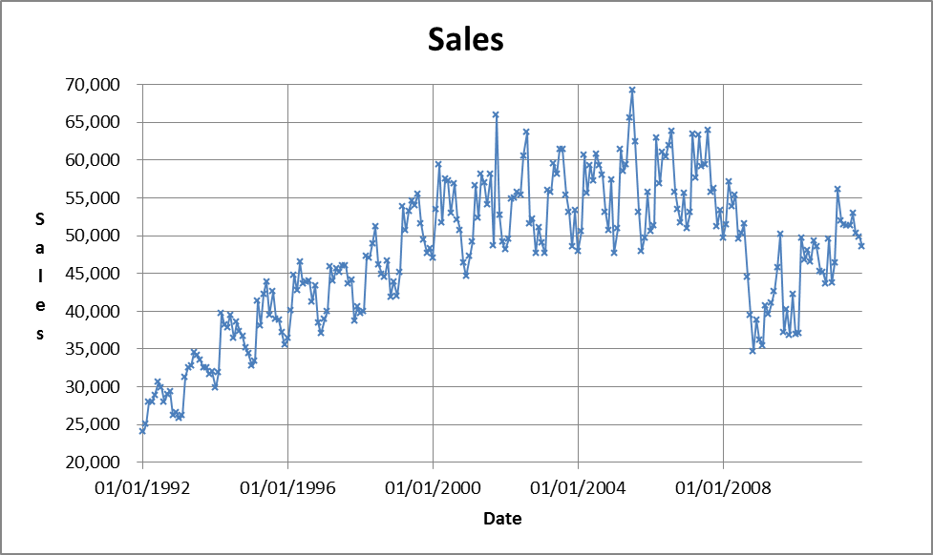

A review of the correlogram shows the autocorrelations do not trend to zero in a rapid fashion. The autocorrelation crosses zero 3 distinct times before trending to zero. By demonstration, the raw data is not a stationary process.
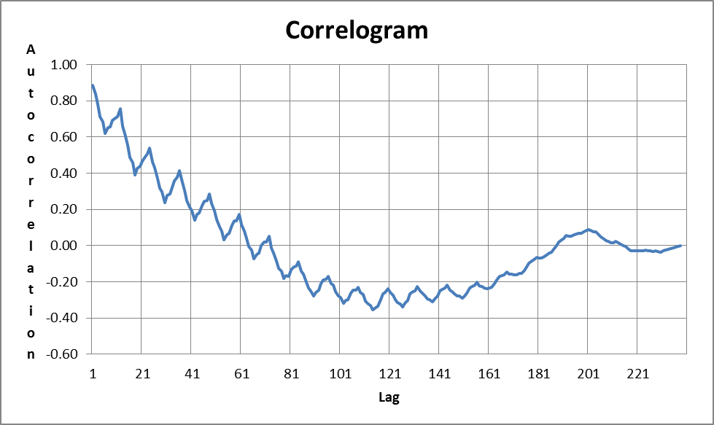
A logical step in time series methods is to generate the first differences of the data and determine if the following process is stationary. The first difference of sales produces a graph that oscillates about zero. From first impressions, it would seem taking the first difference may be beneficial.
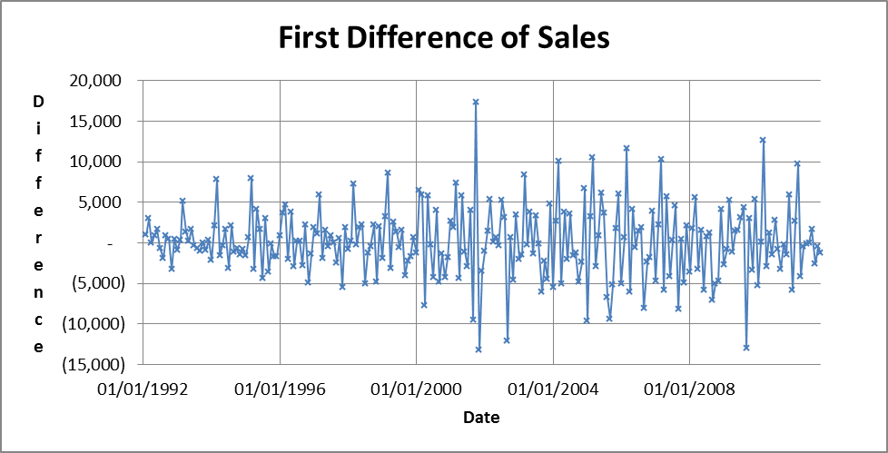

To confirm the initial inspection, analysis of the correlogram is needed. Based upon the correlogram, the autocorrelations trend to zero in a rapidly sufficient fashion. The oscillation of the figure and geometric decrease of the autocorrelation seem indicative of an auto-regressive process. Of note is that the spikes in the oscillation occur at periods of 12, indicating seasonal is inherent. The red lines on the graph represent a Bartlett’s test on the data, which is equal to a 95% confidence interval about zero. This is equivalent to 1.96/√238 = 0.127. We will proceed with developing ARI(1,1)x(1) ₁₂, ARI(2,1)x(1) ₁₂, and AR(3,1)x(1)₁₂ models fit to the data.
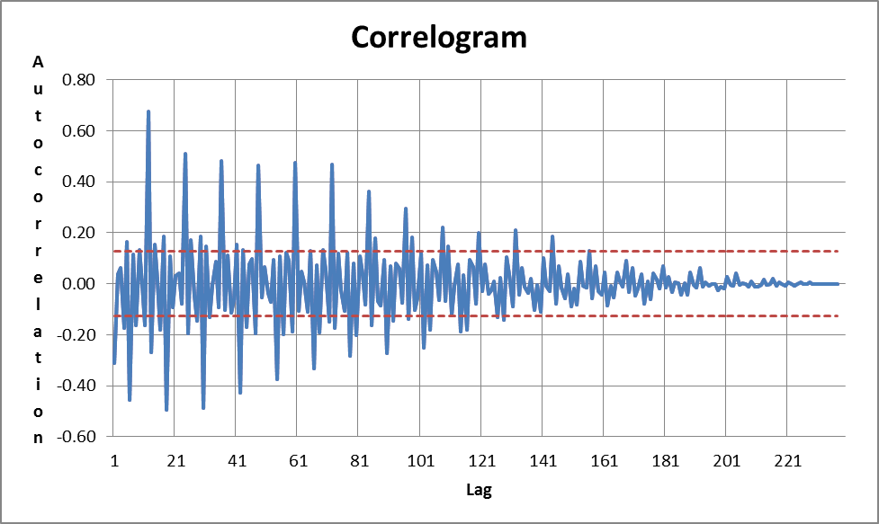

Model Analysis:
The method to determine a suitable time series model will involve fitting a regression to the time series with explanatory variables being represented by the time series shifted back to represent the appropriate lag.

Regression Model 1: ARI(1,1)x(1)₁₂
For an ARI(1,1)x(1)₁₂ process, the model is assumed to have the form
W_{t} = M * W_{t-1} + A * W_{t_12} + B + e_{t}.
Excel’s regression analysis tool provides the following results:
Regression Statistics
Multiple R | 0.719975254
R Square | 0.518364366
Adjusted R Square | 0.514044764
Standard Error | 3095.072077
Observations | 226
ANOVA
 | df | SS | MS | F | Significance F
Regression | 2 | 2.299E+09 | 1.15E+09 | 120.0028 | 4.199E-36
Residual | 223 | 2.136E+09 | 9579471.2
Total | 225 | 4.435E+09
 | Coefficients | Standard Error | t Stat | P-value | Lower 95% | Upper 95% | Lower 95.0% | Upper 95.0%
Intercept | 63.37429467 | 205.9962 | 0.3076479 | 0.7586374 | -342.57395 | 469.32254 | -342.57395 | 469.32254
Wt-1 | -0.203012898 | 0.0471262 | -4.3078579 | 2.472E-05 | -0.2958825 | -0.1101433 | -0.2958825 | -0.1101433
Wt-12 | 0.670961037 | 0.0480452 | 13.965206 | 2.9E-32 | 0.5762803 | 0.7656417 | 0.5762803 | 0.7656417
The regression analysis indicates M = 0.203, A = 0.671 and B = 63.374. The model would then have the form
W_{t} = 0.203 * W_{t-1} +0.671 * W_{t-12} + 63.374 + e_{t}
Of note is the adjusted R² is 0.514, and the P-value for the W_{t-1} and W_{t-12} variable are less than 0.001, indicating significance.

A graph of the actual sales figures versus the forecasted sales figures is:
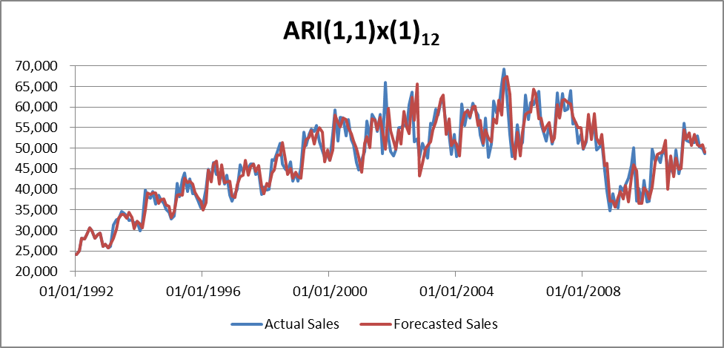
Regression Model 2: ARI(2,1)x(1)₁₂
For an ARI(2,1)x(1)₁₂ process, the model is assumed to have the form
W_{t} = M * W_{t-1} + N * W_{t-2} + A * W_{t-12} + B + e_{t}
Excel’s regression analysis tool provides the following results:
Regression Statistics
Multiple R | 0.720387225
R Square | 0.518957754
Adjusted R Square | 0.512457184
Standard Error | 3100.123643
Observations | 226
ANOVA
 | df | SS | MS | F | Significance F
Regression | 3 | 2301758696 | 767252899 | 79.832643 | 4.553E-35
Residual | 222 | 2133590186 | 9610766.6
Total | 225 | 4435348882
 | Coefficients | Standard Error | t Stat | P-value | Lower 95% | Upper 95% | Lower 95.0% | Upper 95.0%
Intercept | 67.09727911 | 206.4550271 | 0.3249971 | 0.7454894 | -339.76516 | 473.95972 | -339.76516 | 473.95972
Wt-1 | -0.211270369 | 0.049770721 | -4.2448726 | 3.215E-05 | -0.3093539 | -0.1131868 | -0.3093539 | -0.1131868
Wt-2 | -0.025688312 | 0.049088674 | -0.5233043 | 0.6012845 | -0.1224277 | 0.0710511 | -0.1224277 | 0.0710511
Wt-12 | 0.669459634 | 0.048209061 | 13.886593 | 5.664E-32 | 0.5744537 | 0.7644656 | 0.5744537 | 0.7644656
The regression analysis indicates M = -0.211, N = -0.026, A = 0.669 and B = 67.097. The model would then have the form
W_{t} = -0.211 * W_{t-1} - 0.026 * W_{t-2} + 0.669 * W_{t-12} + 67.097 + e_{t}
Of note is the adjusted R² is 0.512, and the P-value for the W_{t-1} and W_{t-12} variable are less than 0.001, indicating significance. The P-value for the W_{t-2} variable is 0.601, which is insufficient to determine significance.
A graph of the actual sales figures versus the forecasted sales figures is:
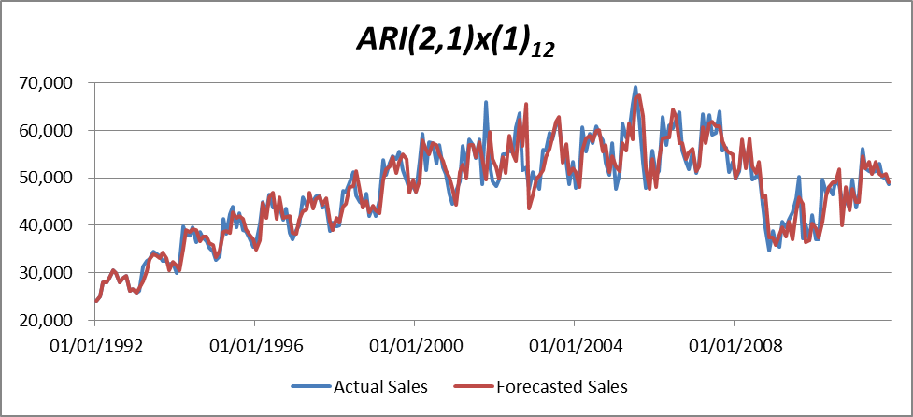
Regression Model 3: ARI(3,1)x(1)₁₂
For an ARI(2,1)x(1)₁₂ process, the model is assumed to have the form
W_{t} = M * W_{t-1} + N * W_{t-2} +P * W_{t-3} + A * W_{t-12} + B + e_{t}
Excel’s regression analysis tool provides the following results:
Regression Statistics
Multiple R | 0.721247803
R Square | 0.520198394
Adjusted R Square | 0.511514202
Standard Error | 3103.12025
Observations | 226
ANOVA
 | df | SS | MS | F | Significance F
Regression | 4 | 2307261364 | 576815341 | 59.901761 | 3.345E-34
Residual | 221 | 2128087518 | 9629355.3
Total | 225 | 4435348882
 | Coefficients | Standard Error | t Stat | P-value | Lower 95% | Upper 95% | Lower 95.0% | Upper 95.0%
Intercept | 72.02934801 | 206.7575555 | 0.3483759 | 0.7278895 | -335.43939 | 479.49809 | -335.43939 | 479.49809
Wt-1 | -0.212863044 | 0.049863361 | -4.2689269 | 2.916E-05 | -0.3111316 | -0.1145945 | -0.3111316 | -0.1145945
Wt-2 | -0.037888854 | 0.051718888 | -0.7325922 | 0.4645834 | -0.1398142 | 0.0640365 | -0.1398142 | 0.0640365
Wt-3 | -0.03750178 | 0.049609383 | -0.7559413 | 0.4504894 | -0.1352698 | 0.0602662 | -0.1352698 | 0.0602662
Wt-12 | 0.674484354 | 0.048711303 | 13.846568 | 8.281E-32 | 0.5784863 | 0.7704825 | 0.5784863 | 0.7704825
The regression analysis indicates M = -0.212, N = -0.038, P = -0.038, A = 0.674 and B = 72.029. The model would then have the form
W_{t} = -0.212 * W_{t-1} - 0.038 * W_{t-2} - 0.38 * W_{t-3} + 0.674 * W_{t-12} + 72.029 + e_{t}
Of note is the adjusted R² is 0.512, and the P-value for the W_{t-1} and W_{t-12} variable are less than 0.001, indicating significance. The P-value for the W_{t-2} variable is 0.465 and the P-value for the W_{t-3} variable is 0.451.
A graph of the actual sales figures versus the forecasted sales figures is:
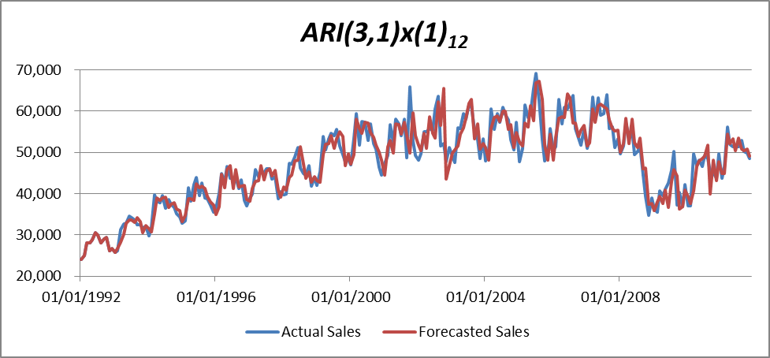

Model Selection:
To properly select the best time series model for sales at new car dealerships, a comparison of the R² values from each regression analysis, the Durbin-Watson statistic, the Box-Pierce Q statistic, and the χ² critical values will be useful.
Model | Adjusted R² | Durbin Watson Statistic | Box-Pierce Q Statistic | χ² at 10%
ARI(1,1)x(1)₁₂ | 0.514045 | 2.20 | 173.67 | 251.5
ARI(2,1)x(1)₁₂ | 0.512457 | 2.19 | 180.33 | 250.5
ARI(3,1)x(1)₁₂ | 0.511514 | 2.20 | 185.42 | 249.4
It is clear from the chart that the adjusted R² and the Durbin-Watson statistic are consistent across all 3 models. Furthermore, the Durbin-Watson statistic is a little higher than 2, implying a slight negative correlation, but nothing to be alarmed about. All of the Box-Pierce Q statistics are below the critical χ² critical values, meaning that the null hypothesis that the residuals are white noise processes cannot be rejected. Analyzing the regression data, I have chosen the ARI(1,1)x(1)₁₂ model as all the coefficients of the regression are significant and it has the highest R² of the 3 models.
Relevant findings from this project include:
- Sales for new auto dealers are represented by a non-stationary series.
- The first difference of sales was confirmed to be a stationary series.
  - A correlogram and Bartlett’s test provided confirmation.
- The first difference of sales series was modeled by an autoregressive process containing non-seasonal terms and seasonal terms, surprisingly.
- The use of the adjusted R², Durbin-Watson statistic, and the Box Pierce Q statistic assisted in choosing a preferable model.
  - The Box-Pierce Q statistic verified that the hypothesis that the residuals are a white noise process could not be rejected.
- The chosen model is able to produce sensible results when compared to the original sales data.

