xxxx xxxxx
NEAS VEE Fall 2011
Time Series Student Project
Introduction
There have been reports of Unidentified Flyer Objects (UFOs) as far back as the time of Alexander the Great. After World War II these sightings have become more frequent and have become even more frequent since the mid-1990s. This project chooses an ARIMA model to forecast monthly UFO sightings and analyzes the residuals for the chosen model.
The Data
The data used in this project was taken from the National UFO Reporting Center (www.nuforc.org). The raw data from this site shows reports as far back as the 15th Century and groups the reports by type (such as triangular, fire balls, saucers, along with others). For this report only sitings from 2000 to 2010 are used for fitting the model. Only the types that are “round” were included. In addition to the limits described above, I also only included sitings with complete data and only allowed one siting per state per day. This was to eliminate duplicate reports. 2011 data will be used to test the model’s forecasting ability.
The following chart graphs the data by month. It is not entirely clear by looking at the graph if the data are stationary. It looks like there may be a slight upward trend and this can be confirmed by looking at the autocorrelation function.
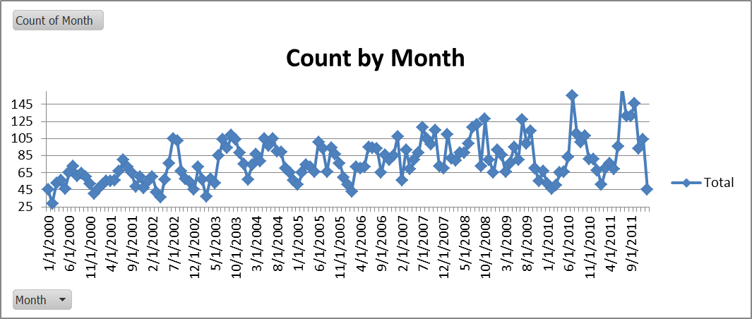
The correlogram below shows that the autocorrelation function does not tail off quickly which may indicate that there is a trend in the series. It also shows strong seasonality.
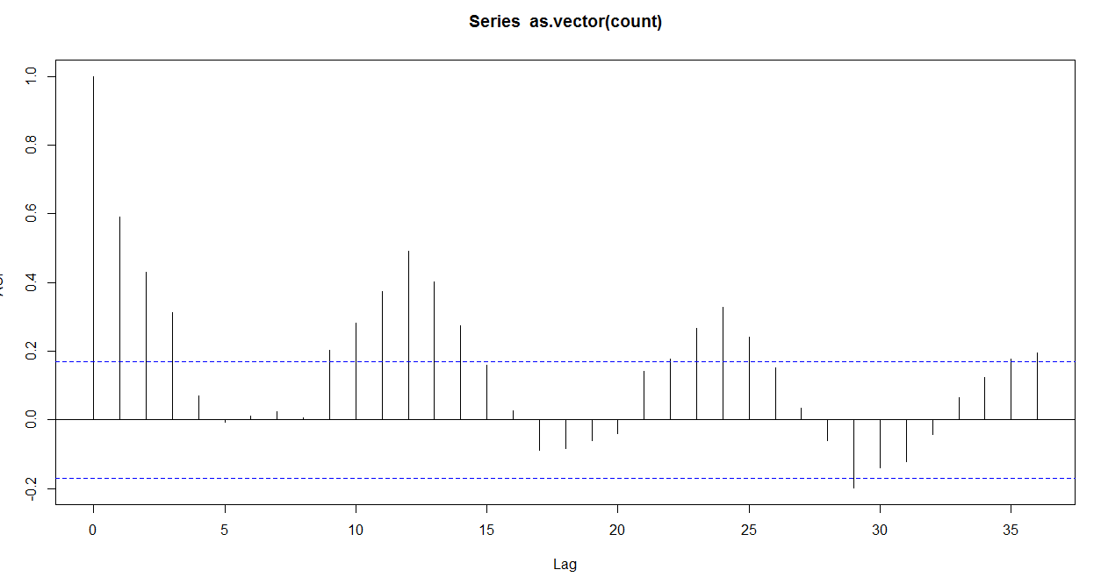
Auto Correlation Function – Raw Data
Choosing the Model
To make the series stationary, seasonal and first differences were taken from the original data. These adjustments appear to create a stationary series.
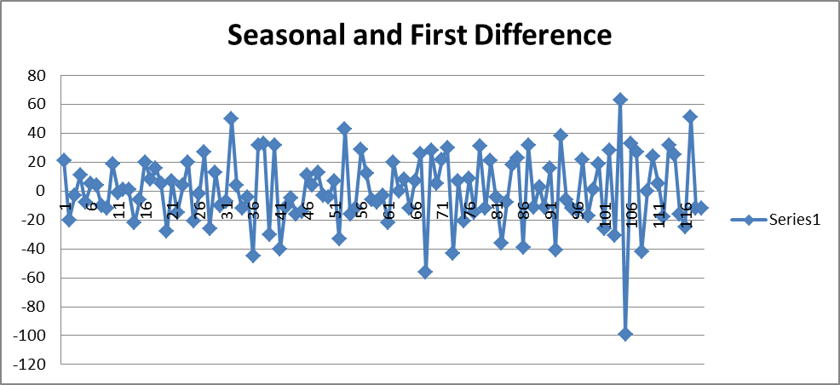
The correlogram confirms what the graph suggests. There is correlation at lags 1, 12 and 13. R was used to determine which model to use and what the coefficients should be.
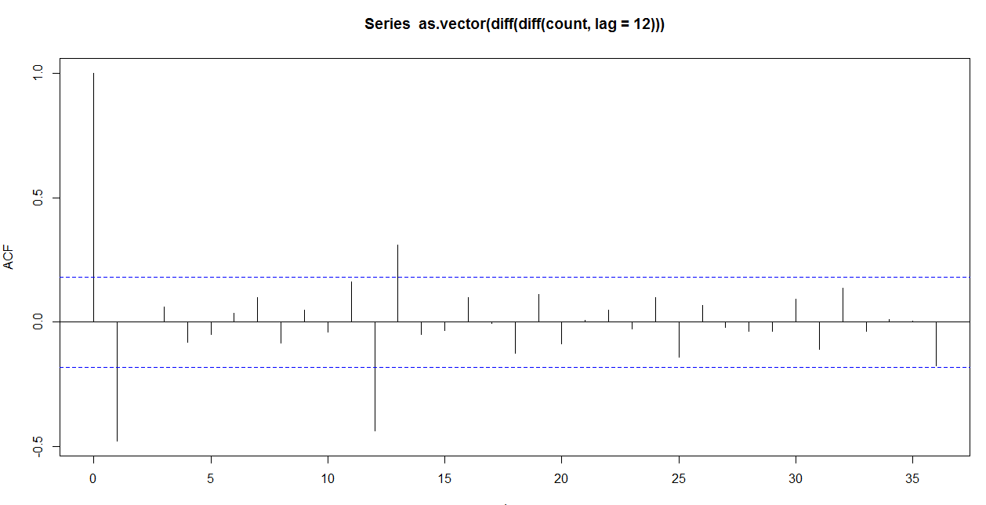
Auto Correlation Function – Seasonally Adjusted First Difference
The next table shows some key outputs from R. It includes coefficients and log likelihood values. The likelihood comparison test says that if two models have the same number of variables, choose the one with the higher likelihood. This test says to choose the moving average model over the auto regression model. It also says that in order to add additional variables, an increase of 3.841 to the likelihood is needed (assuming a Chi² distribution at p=.05). This test says to choose the model with only one moving average component. We conclude that model of best fit is the one listed below the table.
Model | Log Likelihood | AR1 | SAR | MA1 | MA2 | SMA
ARIMA(1,1,0)x(1,1,0)₁₂ | -520.97 | -0.4538 | -0.4355 | 0 | 0 | 0
ARIMA(0,1,1)x(0,1,1)₁₂ | -502.4 | 0 | 0 | -0.7612 | 0 | -0.9495
ARIMA(0,1,2)x(0,1,1)₁₂ | -502.33 | 0 | 0 | -0.7396 | -0.0366 | -0.9356

Model Analysis
A graphical analysis of the forecast quickly reveals that the forecast does not handle the peaks well. This is generally true for moving average models. As the more recent reports are analyzed, some of the unidentified objects will be identified and the recent actual peaks will likely be lowered. This type of analysis is beyond the scope of this project. We will look at several charts and statistics that will help us determine if the residuals are correlated.
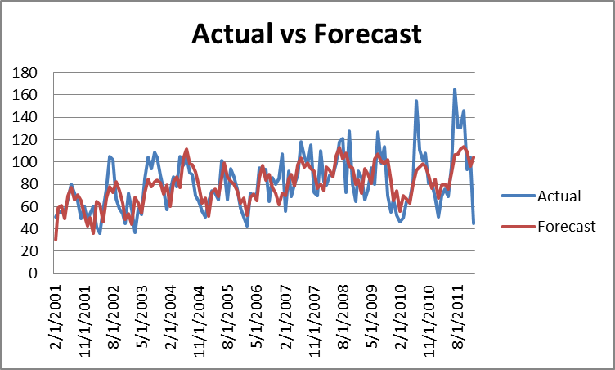
Both the historgram and the correlogram of the standardized residuals suggest that the residuals are not correlated, but neither can definitely tell us this.
The histogram has a mostly bell shape, indicating the residuals are approximately normally distributed. The fact that the histogram is not entirely symmetrical emphasizes the need to calculate statistics to confirm that the residuals are normally distributed. The attached Excel workbook has a Q-Q plot that indicates the same thing.
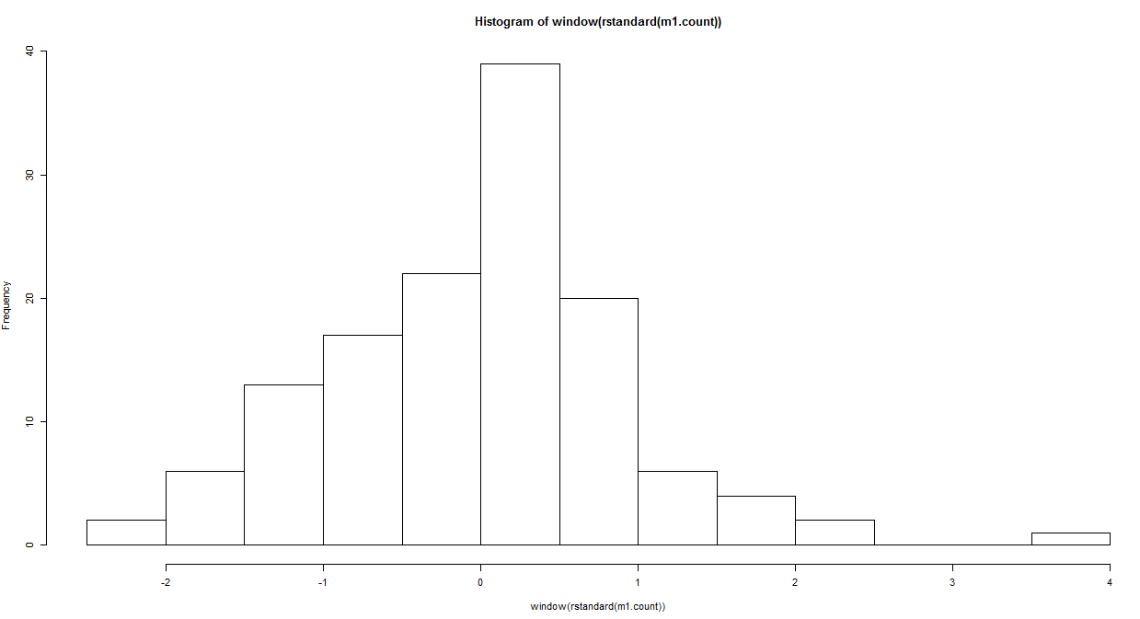
Histogram of Standardized Residuals
Similarly, the autocorrelation function does not show strong correlation, but there are several lags that show slightly significant correlation.
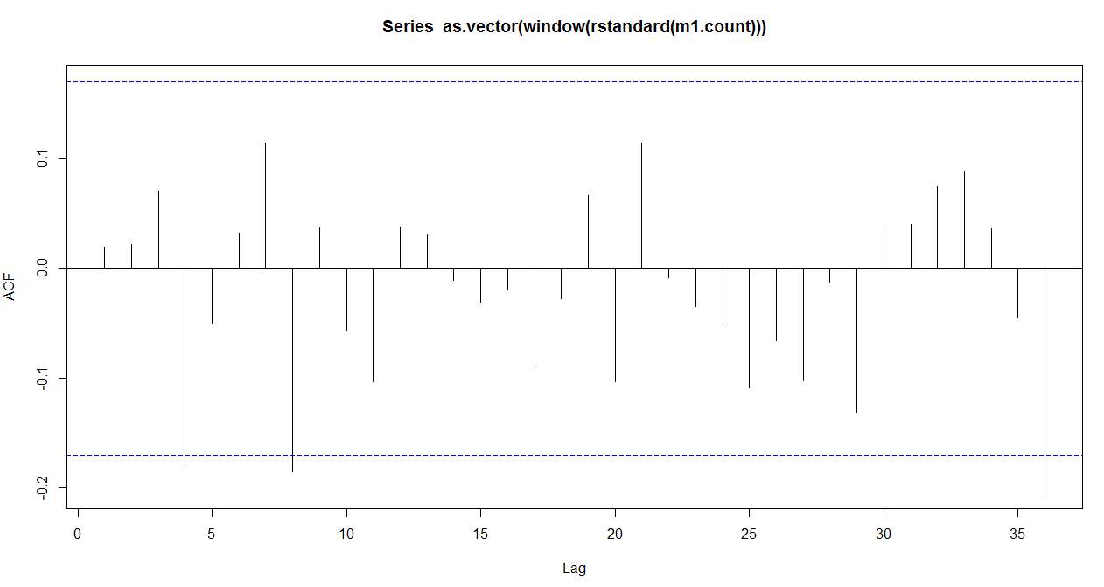
Auto Correlation Function – Standardized Residuals
The Durbin Watson Statistic is 2.04. A statistic close to 2 indicates that there is very little autocorrelation within the residuals.
At lag 36 the Box-Pierce Q is 23.51. This is less than the Chi² Q of 30.81 (at the 10% level). Therefore we do not have enough evidence to reject the null hypothesis that the residuals are a white noise process.
Conclusion
This project shows that UFO sitings can be modeled using an ARIMA(0,1,1)x(0,1,1)₁₂ model. Both the Durbin Watson and the Box-Pierce statistics from the chosen model show that the residuals are not correlated.

