xxxx xxxxx
Time Series Analysis (Cryer & Chan)
Fall 2011

STUDENT PROJECT WRITE-UP
Testing the P&C Underwriting Cycle
INTRODUCTION AND DATA:
I pulled a sample of data from www.snl.com, a website to which I have access via an account through my employer. Specifically, I pulled Schedule P Part 1 Net Earned Premiums and Schedule P Part 1 Net Loss and LAE for all available years (1987 to 2010) for the P&C industry in aggregate. I would’ve liked more data, but 1987 is as far back as the data goes from this source. Schedule P is an annual supplement, so I have yearly records, for 24 total (48 if you count premium and loss separately). Quarterly data was available from 2001 to 2010 via the income statement; I preferred the longer, less frequent data set.
I also used the IMF (International Monetary Fund) World Bank website to pull nominal US GDP dollars for the same periods in question. All dollars from all sources should be nominal (though the match isn’t perfect, e.g. AY insurance data and CY GDP data, issues will be ignored).
I’m going to test if I have enough data to observe any movements in the insurance “underwriting cycle”, and then see if I can build a model to forecast the cycle. This is inspired by a related project I observed but was not involved in at work. Since I found the subject interesting, I thought I would explore it on my own time for this project.
HYPOTHESIS:
I hypothesize that I can create a superior model of insurance industry P&C underwriting cycles by introducing a “shock” component, as represented by prior loss. Specifically, I’m betting that large loss years are followed by movements in premiums in subsequent years, and that these movements then show some level of noisiness about a decay until another shock happens. I believe this makes my approach a combination time series/structural model. Hopefully I’ll have enough data.
ASSUMPTIONS:
I don’t think I have any substantive assumptions beyond what was already described. I used Excel for all my work. My time series are all AR processes for ease of implementation (and this fits my decay hypothesis). I used the Excel Regression plug-in and regressed T against T-1 for the given data.
Preliminary Data and Adjustments:
I made several experimental adjustments to the data and then ran 9 different models using some of the adjusted data sets. All are documented and demonstrated in the accompanying Excel work book with required charts and output. I will spend little time discussing sub-optimal results because of the number of models I tested.

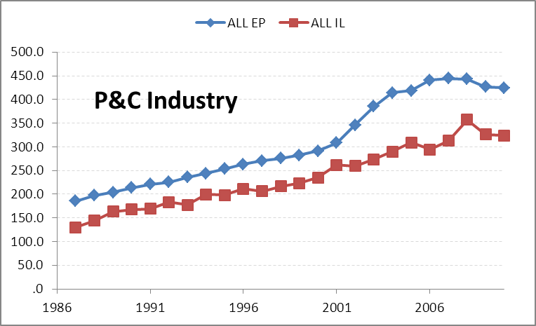
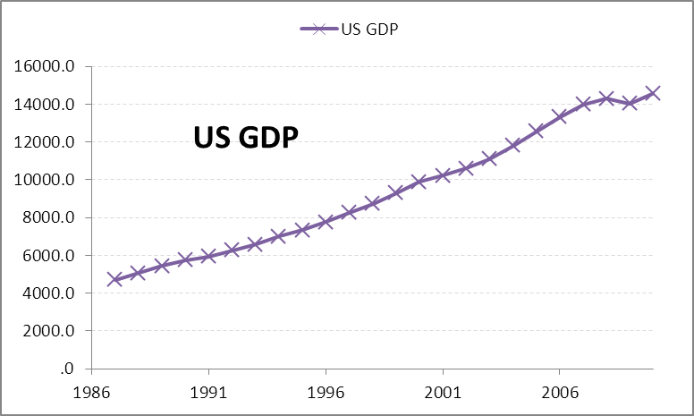
First look at the data. All numbers in millions of US dollars. We see an expected pattern: growing amounts in nominal terms. We’ll test logs and first differences to see how the data looks.
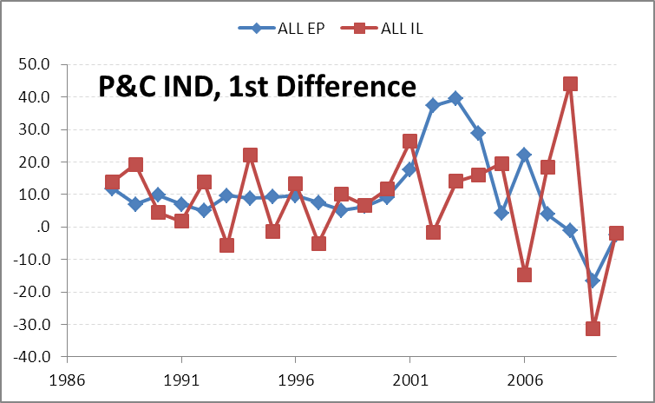
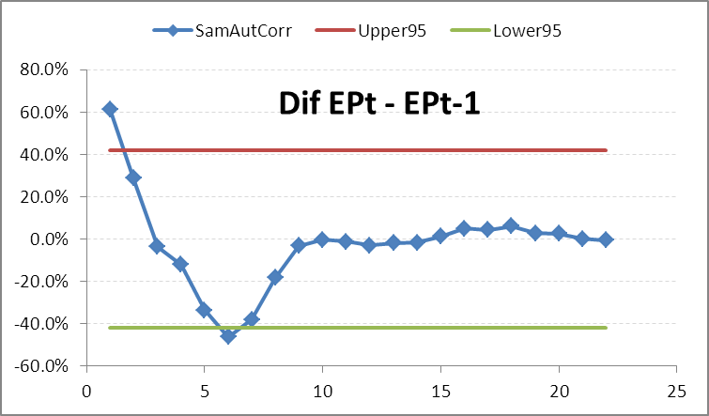
Taking first differences of the premium and loss data, above, gives a picture that might be construed as a stationary process with a positive mean. Also, the correlogram looks like it could be from an AR(2) process with first term positive and second term negative. It does decay to 0 pretty rapidly, however.
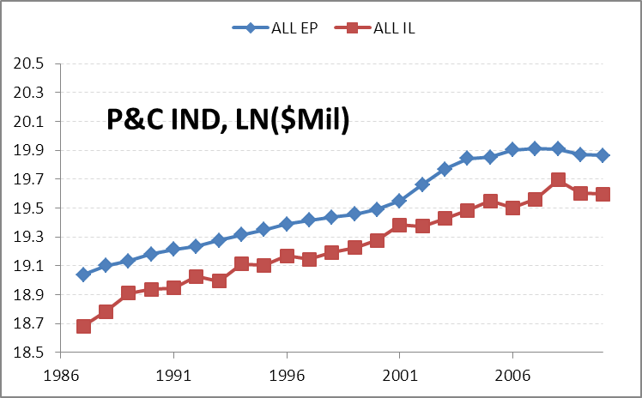
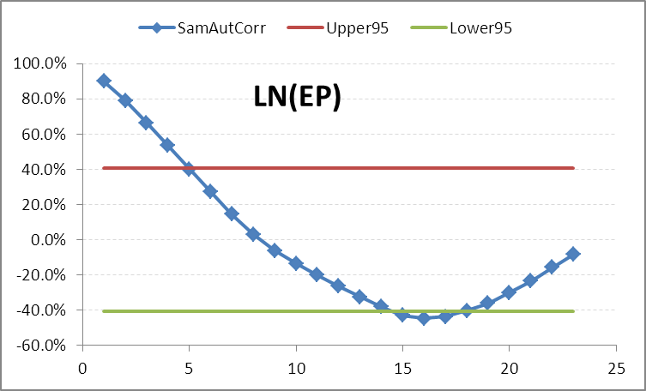
Logging the data doesn’t give anything more useful than the data itself. However – this is an interim step. We expect that the difference of logs will be useful if there is an underlying exponential trend. I’m also unsure what to make of the correlogram; the long descent overshooting zero and then trending back up shows nice smooth decay that resembles AR, and the decay is over many, many lags.
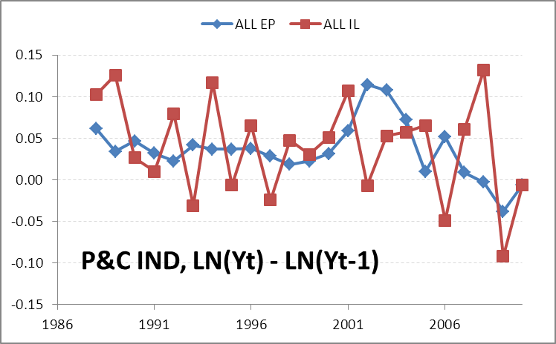
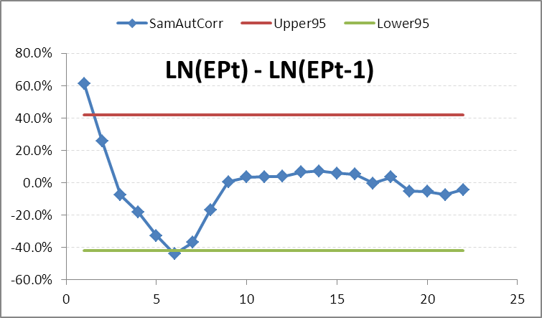
This story is similar to the untransformed first differences. I’m not compelled to believe in a trend as exponential versus linear given the two charts. More importantly, I’m not satisfied with any appearance of an underwriting cycle. We’ll see better soon. On the other hand, there is some reason to believe this correlogram resembles an AR(2) process with first term positive and second term negative.
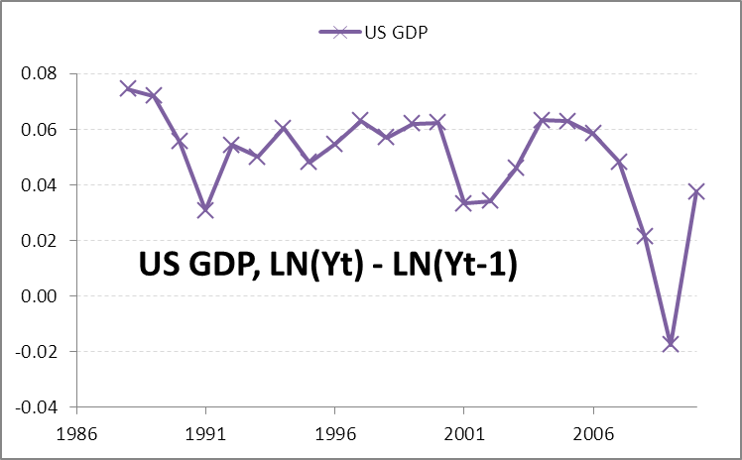
For fun, the first difference of logs of GDP is above. We see reasonably convincing evidence of exponetial growth of nominal dollars in the range of 5%, with the obvious turbulence of 2007-present showing at the end of the graph.
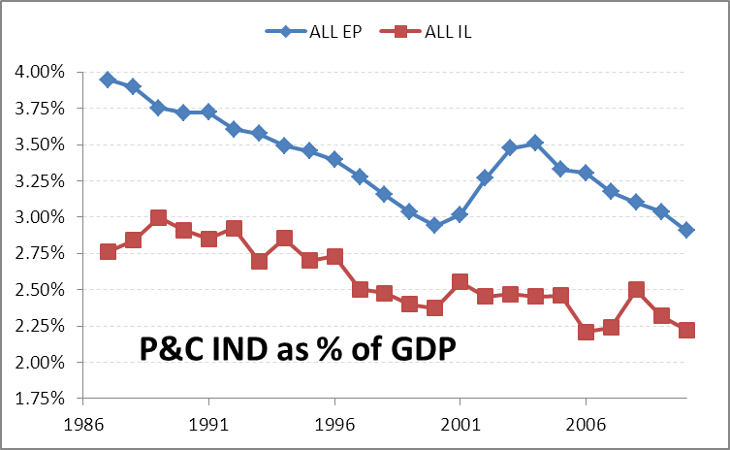
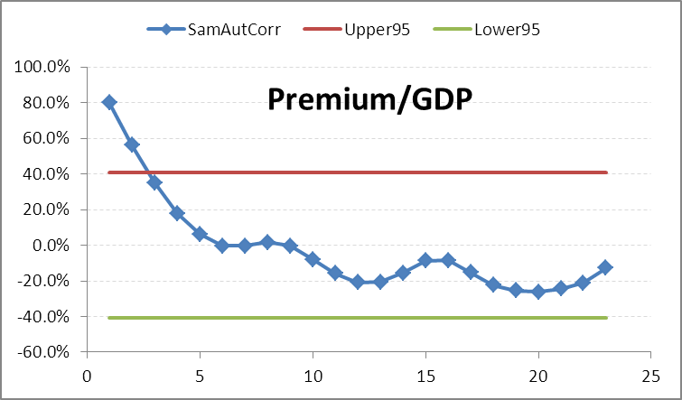
Above is the transformation that will ultimately produce the best results for testing my hypothesis. I’ve taken both premiums and losses in nominal dollars and divided by nominal GDP to observe how the P&C industry has moved as a % of the overall national output. I think this is an excellent way to look for underwriting cycles, as we’ve used GDP to control for changes in the economy at large to isolate the insurance effects we want to test. There is good indication of a downward trend in both premiums and losses. This suggests that I don’t have a stationary process with this transform. That may be a symptom of my short data set; 50+ years of data could show oscillation about a mean of premium to GDP that I can’t observe with 24 years. I’ll point out I like this transformation for its preservation of data.
The smooth decay of the correlogram looks like an AR process to me, and the wiggle makes me think possibly AR(2) with first term positive and second term negative. Nearly all of the lags spend their time in the 90% interval.

ANALYSIS:
As mentioned earlier, I tested 9 models. The focus is on P&C industry premiums.
- AR(1) on the first difference of logs of premiums.
- AR(1) on first differences of premiums.
- A regression of premium/GDP at time T to loss/GDP at time T-1.
- AR(1) on premium/GDP.
- AR(1) on premium/GDP with a second X of loss/GDP at time T-1.
- AR(2) on the first difference of logs of premiums.
- AR(2) on premium/GDP.
- AR(2) on premium/GDP with a third X of loss/GDP at time T-1.
- AR(3) on premium/GDP.
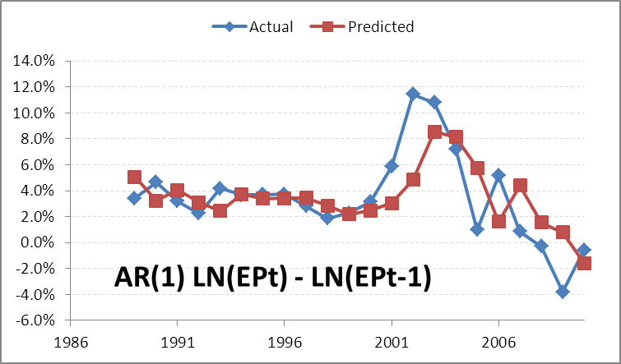
Model 1
Regression Statistics
Multiple R | 0.649354916
R Square | 0.421661807
Adjusted R Square | 0.392744897
Standard Error | 0.026574598
Observations | 22
ANOVA
 | df
Regression | 1
Residual | 20
Total | 21
 | Coefficients
Intercept | 0.009623337
X Variable 1 | 0.665049286

The first model, above, had a mediocre fit.
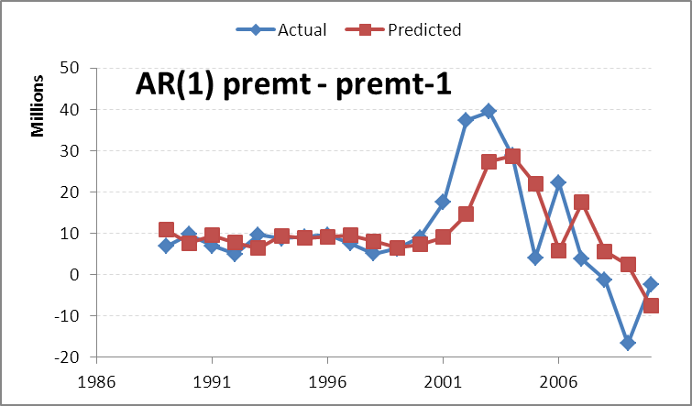
Model 2
Regression Statistics
Multiple R | 0.630633454
R Square | 0.397698553
Adjusted R Square | 0.36758348
Standard Error | 10009035.02
Observations | 22
ANOVA
 | df
Regression | 1
Residual | 20
Total | 21
 | Coefficients
Intercept | 3217708.746
X Variable 1 | 0.647494824

The second model isn’t any better.

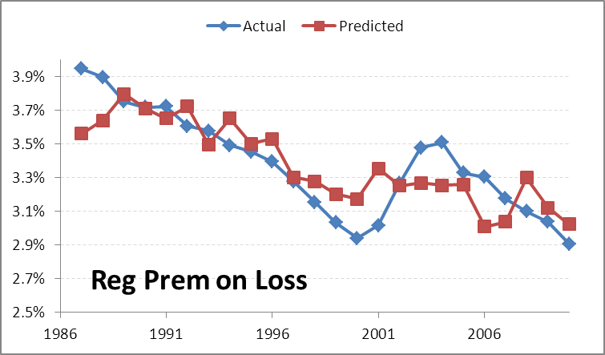
Model 3
Regression Statistics
Multiple R | 0.791295234
R Square | 0.626148147
Adjusted R Square | 0.609154881
Standard Error | 0.001878271
Observations | 24
ANOVA
 | df
Regression | 1
Residual | 22
Total | 23
 | Coefficients
Intercept | 0.008122246
X Variable 1 | 0.995285048

The third model isn’t really a time series. It is a regression of EP on IL. The R^2 is getting better at 0.62. I’m actually fairly happy with these results: the correlogram shows movement that is probably NOT white noisy, but still controlled. This lends some beliievability, I think, to the idea that loss shocks might “move the needle”, but premiums still have a strong time series component.
I should point out that from this point onward, all models use Premium/GDP as the “Y”.
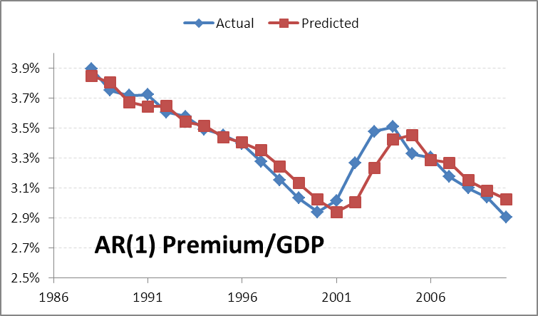
Model 4
Regression Statistics
Multiple R | 0.931831943
R Square | 0.86831077
Adjusted R Square | 0.862039854
Standard Error | 0.001044873
Observations | 23
ANOVA
 | df
Regression | 1
Residual | 21
Total | 22
 | Coefficients
Intercept | 0.002773097
X Variable 1 | 0.905154645

The fit is better than I expected for this very simple model with a very straight forward transform. Notice how the predicted values lag the actuals after the big swing around CY2000.
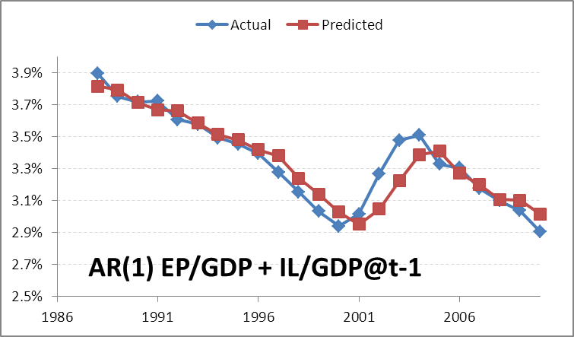
Model 5
Regression Statistics
Multiple R | 0.938261772
R Square | 0.880335152
Adjusted R Square | 0.868368667
Standard Error | 0.001020625
Observations | 23
ANOVA
 | df
Regression | 2
Residual | 20
Total | 22
 | Coefficients
Intercept | 0.0017118
X Variable 1 | 0.207514142
X Variable 2 | 0.778003808

This model has two independent variables: the AR(1) component as represented by the EP/GDP at time T-1 and the “regression component” of IL/GDP at time T-1. The reality is that this model doesn’t do any better than the simpler AR(1) model using premium only. I found that result surprising.
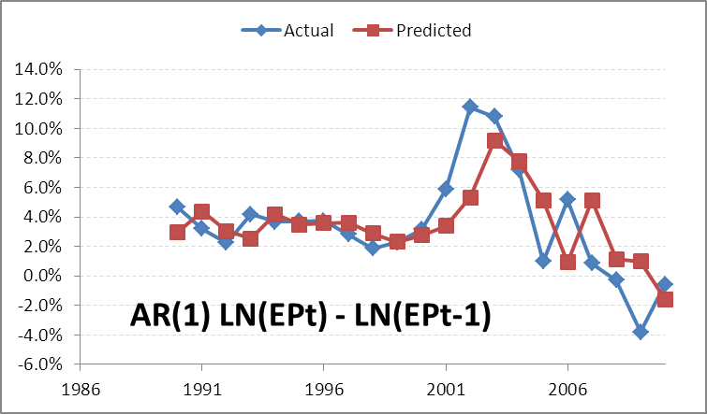
Model 6
Regression Statistics
Multiple R | 0.666892893
R Square | 0.444746131
Adjusted R Square | 0.383051257
Standard Error | 0.027447214
Observations | 21
ANOVA
 | df
Regression | 2
Residual | 18
Total | 20
 | Coefficients
Intercept | 0.013252633
X Variable 1 | 0.770380606
X Variable 2 | -0.16201719

Model 6 has a lower R^2 than I would have expected. But look at those coefficients. First term positive second term negative. Hot damn! I can read a correlogram. Or I got lucky. The big problem this model seems to face is being too reactive instead of predictive.
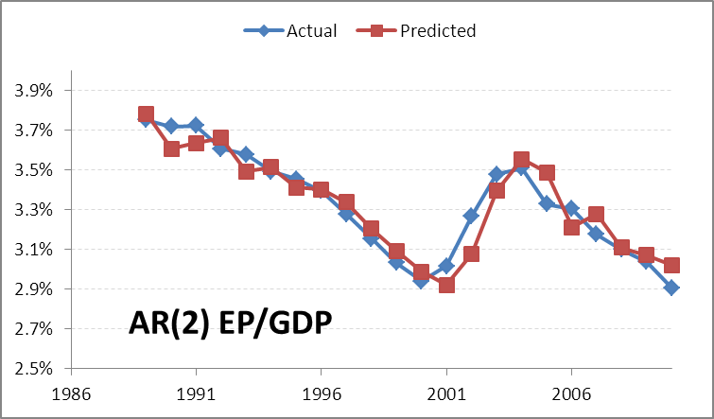
Model 7
Regression Statistics
Multiple R | 0.943414014
R Square | 0.890030001
Adjusted R Square | 0.878454212
Standard Error | 0.000911216
Observations | 22
ANOVA
 | df
Regression | 2
Residual | 19
Total | 21
 | Coefficients
Intercept | 0.003938703
X Variable 1 | 1.414155345
X Variable 2 | -0.53760123

We’ve tightened up our fit a bit with two autoregressive terms. R^2 is 0.89. We still lag the big change around 2000. I will again point out the positive first coefficient and negative second, suggesting a connection back to the reading of the correlogram. This model is a very good fit for its simplicity. Further evidence of the possibility of a stationary AR(2) for this data, from textbook page 72, we have
- phi1 + phi2 = 0.877 < 1
- phi2 – phi1 = -1.95 < 1
- |phi2| = 0.537 < 1

Mixed with an R^2 nearly at 90, these are compelling results, though they only support part of my hypothesis.
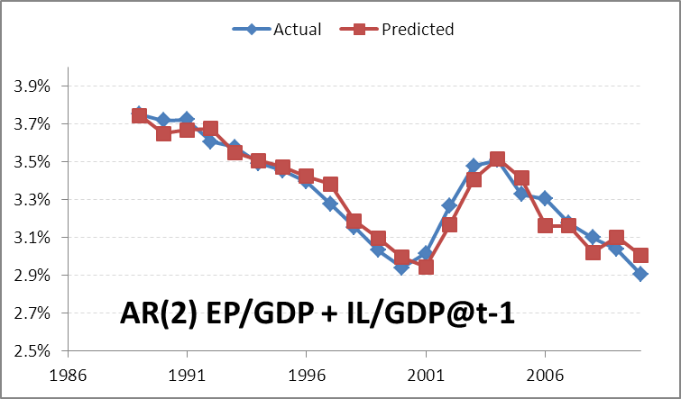
Model 8
Regression Statistics
Multiple R | 0.963809355
R Square | 0.928928473
Adjusted R Square | 0.917083219
Standard Error | 0.000752615
Observations | 22
ANOVA
 | df
Regression | 3
Residual | 18
Total | 21
 | Coefficients
Intercept | 0.00295291
X Variable 1 | 0.36275741
X Variable 2 | 1.289018561
X Variable 3 | -0.65982592

Model 8 has several distinctions. First, it is my favorite: it represents my hypothesis fairly well; by incorporating the IL loss as a shock term at time T-1, our fit no longer lags after the big shifts. And still, the AR(2) part of the process does an excellent job capturing the noise. This fit also has the highest R^2 of any model tested at 0.93; it is the only model to break 90. I’m not quite sure how to interpret the marriage of the AR(2) with the regression on IL@T-1. Nonetheless, I’ll point out that the amazing fit of this model coupled with the excellent overall time series performance of the AR(2) as shown in model 7 makes me confident my hypothesis considered the correct components.
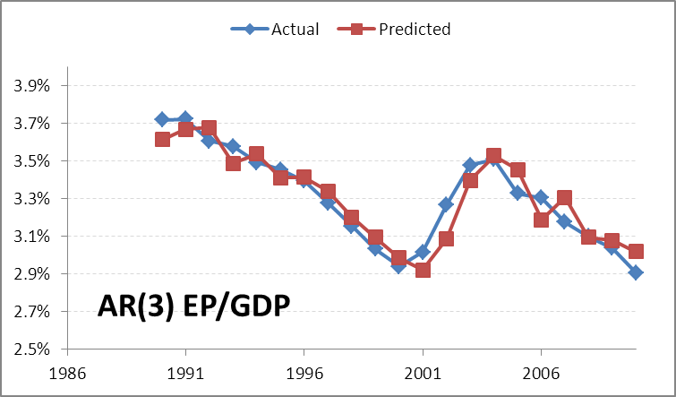
Model 9
Regression Statistics
Multiple R | 0.937451502
R Square | 0.878815318
Adjusted R Square | 0.857429786
Standard Error | 0.00094316
Observations | 21
ANOVA
 | df
Regression | 3
Residual | 17
Total | 20
 | Coefficients
Intercept | 0.002846716
X Variable 1 | 1.533544409
X Variable 2 | -0.80723138
X Variable 3 | 0.182147562

Model 9 was an afterthought. When model 8 fit as well as it did, I needed to consider that it also had one more independent variable than the other models tested. Further, the AR(p) models were doing fairly well on their own. The AR(3) was the next logical step. The R^2 is 0.88. Not only did it underperform model 8, it also underperformed the simpler AR(2) of model 7. This suggests to me that an AR(2) is possibly a very good model for capturing the noisiness of the underwriting cycle, and adding the loss shock explains larger swings in the cycle.
CONCLUSION
I think these results test well and are intuitive: we expect the industry to respond with premium changes when losses are high(er), especially if they trend up for several periods. Note the small bump in 1992 in loss, most likely due to hurricane Andrew. As losses fell off after this bump, there was little response from the industry, and premiums continued their downward decline relative to GDP. However, shakeups in the early to mid 2000s, largely due to casualty business (I think) followed by more hurricanes (e.g. Katrina), showed several years of increasing losses, and premiums responded with a hardening of the market.
Models Tested
Model | Parameters | R^2 | Adj R^2 | DWS
1 | AR(1) on the first difference of logs of premiums. | 0.422 | 0.393 | 1.777
2 | AR(1) on first differences of premiums. | 0.398 | 0.368 | 1.895
3 | A regression of premium/GDP at time T to loss/GDP at time T-1. | 0.626 | 0.609 | 0.912
4 | AR(1) on premium/GDP. | 0.868 | 0.862 | 0.958
5 | AR(1) on premium/GDP with a second X of loss/GDP at time T-1. | 0.880 | 0.868 | 0.820
6 | AR(2) on the first difference of logs of premiums. | 0.445 | 0.383 | 2.016
7 | AR(2) on premium/GDP. | 0.890 | 0.878 | 1.696
8 | AR(2) on premium/GDP with a third X of loss/GDP at time T-1. | 0.929 | 0.917 | 1.646
9 | AR(3) on premium/GDP. | 0.879 | 0.857 | 1.848

Some of the evaluation metrics appear to conflict. For instance, model 8 best represents my hypothesis and outperforms all other models on a “goodness of fit” test using adjusted R^2 to attempt to account for the number of parameters used. On the other hand, the DWS is lower than for some other models that showed less fit. I’m uncertain how exactly to interpret this, especially given that DWS at 1.7 is starting to get out of the “close enough to 2” range. This suggests my residuals are not white noise, and I’ve missed something in the process. On the other hand, some of the highly transformed models do have true white noise residuals (at least as far as DWS tests) but have significantly less predictive power. I think this suggests the transformations caused a loss of useful information.

SUMMARY AND FUTURE WORK
After the fact, it is clear I need more data points. Underwriting cycles in insurance can last many years, and I’ve only managed to possibly see one complete up-down-up cycle in my 24 years of data. Beyond that limitation, I’m impressed with the predictive power of at least two of my models and the degree to which they make my hypothesis believable.

