Introduction
My weekday mornings begin with a perennial struggle between me and my alarm clock. I imagine that the number of times I hit the snooze has a Poisson distribution of unknown (but relatively high) λ. Returning home from work, I find my situation no better, and I often longingly look at my bed (or having crawled into it, look despairingly outwards), before somehow cajoling or forcing myself to take exile in the library and perform at times seemingly useless calculations of life contingencies or credibility estimates.
In other words, sleep interests me. And having found on the Internet a data set containing the total daily sleep requirements for approximately 60 mammals along with other measures such as body weight and gestational period, I decided that this would make a fine topic for analysis.
Unfortunately, vague recollections of sophomore year Introductory Neuroscience and junk popular science aside, I have little understanding of the biology of sleep. I note that this is an entirely unsatisfactory condition in which to begin a statistical analysis, as it leaves me open to misinterpreting my data and making spurious conclusions. Nonetheless, I proceed as my objective is less to make scientific conclusions and more to explore statistical principles
My a priori hypothesis is that smarter animals, larger animals, and animals in less danger will need the most sleep. I make this hypothesis because smarter animals expend more brain energy that seems to be recharged by sleep, larger animals expend more physical energy (although admittedly perhaps not more energy per unit of mass) and hence may require more rest (if not sleep), and animals in less danger have the luxury to sleep more even if it is not necessary.

Data
I used data for 62 mammals drawn from “Sleep in Mammals: Ecological and Constitutional Correlates” by T. Allison and D. Cicchetti which appeared in a 1976 edition of Science. The data is now available online here:
http://ifasstat.ifas.ufl.edu/STA%205106/5106F06data/sleeptime.txt
Since a number of observations were missing data, I decided to exclude these observations, so as not to have to deal with the complications of incomplete data. This brought the set down to 42 observations.
I will regress total sleep (in hours/day) on other variables in the set. The potential regressors I decided to look at:
body weight: measure of largeness of animal
brain weight: possible measure of intelligence of animal
gestational period: possible measure of intelligence of animal. Animals with long gestational periods (e.g. humans, elephants, chimpanzees) are more intelligent, the theory being that it takes a longer time for them to develop gestationally due to requirements of brain formation.
life span: a prior I do not have a reason to include. Perhaps animals that live longer will sleep more to account for the fact that less of their lives is active.
% of total sleep devoted to slow wave sleep: possible measure of (negative) intelligence. Animals that seem to devote more sleep to “paradoxical” sleep (e.g. elephants, humans) are more intelligent. Perhaps even, humans, elephants, and other intelligent animals sleep more so that they can have dreams.
Some of the other potential regressors in the model were intriguing –e.g. the indices for predation, sleep exposure, and overall danger. However, without more information on how they were determined, it is difficult to determine if they are valid. Moreover, as they are not quantifiable, except on the arbitrary scale determined by researchers, they would have to be coded as dummy variables. Having this many dummy variables would be time-consuming, and would still be difficult to interpret due to the scale.

Transformations of Data
Since I want data to be approximately normally distributed, I will make appropriate transformations. The first transformation I apply is to take the logit transformation of % of total sleep devoted to slow wave sleep, as I want to smooth out the extremes associated with percentages.
After applying the logit transformation, one immediately notices a limitation of this transformation. The transformation is defined as 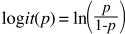 However, this transformation necessarily fails when p is 0. Taking the limit as n → 1, one obtains ∞, which is not useful for regression analysis. Because of this limitation, I will toss out the Echidna observation, which has 100% slow wave sleep. This decision is justified not only by the limitations of the logit transformation but also by the suspect nature of the observation. It seems unlikely that the Echidna is the only mammal that has absolutely no paradoxical sleep; if this is indeed, the case it makes the Echidna an even more fascinating animal, but also perhaps an outlier that could skew the data. After this removal, I am left with 41 observations.
To make other transformations, I look at the variables one by one using boxplots and see if they are approximately, normal and then see if I can make transformations to make them more normal following Tukey and Mosteller’s bulging rule. For most of the variables, it is clear that the untransformed variable is not normal, and that taking the log of the variable produces a much more satisfactory result. This is reasonable as it seems that there is a wide distribution in size of animals, but that some variables are constrained (e.g. Total sleep can only reach up to 24 hours/day). Box plots are shown on succeeding pages.

Variable | Regressor as is | Log transformation of Regressor
Total sleep | 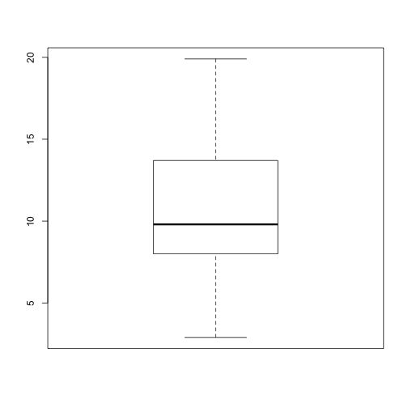 | Not necessary
Body weight | 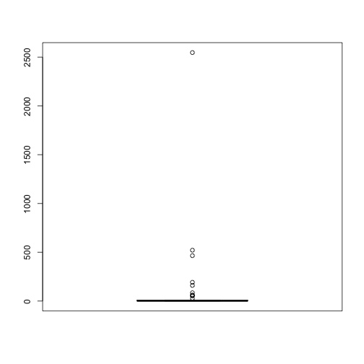 | 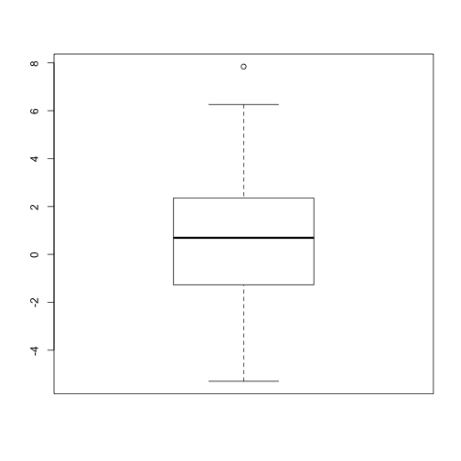
Brain weight | 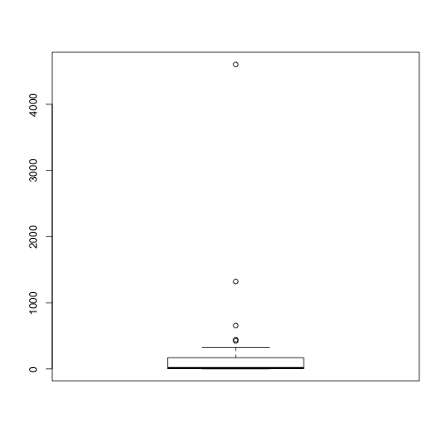 | 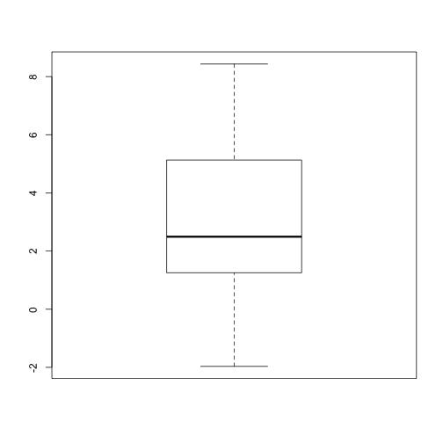
Life span | 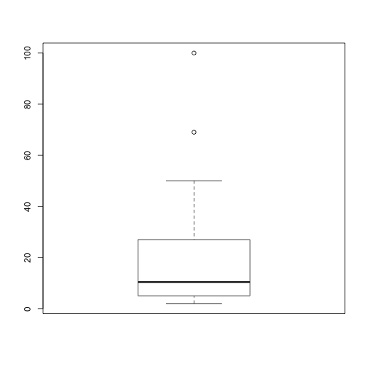 | 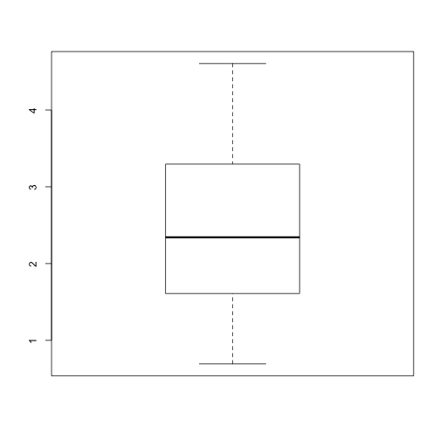
Gestation | 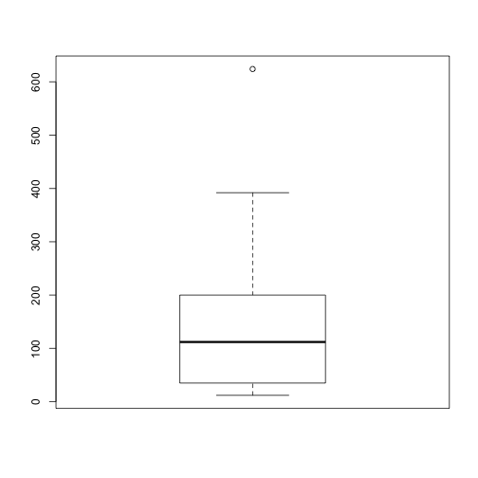 | 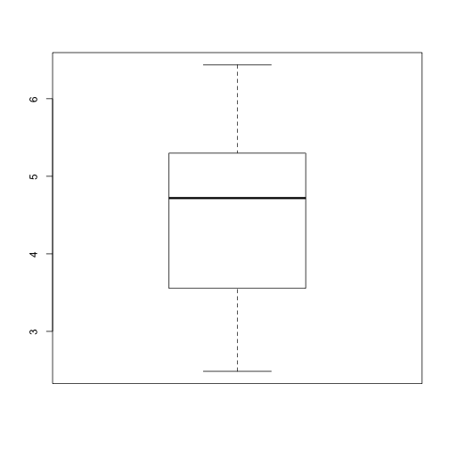

Correlations between variables
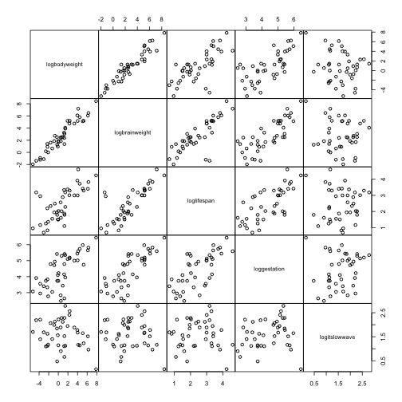
From scatterplot matrix (above), a very strong correlation is noted between log(brain weight) and log(body weight). A correlation is also observed between log(brain weight) and log(life span). However, there do not appear to be any obvious nonlinear relations requiring further transformations.
I check the correlations of the variables with a matrix of correlations (below) and confirm their high correlation (the correlation coefficient for log(body weight) and log(brain weight) is .95. This relation makes sense as it seems reasonable that larger animals would have large brains, regardless of level of intelligence. It would have made more sense, perhaps, to take brain weight as a % of body weight, but I will not make this correction in interests of time and limits of the scope of this project. Anyway, because of the correlation between these variables, it seems reasonable to remove log(brain weight) as a possible explanatory variable. Leaving it in the model would distort the regression line and make attribution to variables more difficult. Other correlations are less than about .72, although there do appear

Correlation Coefficient Matrix (r)
log (body weight)
0.951 | log (brain weight)
0.723 | 0.807 | log (life span)
0.718 | 0.791 | 0.702 | log (gestation)
-0.234 | -0.119 | -0.011 | 0.162 | logit(% slow wave sleep)

Model fitting
I next move on to fitting a model by use of regression analysis. I hypothesize the model will therefore take the form
where a is the intercept, x₁ is log(body weight in kg), x₂ is log(life span in years), x₃ is log(gestation period in days) and x₄ is logit transformation of % of slow wave sleep
I will start with a model which includes the four possible identified explanatory regressors and eliminate each until a satisfactory model is found.
MODEL 1
The first model with all potential regressors:
Call:
lm(formula = totalsleep ~ logbodyweight + loglifespan + loggestation + logitslowwave)
Residuals:
Min 1Q Median 3Q Max
-6.9450 -1.8441 -0.7727 1.9254 8.7996
Coefficients:
Estimate Std. Error t value Pr(>|t|)
(Intercept) 18.6541 3.2433 5.752 1.49e-06 ***
logbodyweight -0.7437 0.3248 -2.290 0.0280 *
loglifespan 1.5207 0.8585 1.771 0.0850 .
loggestation -2.3535 0.8970 -2.624 0.0127 *
logitslowwave -0.4587 1.1190 -0.410 0.6843
---
Signif. codes: 0 ‘***’ 0.001 ‘**’ 0.01 ‘*’ 0.05 ‘.’ 0.1 ‘ ’ 1
Residual standard error: 3.475 on 36 degrees of freedom
Multiple R-squared: 0.5196, Adjusted R-squared: 0.466 F-statistic: 9.733 on 4 and 36 DF, p-value: 1.926e-05
The output from the running the first model through R is shown above. It is seen that the adjusted R² value is only .466, a not very satisfactory result. The F-statistic of 9.733 on 4 and 36 degrees of freedom is also statistically significant but not exactly indicative of a wonderful result.
Looking at the individual variables, one sees almost no statistical significance for logit transformation of % of slow wave sleep (the p value equals .6843) Moreover, the p-value for log (life span) (.085) also shows the coefficient on that regressor fails to meet significance at the .05 level.
MODEL 2
I next eliminate the logit transformation of % slow wave sleep from the model and use the remaining three regressors. I hold off on eliminating log(life span) for now to see if results might improve in revised model
Call:
lm(formula = totalsleep ~ logbodyweight + loglifespan + loggestation)
Residuals:
Min 1Q Median 3Q Max
-6.8433 -1.5194 -0.5515 2.1063 8.8551

Coefficients:
Estimate Std. Error t value Pr(>|t|)
(Intercept) 18.6371 3.2064 5.812 1.13e-06 ***
logbodyweight -0.6784 0.2799 -2.424 0.02037 *
loglifespan 1.4979 0.8470 1.769 0.08521 .
loggestation -2.5162 0.7953 -3.164 0.00311 **
---
Signif. codes: 0 ‘***’ 0.001 ‘**’ 0.01 ‘*’ 0.05 ‘.’ 0.1 ‘ ’ 1
Residual standard error: 3.436 on 37 degrees of freedom
Multiple R-squared: 0.5173, Adjusted R-squared: 0.4782
F-statistic: 13.22 on 3 and 37 DF, p-value: 5.123e-06
Log(life span) still appears not to be significant (p-value: .085). I will therefore, eliminate it and see the results.
MODEL 3
Call:
lm(formula = totalsleep ~ logbodyweight + loggestation)
Residuals:
Min 1Q Median 3Q Max
-7.0353 -2.4779 -0.2404 1.7759 7.6848
Coefficients:
Estimate Std. Error t value Pr(>|t|)
(Intercept) 19.7740 3.2281 6.126 3.83e-07 ***
logbodyweight -0.4602 0.2582 -1.782 0.0827 .
loggestation -1.9806 0.7557 -2.621 0.0125 *
---
Signif. codes: 0 ‘***’ 0.001 ‘**’ 0.01 ‘*’ 0.05 ‘.’ 0.1 ‘ ’ 1
Residual standard error: 3.531 on 38 degrees of freedom
Multiple R-squared: 0.4765, Adjusted R-squared: 0.449
F-statistic: 17.29 on 2 and 38 DF, p-value: 4.564e-06
With, log(life span) remove, log(body weight) seems insignificant (p-value: .083). Adjusted R² has fallen to .449 from .4782 in Model 2. As log(body weight) is no longer statistically significant, I will remove it and test a linear regression with only log(gestation)
MODEL 4
Call:
lm(formula = totalsleep ~ loggestation)
Residuals:
Min 1Q Median 3Q Max
-5.5188 -2.2972 -0.7902 2.3765 7.9042
Coefficients:
Estimate Std. Error t value Pr(>|t|)
(Intercept) 23.6629 2.4445 9.680 6.37e-12 ***
loggestation -2.9478 0.5404 -5.455 2.96e-06 ***
---
Signif. codes: 0 ‘***’ 0.001 ‘**’ 0.01 ‘*’ 0.05 ‘.’ 0.1 ‘ ’ 1
Residual standard error: 3.628 on 39 degrees of freedom
Multiple R-squared: 0.4327, Adjusted R-squared: 0.4182
F-statistic: 29.75 on 1 and 39 DF, p-value: 2.96e-06
CHOOSING A MODEL
This final model shows that the model with only log(gestation) has a lower adjusted R² value than do other models. The model that included log(body weight), log(life span), log(gestation) (.4182 vs. .4782), moreover while the last model has the highest F-statistics, because it has only 1 degree of freedom, the corresponding p-value for this F-statistics is not the best. Since no models achieved an adjusted R² greater than .5, it seems a stretch to say that any are appropriate.

Testing the Chosen Model
For purpose of completeness, I will, however, choose the second model including log(body weight), log(life span) and log(gestation) as the least bad. Here, my criteria were the adjusted R² and the significance of the F-statistic. I then test this model to see if certain key assumptions of regression analysis hold up.
Normality: A qq plot and a histogram of the residuals suggests that the residuals are not exactly normal; the histogram suggests they are slightly skewed to the left. This is a potential problem, but as the model is not a particularly good fit in the first place, it seems unreasonable to invest time trying to eliminate this problem
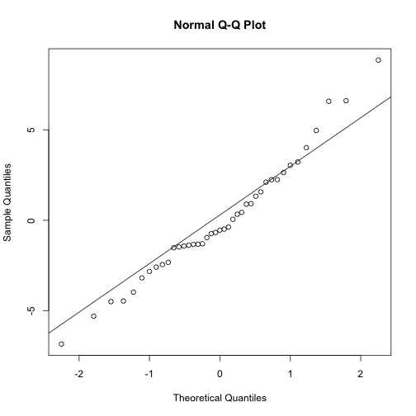
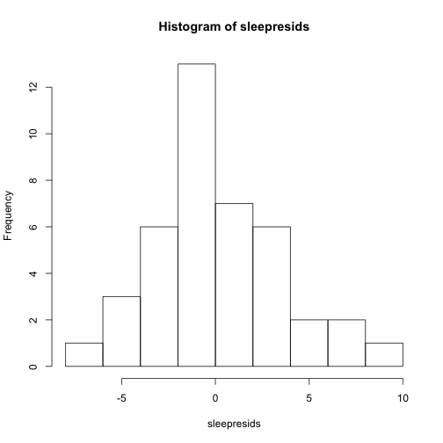
Independence: A graph of residuals vs. fitted values reveals no obvious trends, and the acf of residuals is inconclusive as there is a significant value at lag 1. 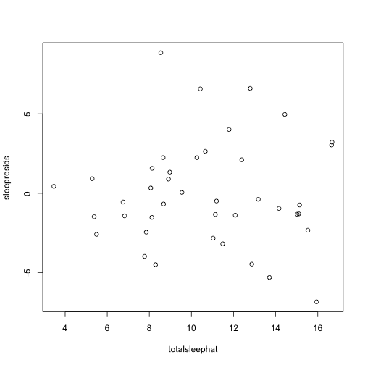
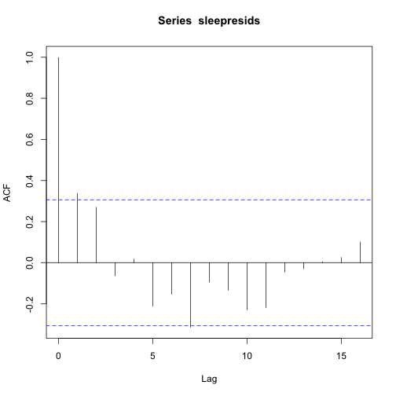
Constant variance: The acf of squared residuals does not show any significant values apart from at lag 0, suggesting that variance is not serially correlated or varying in a predictable fashion
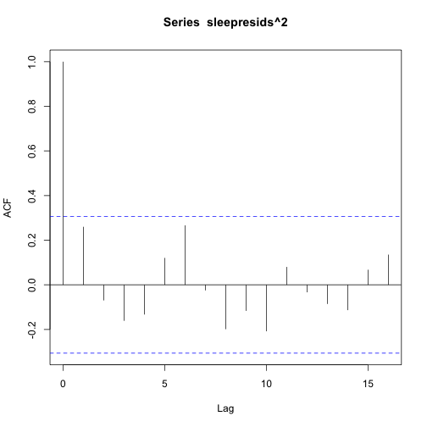
Conclusions
The regressor with the most clear statistical significance seems to be log(gestation). Surprisingly, the coefficient associated with this regressor is negative, suggesting that as the length of gestational period increases, the total amount of sleep per day needed decreases. This relationship holds on all models, even on the simple linear regression model. This result is particularly surprising to me; before starting the regression I had assumed that gestational period was correlated with intelligence (hence highly intelligent animals like humans and elephants have long gestational periods). Moreover, I had assumed that the more intelligent an animal the more sleep it would need (the popular science notion seems to be that sleep is important for recharging our brains). However, there is in fact a negative relationship between gestational period and sleep needs, suggesting that mammals that are birthed more quickly need to sleep more. I cannot posit a truly reasonable explanation. Perhaps, there is a tradeoff between quick birthing and later sleep, such that later sleep helps compensate for the development foregone in the short gestational period.
It is important to note, at least cursorily, that there may be problems with the model due to the correlation between regressors. More adequate models for explaining sleep needs should look for other regressors (perhaps in addition to gestational period) that are noncorrelated and do a better job of explaining total sleep needs. Perhaps, one should use some of the categorical variables that I decided to ignore due to interpretation problems (see discussion under Data section). Appropriate measures of these variables might produce interesting results, and we might use them as a basis to model possible interactions (for instance, we could test if body weight X predator/not predator yields significant results). Another intriguing possibility would include a dummy regressor for domesticated animals; as sleep needs might have evolved differently for wild vs. domestic animals (e.g. jaguar vs. cat)
Ultimately, I have not been able to explain why I, or any other mammal, might feel the need to keep hitting the snooze button. I do know, however, that after my efforts here, I am about ready for a nap.

