xxxxx xxxxxxxx
Time Series – Fall 2011

Monthly Retail Inventories
Introduction
This project focuses on monthly inventories for the retail industry. It will attempt to develop a model to predict future inventory levels.
Data
The data for the analysis was found at the U.S. Census Bureau website. I used the Retail Inventories and Inventories/Sales Ratios excel file including January 1992 through November 2011. The specific data used is in row 7 – Unadjusted Retail inventories, total. (http://www.census.gov/retail/)
Analysis
Before building the forecast equation, the initial data needs to be observed. The forecast equation will be constructed using data from January 1992 through November 2011. The numbers are shown in millions of dollars. The initial look at the data shows a mostly rising curve with a dip around 2009. There also appears to be a seasonal trend.
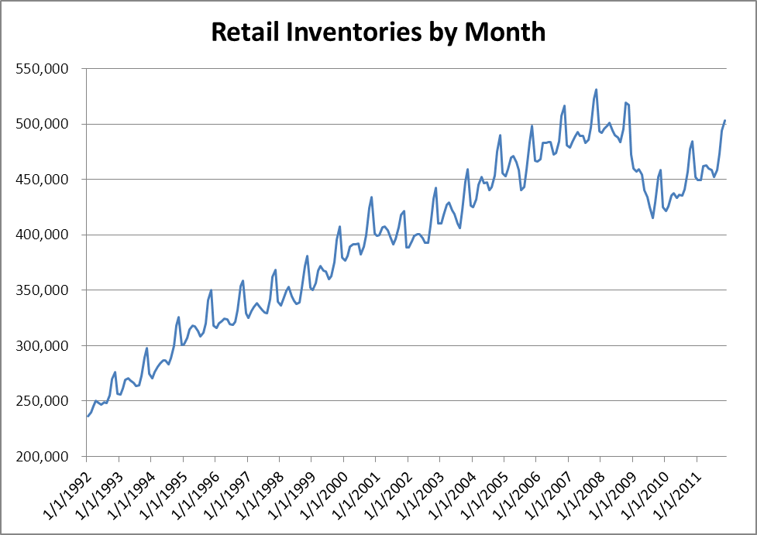
The next step consists of graphing the autocorrelations in a correlogram. This view reveals that the autocorrelations do not converge to zero. This means an autoregressive model will be appropriate, and that the data is not stationary. The dotted red lines represent a 95% confidence interval based on the sample size. The hope is that taking first differences will achieve the necessary stationary data that is required.
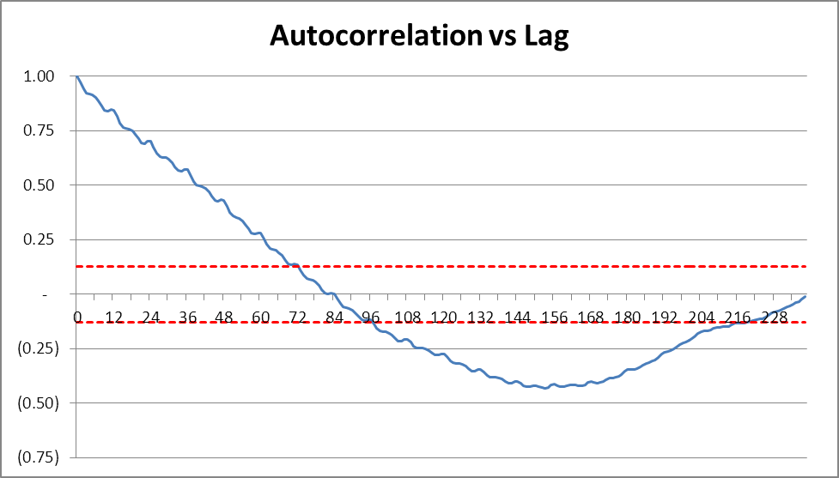
At first glance, the graph of first differences displays the stationary data that is needed. The corresponding correlogram will hopefully confirm.
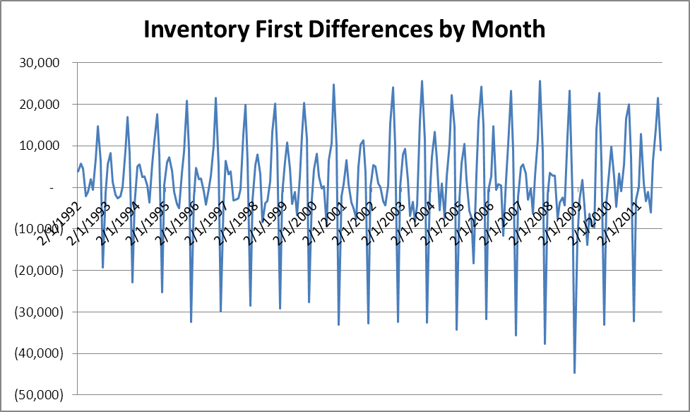
The correlogram shows that the autocorrelation does eventually converge to within the 95% confidence interval. The next step will be to produce Seasonal Autoregressive models to predict future inventories.
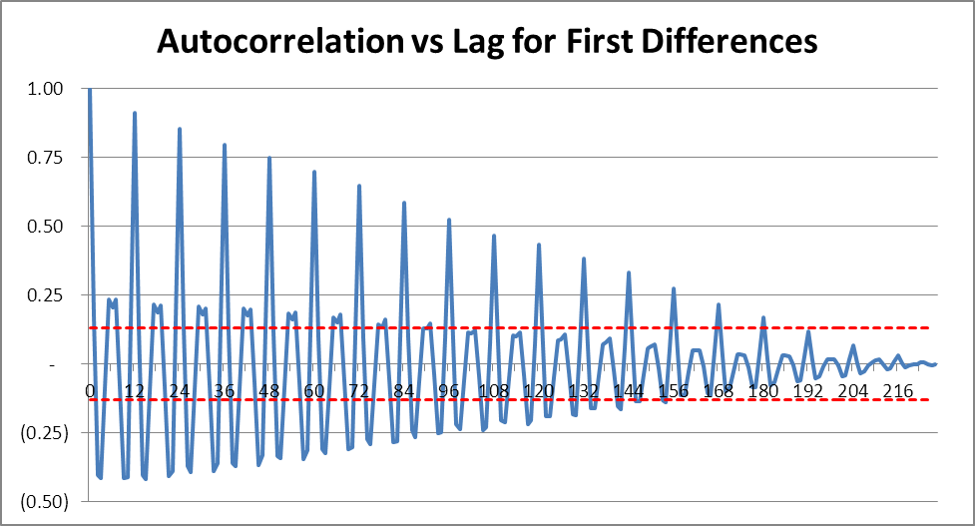

Models
The regression analysis will be completed in Microsoft Excel, with the Regression Analysis Tool. The data will be first differences, meaning that the forecast will be of first differences. The inventory forecast will be based on the forecast of first differences.
The initial model is an ARI(2,1)x(1)12 process with formula:
Yt – Yt-1 = A + B1*(Yt-1 – Yt-2) + B2*(Yt-2 – Yt-3) + B3*(Yt-12 – Yt-13) + et
Excel produces the following output:
Regression Statistics
Multiple R | 0.946850324
R Square | 0.896525535
Adjusted R Square | 0.895127232
Standard Error | 4121.817658
Observations | 226
 | df | SS | MS | F
Regression | 3 | 32678341059 | 10892780353 | 641.1522868
Residual | 222 | 3771642538 | 16989380.8
Total | 225 | 36449983597
 | Coefficients | Standard Error | t Stat | P-value
Intercept | 20.519912 | 277.269346 | 0.074007 | 0.941071
Yt-1 - Yt-2 | 0.028949 | 0.022836 | 1.267695 | 0.206235
Yt-2 - Yt-3 | -0.006272 | 0.024780 | -0.253118 | 0.800411
Yt-12 - Yt-13 | 0.955941 | 0.025139 | 38.026130 | 0.000000
Resulting in:
Yt – Yt-1 = 20.520 + 0.029*(Yt-1 – Yt-2) – 0.006*(Yt-2 – Yt-3) + 0.956*(Yt-12 – Yt-13) + et
This forecast has an R Square value of 89.653%, which means that (Yt-1 – Yt-2), (Yt-2 – Yt-3), and (Yt-12 – Yt-13) account for 89.653% of the variance of (Yt – Yt-1) about the mean of (Yt – Yt-1). Notice, the only variable with a P-value close to zero is (Yt-12 – Yt-13), and our Adjusted R Square is 89.513%.
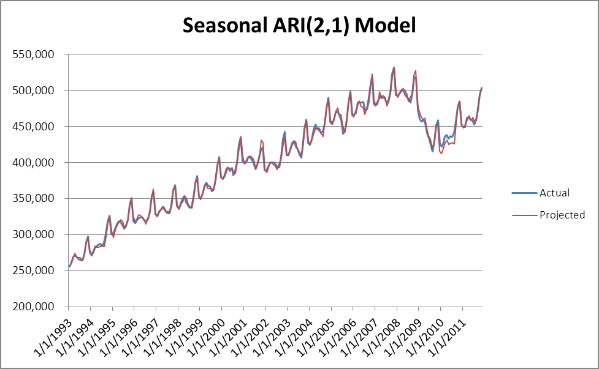
The next model is an ARI(1,1)x(1)12 process with formula:
Yt – Yt-1 = A + B1*(Yt-1 – Yt-2) + B2*(Yt-12 – Yt-13) + et
Excel produces these results:
Regression Statistics
Multiple R | 0.946834554
R Square | 0.896495673
Adjusted R Square | 0.895567383
Standard Error | 4113.158927
Observations | 226
 | df | SS | MS | F
Regression | 2 | 32677252570 | 16338626285 | 965.7496
Residual | 223 | 3772731027 | 16918076.36
Total | 225 | 36449983597
 | Coefficients | Standard Error | t Stat | P-value
Intercept | 13.53429 | 275.31285 | 0.04916 | 0.96084
Yt-1 - Yt-2 | 0.02732 | 0.02187 | 1.24944 | 0.21281
Yt-12 - Yt-13 | 0.95888 | 0.02225 | 43.10268 | 0.00000
Resulting in:
Yt – Yt-1 = 13.534 + 0.027*(Yt-1 – Yt-2) + 0.959*(Yt-12 – Yt-13) + et
This forecast has an R Square value of 89.650%, which means that (Yt-1 – Yt-2) and (Yt-12 – Yt-13) account for 89.650% of the variance of (Yt – Yt-1) about the mean of (Yt – Yt-1). Notice, (Yt-12 – Yt-13) is still the only variable with a P-value close to zero, and our adjusted R Square is 89.557%.
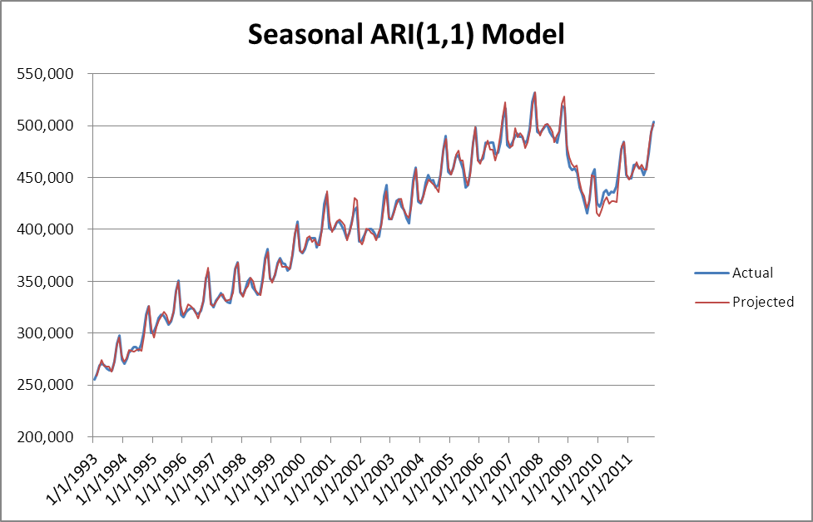
The next model is an ARI(0,1)x(1)12 process with formula:
Yt – Yt-1 = A + B1*(Yt-12 – Yt-13) + et
Excel produces these results:
Regression Statistics
Multiple R | 0.946451844
R Square | 0.895771094
Adjusted R Square | 0.895305786
Standard Error | 4118.307298
Observations | 226
 | df | SS | MS | F
Regression | 1 | 32650841678 | 32650841678 | 1925.115905
Residual | 224 | 3799141920 | 16960455
Total | 225 | 36449983597
 | Coefficients | Standard Error | t Stat | P-value
Intercept | 37.149685 | 275.007086 | 0.135086 | 0.892665
Yt-12 - Yt-13 | 0.963533 | 0.021960 | 43.876143 | 0.000000
Resulting in:
Yt – Yt-1 = 37.150 + 0.964*(Yt-12 – Yt-13) + et
This forecast has an R Square value of 89.577%, which means that (Yt-12 – Yt-13) accounts for 89.556% of the variance of (Yt – Yt-1) about the mean of (Yt – Yt-1). The adjusted R Square is 89.531%.
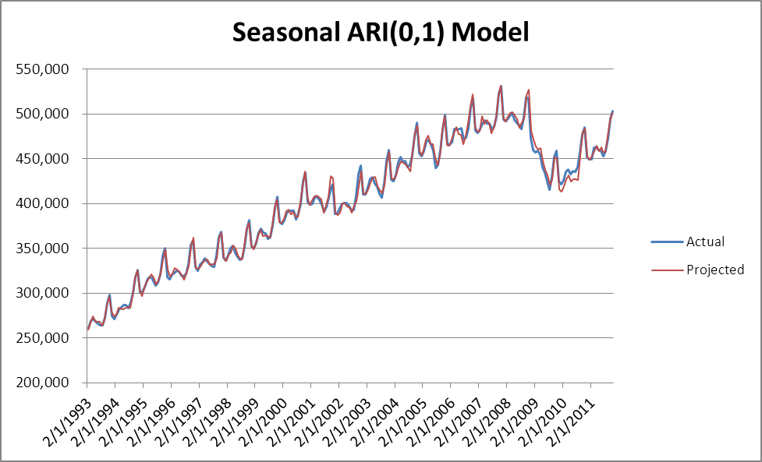
Final Model
In order to choose the best model for the time series, the Durbin Watson Statistic and Box-Pierce Q Statistic will be examined. These processes test the null hypothesis that the residuals follow a white noise process.
 | ARI(2,1)x(1)12 | ARI(1,1)x(1)12 | ARI(0,1)x(1)12
Degrees of Freedom | 3 | 2 | 1
Box-Pierce Q Stat | 232.25 | 231.75 | 236.84
Chi Square - 10% | 249.40 | 250.46 | 251.52
Durbin Watson Stat | 1.2599 | 1.2532 | 1.2014

All Box-Pierce Q statistics fall within their respective 10% significance level on the chi square distribution. The null hypothesis would not be rejected. The Durbin Watson test shows that there is some positive correlation in the data. However, the Durbin Watson statistic is not as effective on first differences.
Based on these results, I would select the ARI(1,1)x(1)12. The adjusted R Square value was highest on the ARI(1,1)x(1)12. I would avoid the ARI(2,1)x(1)12 because the P-value for (Yt-2 – Yt-3) was very high in the ARI(2,1)x(1)12 at 0.8, demonstrating insignificance. The ARI(0,1)x(1)12 would probably be alright, but it appears to have a higher level of positive correlation from its lower Durbin Watson Stat. The model could be tested as time passes and more data becomes available.

