xxxx xxxxxx
Time Series Fall 2011
Course Project

Introduction
Many Americans including myself consume meat in our regular diet. Those of us who buy it notice that the price of meat at the local supermarket seems to have risen in recent memory. We notice that meat, compared to other foods such as produce and grains, are typically the most expensive item in our shopping carts. Indeed, when comparing meat to other foods, I often debate myself on whether it is worth it to eat meat so regularly considering how expensive it has become.

I wanted to investigate the price of meat in the U.S. to see if my observation agrees with the historical evidence. Therefore, the intent of this project is to:
- Identify a time series model that is appropriate for describing the retail price of meat in the U.S.
- Fit this model to a historical dataset
- Form an assessment of how well our model fits the data.

Data
The data for this analysis comes from the Economic Research Service arm of the United States Department of Agriculture. This agency has provided its own adjustments to the data and describes the methodologies on its website. No attempt was made to validate the data provided from this agency; therefore, the quality of this model and analysis is inherently dependent on the integrity of the underlying data.

Model Specification
We focus our attention specifically to the price of beef products. A graph of beef prices is shown below:

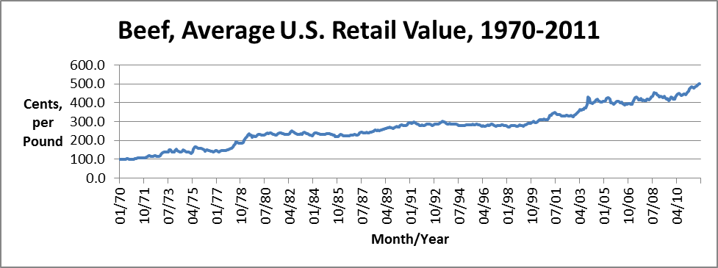

The graph shows a consistent upward trend, which implies that the original series is nonstationary. This is fairly trivial, as we would expect prices for most products to grow over time due to inflation, among other common factors.

The correlogram of the original time series data further shows that the original series is nonstationary. The correlogram below illustrates the autocorrelation function (ACF) at lags from k=1 to 36:

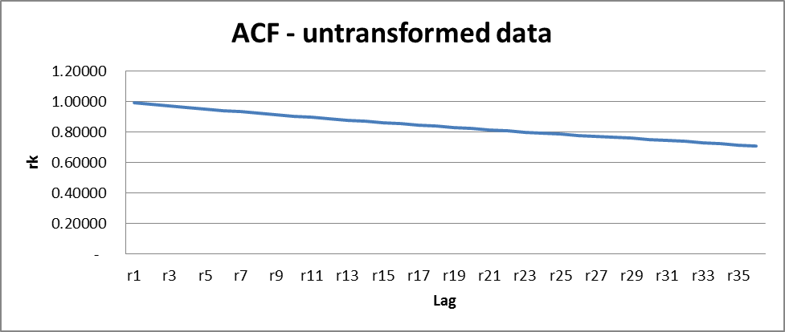

Notice that the ACF for the original time series decays very slowly; after 36 lags the autocorrelation remains at approx. 0.70 and above. Therefore, it is clear that in order to see whether or not this time series is stationary, we will need to transform the data.

We start with the simple first difference transformation:

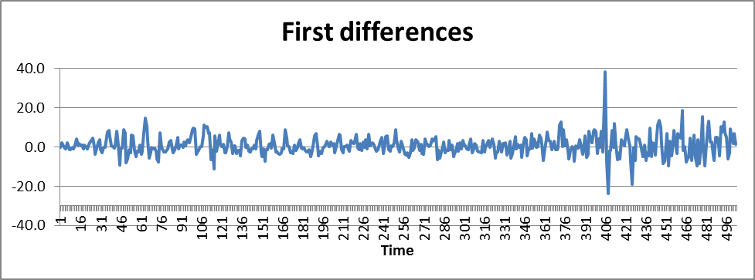

The process is now far more stable over time (except for some potential outliers in the data at around time periods 401-417). It appears that taking first differences to the data is a meaningful transformation, so we analyze further by observing the correlogram:
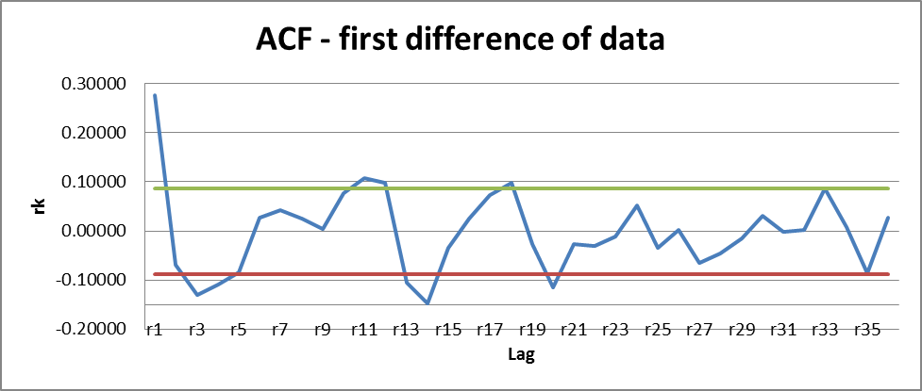
Unlike the original time series, the ACF of the first differences seems to cut off after lag 1. The green and red lines indicate upper and lower bounds (respectively) at the 95% significance level. While there are correlations that exceed our significance level (e.g. at k=3, 11, 14, and 18), there does not appear to be an amount of correlation substantial enough to indicate variation in this process beyond white noise fluctuation.

Both the logarithm of first difference and second difference transformations create extraneous complexity to this time series. Graphs of each of these transformations are shown as follows:

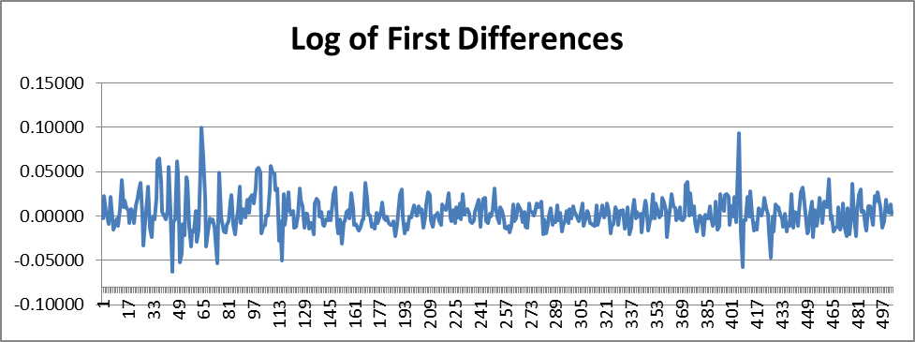

Compared to the first differences graph, there is much more volatility from time period 30-130, while the outlier(s) from time period 401-417 remain.
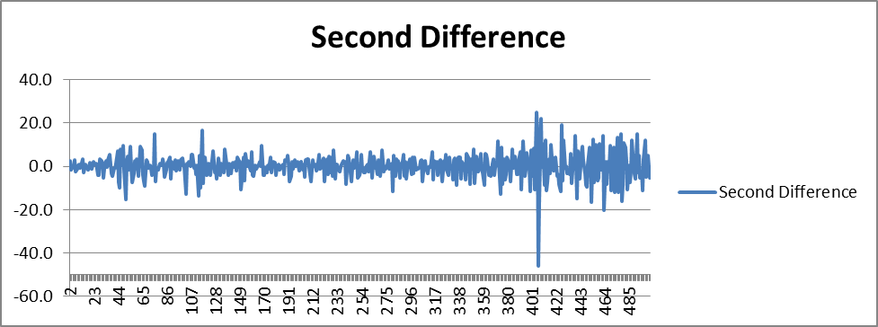

The second difference graph actually augments the outlier in time period 401-417 while not doing much to dampen volatility at other periods.

To sum up, these are the following points to take from this discussion:
- The first difference of the time series is stationary
- The ACF of the first difference cuts off after the first lag, which indicates that a moving average process of order 1 is a suitable candidate for the time series model
We will select an ARIMA model of the type IMA(1,1) (or ARIMA(0,1,1)). Our generic equation is
Y_{t} – Y_{t-1} = e_{t} - θe_{t-1}

Model Fitting
We now wish to obtain an estimate of the parameter θ for our IMA(1,1) model. Equation 7.1.4 in the Cryer-Chan text suggests calculating θ using the known relationship between the correlation coefficient ρ₁ and the true parameter θ, and then using the sample autocorrelation at lag 1, namely r₁, as a rough estimate for ρ₁.

Again, using the first difference of the time series, the lag 1 sample autocorrelation is 0.27646, and so by Equation 7.1.4, we estimate θ to be about -0.3016. The complete modeling equation is thus
Y_{t} – Y_{t-1} = e_{t} + 0.3016e_{t-1}

Model Diagnostics
We shall now demonstrate this model in practice and comment about the reliability of its output.

Because moving average models rely on the residuals e_{t} for t = 0, 1, … , we begin by computing the residuals with the help of the Regression feature from the Microsoft Excel Analysis ToolPak. With the residuals, we can implement the modeling equation from the previous section (with its θ parameter). The month-by-month calculations can be found on the ‘Residual analysis’ tab of the supporting Excel workbook. A graph of the model’s one-year-ahead forecasts compared to the actual data progression is also useful to visually assess the model’s fit. Such a graph is provided below:

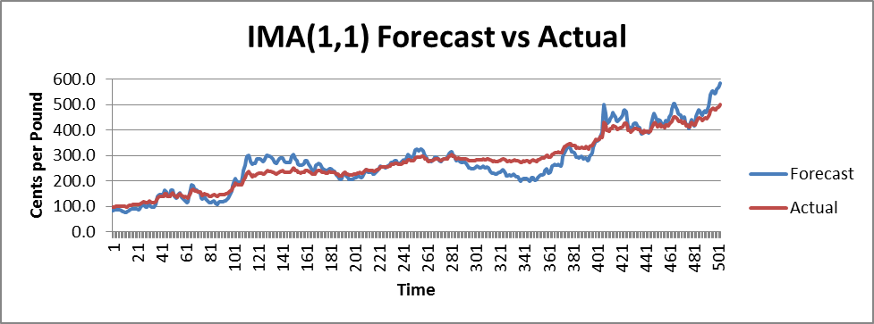

The IMA(1,1) model fits moderately well to the data; both positive and negative residuals are apparent, and the model’s prediction stays in proximity to the actual data throughout the time series. However, there seems to be a possible skew in the model starting from after t=400, so we expand the graph starting from this time:

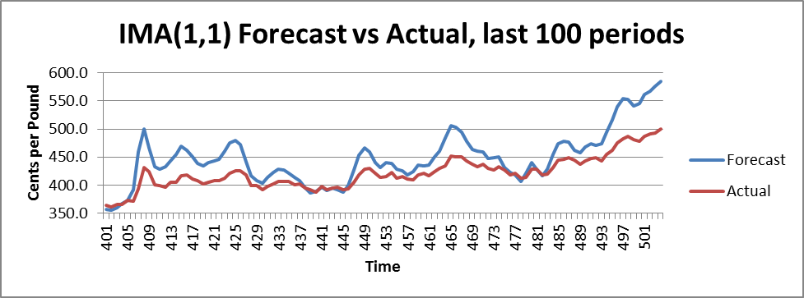

On a closer look, it appears that the forecast is almost uniformly overestimating the actual amount. A statistician may want to revisit the Model Specification phase to determine if some combination of an autoregressive component is justified. Nevertheless, the IMA(1,1) model did turn out to be a good model for this time series given its simplicity in equation form and implementation.

Conclusion

The IMA(1,1) model provides a valuable model of over four decades of U.S. beef price data. It illustrates a reasonable fit to the actual time series data, and it also has the benefit of relying on only one estimated parameter thus maintaining the principle of parsimony.

It should be noted that this model, like so many others that attempt to model a stochastic process, is flawed. Indeed the model’s tendency to overestimate towards the end of this time series should raise some concerns. Yet the model can be improved in numerous ways. For example, a renewed discussion on Model Specification could continue by considering whether or not adding an autoregressive parameter would improve on the accuracy of the model. A Partial Autocorrelation graph would be a useful tool in this regard. Furthermore, deeper testing on Model Diagnostics could be performed; for example, one could calculate residual autocorrelations to determine the Box-Pierce (or Ljung-Box) statistic and compare it to the chi-square distribution. This would be valuable for gaining more than just a graphical determination of goodness-of-fit. The fact that additional work can be done to improve this time series model is a testament to the iterative nature of ARIMA process modeling.

Reference
“Historical monthly price spread data for beef, pork, broilers, turkeys, and eggs”, Economic Research Service, United States Department of Agriculture. February 17, 2012. <http://www.ers.usda.gov/Data/MeatPriceSpreads/>.

