xxxxxxx xxxxx
Regression
Fall 2011
Student Project

Calorie Content of Taco Bell’s Menu Items

OBJECTIVE

Construct a regression analysis to determine the calorie content of the various menu items offered by Taco Bell using the underlying nutritional information. References to the accompanying spreadsheet have been included in brackets.

DATA

Data on Taco Bell’s menu was obtained from http://www.tacobell.com/nutrition/information [Taco Bell Data]. I restricted the analysis to 56 main dishes, excluding beverages, condiments, etc. I used 48 data points for the regression, holding 8 points to use as a validation data set. A data sample is given below:

 | (Y) calories | (X₁) total fat (g) | (X₂) saturated fat (g) | (X₃) cholesterol (mg) | (X₄) sodium (mg) | (X₅) carbohydrates (g) | (X₆) dietary fiber (g) | (X₇) sugars (g) | (X₈) protein (g) | serving size (g)
1/2 lb.* Cheesy Potato Burrito | 540 | 26 | 7 | 45 | 1360 | 59 | 7 | 4 | 19 | 248
1/2 lb.* Combo Burrito | 460 | 18 | 7 | 45 | 1330 | 53 | 9 | 3 | 21 | 241
7-Layer Burrito | 500 | 18 | 6 | 20 | 1090 | 69 | 12 | 5 | 17 | 283
Beefy 5-Layer Burrito | 540 | 22 | 8 | 35 | 1280 | 68 | 9 | 6 | 19 | 245
Beefy Crunch Burrito | 500 | 22 | 6 | 30 | 1060 | 61 | 5 | 5 | 14 | 220
Burrito Supreme® - Beef | 420 | 16 | 6 | 35 | 1100 | 53 | 9 | 5 | 17 | 248
Burrito Supreme® - Chicken | 400 | 12 | 5 | 40 | 1060 | 51 | 7 | 5 | 21 | 248
Burrito Supreme® - Steak | 390 | 13 | 5 | 30 | 1100 | 51 | 7 | 5 | 17 | 248

To normalize the data, all values were divided by the serving size [Normalized Data]. This reduced any correlation that would have been due purely to the size of the menu item.

Variables
The variables were defined as:
Y: calories

X₁: total fat (g)
X₂: saturated fat (g)
X₃: cholesterol (mg)
X₄: sodium (mg)
X₅: carbohydrates (g)
X₆: dietary fiber (g)
X₇: sugars (g)
X₈: protein (g)

Data Analysis
I began the data analysis by examining the correlation between each set of variables [Normalized Correlations].

 | calories | total fat (g) | saturated fat (g) | cholesterol (mg) | sodium (mg) | carbohydrates (g) | dietary fiber (g) | sugars (g) | protein (g)
calories | 1.000
total fat (g) | 0.944 | 1.000
saturated fat (g) | 0.770 | 0.738 | 1.000
cholesterol (mg) | 0.677 | 0.626 | 0.879 | 1.000
sodium (mg) | 0.872 | 0.713 | 0.824 | 0.766 | 1.000
carbohydrates (g) | 0.941 | 0.793 | 0.643 | 0.533 | 0.887 | 1.000
dietary fiber (g) | 0.795 | 0.665 | 0.512 | 0.385 | 0.770 | 0.862 | 1.000
sugars (g) | 0.728 | 0.594 | 0.495 | 0.531 | 0.654 | 0.773 | 0.579 | 1.000
protein (g) | 0.799 | 0.660 | 0.830 | 0.914 | 0.885 | 0.742 | 0.602 | 0.665 | 1.000

As can be seen, there are some rather large correlations between some of the dependent variables. This may be problematic if too many highly correlated variables remain in the final model.

I also visually examined graphs of each dependent variable against calories [Normalized Data]. Certain variables such as total fat and carbohydrates exhibit much stronger patterns. No variable appeared to have a nonlinear pattern, so no data transformations were employed.

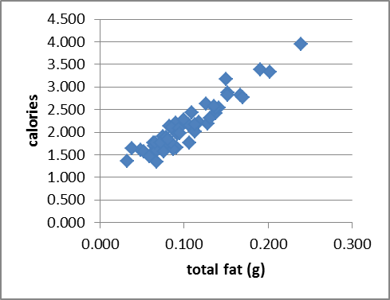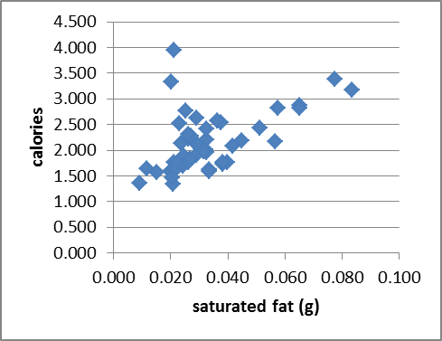

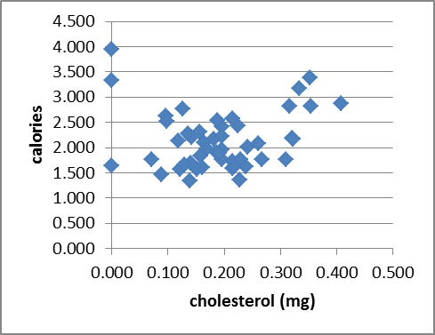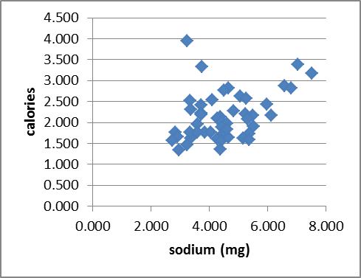
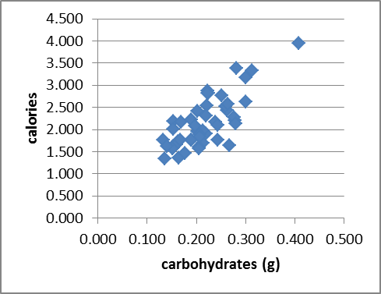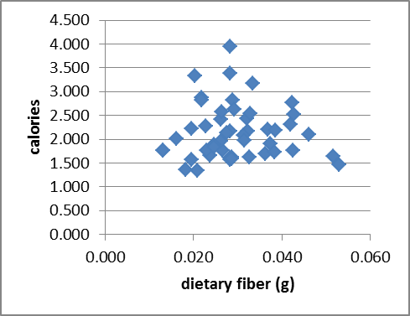
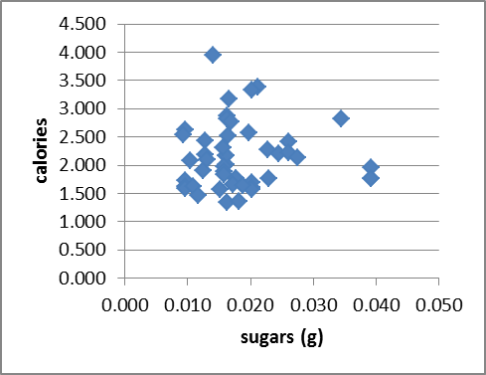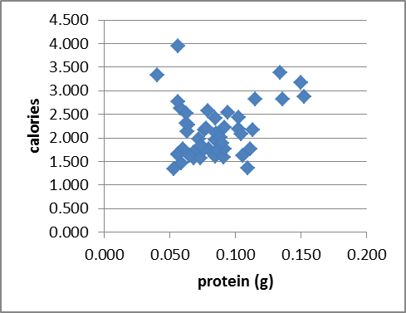

MODEL ANALYSIS

For the model analysis, I utilized Excel’s data analysis regression tool. I began with a model containing all potential dependent variables and eliminated variables to select a model. For each iteration, I will eliminate the variable with the highest p-value until only significant variables remain.
8 Dependent Variables [Model 1] – Full Model
Model: Y =  + ₁X₁ + ₂X₂ +₃X₃ +₄X₄ +₅X₅ +₆X₆ +₇X₇ +₈X₈

Regression Statistics
Multiple R | 0.99912287
R Square | 0.99824651
Adjusted R Square | 0.997886819
Standard Error | 0.026285559
Observations | 48
ANOVA
 | df | SS | MS | F
Regression | 8 | 15.34028616 | 1.91753577 | 2775.29428
Residual | 39 | 0.026946294 | 0.000690931
Total | 47 | 15.36723245
 | Coefficients | Standard Error | t Stat | P-value
Intercept | 0.026026804 | 0.041894052 | 0.621252969 | 0.538047679
(X1) total fat (g) | 9.31179294 | 0.182623843 | 50.98892218 | 2.599E-37
(X2) saturated fat (g) | 0.05644313 | 0.789937706 | 0.071452635 | 0.943402689
(X3) cholesterol (mg) | -0.227443884 | 0.163886533 | -1.387813142 | 0.173072391
(X4) sodium (mg) | 0.017444432 | 0.00787126 | 2.216218453 | 0.032579484
(X5) carbohydrates (g) | 3.626420539 | 0.180302343 | 20.11299734 | 3.41433E-22
(X6) dietary fiber (g) | -0.373515136 | 0.556445526 | -0.671251936 | 0.506016623
(X7) sugars (g) | 0.173704868 | 0.684538297 | 0.253754784 | 0.801018048
(X8) protein (g) | 3.94931427 | 0.400362722 | 9.864340641 | 3.76207E-12

The R² indicates that 99.8% of the variation of Y about the mean of Y is explained by this model.

(X₂) saturated fat has the lowest t-statistic and the highest p-value. We eliminate it and regress on the remaining variables.

7 Dependent Variables [Model 2]
Model: Y =  + ₁X₁ + ₃X₃ +₄X₄ +₅X₅ +₆X₆ +₇X₇ +₈X₈

Regression Statistics
Multiple R | 0.999122755
R Square | 0.99824628
Adjusted R Square | 0.997939379
Standard Error | 0.025956609
Observations | 48
ANOVA
 | df | SS | MS | F
Regression | 7 | 15.34028263 | 2.191468947 | 3252.665643
Residual | 40 | 0.026949821 | 0.000673746
Total | 47 | 15.36723245
 | Coefficients | Standard Error | t Stat | P-value
Intercept | 0.023923901 | 0.029442037 | 0.812576288 | 0.421271056
(X1) total fat (g) | 9.318404842 | 0.15547381 | 59.93552758 | 8.67219E-41
(X3) cholesterol (mg) | -0.22148455 | 0.139311788 | -1.589847873 | 0.119742841
(X4) sodium (mg) | 0.017718718 | 0.006785754 | 2.611164062 | 0.012642098
(X5) carbohydrates (g) | 3.627021121 | 0.177852379 | 20.39343606 | 9.57422E-23
(X6) dietary fiber (g) | -0.35656901 | 0.497073149 | -0.717337098 | 0.477334515
(X7) sugars (g) | 0.184009052 | 0.66080134 | 0.278463497 | 0.782091091
(X8) protein (g) | 3.950180756 | 0.395170989 | 9.996130446 | 1.95299E-12

The R² remains 99.8%.

(X₇) sugars has the lowest t-statistic and the highest p-value. We eliminate it and regress on the remaining variables.

6 Dependent Variables [Model 3]
Model: Y =  + ₁X₁ + ₃X₃ +₄X₄ +₅X₅ +₆X₆ +₈X₈

Regression Statistics
Multiple R | 0.999121054
R Square | 0.99824288
Adjusted R Square | 0.997985741
Standard Error | 0.025662949
Observations | 48
ANOVA
 | df | SS | MS | F
Regression | 6 | 15.34023039 | 2.556705065 | 3882.1071
Residual | 41 | 0.027002065 | 0.000658587
Total | 47 | 15.36723245
 | Coefficients | Standard Error | t Stat | P-value
Intercept | 0.027484403 | 0.02622062 | 1.04819805 | 0.300687337
(X1) total fat (g) | 9.30144861 | 0.1414349 | 65.76487575 | 3.429E-43
(X3) cholesterol (mg) | -0.211485568 | 0.133081802 | -1.589139644 | 0.11971152
(X4) sodium (mg) | 0.016785892 | 0.005834473 | 2.877019327 | 0.006345301
(X5) carbohydrates (g) | 3.65002769 | 0.155715631 | 23.44034234 | 2.29402E-25
(X6) dietary fiber (g) | -0.412567281 | 0.449435589 | -0.917967538 | 0.364004664
(X8) protein (g) | 3.956886365 | 0.389974143 | 10.14653519 | 9.55761E-13

The R² remains 99.8%.

(X₆) dietary fiber has the lowest t-statistic and the highest p-value. We eliminate it and regress on the remaining variables.

5 Dependent Variables [Model 4]
Model: Y =  + ₁X₁ + ₃X₃ +₄X₄ +₅X₅ +₈X₈

Regression Statistics
Multiple R | 0.999102981
R Square | 0.998206767
Adjusted R Square | 0.997993287
Standard Error | 0.025614836
Observations | 48
ANOVA
 | df | SS | MS | F
Regression | 5 | 15.33967542 | 3.067935084 | 4675.87622
Residual | 42 | 0.027557033 | 0.00065612
Total | 47 | 15.36723245
 | Coefficients | Standard Error | t Stat | P-value
Intercept | 0.014929168 | 0.022328908 | 0.668602721 | 0.507407244
(X1) total fat (g) | 9.308328425 | 0.140971401 | 66.02990644 | 4.58573E-44
(X3) cholesterol (mg) | -0.204893475 | 0.132638772 | -1.544747977 | 0.129909549
(X4) sodium (mg) | 0.015542693 | 0.005664478 | 2.743887965 | 0.008891731
(X5) carbohydrates (g) | 3.648111517 | 0.155409729 | 23.47415141 | 9.04624E-26
(X8) protein (g) | 4.008292288 | 0.385208914 | 10.40550243 | 3.37912E-13

The R² remains 99.8%.

(X₃) cholesterol has the lowest t-statistic and the highest p-value. We eliminate it and regress on the remaining variables.

4 Dependent Variables [Model 5]
Model: Y =  + ₁X₁ + ₄X₄ +₅X₅ +₈X₈

Regression Statistics
Multiple R | 0.999051992
R Square | 0.998104883
Adjusted R Square | 0.997928594
Standard Error | 0.02602445
Observations | 48
ANOVA
 | df | SS | MS | F
Regression | 4 | 15.33810976 | 3.834527439 | 5661.724421
Residual | 43 | 0.029122696 | 0.000677272
Total | 47 | 15.36723245
 | Coefficients | Standard Error | t Stat | P-value
Intercept | 0.003152627 | 0.02132277 | 0.147852584 | 0.883150248
(X1) total fat (g) | 9.176993863 | 0.114246066 | 80.32656357 | 1.7087E-48
(X4) sodium (mg) | 0.012448181 | 0.005383154 | 2.312432585 | 0.025606555
(X5) carbohydrates (g) | 3.831763552 | 0.101689622 | 37.68096958 | 1.4342E-34
(X8) protein (g) | 3.540381273 | 0.241786308 | 14.64260444 | 2.58067E-18

The R² remains 99.8%.

(X₄) sodium has the lowest t-statistic and the highest p-value. We eliminate it and regress on the remaining variables.

3 Dependent Variables [Model 6]
Model: Y =  + ₁X₁ + ₅X₅ +₈X₈

Regression Statistics
Multiple R | 0.998934038
R Square | 0.997869213
Adjusted R Square | 0.997723932
Standard Error | 0.027279822
Observations | 48
ANOVA
 | df | SS | MS | F
Regression | 3 | 15.33448815 | 5.11149605 | 6868.548321
Residual | 44 | 0.032744303 | 0.000744189
Total | 47 | 15.36723245
 | Coefficients | Standard Error | t Stat | P-value
Intercept | 0.003279498 | 0.022351268 | 0.146725362 | 0.884019023
(X1) total fat (g) | 9.110971747 | 0.115957165 | 78.57187401 | 5.96447E-49
(X5) carbohydrates (g) | 3.956031697 | 0.090494492 | 43.71571796 | 6.80596E-38
(X8) protein (g) | 3.964947926 | 0.164913616 | 24.04257464 | 6.09304E-27

The R² remains 99.8%.

At this point, all remaining variable would be considered significant with p-values < 0.1%. However, to continue testing variables, we eliminate another variable. (X₈) protein has the lowest t-statistic and the highest p-value. We eliminate it and regress on the remaining variables.

2 Dependent Variables [Model 7]
Model: Y =  + ₁X₁ + ₅X₅

Regression Statistics
Multiple R | 0.984822938
R Square | 0.969876218
Adjusted R Square | 0.968537384
Standard Error | 0.101425304
Observations | 48
ANOVA
 | df | SS | MS | F
Regression | 2 | 14.9043133 | 7.452156649 | 724.4181755
Residual | 45 | 0.462919154 | 0.010287092
Total | 47 | 15.36723245
 | Coefficients | Standard Error | t Stat | P-value
Intercept | 0.378901483 | 0.059428638 | 6.375739007 | 8.6289E-08
(X1) total fat (g) | 9.896738643 | 0.413645977 | 23.92562525 | 3.14485E-27
(X5) carbohydrates (g) | 3.38919225 | 0.324835781 | 10.43355582 | 1.35306E-13

The R² decreased to 97.0%. Of more significance, the F-statistic dropped from 6869 to 724 and the standard error increased from 2.7% to 10.1%, indicating the last variable eliminated should be added back to the model.

MODEL SELECTION

Based on the above results, Model 6 with 3 dependent variables appears to be the best model. A summary of the results is below.

Model | R² | F-statistic | Standard Error
1 | 99.8% | 2775 | 2.6%
2 | 99.8% | 3253 | 2.6%
3 | 99.8% | 3882 | 2.6%
4 | 99.8% | 4676 | 2.6%
5 | 99.8% | 5662 | 2.6%
6 | 99.8% | 6869 | 2.7%
7 | 97.0% | 724 | 10.1%

I examine the residuals of the selected model to show that they appear normally distributed [Model 6]. This is further indication of a good model selection.

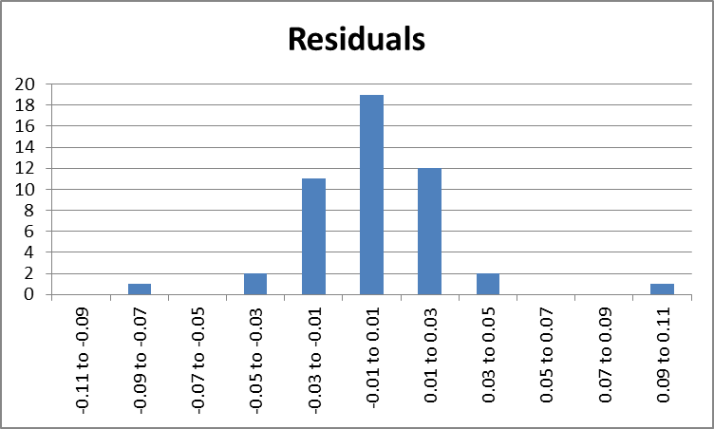

MODEL VALIDATION

Using the 8 data points set aside before beginning the analysis, I attempted to validate the accuracy of the model predictions [Validation]. In order to get the full caloric content, the portion size is needed to de-normalize the data.

 | Normalized |  |  | Full Portion
 | Predicted | Actual | Difference | Predicted | Actual | Difference
Bean Burrito | 1.843 | 1.869 | 0.026 | 365 | 370 | 1.4%
Chalupa Supreme - Chicken | 2.266 | 2.288 | 0.022 | 347 | 350 | 1.0%
Chicken Soft Taco | 1.893 | 1.875 | -0.018 | 182 | 180 | -0.9%
Double Decker® Taco Supreme® | 1.867 | 1.862 | -0.005 | 351 | 350 | -0.3%
Fiesta Taco Salad-Steak | 1.550 | 1.533 | -0.016 | 717 | 710 | -1.0%
Grilled Chicken Burrito | 2.406 | 2.429 | 0.024 | 426 | 430 | 1.0%
Original Chicken Flatbread Sandwich | 2.685 | 2.661 | -0.024 | 293 | 290 | -0.9%
Volcano Taco | 2.535 | 2.500 | -0.035 | 233 | 230 | -1.4%

CONCLUSION

The 3 variable model using total fat, carbohydrates, and protein is a good predictor of the number of calories in a typical Taco Bell menu item. The model produces the highest F-statistic and an R² of 99.8%.

The selected model is: Y = 0.003+ 9.111X₁ + 3.956X₅ +3.965X₈

